Report of index aggregation

Luna Zhang, AbacusBio

2022-07-11

Article Outline

Disclaimer 1

Background 1

Input 1

Files 1

Filters 2

Summary statistics 2

Breeding value 2

Classification variable 3

Aggregated index relative economic weight (RW) 3

# Disclaimer

This report is generated from the **Plant Index Aggregation App**. You may notice some NULL or NA in the report. It means the corresponding analysis was skipped when the app was used.

# Background

The objective of this analysis is to create aggregated indexes that can represent clusters of numeric original indexes. The report contains the information of the original and aggregated indexes, the process of cluster forming, and the evaluation of the performance of the aggregated indexes.

# Input

## Files

| Table | File |
| --- | --- |
| Breeding value | demo |
| Economic value | demo |
| Economic value weight | demo |

# Filters

Missing EBV set to 0:, FALSE

Table filters

| Table | column | level |
| --- | --- | --- |
| Breeding value |  |  |
| Economic value |  |  |

# Summary statistics

## Breeding value

Breeding value summary statistics

| variable | mean | sd | min | max | n_missing | n | n_obs |
| --- | --- | --- | --- | --- | --- | --- | --- |
| GLEAFSPOT | -0.09 | 0.47 | -1.46 | 1.29 | 450 | 949 | 499 |
| ANTHRAC | -0.83 | 0.82 | -3.63 | 1.41 | 450 | 949 | 499 |
| GOSSWILT | -0.09 | 0.89 | -2.69 | 2.98 | 449 | 949 | 500 |
| FUSARIUM | -0.02 | 1.03 | -3.12 | 3.76 | 449 | 949 | 500 |
| GIBBERELLA | 0.44 | 0.86 | -1.64 | 2.93 | 449 | 949 | 500 |
| NLEAFBLIGHT | 0.02 | 0.67 | -2.06 | 1.89 | 449 | 949 | 500 |
| BROWNRUST | -0.42 | 1.00 | -3.79 | 2.84 | 449 | 949 | 500 |
| TARSPOT | -0.01 | 0.11 | -0.35 | 0.33 | 449 | 949 | 500 |
| YIELD | 4.42 | 8.51 | -20.22 | 32.24 | 449 | 949 | 500 |
| GREENSNAP | -0.41 | 6.64 | -18.31 | 16.28 | 449 | 949 | 500 |
| ROOTLODGE | -0.10 | 2.55 | -7.48 | 7.32 | 449 | 949 | 500 |
| STALKLODGE | -0.06 | 1.27 | -4.09 | 3.86 | 449 | 949 | 500 |
| TESTWT | 0.00 | 0.98 | -2.88 | 3.63 | 449 | 949 | 500 |
| MOIST | 0.24 | 1.79 | -6.24 | 6.45 | 449 | 949 | 500 |

## Warning: Removed 450 rows containing non-finite values (stat_bin).  
## Removed 450 rows containing non-finite values (stat_bin).

## Warning: Removed 449 rows containing non-finite values (stat_bin).  
## Removed 449 rows containing non-finite values (stat_bin).  
## Removed 449 rows containing non-finite values (stat_bin).  
## Removed 449 rows containing non-finite values (stat_bin).  
## Removed 449 rows containing non-finite values (stat_bin).  
## Removed 449 rows containing non-finite values (stat_bin).  
## Removed 449 rows containing non-finite values (stat_bin).  
## Removed 449 rows containing non-finite values (stat_bin).  
## Removed 449 rows containing non-finite values (stat_bin).  
## Removed 449 rows containing non-finite values (stat_bin).  
## Removed 449 rows containing non-finite values (stat_bin).  
## Removed 449 rows containing non-finite values (stat_bin).

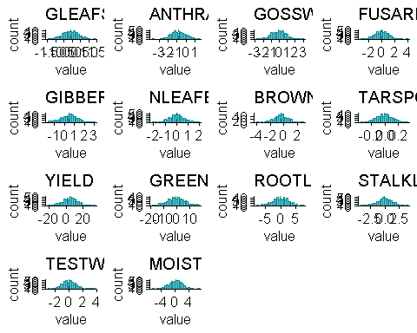

### Classification variable

#### Distribution

#### Full table

## Aggregated index relative economic weight (RW)

$$RW=EV×SD\left(EBV\right)$$