Before you being, please copy over the LawFirmDRM.bak into a local directory such as C:\Temp\.

* You can restore the current database if LawFirmDRM is already available by using the following, or…

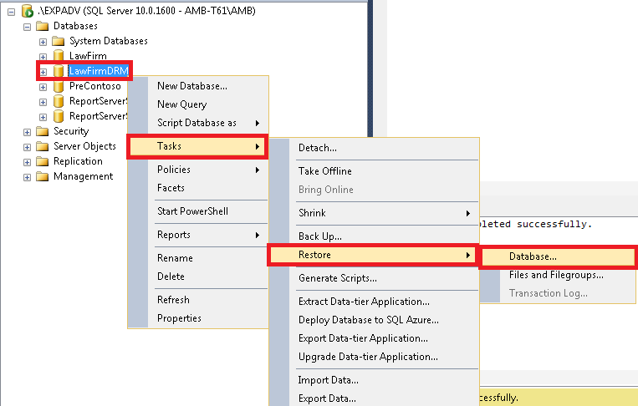

* You can Restore a New database by right-clicking on the ‘Databases’ directory, then performing the following.

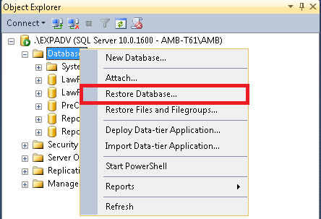

* **Either way,** you will follow the steps outlined below to restore the database.

