|  |
| --- |
| RELATIONSHIPS |
| MANY employees TO MANY cases  ONE client TO MANY cases  MANY specialists TO MANY cases  MANY cases TO MANY expenses |

|  |
| --- |
| ENTITIES |
| CLIENTS, EMPLOYEES, CASE, SPECIALISTS, CASE_EMPLOYEE, CASE_SPECIALIST, CASE_EXPENSES  LOOKUPS:  CLIENT_STATUS  CLIENT_SUFFIX  EMPLOYEE_TYPE  CASE_TYPE  SPECIALIST_TYPE  EXPENSE_TYPES |

|  |
| --- |
| DBDL |
| **CLIENTS**(CLIENT_ID, ,,,CLIENT_STATUS_ID, CLIENT_SUFFIX_ID  PK CLIENT_ID  FK CLIENT_STATUS_ID 🡺 CLIENT_STATUS  FK CLIENT_SUFFIX_ID 🡺 CLIENT_SUFFIX  **CLIENT_STATUS**(CLIENT_STATUS_ID,,  PK CLIENT_STATUS_ID  **CLIENT_SUFFIX**(CLIENT_SUFFIX_ID,  PK CLIENT_SUFFIX_ID  **EMPLOYEES**(EMPLOYEE_ID,,,,EMPLOYEE_TYPE_ID  PK EMPLOYEE_ID  FK EMPLOYEE_TYPE_ID 🡺 EMPLOYEE_TYPE  **EMPLOYEE_TYPE**(EMPLOYEE_TYPE_ID,  PK EMPLOYEE_TYPE_ID  **CASE**(CASE_ID,,,,CASE_CATEGORY_ID, CLIENT_ID  PK CASE_ID  FK CASE_CATEGORY_ID 🡺 CASE_CATEGORIES  FK CLIENT_ID 🡺 CLIENTS  **CASE_TYPE**(CASE_CATEGORY_ID, TITLE, AMOUNT  PK CASE_CATEGORY_ID  **SPECIALISTS**(SPECIALIST_ID,,,SPECIALIST_TYPE_ID  PK SPECIALIST_ID  FK SPECIALIST_TYPE_ID 🡺 SPECIALIST_TYPE  **SPECIALIST_TYPE**(SPECIALIST_TYPE_ID)  PK SPECIALIST_TYPE_ID  **EXPENSE_TYPES**(EXPENSE_TYPE_ID)  PK EXPENSE_TYPE_ID  **CASE_EMPLOYEE**(CASE_ID, EMPLOYEE_ID, RATE)  PK CASE_ID  PK EMPLOYEE_ID  **CASE_SPECIALIST**(CASE_ID, SPECIALIST_ID, RATE)  PK CASE_ID  PK SPECIALIST_ID  **CASE_EXPENSES**(CASE_ID, EXPENSE_TYPE_ID, RATE)  PK CASE_ID  PK EXPENSE_TYPE_ID |
|  |

­

**Entity Relationship Overview:**

MATERIALS

MATERIAL_TYPE

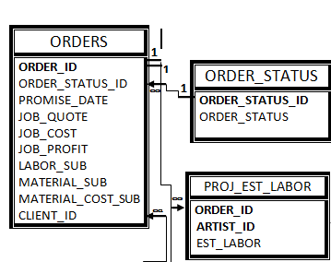**Entity Relationship Detailed Overview:**