Report 1: Housing Price Prediction Pipeline
Abdurasul Bobonazarov, Maxmudbek Muzaffarov, Data Science Project ICT/Data Science — Year 2025 November 29th, 2025
1. Introduction
The objective of this project is to build and evaluate a predictive model for housing prices based on available property data. The pipeline includes data loading, preprocessing, model training, validation, diagnostics, and saving of results for future analysis. Housing data was sourced from uybor_clean.csv, containing key features such as rooms, size, level, max_levels, lat, lng, price_per_sqm, and the target variable price. Missing values were filled with -1.
The model predicts property prices in logarithmic scale (log1p(price)), and predictions are back-transformed using expm1() for RMSE and R² computation.
2. Data and Features
- Input features (X): ['rooms','size','level','max_levels','lat','lng','price_per_sqm']
- Target (y): log1p(price)
- Missing values: Filled with -1
- Train/validation split: 80% training / 20% validation (random_state=42)
- Training size: 5936 samples
- Validation size: 1485 samples
3. Model
Primary model: LightGBM (learning_rate=0.05, num_leaves=31, early stopping enabled)
Model in this run: sklearn HistGradientBoostingRegressor (fallback, since LightGBM unavailable)
Evaluation: Predictions are transformed back to original scale using expm1()
Metrics (validation set):
- RMSE: 6386.42
- R²: 0.9778
4. Pipeline Overview
- Data was loaded and preprocessed.
- The model was trained on the training set.
- Predictions were generated on the validation set and saved (predictions.csv).
- Metrics were computed and stored in metrics.json.
- Diagnostic plots were generated:
- Residual distribution: residuals_hist.png
- Residual vs predicted scatter: residuals_vs_pred.png
- Overall summary plot: summary_plot.png
- Predicted vs original prices: prediction_vs_original_line.png
- Enhanced 3-panel residual/outlier view: pred_true_enhanced.png
Textual summary of results: results_summary_inline_<timestamp>.txt
5. Diagnostics and Insights
- Residuals were analyzed for normality and skewness.
- Heteroscedasticity was checked via residual vs predicted scatterplots.
- Predicted vs true prices show strong agreement across most ranges.
- Outliers: Using a threshold of 2×RMSE ≈ 12772.8, 21 high-price outliers were detected, primarily in the extreme upper tail.
- Additional error analysis included grouping RMSE by size quantiles or districts (where available).
Overall model summary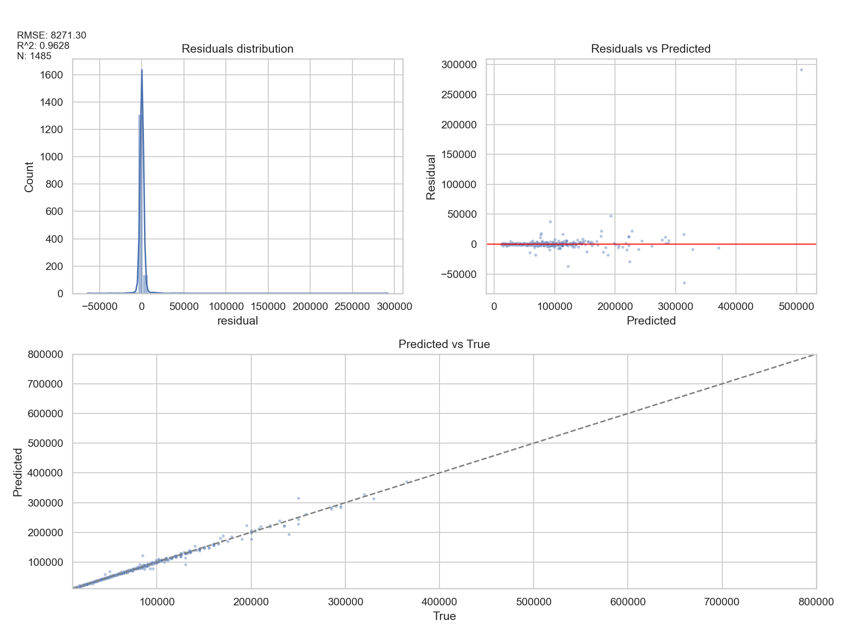
________________________________________
6 Recommendations
- Cross-validation and hyperparameter tuning (Optuna/GridSearch) for more robust estimates.
- Feature importance via LightGBM gain or SHAP to explain model drivers.
- Error slicing: RMSE by district, rooms, and size quantiles.
- Calibration/quantile metrics: e.g., MAPE, P50/P90 errors to characterize tails.
- Data leakage / time-split checks if temporal effects are possible.

