Student name: Tsoi Yiu Chik

Student ID: 20195601A

Tutorial group: 202C

# Question 1

1. For star topology, advantages:

It uses less cables and ports, and is has high robustness

Star topology disadvantages:

One point failure may occur, because the network relies on the hub/ central controller

For bus topology, advantages:

It is easy to install with least cables and ports

Bus topology disadvantages:

Power loss cannot be ignored, number and the distance of taps are limited. Also, difficult reconfiguration and fault isolation

Real life example:

A bus topology is used to connect two floors using a single line. Then each node extends to a star topology for different devices.

1. Screen cap of the drawing, each device(except modem) connects to 2 switches, then the switch connects to 2 modems. Each office has 2 modems. Each modem in one office connects to all other modems in another office. Therefore, when any one of the modems/switches is down, there is always 1 back-up device to maintain the network, so no one point failure will occur.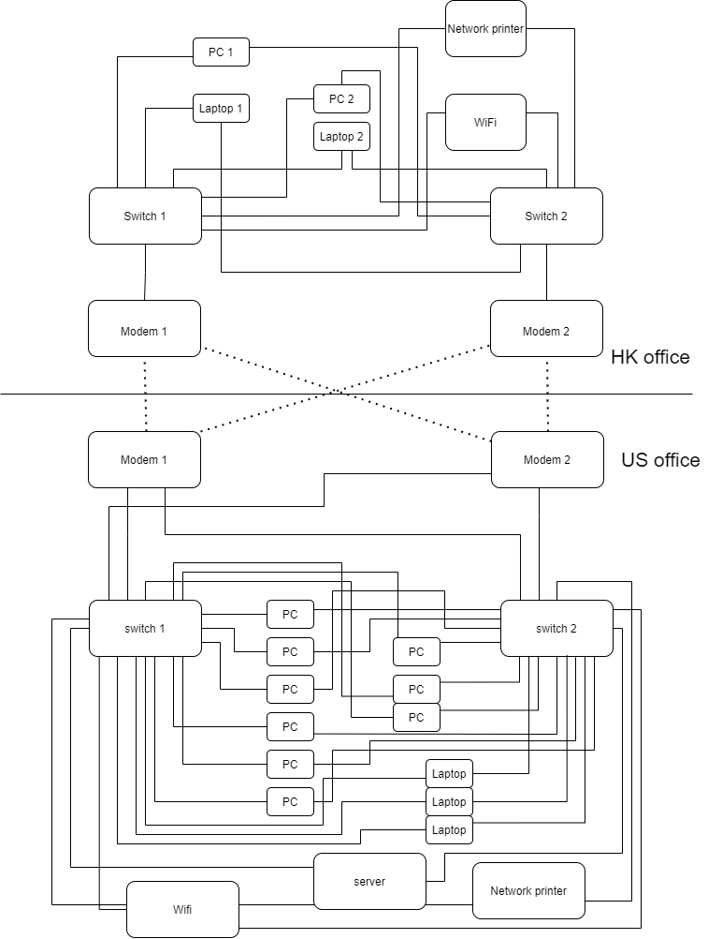

# Question 2

1. Chart, histogram

   Description automatically generated



1. Chart

   Description automatically generated



1. Let P2 be the signal power at the receiverText

   Description automatically generated
2. Fmax = 36

Sampling rate = 2 * 36 = 72 Hz

No. of bits required for 1 sample,

$\left\lceil \log_{2}{127}\right\rceil =7$ bits

Total sample = 72 * 20 =1440

Minimum size of the resulted digital data = 1440 * 7 = 10080 bits

# Question 3

1. Bitstream: 1001000 1101001 0100001
2. 1001000 1

1101001 1

0100001 1

1111111 0

1. Transmitting: 10010001 11010011 01000011 11111110
2. HA 🡺 1001000 1000001

CRC polynomial X^4 + X^3 + 1 🡺 11001

Zero added dataword: 100100010000010000

Polynomial is: 11001

crc is: 1011

1. Bit stream to be transmitted is: 100100010000011011
2. At sender side, CRC only generate bits based on what the data is, if the original data is incorrect, CRC can’t perform error detection and correction.

At receiver side, CRC cannot be used for error correction, because CRC can only detect burst errors, but not specific bit.

# Question 4

1. 180Mb = 105882 * 1700 bits + 600 bits

105882+1 = 105883 data frames will be sent

Size of data frames = 1700 + 32 = 1732 bits

Size of last data frames = 600 + 32 = 632bits

1. When the sender receives the ACK frame from the receiver, the first frame is confirmed.

Time for sender to send the first package = propagation time + transmission time

Propagation time = (8*1000)/(4*10^8) = 20 µs

Transmission time for sender sending first frame = 1732/ (50* 10^6) = 34.64 µs

Transmission time for receiver sending ACK frame = 60 / (50 * 10 ^ 6) = 1.2 µs

Total time for confirming first frame is correctly received by the receiver:

34.63 + 1.2 + 20 * 2

= 75.84 µs

1. For the first 105882 frames fully filled with data:

Time = 75.84 µs *105882 = 8.0300 s (4 d.p.)

For the last 600 data bit:

Transmission time: (600 + 32)/(50*10^6) = 12.64 µs

Total transfer time for 600 bits data = 12.64+ 1.2 + 20*2 = 53.84 µs

Overall time: 8.0300 s + 53.84 µs = 8.0301 s

1. Assuming the sender sends Frame 0 to the receiver, and the ACK 1 is sent from the receiver and delayed.

The sender times out and resend the Frame 0 to the receiver again. The receiver gets Frame 0 again which is not the receiver expects, it will first resend the ACK 1 to the sender and discard Frame 0.

During the receiver is handling the resent Frame 0, sender receives ACK 1, it sends Frame 1 to receiver.

After sending the Frame 1, the sender receives ACK 1 again, and it will be discarded.

1. x = 9

timeout value = 10 * 9 = 90 ms

First 105882 frames have lost frames

Transmission time of 1732bit frame = 1732/(50*10^6) = 34.64 µs

Total transmitted frames with 1732 bit = $105882 + \left\lfloor 105882/200\right\rfloor * 3 +\left\lfloor 1587/200\right\rfloor * 3 = 107490$

Total time out = $(\left\lfloor 105882/200\right\rfloor * 3 +\left\lfloor 1587/200\right\rfloor * 3)*90 ms=1608 * 90 ms=144.72 s$

Total time = 107490 * 34.64 µs + time for transmitting (600+32)bit data frame + total time of transmitting ACK frame + total propagation time of data frames + total propagation time of ACK frame + total time out

= 3.72345 s + (600 + 32)/(50*10^6) + 105883*60 / (50 * 10 ^ 6) + (107490 + 1) * (8*1000)/(4*10^8) + $(105882+1) * (8*1000)/(4*10^8)$ + 144.72 s

= 3.72345 s + 12.64 µs +127.0596 ms + 2.14982 s + $2.11766 s$ + 144.72 s

=152.8380 s