**Tutorial of week 10**

**This week’s tutorial is submission-based.**

Task: heap implementation and operation.

**Instruction:**

Our demo contains a random number generator, and the goal is to implement a program that contains two functions:

1. Take the array as input and convert it into a **max** heap.

3. Implement the heap sort function.

When you implement the heapify-based heap construction, output “heapify(H,i)” for each  
called heapify function using this function: cout<<”heapify(H”<<i<<”)”<<endl. Study how the  
heapify function is called.

**For example:**

The pseudocode of the heapify function:

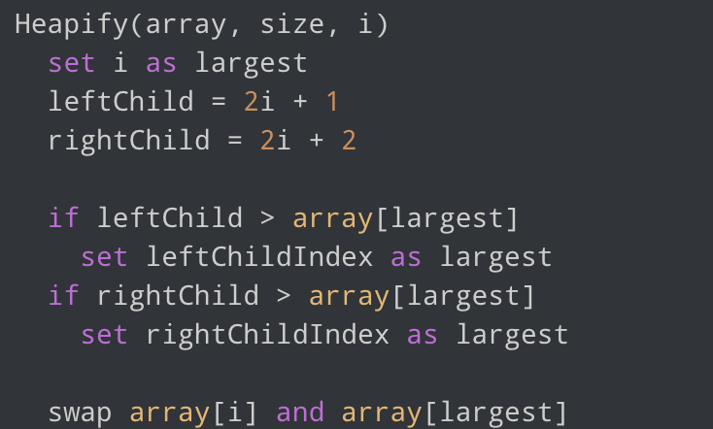

1. Let the random array be:

3 9 2 1 4 5

2. The heapified array will be:

9 4 5 1 3 2

3. The sorted array will be:

9 5 4 3 2 1