**Tutorial of week 10**

**This week’s tutorial is submission(attendance)-based.**

Task: Hash implementation and operation.

**Instruction:**

Our demo contains a hash table class (hash), and some related functions such as Insert and SearchKey

Insert function: The input of the Insert function is k (key) and v (value). The goal of this function is to map a key to a location in the hash table and store the value

SearchKey function: The input of the SearchKey function is k (key) and the goal is to find a value in the has table using the given key.

There are two tasks in this tutorial:

1. Load a file containing 100 student records and store them in a hash table using the Insert function. The file format is shown as follows:

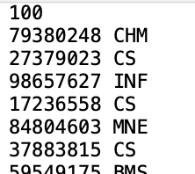

1. Implement a program where users can search for values by giving the program a key.