CITY UNIVERSITY OF HONG KONG

Course title : Machine Learning

Session : Semester A 2025/26
Type : Sample Questions

1. Describe the similarities and differences for each pair of terms.

1a) Principal Component Analysis (PCA) and Kernel Principal Component Analysis (KPCA)
Similarities:

Differences:

1b) Dimensionality Reduction and Feature Selection.
Similarities:

Differences:

2. Describe the advantages and disadvantages of each method.

2a) Ridge Regression.
Advantages:

Disadvantages:

2b) Mini-batch Gradient Descent.
Advantages:

Disadvantages:

3. Answer each of the following questions.

3a) Bob plans to train a binary classifier to filter spam emails using $l_{2}$-norm regularized logistic regression, whose objective function is given by$${\text{argmin}}_{w }λw^{T}w- \sum_{i=1}^{m}{log p{(y^{\left(i\right)}|x^{\left(i\right)};w)}}$$
After training the classifier with gradient descent, he gets an unacceptable high test error. He has also plotted training and test error as a function of training set size

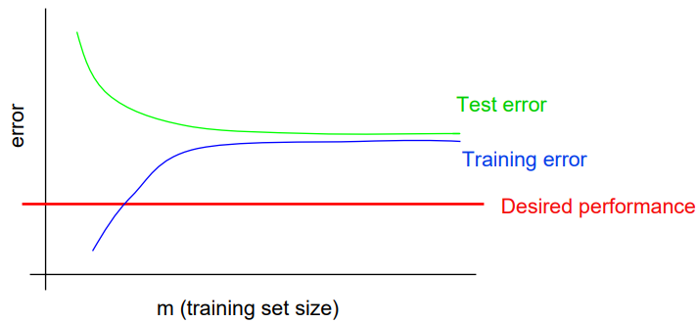
Image courtesy of Andrew Ng

Please help Bob diagnose the problem and suggest possible steps to improve the classification performance.

3b) The closed-form expression for linear regression is given by

$$w^{*}= {(X^{T}X)}^{-1}X^{T}y,$$
where $X$ is an M by N+1 matrix by stacking each training sample per row and $y$ is an M by 1 vector consisting of desired output values. Remember that M is the number of training samples and N is the number of features to represent each training example.
- Can we use the closed-form expression to estimate $w$, when $M<N+1$? If not, give your reasons and possible solutions to fix it.
- How to estimate $w$ when N is too large? In this case, computing the inverse of $(X^{T}X)$ is not computationally feasible.
- How to estimate $w$ when M is too large? In this case, computing the matrix product $(X^{T}X)$ itself is not computationally feasible.

4. Answer each of the following questions.

4a) What is the effect of an unbalanced dataset when training a classifier? Give a real-world example of a classification problem that might have an unbalanced dataset. How do you fix this problem?

4b) Consider the following optimization problem

${\text{minimize}}_{w }c^{T}w$
${\text{Subject to}}_{ }Aw≤b,$

where $w$ is an N by 1 parameter vector to be optimized, $A$ is a fixed M by N matrix and $b$ is a fixed M by 1 vector, together imposing M constraints on $w$.
- Is it a convex optimization problem? Give your reasons.
- Formulate the dual problem of the above primal problem. Hint: associate the right number of Lagrange multipliers to the constraints.

- END -

