Q1)

The aim of configuration management is to support the system integration process so that all developers can access the project code and documents in a controlled way, find out what changes have been made, and compile and link components to create a system.

Q2)

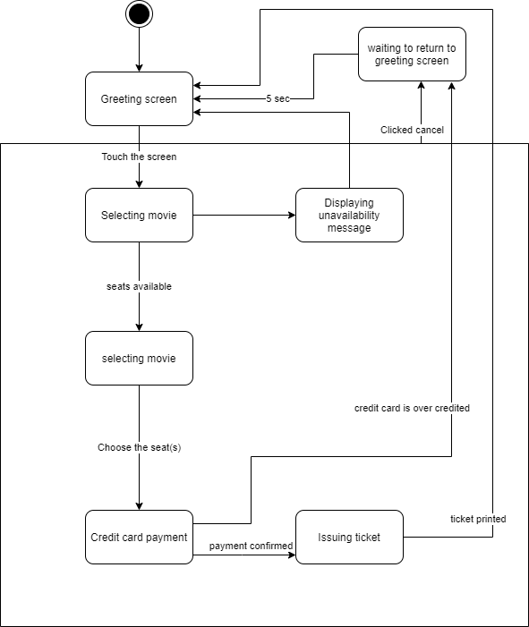

Q3)

As the founder of a company, Jack’s objective is to get profit from their product and related service. Distributing the initial version is aimed to give a taste for the potential users. However, distributing the app doesn’t meaning to provide the source for the community developers, the company should reserve the copyright of source code if the future product is aimed to be a paid software.