**Theoretical questions Assignment 3:**

**Eden Abadi**

**Noam Weiler**

**Part 1:**

1. For each “Special form” a special evaluation rule exists, while the evaluation of “Primitive operators” is built in the interpreter and not explained by the semantic of the language.

Examples from the interpreter code:

While the expression of an primitive operator stays the same, for the special form if we have a specific evaluation function.

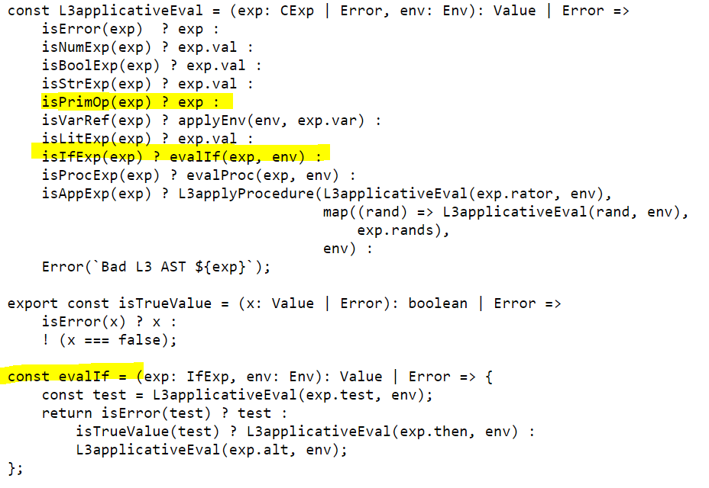

1. Assus or-exp is <curr_exp, or_tail>

A. Eval(<or-exp>,env) =>

Let curr_exp:Value = eval(exp.curr_exp)

If curr_exp is considered a true value

Return True

Else

Return eval(exp.or_tail,env)

B. Eval(<or-exp>,env) =>

Return eval(curr_exp,env) || eval(or_tail,env)

1. We would prefer VarRef and that’s because PrimOp is defined inside the interpreter while we can easily change the implementation of VarRef as we please defined in the GE.
2. We would like to switch from applicative order to normal order when the calculation is very long and not needed at some of the evaluation process, normal evaluation is done in a “lazy” while – computed only when needed and therefore some times more efficient, also in some cases applicative eval can fail/go into an infinite loop, while normal eval wont - For example:

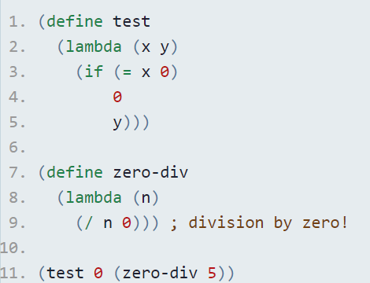

In this example normal eval will return 0 because it hasn’t computed y at this point, while applicative eval will throw an exception of division by zero while evaluating y.

1. There some cases when the first evaluation can save us some time later - this can happen when this specific evaluation happens several times in the code, for example:

(define long_calc

(lambda (x)

(if ( > 5 x)

(display x)

(display (+ 5 x)))))

(define square (lambda(x) (*x x)))

(long_calc (squre 3))

In this example 9 will be calculated 3 times instead of 1 time at first.

1. The environment model is an optimization of the substitution applicative model of the operational semantics. It changes the way we map variables to their values. Instead  of eagerly substituting variables by their values when we apply a closure, we leave the body of the closure untouched, and maintain an environment data structure on the side. The main problem of the substitution approach is that substitution requires repeated analysis of procedure bodies. In every application, the entire procedure body is repeatedly renamed, substituted and reduced. These operations on ASTs actually **copy** the structure of the whole AST - leading to extensive memory allocation / garbage collection when dealing with large programs. Therefore, environment model might save us computation time and memory.

For example:

(define no_op (lambda (x) (let (x lambda(x) (let (lambda(x) …)) and so on.

1. Equivalent example:

(define impl_display (lambda(x) (display x)))

Non- Equivalent example:

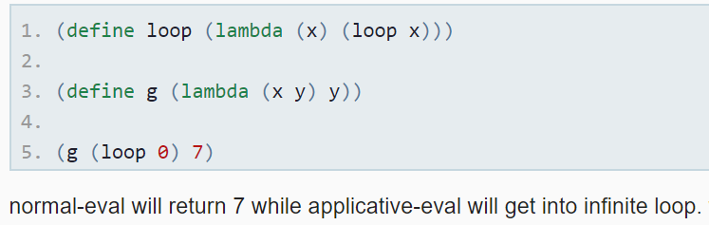

1. Since we are delaying the evaluation to the point where we need the value, the arguments are received as cexp. One a cexp is evaluated, it is used, so there is no need to turn it into a cexp.
2. Since we don’t perform substitution, the value will not be placed in the AST. when we come across a var-ref we will have the variable with its matching value in the environment ready for use.
3. In class we learned that a variable defined by let may contained a value such as closure as well. The first definition we made was to bind the var ref inside the let expression to its relevant value by binding operation, that binding may contain the binding of a closure to a var ref, we also demonstrated the problem with that definition when trying to define a recursive procedure inside let, we solved it by defining letrec for recursive procedures. – not completed!
4. // LET: Direct evaluation rule without syntax expansion
5. // compute the values, extend the env, eval the body.
6. const evalLet4 = (exp: LetExp4, env: Env): Value4 | Error => {
7. const vals = map((v) => L4applicativeEval(v, env), map((b) => b.val, exp.bindings));
8. const vars = map((b) => b.var.var, exp.bindings);
9. if (hasNoError(vals)) {
10. return evalExps(exp.body, makeExtEnv(vars, vals, env));
11. } else {
12. return Error(getErrorMessages(vals));
13. }
14. }

// LETREC: Direct evaluation rule without syntax expansion

// prepare the values as a RecEnv, eval the body (no eval needed for the vals).

const evalLetrec4 = (exp: LetrecExp4, env: Env): Value4 | Error => {

const vars = map((b) => b.var.var, exp.bindings);

const vals = map((b) => b.val, exp.bindings);

if (allT(isProcExp4, vals)) {

const paramss = map((v) => v.args, vals);

const bodies = map((v) => v.body, vals);

return evalExps(exp.body, makeRecEnv(vars, paramss, bodies, env));

} else {

return Error("Letrec: all variables must be bound to procedures");

}

}