**Part 2:**

**2.1**

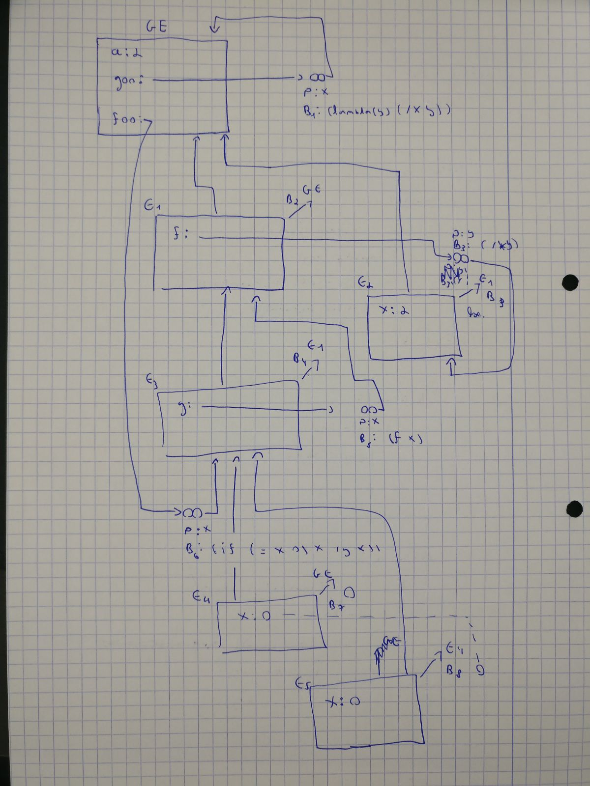

**2.2**

(define foo

(lambda (goo)

(let ((goo (lambda (y) (+ y 5))))

(lambda (a b) a)

(let ((a 1) (b 2))

(lambda (arg)

(goo arg))))))

(define goo (foo (lambda () 0)))

(goo 5)