Mainframe Mini Project

Vehicle Insurance

**INTRODUCTION**

This document outlines a Mini Project for the Mainframe LOT. The project is to develop Vehicle Insurance Application. This document contains the workflow of the system and gives guidelines on how to build the functionality gradually in each of the course modules of the Mainframe LOT.

**SETUP CHECKLIST FOR MINI PROJECT**

**Minimum System Requirements**

1. Intel Pentium 90 or higher (P166 recommended)
2. Microsoft Windows 95, 98, or NT 4.0, 2k, XP, 2007 Pro
3. Memory: 32MB of RAM (64MB or more recommended)
4. Quick 3270 secure Software installed on local machine

**OBJECTIVE**

Development of a Vehicle Insurance Application.

**ABSTRACT OF THE PROJECT**

The Vehicle Insurance Application will be used to check the Insurance status of customer and allow customer to browse their data.

**FUNCTIONAL COMPONENTS OF THE PROJECT**

Following is the list of the features of our application-

1. The project is to store the details of the customers who had registered for Insurance.
2. In this application two types of people can login. One is Administrator and another one is Client.
   1. Administrator has access to Add, Update, Delete and Browse the Records.
   2. Whereas, Client can only browse his/her details.
3. Administrator Part
   1. Admin can login through his/her login details (i.e. ID and Password).
   2. After successful login he/she can Add, Update, Delete and Browse the Records of their clients.
   3. And if he/she enter wrong Id and Password then the message will display “Error Accessing Login”.
4. Client Part
   1. After selecting Client option the Client screen will be displayed and will ask to enter the Vehicle Number.
   2. After entering the correct details the detailed map will be displayed showing the details about his/her vehicle Insurance.
5. The third option in our project is about Terms and Condition. It will displayed the map showing all the terms of service.
6. If any invalid key is pressed on any screen then the error message will be display related to that error.

**TECHNOLOGY USED:**

* Business Logic Components:-
  + COBOL
  + CICS
* Job Control Language
  + MVS
* Access Methods
  + DB2

**TECHNICAL SPECIFICATION:**

The project specifications are:-

* COBOL programs with embedded CICS and SQL statements - 9 programs
* Number of Maps – 8 Maps
* Mapset - 1
* JCL programs – one JOB for CICS map, one for CICS and DB2.

**CONVENTIONS**

**A. Table Names:**

1. ADMIN_TABLE
2. BIKE_TABLE
3. CLIENT1_TABLE
4. CLIENT2_TABLE

**B. Program Names:**

1. P05AP01
2. P05AP02
3. P05AP03
4. P05AP04
5. P05AP05
6. P05AP07
7. P05AP08
8. P05AP09

**C. Transaction ID:**

1. P05A
2. P05B
3. P05C
4. P05D
5. P05E
6. P05G

**D. Map Names:**

1. WELCOME
2. ALOGIN
3. KEYMAP
4. DETAIL
5. NEWMAP
6. DETAILD
7. CLOGIN
8. TANDC

**E. Mapset Name:**

1. P05AS01

**TEST CASES**

1. **Welcome Screen-** After Pressing an Enter key with a valid choice (Option 1,2,3).

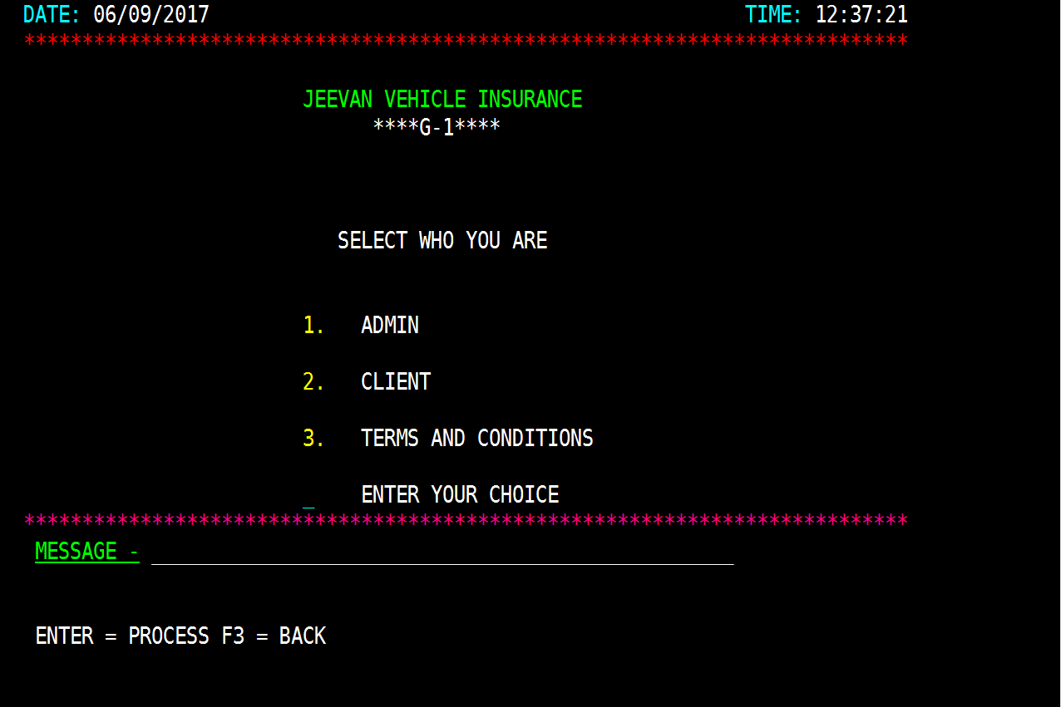

1. Option 1:- Go to admin login.

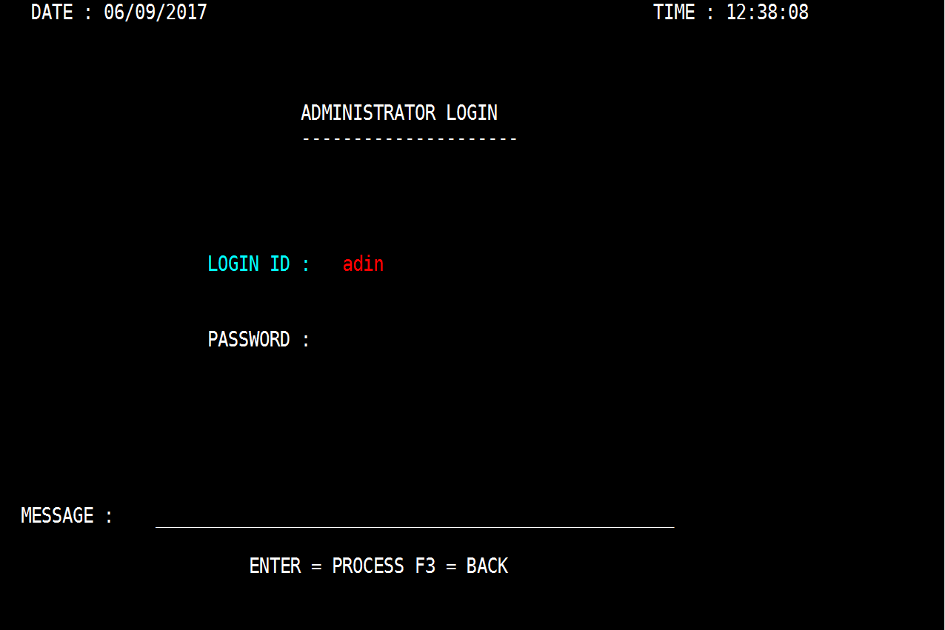

1. Option 2:- Go to client login.

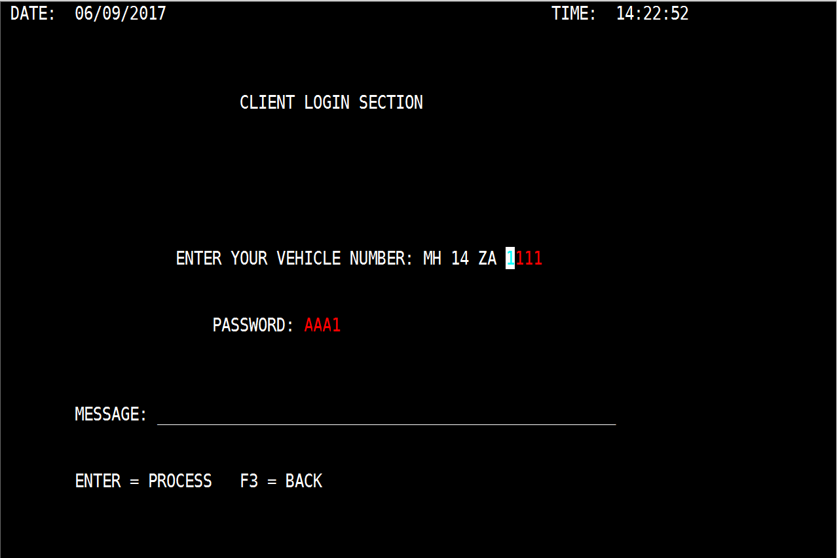

1. Option 3:- Go to Terms & Conditions screen

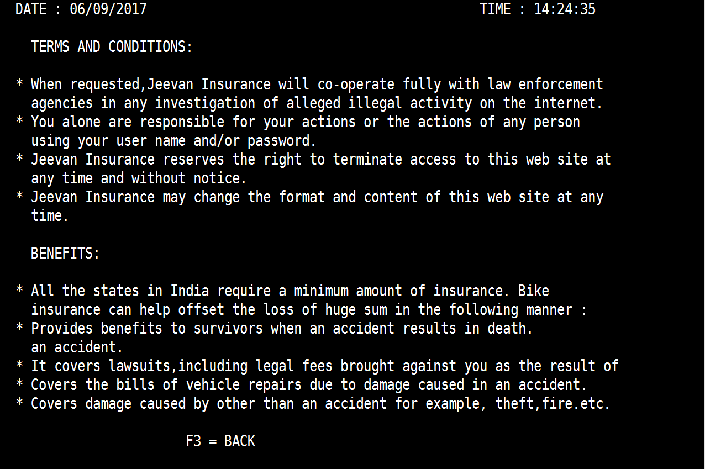

1. Option 4:- Pressing F3 will end the program**.**

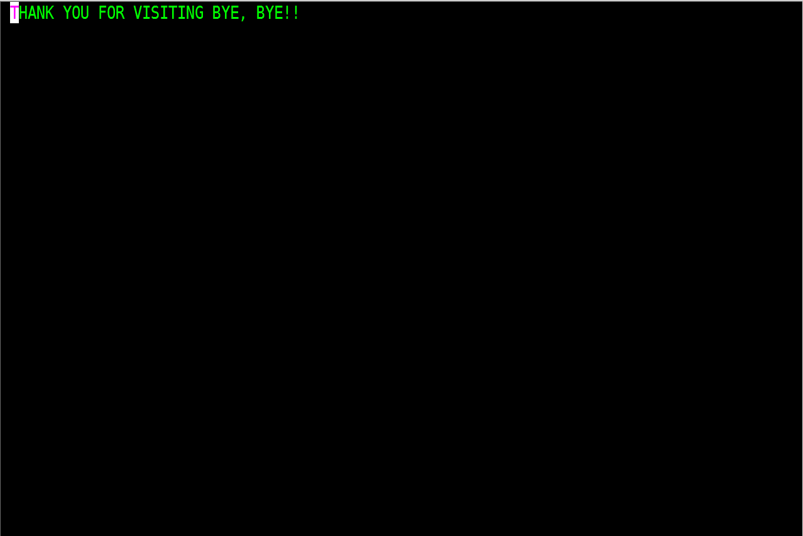

1. Option 5:- Pressing any other AID keys or choosing wrong options will give an error message.

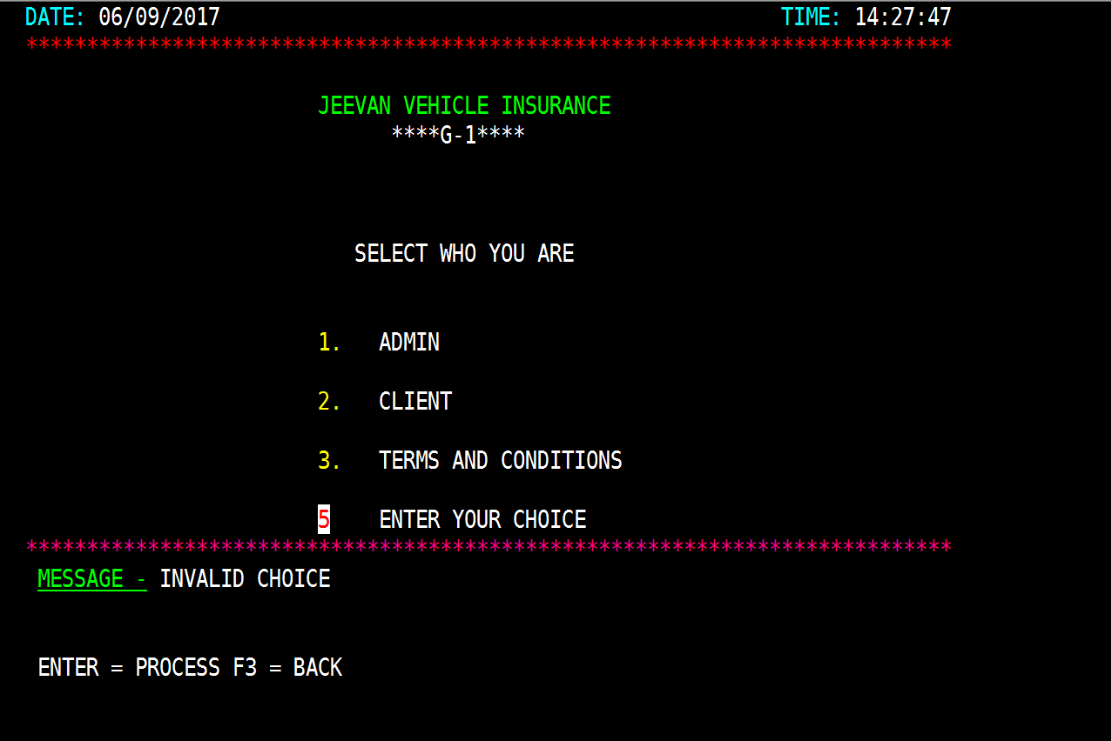

1. Admin Login Screen

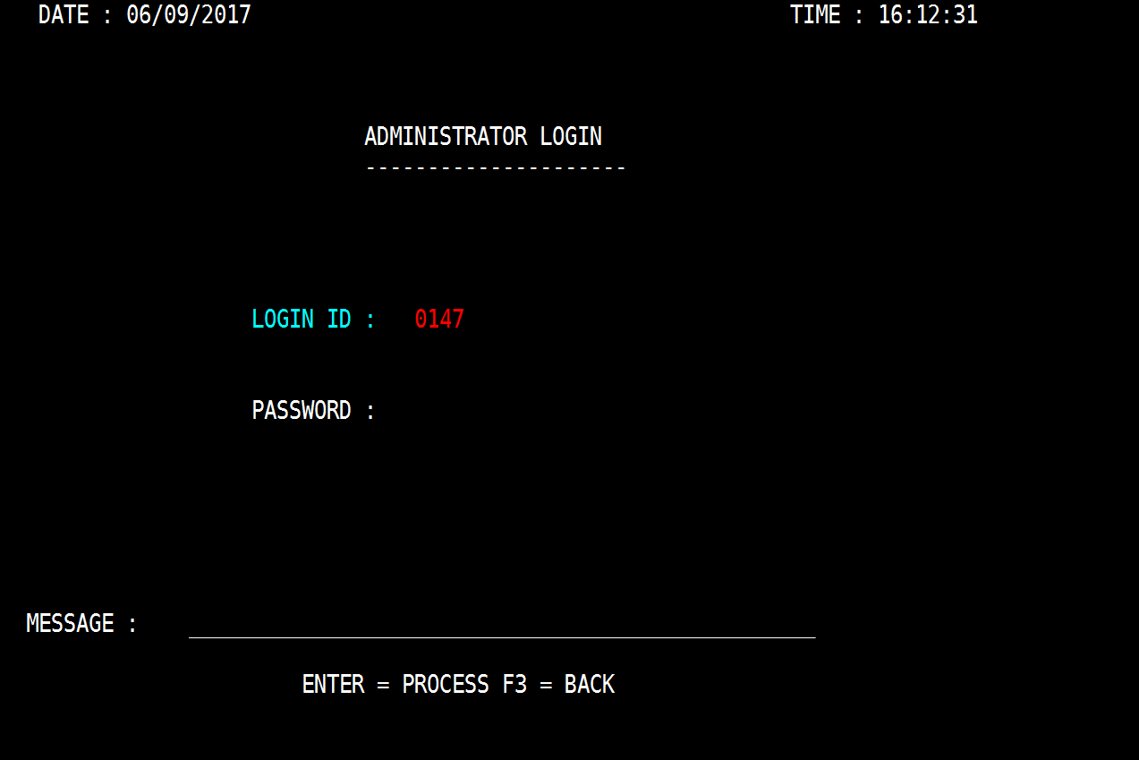

1. Pressing an Enter key with a valid id and password will go to key map to accept vehicle number.

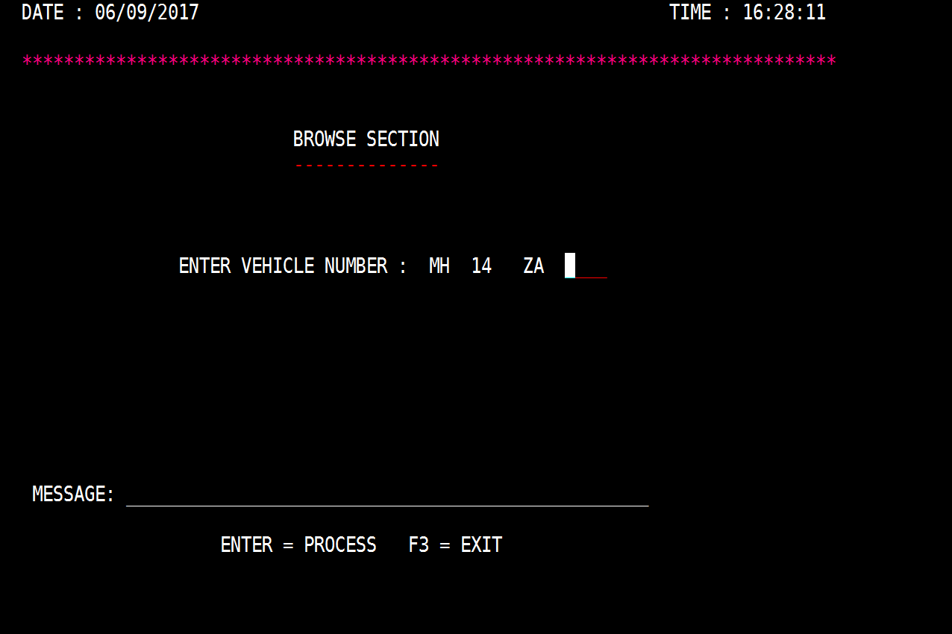

1. Pressing F3 will go to welcome screen.



1. Pressing any other AID keys or choosing invalid id and password will give an error message.

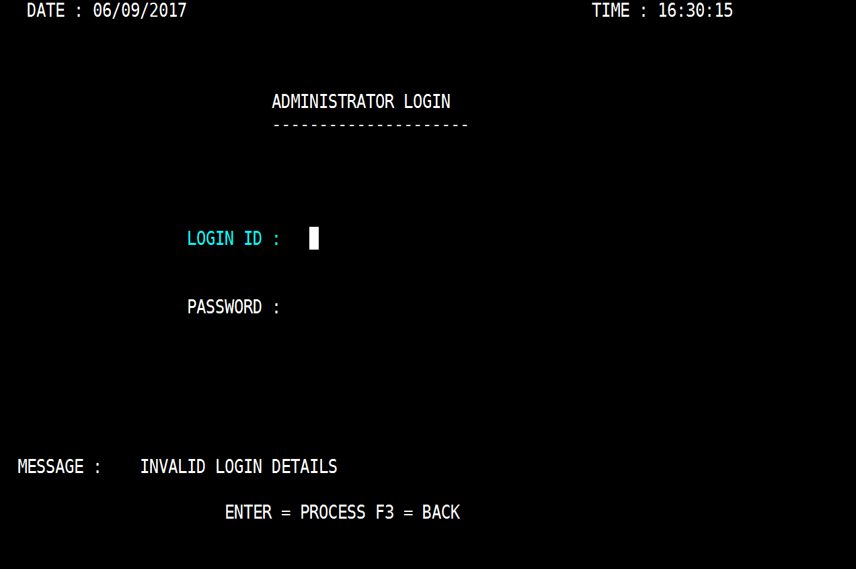

1. Browse Section Screen (with input)

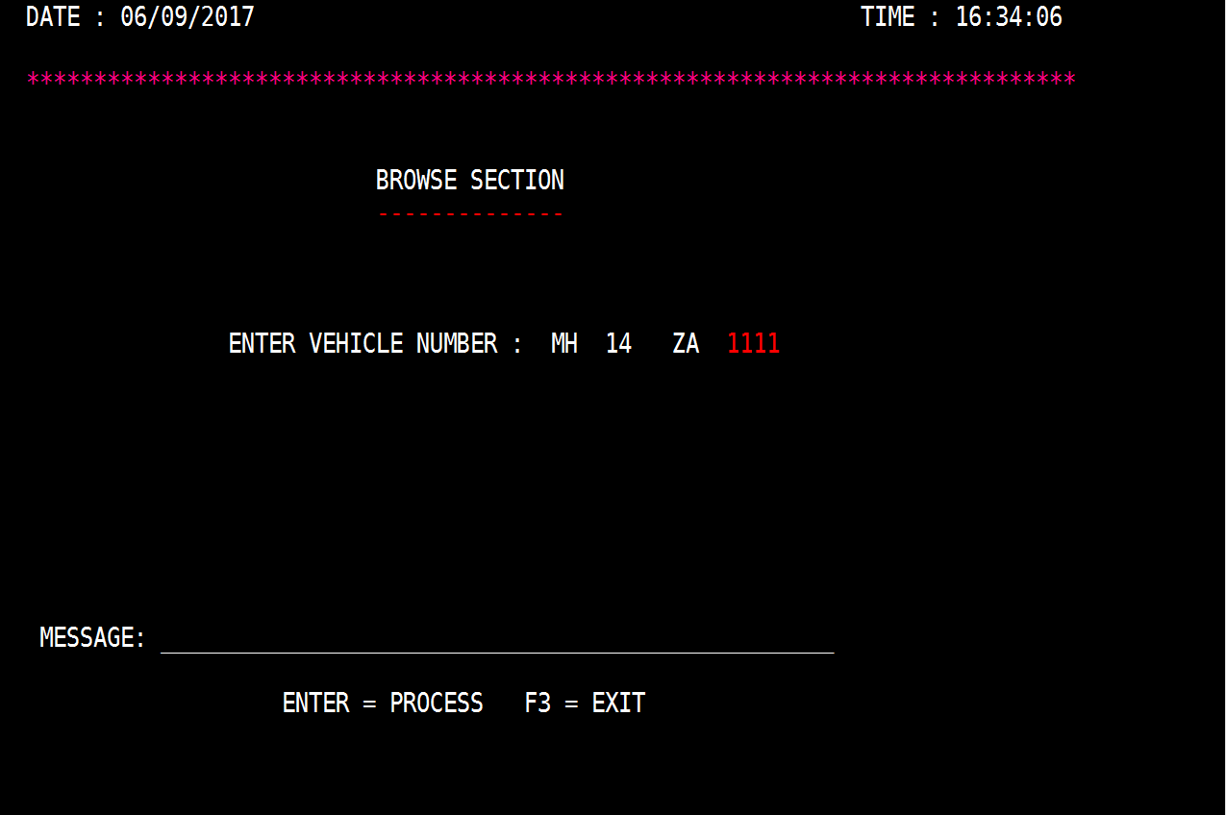

1. Pressing an Enter key with a valid vehicle number will go to detail map to update or delete the information.

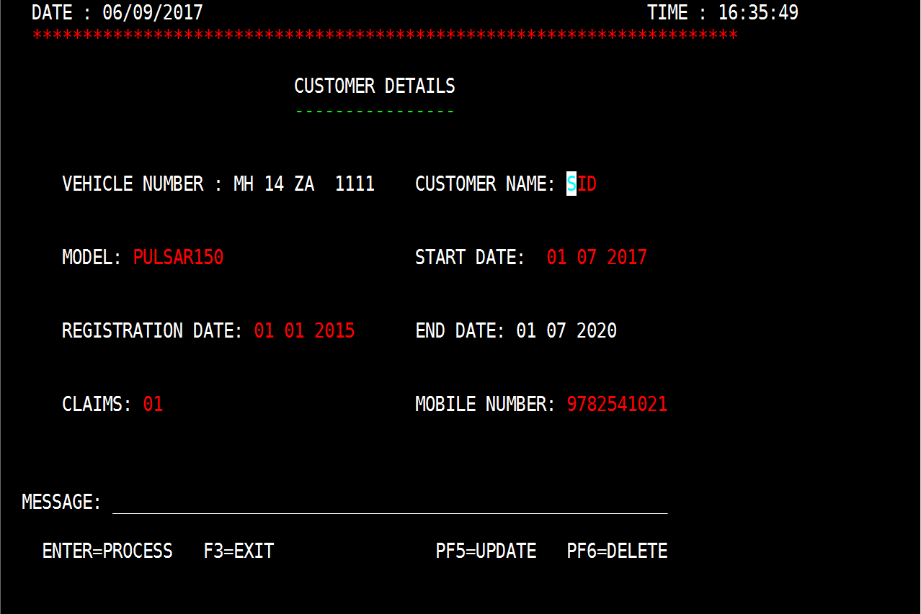

1. Pressing an Enter key with a invalid vehicle number will go to add new login screen.

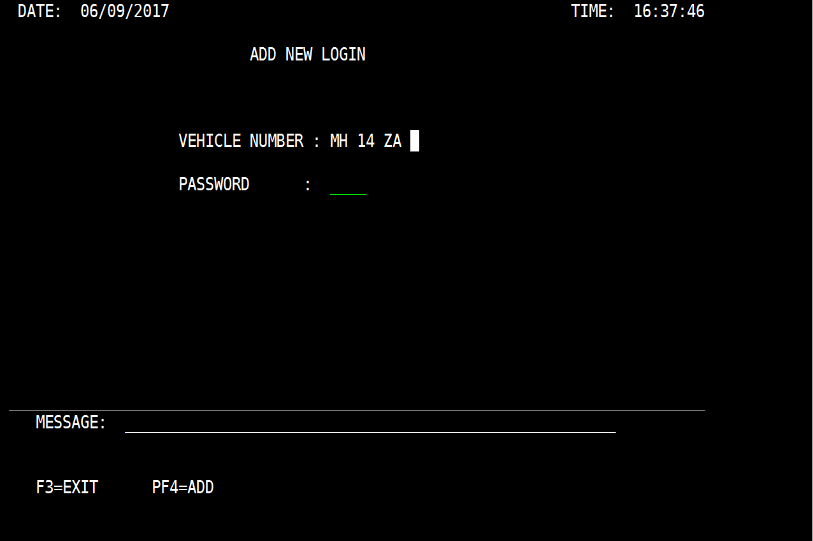

1. Pressing F3 will go to Admin login screen.

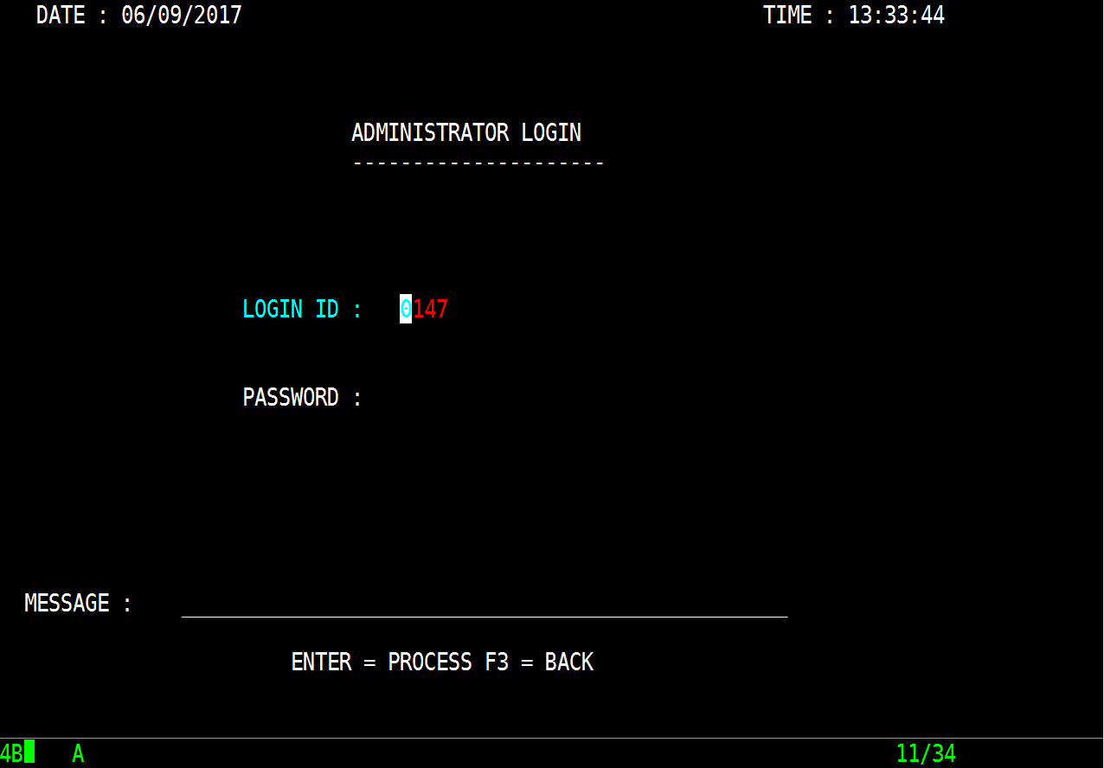

1. Pressing any other AID keys error message.

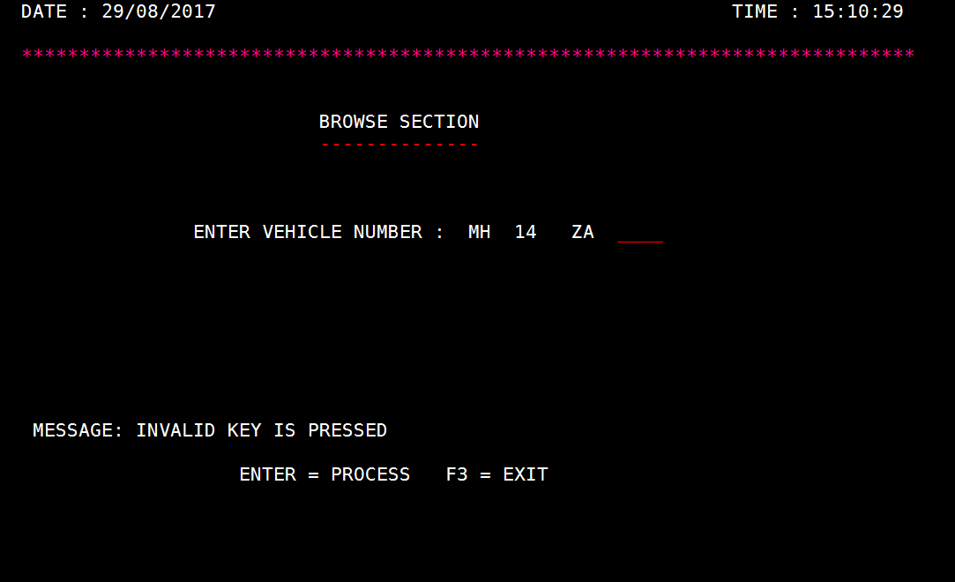

1. Pressing F3 will go to browse section.

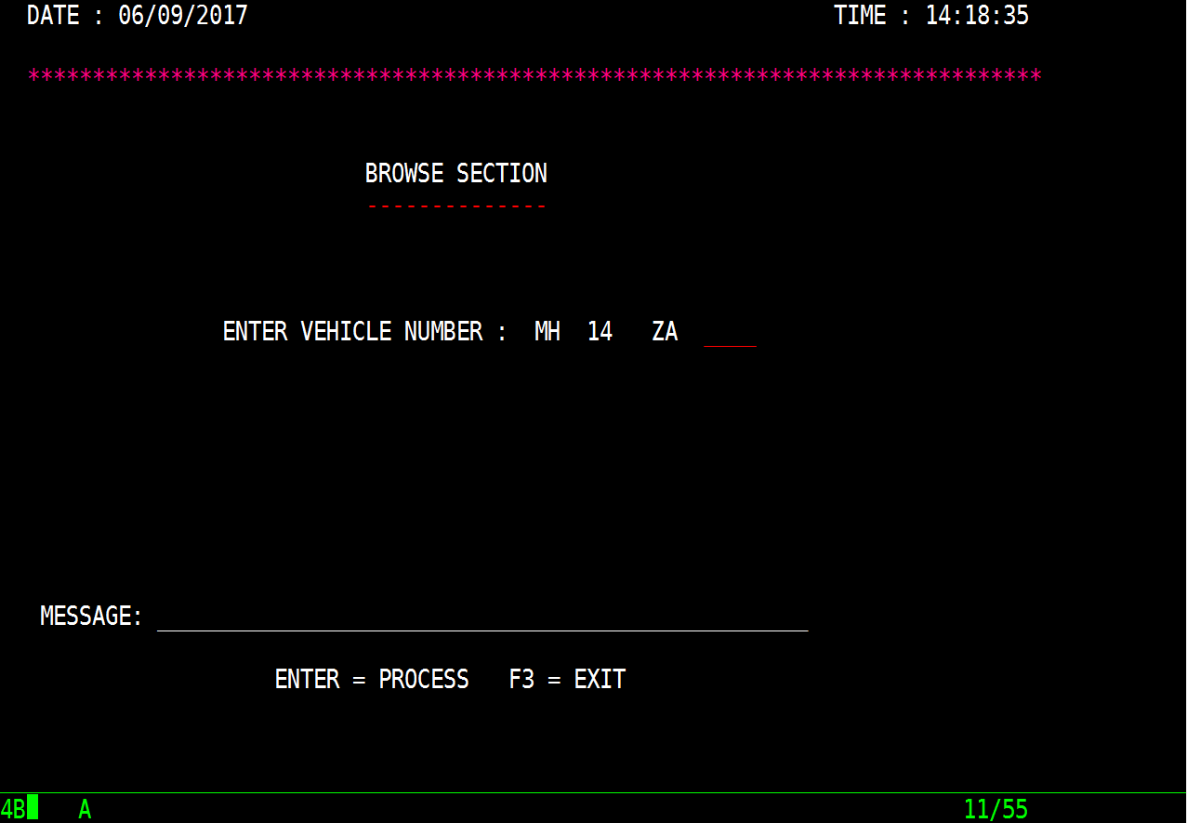

1. Pressing F5 will update the data and go to browse section giving the some message.

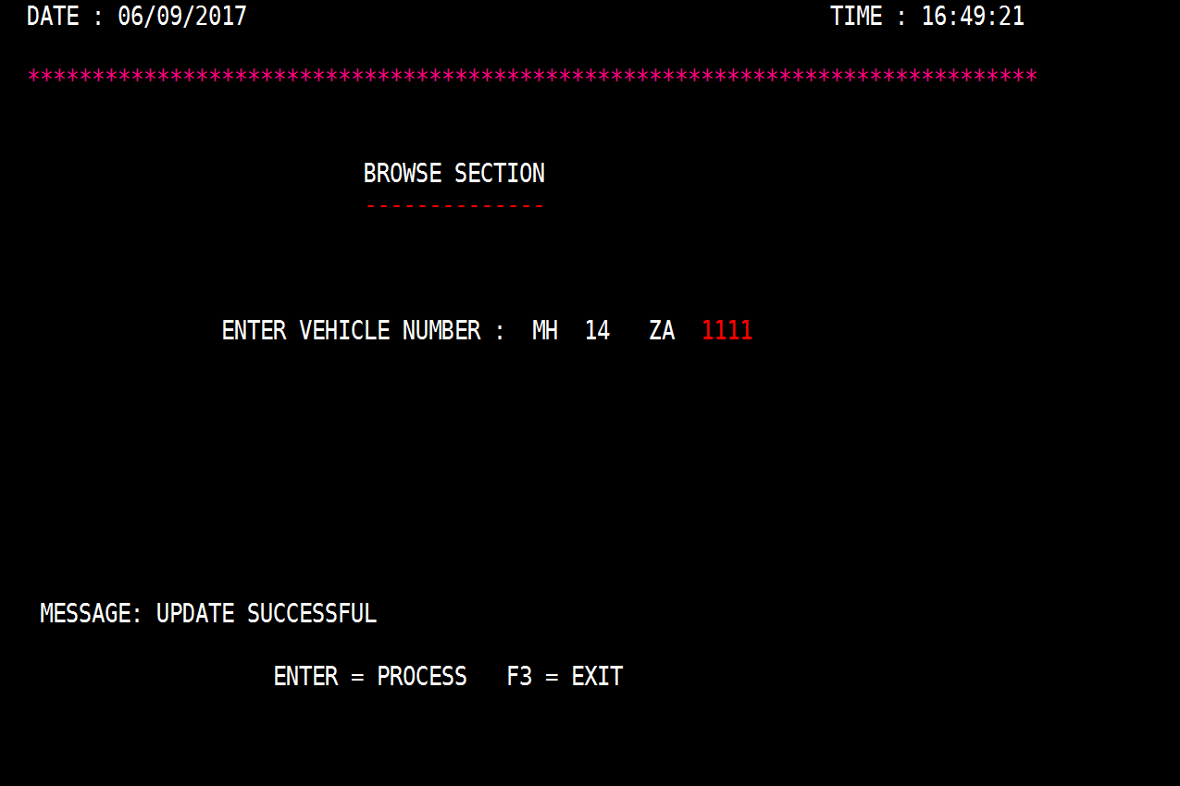

1. Pressing F6 will delete the data and go to browse section giving some message.

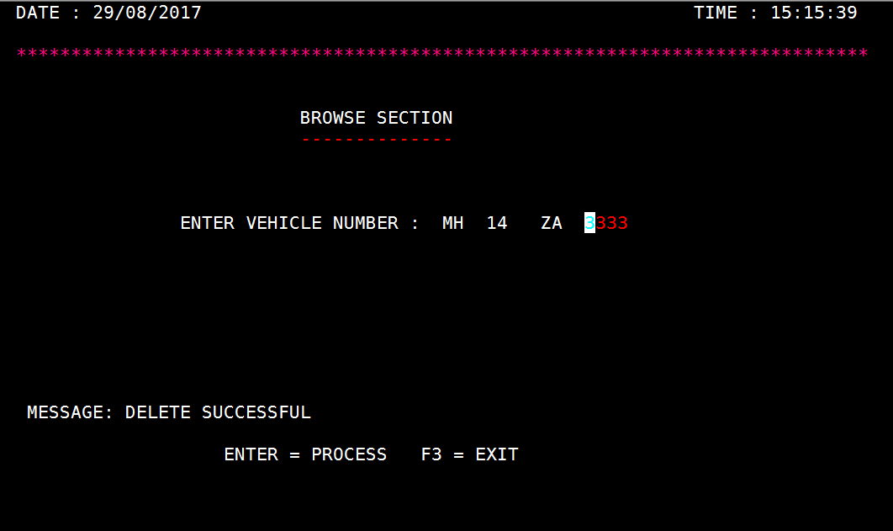

1. Pressing any other AID keys will give an error message

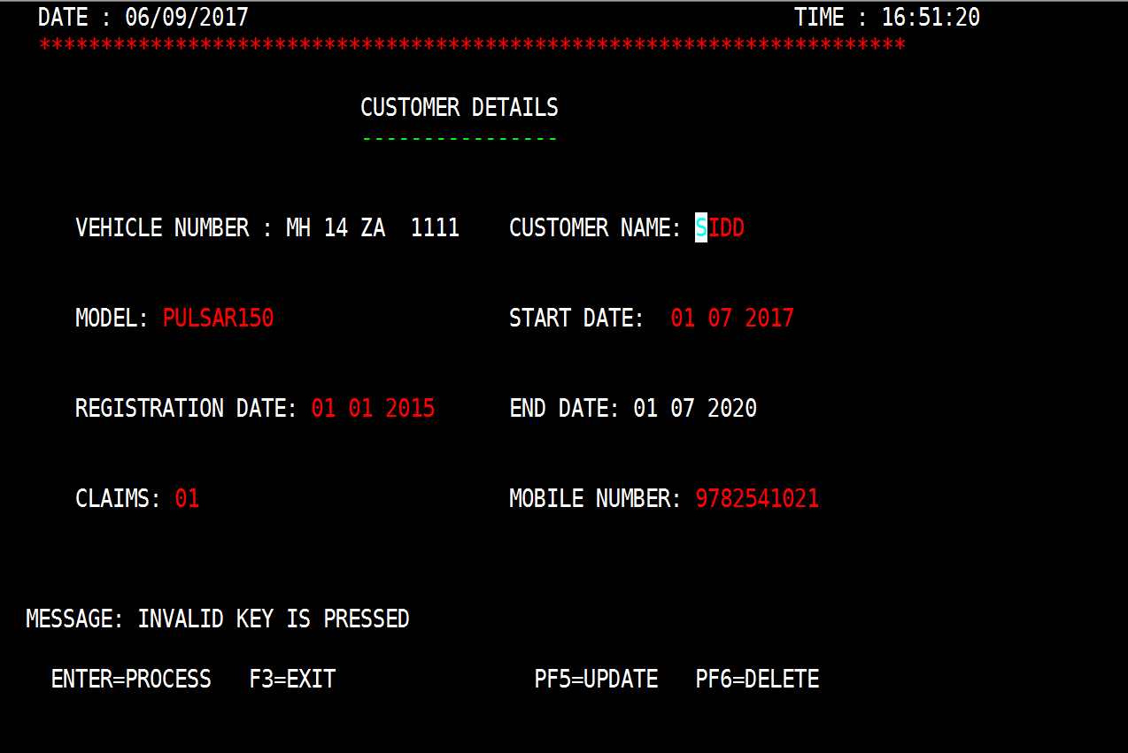

1. Add New Login Screen (With Inputs)

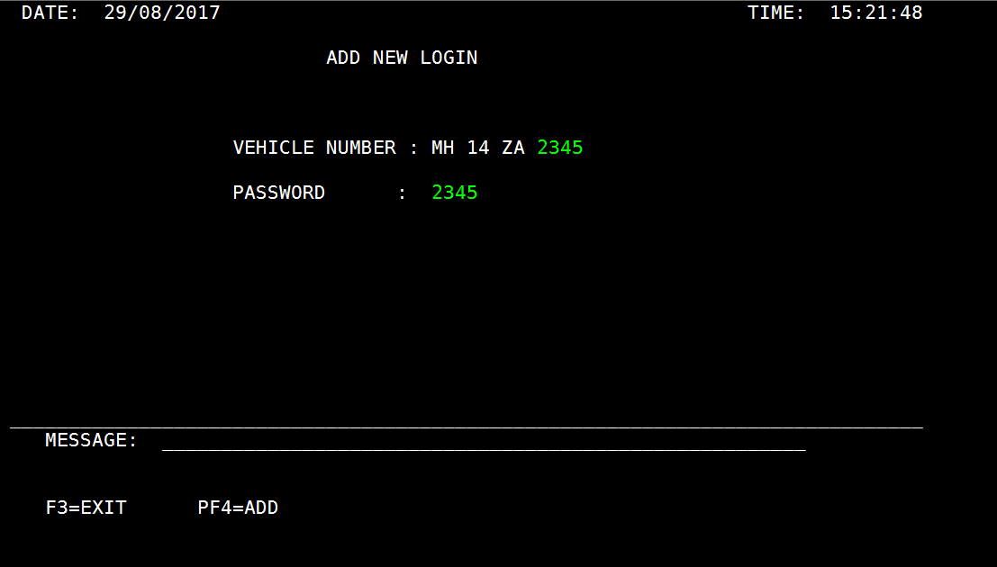

1. Pressing an F4 key with a valid id and password will go to Add detail map (DETAILD).

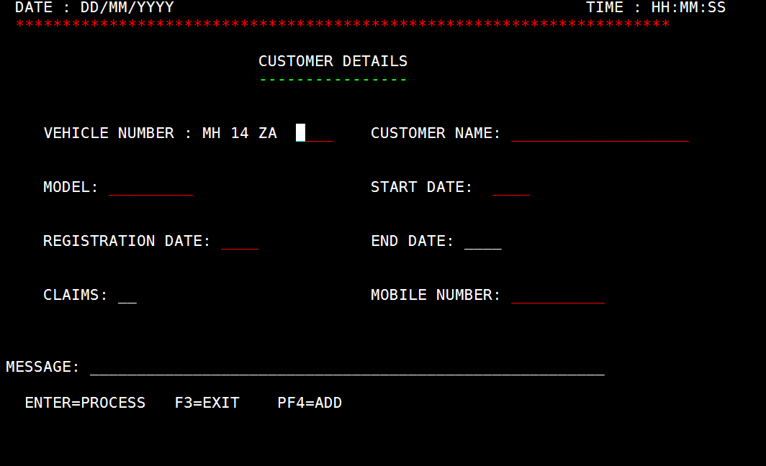

1. Pressing F3 will go to Browse Section



1. Pressing any other AID keys will give an error message.

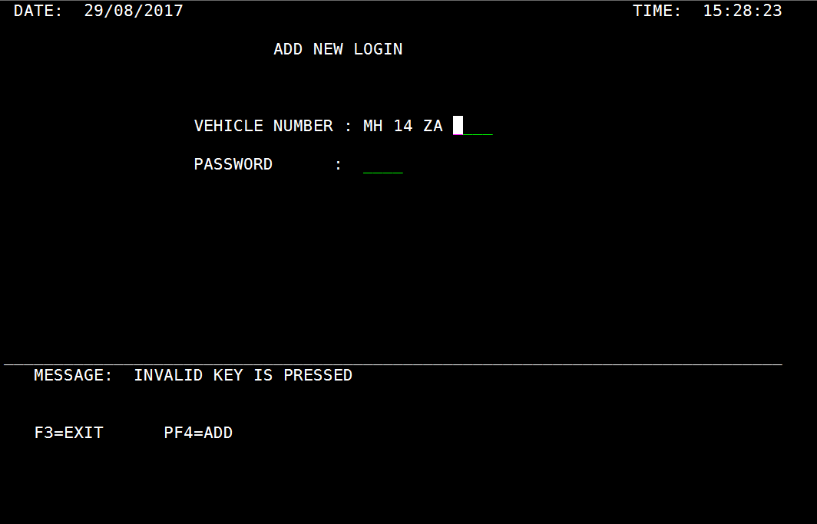

1. Pressing F4 will add details of new customer.

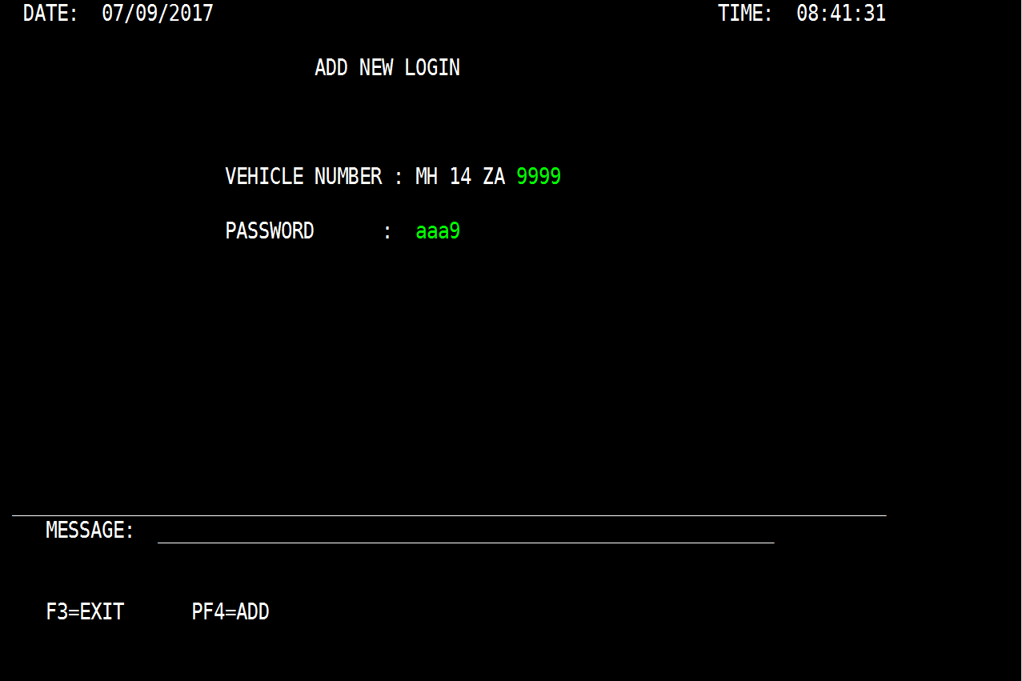

1. Pressing F3 will go to browse section giving some message.

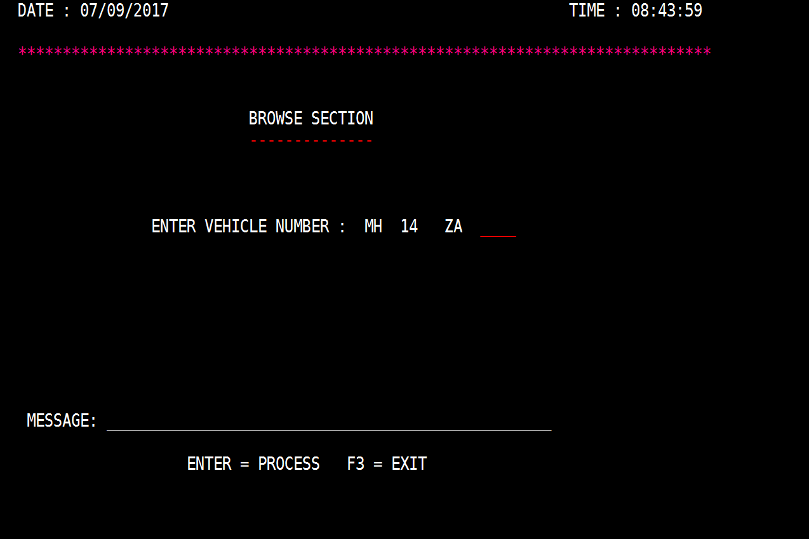

1. Pressing any other AID keys will give an error message.

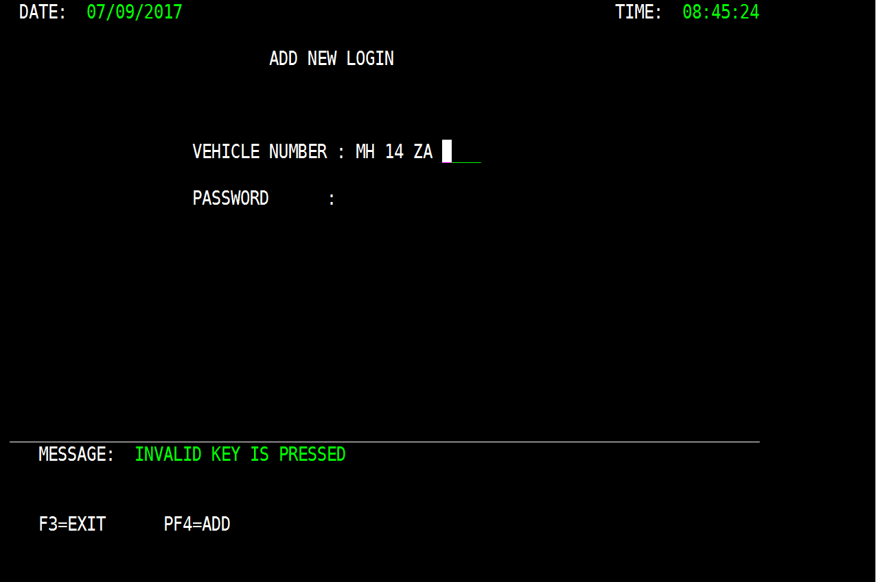

1. Client Login Screen (With Inputs)

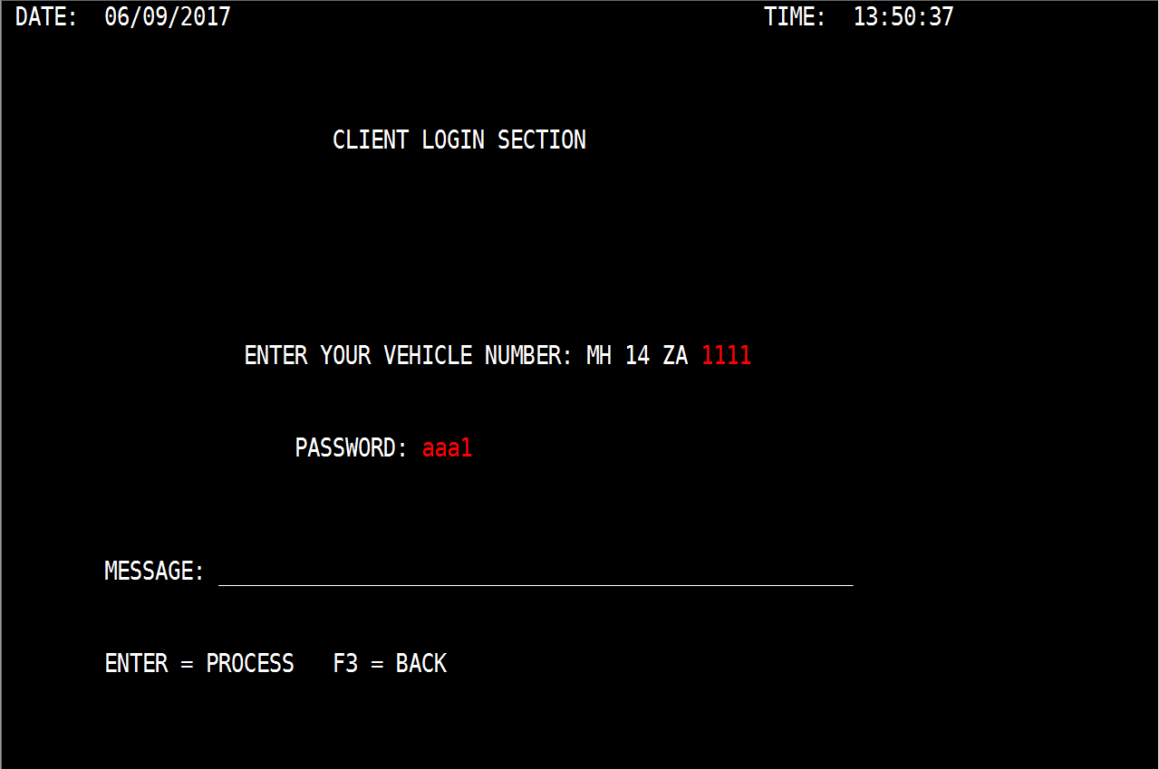

1. Pressing an Enter key with a valid id and password will go to browse map to show the customer details.

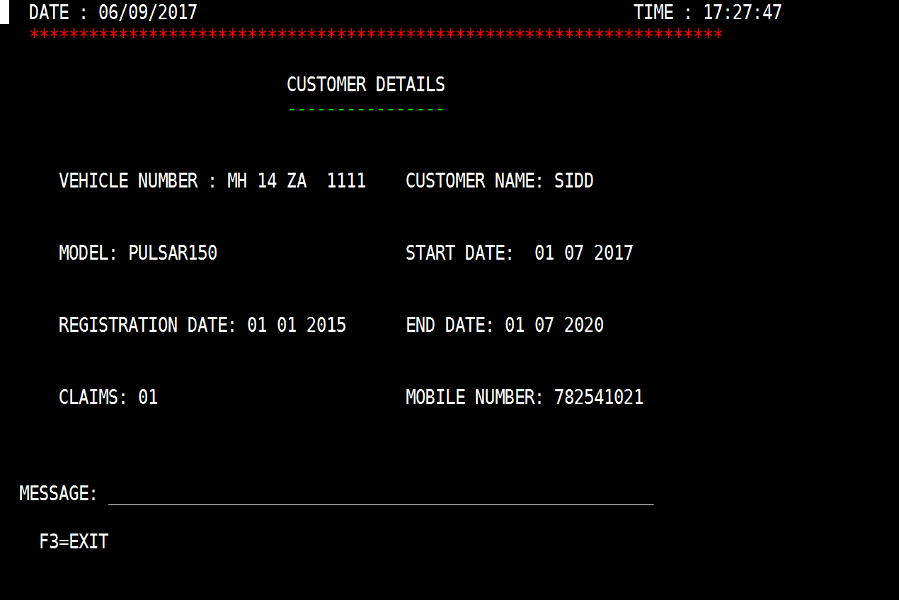

1. Pressing F3 will go to welcome screen.

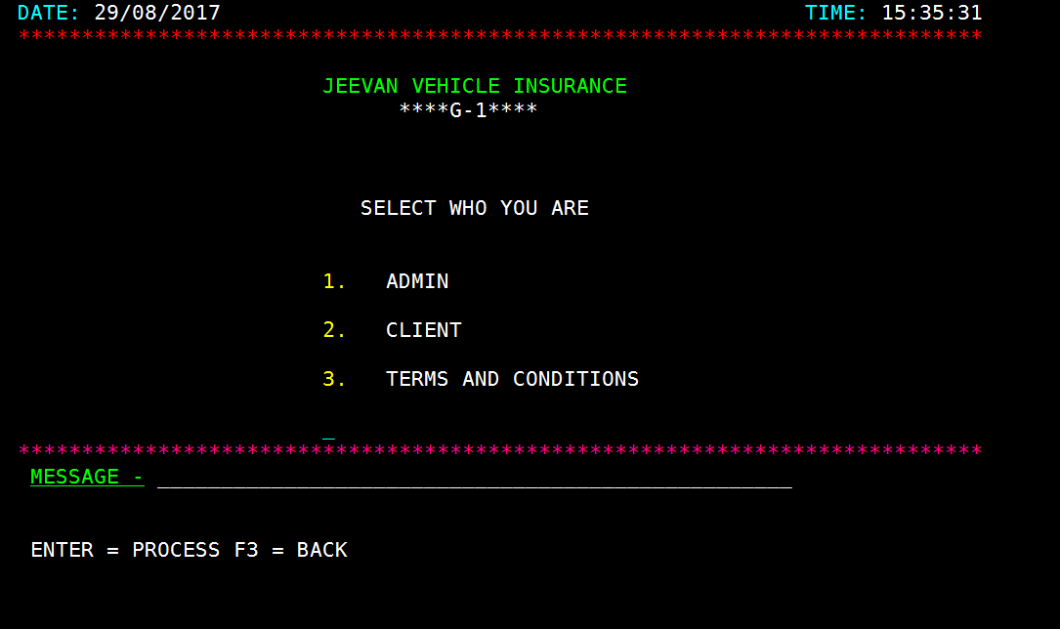

1. Pressing any other AID keys or choosing invalid id and password will give an error message.

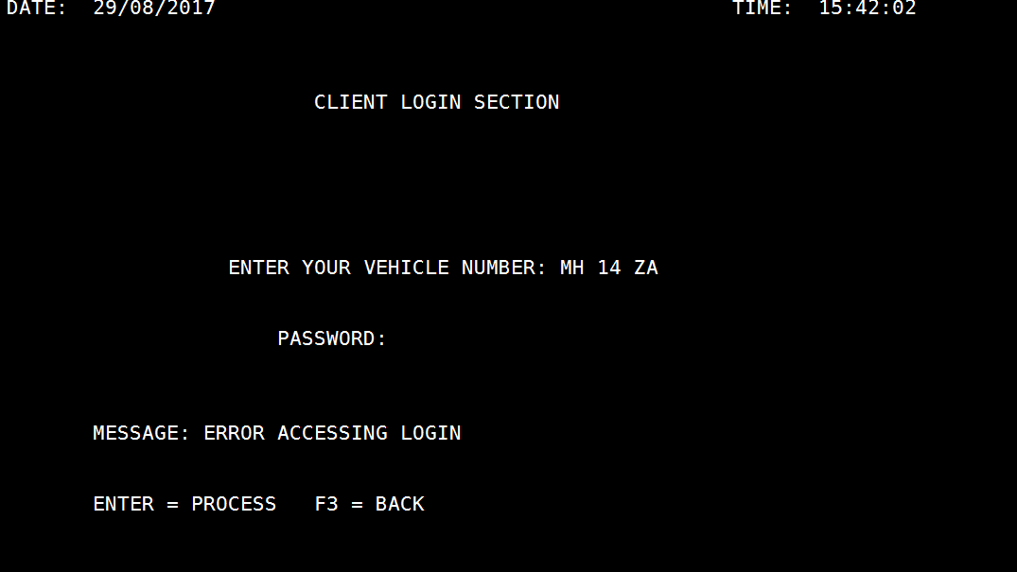

1. Terms and Conditions Screen:-

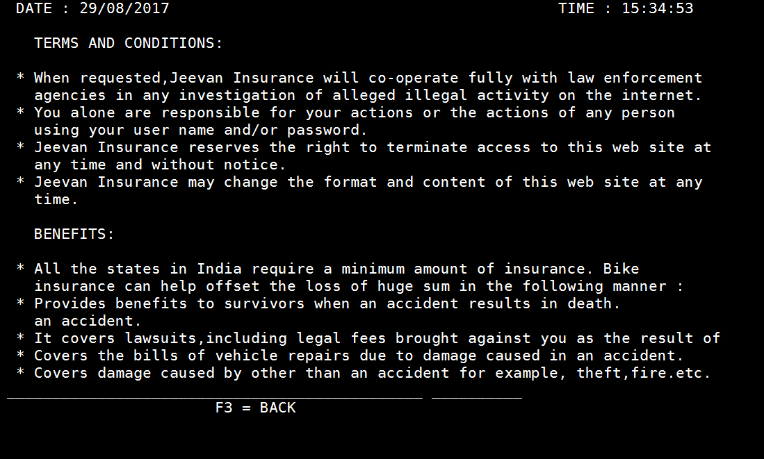

1. Pressing F3 will go to welcome screen.



**TESTING RESULTS**

**Self-Review**

* **Test Result:-**

1. Validations are not working
2. Fields are taking Garbage Values in some cases.
3. Add new record login is not working.
4. In some cases messages are not showing.

**Code Review (Done by G-2)**

* **Test Result:-**

1. No Author name is given in any of the programs.
2. Comments are not given in Rep1 and Rep2.
3. Variable Names are bit complicated in Rep2.
4. Good coding standards are followed.
5. Validations are partial.
6. Spaces are not given after paragraphs, hence not properly readable.