TELÉFONO

pORTADA

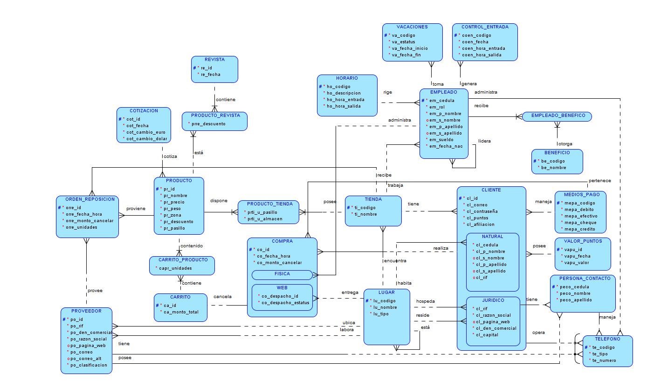

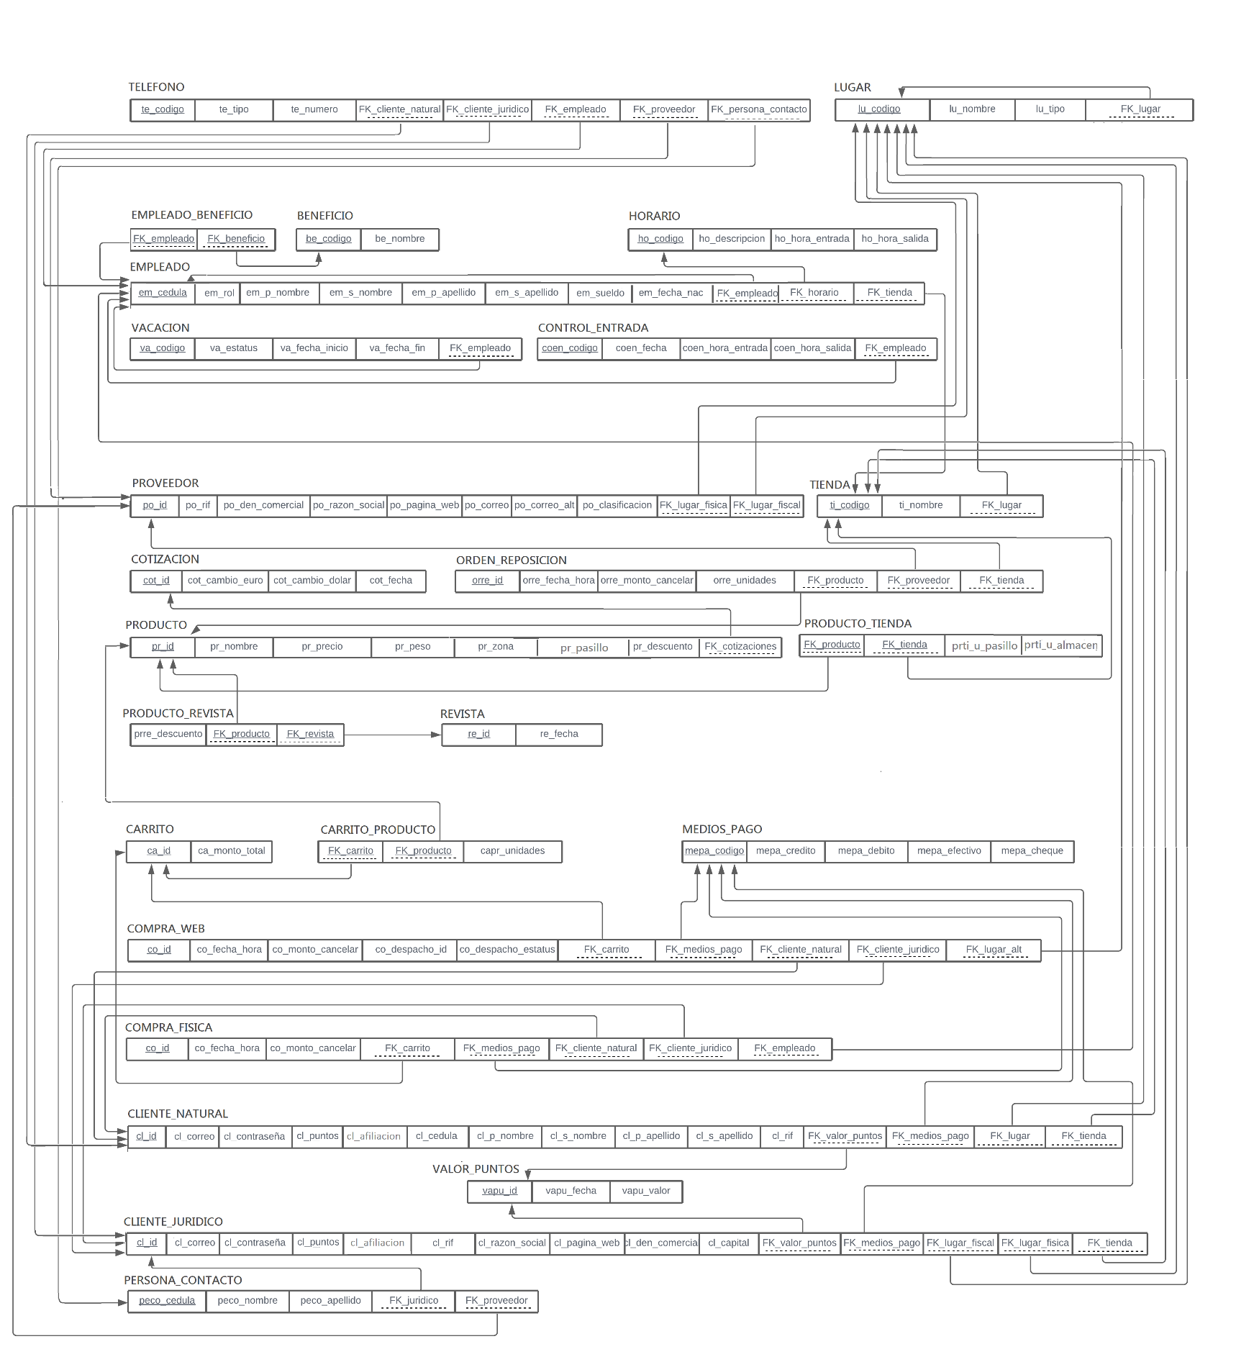

TELÉFONO

|  |  |  |  |  |  |  |  |
| --- | --- | --- | --- | --- | --- | --- | --- |
| Atributo | Clave primaria | Clave foránea | Not null | Unique | Check | Tipo de dato |  |
| te_codigo | * |  | * | * |  | **NUMERIC(10)** |  |
| te_tipo |  |  | * |  | Casa, Oficina,  Celular | **VARCHAR(20)** |  |
| te_numero |  |  | * |  |  | **NUMERIC (10)** |  |
| FK_cliente_natural |  | * |  |  |  | **NUMERIC (10)** |  |
| FK_cliente_jurídico |  | * |  |  |  | **NUMERIC (10)** |  |
| FK_empleado |  | * |  |  |  | **NUMERIC (10)** |  |
| FK_proveedor |  | * |  |  |  | **NUMERIC (10)** |  |
| FK_persona_contacto |  | * |  |  |  | **NUMERIC (10)** |  |

EMPLEADO_BENEFICO

|  |  |  |  |  |  |  |  |
| --- | --- | --- | --- | --- | --- | --- | --- |
| Atributo | Clave primaria | Clave foránea | Not null | Unique | Check | Tipo de dato |  |
| FK_empleado | * | * | * |  |  | **NUMERIC(10)** |  |
| FK_beneficio | * | * | * |  |  | **NUMERIC(10)** |  |