**Instructions on How to Use Final Deliverables:**

**ArcGIS Map/Report**

1. Open [link](https://www.arcgis.com/apps/mapviewer/index.html?webmap=6b64cb646f19489982f24ac91f7935d8&extent=-76.9431,38.9707,-76.856,39.0106) provided to the ArcGIS map.
2. Click this button on the toolbar on the left side to view the different layers of the map.
   1. 
3. Click the 3 dots to view tabular data and other properties of each layer
   1. .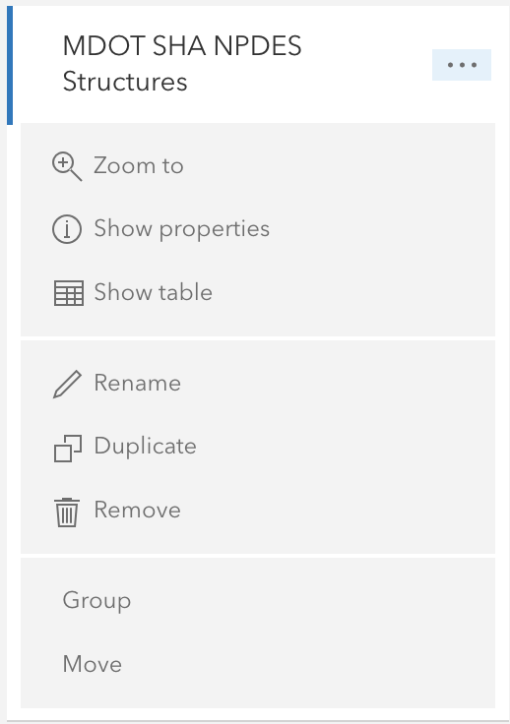
4. Continue with step 3 for all five layers included
5. After selecting a layer in the layer tab, select the legend button to view the legend for that layer.
   1. 
6. Click on any point on the map to view specifics about that data point.
   1. 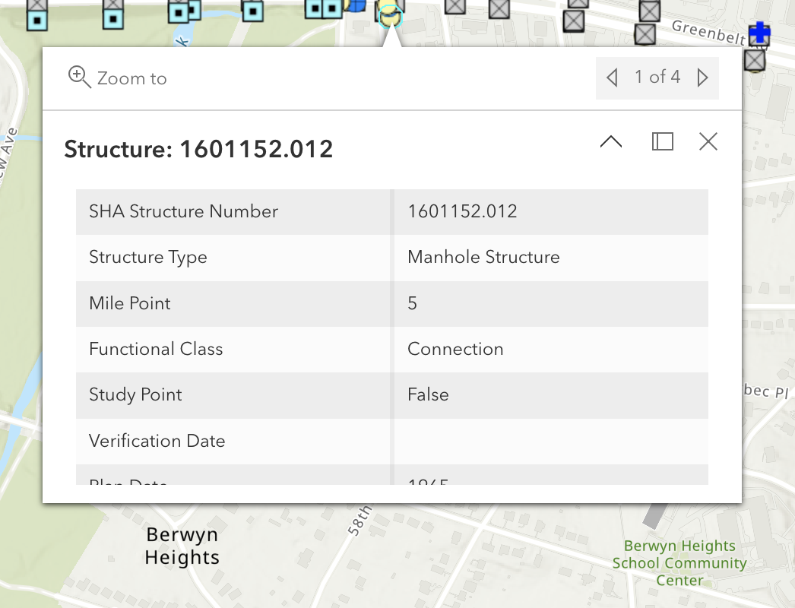
7. View Final Report document to read specifics on the information we gathered from our research and findings from the map