THE OUTFIT

SPORTS TRAINING FACILITY

DATABASE PROJECT

PROJECT REPORT



**Course Number: MIS 6326.501-S17**

**Instructor: Dr. Kutsal Dogan**

**Group Members:**

Lohith Padmaraju

Hersh Mandal

Sairam Venkatesh Kumar

Brahma Nand Aditya Bahl

**Table of Contents**

Problem Description 2

Company Background 2

Current Database Issues 2

Proposed Solutions 2

Scope of Database 4

**Employees Table** 4

**Customers Table** 5

Trainers Table 6

Transactions Table 7

Contract Table 8

Service Schedule Table 9

Service Table 10

Entity Relationship Diagram with Definitions 11

Relational Database Schema 12

Employees Table 12

Customer Table 13

Trainers Table 17

Contract Table 20

Service Table 22

Service Schedule Table 24

Transaction Table 26

Menu and Data Input Screens 29

Sample Reports 39

Contributions.............................................................................................................................................46

**1.Problem Description**

**1.1. Company Background**

Kris, Huzefa, Devrath, three friends – Kris, a sports consultant; Huzefa, an investment banker; Devrath, a software engineer. All three united by their passion towards fitness wanted to start a sports functional facility. After pooling the required money and resources, they opened the first branch in December 2014 ‘The OutFit’ in Dallas, TX. It is a sports training facility where its sole purpose is to make their clients fit and provide world-class training programs to the people.

Dallas has a population of approximately 11.5 million according to the Census data. The increase in awareness of fitness especially among the working class created a wide scope of business for the facility. The Outfit, being one of its kind sports facility it offers training regimes which works on Strength, Sports Conditioning, Agility, Flexibility, Power, Balance and Skills. This aspect of various forms of training is what makes them stand out from the other competitors. Having the best trainers and staff in business, the business boomed after the initial stages. This led to opening the next branch and so on. Now they have four branches across the city.

Initially they used a log and proceeded to maintaining an excel file to maintain information. As they expanded, with more number of branches, more clients, more services, dealing with such volume of information and data with these methods are no longer feasible and sufficient. This led to affecting their growth.

**1.2 Current Database Issues:**

* Time consuming and inefficient
* Large amount of maintenance is needed
* Majority of records initially were hand written which leads to inconsistency information
* Customer information, transaction information is unorganized and varies on paper and computer records.
* Expensive and impractical for the increasing number of clients and business.

**1.3 Proposed Solution:**

With the expansion of the facility, the existing spreadsheet business solution is out of date. A large amount of time is necessary to search for information and consistency update records with current information. So, we need an easy new database to be implemented that all his employees can be easily trained to diminish training costs. A simple database is suggested to facilitate the storage of information such as client details, training assigned. The layout and implementation of the database is explained in detail in the following sections.

**Proposed Tables(Entities) for The Outfit database with their purpose:**

1. Employee: This table will be used to store basic employee information like Name, Email, Address, Privileges, Specialty or Type, Salaries, Temporary or Permanent etc.
2. Customer: This table will be used to record customer details such as information like Name, Email, Contact, Address, Emergency contact, Phone No, Gender, Height, Weight, BMI and Health Condition
3. Service: This table will hold information about each service the facility provides (current and potential) such as ServiceID, ServiceName (Kind of training offered), Price.
4. Service Schedule: This table will hold information regarding schedule service like Service days, Start time and End time.
5. Contract: This table will be used to keep track of the what services a client is enrolled in, this will hold information like Start date, Expiration Date and Contract Info.
6. Transaction: This table will keep track of all the transactions taking place like Transaction Date, Payment Date and Offer Type.
7. Trainer: This table will be used to store trainer information like Name, Email, Phone, Address, Specialization or Certifications

## Scope of Database

Currently Outfit uses unorganized Excel Spreadsheets that create more problems and inefficiency than solutions. With the implementation of the new database, these errors will be corrected. There are a total of seven tables in the new database. Detailed descriptions of each table are described below.

### Employees Table

This table consists of all personal information pertaining to each individual employee employed at The Outfit. Each employee is identified by a unique number labeled as ID. Information ranging from their full name, email address, various phone numbers and address is included in this table.

|  |  |  |  |
| --- | --- | --- | --- |
| **File Name** | **Description** | **Data Type (Size)** | **Remarks** |
| ID | Identify Individual Employee | INTEGER | Primary Key |
| Last Name | Employee's Last Name | VARCHAR (50) | Required |
| First Name | Employee's First Name | VARCHAR (50) | Required |
| E-mail Address | Employee's E-mail | VARCHAR (50) | Required |
| Job Title | Employee's Job Title | VARCHAR (50) | Required |
| Mobile Phone | Employee’s Mobile Phone | VARCHAR (255) | Required |
| Address | Employee's Address | VARCHAR (255) | Required |
| City | City of Employee's Address | VARCHAR (50) | Required |
| State/Province | State/Province of Employee's Address | VARCHAR (50) | Required |
| ZIP/Postal Code | ZIP/Postal Code of Employee's Address | INTEGER | Required |

### Customers Table

This table consists of customer information. Each customer is assigned and identified by a unique number labeled as ID. This table also contains personal information of the customer. This information ranges from their full name, current job, e-mail address, various phone numbers and their address.

|  |  |  |  |
| --- | --- | --- | --- |
| **File Name** | **Description** | **Data Type (Size)** | **Remarks** |
| ID | Identify Individual Customer | INTEGER | Primary key |
| Last Name | Customer's Last Name | VARCHAR (50) | Required |
| First Name | Customer's First Name | VARCHAR (50) | Required |
| Job Title | Customer’s Career Title | VARCHAR (50) | Not Required |
| E-mail Address | Customer's E-mail Address | VARCHAR (50) | Required |
| Home Phone | Customer's Home Phone Number | VARCHAR (255) | Required |
| Mobile Phone | Customer's Mobile Phone Number | VARCHAR (255) | Required |
| Fax Phone | Customer's Fax Phone Number | VARCHAR (255) | Required |
| Address | Customer's Address | VARCHAR (255) | Required |
| City | City of Customer’s Address | VARCHAR (50) | Required |
| State/Province | State/Province of Customer’s Address | VARCHAR (50) | Required |
| ZIP/Postal Code | ZIP/Postal Code of Customer’s Address | INTEGER | Required |
| Special Condition | Special Health Condition | VARCHAR (255) | Optional |
| Gender | Gender of Customer | VARCHAR | Required |
| Height | Height of Customer | NUMBER (10,2) | Required |
| Weight | Weight of Customer | NUMBER (10,2) | Required |
| BMI | BMI of Customer | NUMBER (10,2) | Required |

### Trainers Table

This table consists of all personal information pertaining to each individual Trainer employed at The Outfit. Each employee is identified by a unique number labeled as ID. Information ranging from their full name, email address, various phone numbers and address is included in this table.

|  |  |  |  |
| --- | --- | --- | --- |
| **File Name** | **Description** | **Data Type (Size)** | **Remarks** |
| ID | Identify Individual Trainers | INTEGER | Primary Key |
| Last Name | Trainee's Last Name | VARCHAR (50) | Required |
| First Name | Trainee's First Name | VARCHAR (50) | Required |
| E-mail Address | Trainee's E-mail | VARCHAR (50) | Required |
| Job Title | Trainee's Job Title | VARCHAR (50) | Required |
| Mobile Phone | Trainee’s Mobile Phone | VARCHAR (255) | Required |
| Address | Trainee's Address | VARCHAR (255) | Required |
| City | City of Trainee's Address | VARCHAR (50) | Required |
| State/Province | State/Province of Trainee's Address | VARCHAR (50) | Required |
| ZIP/Postal Code | ZIP/Postal Code of Trainee's Address | INTEGER | Required |

### Transaction Table

This table consists of various information pertaining to each transation.at The Outfit. Each transaction is identified by a unique number labeled as Order ID. This table also contains various information about each order including: the employee who took the order (Employee ID), the customer who placed the order (Customer ID), transaction date, taxes, payment type, notes related to the transaction.

**File Name Description Data Type (Size) Remarks**

ID Identify Transaction INTEGER Primary Key

Employee ID Identify Employee INTEGER Required; FK references Employee

(EmployeeID)

Customer ID Identify Individual Customer INTEGER Required; FK

references Customer (CustomerI D)

Transaction Date Date Ordered DATE Required

Payment Type Date Picked up VARCHAR (50) Required

Offer Type Applicable Offers VARCHAR (50) Required

Amount Amount paid including tax INTEGER Required

**Customer Contract:**

This table consists of all details pertaining to all contracts made by individual customers. The details for each contract are identified by a unique number labeled as ID. Information like contract start date, expiration date, contract Info and the Customer ID, Service ID, Transaction ID as foreign keys to the Customer Contract.

|  |  |  |  |
| --- | --- | --- | --- |
| **File Name** | **Description** | **Data Type (Size)** | **Remarks** |
| ID | Identify Health Condition | INTEGER | Primary Key |
| Customer ID | Identify Customer | INTEGER | Required; FK references Customer (CustomerID) |
| Service ID | Identify Service | INTEGER | Required; FK references Service (ServiceID) |
| Transaction ID | Identify the transaction | INTEGER | Required; FK references Transaction (Transaction ID) |
| Start Date | Start Date of Contract | DATE | Optional |
| Expiration Date | Expiration Date of Contract | DATE | Required |
| Contract Info | Additional Information | VARCHAR (255) | Required |

**Service Schedule**:

This table consists of all information related to the Service Schedule at The Outfit. Each Schedule is identified with a unique number labeled as ID. Information included in this table ranges from: Days of service offered, Start time of service, End time of service, notes for additional comments and we have Customer ID, Service ID, Trainer ID as foreign keys to the Customer Contract.

**File Name Description Data Type (Size) Remarks**

ID Identify Service Schedule INTEGER Primary Key

Trainer ID Identify Trainer INTEGER Required; FK references Trainer

(TrainerID)

Customer ID Identify Individual Customer INTEGER Required; FK

references Customer (CustomerID)

Service ID Identify Service INTEGER Required; FK

references Services (ServiceID)

Days Days of Service Offered DATE Required

Start Time Start Time of Service TIME Required

End Time End Time of Service TIME Required

Notes Commentary VARCHAR (255) Optional

**Service:**

This table consists of all information related to the different services and programs provided at The Outfit. Each Service is identified with a unique number labeled as ID. Information included in this table ranges from: Service type or program type, Price and Service Information.

**File Name Description Data Type (Size) Remarks**

ID Identify Service INTEGER Primary Key

Service Type Type of Training VARCHAR (50) Required

Price Price of the Service VARCHAR(50) Required

Service Info Additional Comments VARCHAR (255) Optional

##### **Entity Relationship Diagram with Definitions**

##### C:\Users\Aditya\AppData\Local\Microsoft\Windows\INetCache\Content.Word\ER Diagram - Updated.png

Relational Database Schema

###### Employees Table

DROP TABLE Employees; CREATE TABLE Employees(

|  |  |  |
| --- | --- | --- |
| Employee_ID | INTEGER | NOT NULL PRIMARY KEY, |
| Employee_Last_Name | VARCHAR(100) | NOT NULL, |
| Employee_First_Name | VARCHAR(100) | NOT NULL, |
| Employee_Email_Address | VARCHAR(50) | NOT NULL, |
| Employee_Job_Title | VARCHAR(50) | NOT NULL, |
| Employee_Home_Phone | VARCHAR(255) | NOT NULL, |
| Employee_Mobile_Phone | VARCHAR(255) | NOT NULL, |
| Employee_Address | VARCHAR(255) | NOT NULL, |
| Employee_City | VARCHAR(50) | NOT NULL, |
| Emloyee_StateProvince | VARCHAR(50) | NOT NULL, |
| Employee_ZIPPostal_Code | INTEGER | NOT NULL |

CONSTRAINT PKEmployee_ID PRIMARY KEY (Employee_ID)

);

INSERT INTO Employee(Employee_ID, Employee_Last_Name, Employee_First_Name, Employee_Job_Title, Employee_Email_Address, Employee_Home_Phone, Employee_Mobile_Phone, Employee_Address, Employee_City, Employee_StateProvince, Employee_ZIPPostal_Code)

VALUES (500001,’Urban’, ‘Keith’, ‘Receptionist’, 'k.urban@gmail.com', '940-765-0980’,'940-999-5643’,'2300 W. Plum Street','Seattle','WA',63027);

INSERT INTO Employee(Employee_ID, Employee_Last_Name, Employee_First_Name, Employee_Job_Title, Employee_Email_Address, Employee_Home_Phone, Employee_Mobile_Phone, Employee_Address, Employee_City, Employee_StateProvince, Employee_ZIPPostal_Code)

VALUES (500002,’Legend’, ‘John’, ‘Janitor’, 'j.legend@gmail.com', '940-123-0777’,'940-012-1111’,’7652 Mccallum Blvd',’Dallas’ ,'TX',75252);

INSERT INTO Employee(Employee_ID, Employee_Last_Name, Employee_First_Name, Employee_Job_Title, Employee_Email_Address, Employee_Home_Phone, Employee_Mobile_Phone, Employee_Address, Employee_City, Employee_StateProvince, Employee_ZIPPostal_Code)

VALUES (500003,’Michael’, ‘George’,’Cashier’ , 'g.michael@gmail.com', '940-222-9083’,'940-258-1234’,'1780 S.Houston Street',’Houston’ ,'TX',77070);

INSERT INTO Employee(Employee_ID, Employee_Last_Name, Employee_First_Name, Employee_Job_Title, Employee_Email_Address, Employee_Home_Phone, Employee_Mobile_Phone, Employee_Address, Employee_City, Employee_StateProvince, Employee_ZIPPostal_Code)

VALUES (500004,’Mayer’, ‘John’, ‘Customer Service Rep’ ,'j.mayer@gmail.com', '940-258-0988’,'940-258-1212,'1123 Baker Street',’Austin’ ,'TX',73301);

INSERT INTO Employee(Employee_ID, Employee_Last_Name, Employee_First_Name, Employee_Job_Title, Employee_Email_Address, Employee_Home_Phone, Employee_Mobile_Phone, Employee_Address, Employee_City, Employee_StateProvince, Employee_ZIPPostal_Code)

VALUES (500005,’Puth’, ‘Charlie’,’Clerk ’ ,'c.puth@gmail.com', '940-258-0121’,'940-258-1234’,'1321 Campbell Street','San Francisco','CA',94016);

###### Customers Table

DROP TABLE Customers; CREATE TABLE Customers(

|  |  |  |
| --- | --- | --- |
| Customer_ID | INTEGER | NOT NULL, PRIMARY KEY, |
| Trainer ID | INTEGER | NOT NULL, |
| Customer_Last_Name | VARCHAR(50) | NOT NULL, |
| Customer_First_Name | VARCHAR(50) | NOT NULL, |
| Customer_Email_Address | VARCHAR(50) | NOT NULL, |
| Customer_Home_Phone | VARCHAR(255) | NOT NULL, |
| Customer_Mobile_Phone | VARCHAR(255) | NOT NULL, |
| Customer_Address | VARCHAR(255) | NOT NULL, |
| Customer_City | VARCHAR(50) | NOT NULL, |
| Cutomer_StateProvince | VARCHAR(50) | NOT NULL, |
| Customer_ZIPPostal_Code | INTEGER | NOT NULL, |
| Customer_Emergency_Contact | VARCHAR(100) | NOT NULL, |
| Customer_Health_Condition | VARCHAR(100) | NOT NULL, |
| Customer_Gender | VARCHAR(20) | NOT NULL, |
| Customer_Height | INTEGER(20) | NOT NULL, |
| Customer_Weight | INTEGER(20) | NOT NULL, |
| Customer_BMI | DECIMAL(3,2) | NOT NULL, |
|  |  |  |

CONSTRAINT PKCustomer_ID PRIMARY KEY (Customer_ID)

CONSTRAINT FKTrainer_ID FOREIGN KEY (Trainer_ID) REFERENCES Trainer

ON UPDATE CASCADE

);

INSERT INTO Customer(Customer_ID,Customer_Last_Name, Customer_First_Name , Email_Address, Home_Phone, Mobile_Phone , Address , City , StateProvince , ZIPPostal_Code , Customer_Emergency_Contact, Customer_HealthCondition, Customer_Gender, Customer_Height, Customer_Weight, Customer_BMI , Trainer_ID )

VALUES (1000001,’Lee’, ‘Samy’,'s.lee@gmail.com', '940-258-0980’,'940-258-9874','1600 W. Plum Street','Seattle','WA',63027,’Adam Smith 987-402-8484’ , ‘Diabetic’ , ‘FEMALE’,170 , 150 , 40.1 , 200000 );

INSERT INTO Customer(Customer_ID,Customer_Last_Name, Customer_First_Name , Email_Address, Home_Phone, Mobile_Phone , Address , City , StateProvince , ZIPPostal_Code , Customer_Emergency_Contact, Customer_HealthCondition, Customer_Gender, Customer_Height, Customer_Weight, Customer_BMI , Trainer_ID )

VALUES (1000002,'Grygar',’John’,'g.john@gmail.com', '940-258-6611,'940-258-7272,'1600 W. Plum Street',’Dallas’,’TX’,75252,’Rob Metz 987-402-2322 , ‘High Blood Pressure’, ‘MALE’,175 , 165 , 40.1 , 200001);

INSERT INTO Customer(Customer_ID,Customer_Last_Name, Customer_First_Name , Email_Address, Home_Phone, Mobile_Phone , Address , City , StateProvince , ZIPPostal_Code , Customer_Emergency_Contact, Customer_HealthCondition, Customer_Gender, Customer_Height, Customer_Weight, Customer_BMI , Trainer_ID )

VALUES (1000003,'Rogers',’Brian’,'b.rogers@gmail.com', '940-222-0210,'940-629-0190,'1600 W. Plum Street','Austin','TX',63027,Dan Kuan 987-402-1098 , ‘ Stroke ’ , ‘MALE’,185 , 170 , 40.1 , 200002);

INSERT INTO Customer (Customer_ID,Customer_Last_Name, Customer_First_Name , Email_Address, Home_Phone, Mobile_Phone , Address , City , StateProvince , ZIPPostal_Code , Customer_Emergency_Contact, Customer_HealthCondition, Customer_Gender, Customer_Height, Customer_Weight, Customer_BMI , Trainer_ID )

VALUES (1000004,’Bomer’,’Rex’,'r.bomer@gmail.com', '940-011-5489,'940-999-1090,'1600 W. Plum Street','Houston','TX',77041,’Emelie Ortiz 987-402-7221 , ‘Hypertension’ , ‘MALE’,181 , 160 , 40.1 , 200003);

INSERT INTO Customer(Customer_ID,Customer_Last_Name, Customer_First_Name , Email_Address, Home_Phone, Mobile_Phone , Address , City , StateProvince , ZIPPostal_Code , Customer_Emergency_Contact, Customer_HealthCondition, Customer_Gender, Customer_Height, Customer_Weight, Customer_BMI , Trainer_ID )

VALUES (1000005,’Orban’,’Charles’,'c.orban@gmail.com', '940-110-2019’,'940-201-1090’,'1600 W. PlumStreet','Richmond','VA',63027,’Melanie Lilo 987-402-8484 ‘, ‘Fatty Liver’, ‘MALE’,182 , 150 , 40.1 , 200004);

INSERT INTO Customer(Customer_ID,Customer_Last_Name, Customer_First_Name , Email_Address, Home_Phone, Mobile_Phone , Address , City , StateProvince , ZIPPostal_Code , Customer_Emergency_Contact, Customer_HealthCondition, Customer_Gender, Customer_Height, Customer_Weight, Customer_BMI , Trainer_ID )

VALUES (1000006,’Pratt’, ‘Chris’,'c.pratt@gmail.com', '940-110-2017’,'940-201-2012','8000 S. Plum Street','Dallas','TX',75252,’Andy Flintoff 987-234-8888’ , ‘None’ , ‘MALE’,184 , 178 , 40.1 , 200005 );

INSERT INTO Customer(Customer_ID,Customer_Last_Name, Customer_First_Name , Email_Address, Home_Phone, Mobile_Phone , Address , City , StateProvince , ZIPPostal_Code , Customer_Emergency_Contact, Customer_HealthCondition, Customer_Gender, Customer_Height, Customer_Weight, Customer_BMI , Trainer_ID )

VALUES (1000007,'Diesel',’Vin’,'v.diesel@gmail.com', '940-110-2006,'940-201-2312,'7373 E. Plum Street',’Dallas’,’TX’,75252, Tom Hiddle 987-222-7654 , ‘ None ’, ‘MALE’,182 , 172 , 40.1 , 200006);

INSERT INTO Customer(Customer_ID,Customer_Last_Name, Customer_First_Name , Email_Address, Home_Phone, Mobile_Phone , Address , City , StateProvince , ZIPPostal_Code , Customer_Emergency_Contact, Customer_HealthCondition, Customer_Gender, Customer_Height, Customer_Weight, Customer_BMI , Trainer_ID )

VALUES (1000008,'Gillan',’Karen’,'k.gillan@gmail.com', '940-110-2088,'940-201-7675,'2342 N. Plum Street','Dallas','TX',75252,Thor Asgard 987-444-9383 , ‘Knee Injury ’ , ‘FEMALE’,173 , 151 , 40.1 , 200007);

INSERT INTO Customer(Customer_ID,Customer_Last_Name, Customer_First_Name , Email_Address, Home_Phone, Mobile_Phone , Address , City , StateProvince , ZIPPostal_Code , Customer_Emergency_Contact, Customer_HealthCondition, Customer_Gender, Customer_Height, Customer_Weight, Customer_BMI , Trainer_ID )

VALUES (1000009,’Saldana’,’Zoe’,'z.saldana@gmail.com', '940-110-1112,'940-201-8890,'1231 E. Plum Street','Dallas','TX',75252,’Bruce Wayne 987-111-4343 , ‘Back Injury’ , ‘FEMALE’,172 , 152 , 40.1 , 200009);

INSERT INTO Customer(Customer_ID,Customer_Last_Name, Customer_First_Name , Email_Address, Home_Phone, Mobile_Phone , Address , City , StateProvince , ZIPPostal_Code , Customer_Emergency_Contact, Customer_HealthCondition, Customer_Gender, Customer_Height, Customer_Weight, Customer_BMI , Trainer_ID )

VALUES (1000010,’Lee’,’Stan’,'st.lee@gmail.com', '940-110-8876’,'940-201-1760’,'4234 N. PlumStreet','Dallas','TX',75252,’Bucky 987-111-3333 ‘, ‘None’, ‘MALE’,190 , 180 , 40.1 , 200003);

INSERT INTO Customer(Customer_ID,Customer_Last_Name, Customer_First_Name , Email_Address, Home_Phone, Mobile_Phone , Address , City , StateProvince , ZIPPostal_Code , Customer_Emergency_Contact, Customer_HealthCondition, Customer_Gender, Customer_Height, Customer_Weight, Customer_BMI , Trainer_ID )

VALUES(1000011,’Lawrence’,’Jenn’,'j.law@gmail.com','940-110-2345’,'940-201-1420’,'2341E. PlumStreet','Dallas','TX',75252,’Charlie 987-234-8383 ‘, ‘Slip Disc’, ‘FEMALE’,168 , 160 , 40.1 , 200004);

###### Trainers Table

DROP TABLE Trainer; CREATE TABLE Trainer (

|  |  |  |
| --- | --- | --- |
| Trainer_ID | INTEGER | NOT NULL PRIMARY KEY, |
| Trainer_Last_Name | VARCHAR(100) | NOT NULL, |
| Trainer_First_Name | VARCHAR(100) | NOT NULL, |
| Trainer_Email_Address | VARCHAR(50) | NOT NULL, |
| Trainer_Specialization | VARCHAR(100) | NOT NULL, |
| Trainer_Home_Phone | VARCHAR(50) | NOT NULL, |
| Trainer_Mobile_Phone | VARCHAR(50) | NOT NULL, |
| Trainer_Address | VARCHAR(255) | NOT NULL, |
| Trainer_City | VARCHAR(50) | NOT NULL, |
| Trainer_StateProvince | VARCHAR(50) | NOT NULL, |
| Trainer_ZIPPostal_Code | INTEGER | NOT NULL |

CONSTRAINT PKTrainer_ID PRIMARY KEY (Trainer_ID)

);

INSERT INTO Trainer (Trainer_ID, Trainer_Last_Name, Trainer_First_Name, Trainer_Specialization, Trainer_Email_Address, Trainer_Home_Phone, Trainer_Mobile_Phone, Trainer_Address, Trainer_City, Trainer_StateProvince, Trainer_ZIPPostal_Code)

VALUES (2000001,’Starc’, ‘Mitchell’,’Strength’,'m.starc@gmail.com', '940-258-0980’,'940-765-8987’, 7777 W. Plum Street','Seattle','WA',63027’);

INSERT INTO Trainer (Trainer_ID, Trainer_Last_Name, Trainer_First_Name, Trainer_Specialization, Trainer_Email_Address, Trainer_Home_Phone, Trainer_Mobile_Phone, Trainer_Address, Trainer_City, Trainer_StateProvince, Trainer_ZIPPostal_Code)

VALUES (2000002,’Pollard’, ‘Keiron’,’Conditioning',’k.pollard@gmail.com', '940-258-4523’,'940-654-0098’, 8000 Mccallum Blvd',’Dallas’ ,'TX',75252’);

INSERT INTO Trainer (Trainer_ID, Trainer_Last_Name, Trainer_First_Name, Trainer_Specialization, Trainer_Email_Address, Trainer_Home_Phone, Trainer_Mobile_Phone, Trainer_Address, Trainer_City, Trainer_StateProvince, Trainer_ZIPPostal_Code)

VALUES (2000003,’Gibbs’, ‘Herschelle,’Agility’,'h.gibbs@gmail.com', '940-258-6564’,'940-432-1234’, 9000 S.Houston Street',’Houston’ ,'TX',77070’);

INSERT INTO Trainer(Trainer_ID, Trainer_Last_Name, Trainer_First_Name, Trainer_Specialization, Trainer_Email_Address, Trainer_Home_Phone, Trainer_Mobile_Phone, Trainer_Address, Trainer_City, Trainer_StateProvince, Trainer_ZIPPostal_Code)

VALUES (2000004,’Smith’, ‘Dwayne’,’Crosfit',’d.smith@gmail.com', '940-258-7654’,'940-098-5643’, 8762 Baker Street',’Austin’ ,'TX',73301’);

INSERT INTO Trainer(Trainer_ID, Trainer_Last_Name, Trainer_First_Name, Trainer_Specialization, Trainer_Email_Address, Trainer_Home_Phone, Trainer_Mobile_Phone, Trainer_Address, Trainer_City, Trainer_StateProvince, Trainer_ZIPPostal_Code)

VALUES (2000005,’Lee’, ‘Brett’,’Power,’b.lee@gmail.com', '940-258-2221’,'940-768-0932’, 8765 Campbell Street','San Francisco','CA',94016’);

INSERT INTO Trainer (Trainer_ID, Trainer_Last_Name, Trainer_First_Name, Trainer_Specialization, Trainer_Email_Address, Trainer_Home_Phone, Trainer_Mobile_Phone, Trainer_Address, Trainer_City, Trainer_StateProvince, Trainer_ZIPPostal_Code)

VALUES (2000006,’Kohli’, ‘Virat’,’ Mixed Martial Arts','v.kohli@gmail.com', '940-258-8888’,'940-765-7777’, 4000 Coit Road','Dallas','TX',75252’);

INSERT INTO Trainer (Trainer_ID, Trainer_Last_Name, Trainer_First_Name, Trainer_Specialization, Trainer_Email_Address, Trainer_Home_Phone, Trainer_Mobile_Phone, Trainer_Address, Trainer_City, Trainer_StateProvince, Trainer_ZIPPostal_Code)

VALUES (2000007,’Gayle’, ‘Chris’,’Calistenics',’c.gayle@gmail.com', '940-258-1111’,'940-654-2222’, 6666 Preston Road',’Dallas’ ,'TX',75252’);

INSERT INTO Trainer (Trainer_ID, Trainer_Last_Name, Trainer_First_Name, Trainer_Specialization, Trainer_Email_Address, Trainer_Home_Phone, Trainer_Mobile_Phone, Trainer_Address, Trainer_City, Trainer_StateProvince, Trainer_ZIPPostal_Code)

VALUES (2000008,’Sammy’, ‘Darren’,’Yoga',’D.sammy@gmail.com', '940-258-8954’,'940-258-9999’, 7546 Sprinfield avenue',’Dallas’ ,'TX',75252’);

INSERT INTO Trainer(Trainer_ID, Trainer_Last_Name, Trainer_First_Name, Trainer_Specialization, Trainer_Email_Address, Trainer_Home_Phone, Trainer_Mobile_Phone, Trainer_Address, Trainer_City, Trainer_StateProvince, Trainer_ZIPPostal_Code)

VALUES (2000009,’Bolt’, ‘Usain’,’Road Runner',’u.bolt@gmail.com', '940-258-9090’,'940-098-0070’, 2222 Argentine way,’Dallas’ ,'TX',75252’);

INSERT INTO Trainer(Trainer_ID, Trainer_Last_Name, Trainer_First_Name, Trainer_Specialization, Trainer_Email_Address, Trainer_Home_Phone, Trainer_Mobile_Phone, Trainer_Address, Trainer_City, Trainer_StateProvince, Trainer_ZIPPostal_Code)

VALUES (2000010,’Mahi’, ‘Dhoni’,’Phantom Conditioing',’m.dhoni@gmail.com', '940-268-2635’,'940-268-6565’2000 renner road,'Dallas','TX',75252’);

###### 

###### Contract Table

DROP TABLE Contract; CREATE TABLE Contract (

|  |  |  |
| --- | --- | --- |
| Customer_Contract_ID | INTEGER | NOT NULL, PRIMARY KEY, |
| Customer_ID | INTEGER | NOT NULL, |
| Service_ID | INTEGER | NOT NULL, |
| Transaction_ID | INTEGER | NOT NULL, |
| Contract_StartDate | DATE | NOT NULL, |
| Contract_ExpirationDate | DATE | NOT NULL, |
| Contract_Info | VARCHAR(250) | NOT NULL, |
|  |  |  |

CONSTRAINT PKCUSTOMERCONTRACT PRIMARY KEY (CUSTOMERCONTRACT_ID),

CONSTRAINT FKCUSTOMERID FOREIGN KEY (CUSTOMER_ID) REFERENCES CUSTOMER,

CONSTRAINT FKSERVICEID FOREIGN KEY (SERVICE_ID) REFERENCES SERVICE,

CONSTRAINT FKTRANSACTIONID FOREIGN KEY (TRANSACTION_ID) REFERENCES TRANSACTION

);

INSERT INTO CUSTOMERCONTRACT(CUSTOMERCONTRACT_ID,CONTRACT_STARTDATE,CONTRACT_EXPIRATIONDATE,CONTRACT_INFO,CUSTOMER_ID,SERVICE_ID,TRANSACTION_ID)

VALUES('400001','05/02/2017','06/01/2017','MONTHLY','1000001','600001','900001');

INSERT INTO CUSTOMERCONTRACT(CUSTOMERCONTRACT_ID,CONTRACT_STARTDATE,CONTRACT_EXPIRATIONDATE,CONTRACT_INFO,CUSTOMER_ID,SERVICE_ID,TRANSACTION_ID)

VALUES('400002','06/10/2016','09/09/2016','QUARTERLY','1000002','600002','900002');

INSERT INTO CUSTOMERCONTRACT(CUSTOMERCONTRACT_ID,CONTRACT_STARTDATE,CONTRACT_EXPIRATIONDATE,CONTRACT_INFO,CUSTOMER_ID,SERVICE_ID,TRANSACTION_ID)

VALUES('400003','02/15/2016','08/14/2016','HALFYEARLY','1000003','600003','900003');

INSERT INTO CUSTOMERCONTRACT(CUSTOMERCONTRACT_ID,CONTRACT_STARTDATE,CONTRACT_EXPIRATIONDATE,CONTRACT_INFO,CUSTOMER_ID,SERVICE_ID,TRANSACTION_ID)

VALUES('400004','09/17/2016','09/16/2017','ANNUALLY','1000004','600004','900004');

INSERT INTO CUSTOMERCONTRACT(CUSTOMERCONTRACT_ID,CONTRACT_STARTDATE,CONTRACT_EXPIRATIONDATE,CONTRACT_INFO,CUSTOMER_ID,SERVICE_ID,TRANSACTION_ID)

VALUES('400005','03/19/2017','04/18/2017','MONTHLY','1000005','600005','900005');

INSERT INTO CUSTOMERCONTRACT(CUSTOMERCONTRACT_ID,CONTRACT_STARTDATE,CONTRACT_EXPIRATIONDATE,CONTRACT_INFO,CUSTOMER_ID,SERVICE_ID,TRANSACTION_ID)

VALUES('400006','05/29/2017','11/28/2017','HALFYEARLY','1000006','600006','900006');

INSERT INTO CUSTOMERCONTRACT(CUSTOMERCONTRACT_ID,CONTRACT_STARTDATE,CONTRACT_EXPIRATIONDATE,CONTRACT_INFO,CUSTOMER_ID,SERVICE_ID,TRANSACTION_ID)

VALUES('400007','01/30/2016','01/29/2017','ANNUALLY','1000007','600007','900007');

INSERT INTO CUSTOMERCONTRACT(CUSTOMERCONTRACT_ID,CONTRACT_STARTDATE,CONTRACT_EXPIRATIONDATE,CONTRACT_INFO,CUSTOMER_ID,SERVICE_ID,TRANSACTION_ID)

VALUES('400008','08/07/2016','11/06/2016','QUARTERLY','1000008','600008','900008');

INSERT INTO CUSTOMERCONTRACT(CUSTOMERCONTRACT_ID,CONTRACT_STARTDATE,CONTRACT_EXPIRATIONDATE,CONTRACT_INFO,CUSTOMER_ID,SERVICE_ID,TRANSACTION_ID)

VALUES('400009','04/04/2016','04/03/2017','ANNUALLY','1000009','600009','900009');

INSERT INTO CUSTOMERCONTRACT(CUSTOMERCONTRACT_ID,CONTRACT_STARTDATE,CONTRACT_EXPIRATIONDATE,CONTRACT_INFO,CUSTOMER_ID,SERVICE_ID,TRANSACTION_ID)

VALUES('400010','07/03/2017','01/02/2018','HALFYEARLY','1000010','600010','900010');

###### Service Table

DROP TABLE Service;

CREATE TABLE Service (

|  |  |  |
| --- | --- | --- |
| Service_ID | INTEGER | NOT NULL, PRIMARY KEY, |
| Service_Type | VARCHAR(50) | NOT NULL, |
| Service_Price | VARCHAR(50) | NOT NULL, |
| Servive_Info | VARCHAR(250) | NOT NULL, |
|  |  |  |

CONSTRAINT PKSERVICE PRIMARY KEY (SERVICE_ID)

);

INSERT INTO SERVICE(SERVICE_ID,SERVICE_TYPE,SERVICE_PRICE,SERVICE_INFO)

VALUES('600001','STRENGTH','M-99$,Q-250$,H-449$,Y-799$',NULL);

INSERT INTO SERVICE(SERVICE_ID,SERVICE_TYPE,SERVICE_PRICE,SERVICE_INFO)

VALUES('600002','CONDITIONING','M-99$,Q-250$,H-449$,Y-799$',NULL);

INSERT INTO SERVICE(SERVICE_ID,SERVICE_TYPE,SERVICE_PRICE,SERVICE_INFO)

VALUES('600003','AGILITY','M-99$,Q-250$,H-449$,Y-799$',NULL);

INSERT INTO SERVICE(SERVICE_ID,SERVICE_TYPE,SERVICE_PRICE,SERVICE_INFO)

VALUES('600004','POWER','M-99$,Q-250$,H-449$,Y-799$',NULL);

INSERT INTO SERVICE(SERVICE_ID,SERVICE_TYPE,SERVICE_PRICE,SERVICE_INFO)

VALUES('600005','MIXED MARTIAL ARTS','M-99$,Q-250$,H-449$,Y-799$',NULL);

INSERT INTO SERVICE(SERVICE_ID,SERVICE_TYPE,SERVICE_PRICE,SERVICE_INFO)

VALUES('600006','CROSSFIT','M-99$,Q-250$,H-449$,Y-799$',NULL);

INSERT INTO SERVICE(SERVICE_ID,SERVICE_TYPE,SERVICE_PRICE,SERVICE_INFO)

VALUES('600007','YOGA','M-99$,Q-250$,H-449$,Y-799$',NULL);

INSERT INTO SERVICE(SERVICE_ID,SERVICE_TYPE,SERVICE_PRICE,SERVICE_INFO)

VALUES('600008','ROAD RUNNER','M-99$,Q-250$,H-449$,Y-799$',NULL);

INSERT INTO SERVICE(SERVICE_ID,SERVICE_TYPE,SERVICE_PRICE,SERVICE_INFO)

VALUES('600009','PHANTHOM CONDITIONING','M-99$,Q-250$,H-449$,Y-799$',NULL);

INSERT INTO SERVICE(SERVICE_ID,SERVICE_TYPE,SERVICE_PRICE,SERVICE_INFO)

VALUES('600010','CALITHENICS','M-99$,Q-250$,H-449$,Y-799$',NULL);

###### ServiceSchedule Table

DROP TABLE ServiceSchedule;

CREATE TABLE ServiceSchedule (

|  |  |  |
| --- | --- | --- |
| Customer_ID | INTEGER | NOT NULL, |
| Trainer_ID | INTEGER | NOT NULL, |
| Service_ID | INTEGER | NOT NULL, |
| ServiceSchedule_Days | VARCHAR(50) | NOT NULL, |
| ServiceSchedule_StartTime | VARCHAR(50) | NOT NULL, |
| ServiceSchedule_EndTime | VARCHAR(50) | NOT NULL, |
|  |  |  |

CONSTRAINT PKSERVICESCHEDULE PRIMARY KEY (CUSTOMER_ID,SERVICE_ID,TRAINER_ID),

CONSTRAINT FKCUSTOMERID FOREIGN KEY (CUSTOMER_ID) REFERENCES CUSTOMER,

CONSTRAINT FKSERVICEID FOREIGN KEY (SERVICE_ID) REFERENCES SERVICE,

CONSTRAINT FKTRAINERID FOREIGN KEY (TRAINER_ID) REFERENCES TRAINER

);

INSERT INTO SERVICESCHEDULE(CUSTOMER_ID,SERVICE_ID,TRAINER_ID,SERVICESCHEDULE_DAYS,SERVICESCHEDULE_STARTTIME,SERVICESCHEDULE_ENDTIME)

VALUES('100001','200001','600001','MWF','6:30','7:30');

INSERT INTO SERVICESCHEDULE(CUSTOMER_ID,SERVICE_ID,TRAINER_ID,SERVICESCHEDULE_DAYS,SERVICESCHEDULE_STARTTIME,SERVICESCHEDULE_ENDTIME)

VALUES('100002','200002','600002','TTHS','7:30,18:30','8:30,19:30');

INSERT INTO SERVICESCHEDULE(CUSTOMER_ID,SERVICE_ID,TRAINER_ID,SERVICESCHEDULE_DAYS,SERVICESCHEDULE_STARTTIME,SERVICESCHEDULE_ENDTIME)

VALUES('100003','200003','600003','MTTH','7:30,17:30','8:30,18:30');

INSERT INTO SERVICESCHEDULE(CUSTOMER_ID,SERVICE_ID,TRAINER_ID,SERVICESCHEDULE_DAYS,SERVICESCHEDULE_STARTTIME,SERVICESCHEDULE_ENDTIME)

VALUES('100004','200004','600004','MTWTHF','6:30,8:30,17:30,19:30','7:30,9:30,18:30,20:30');

INSERT INTO SERVICESCHEDULE(CUSTOMER_ID,SERVICE_ID,TRAINER_ID,SERVICESCHEDULE_DAYS,SERVICESCHEDULE_STARTTIME,SERVICESCHEDULE_ENDTIME)

VALUES('100005','200005','600005','TTHF','11:30,17:30','12:30,18:30');

INSERT INTO SERVICESCHEDULE(CUSTOMER_ID,SERVICE_ID,TRAINER_ID,SERVICESCHEDULE_DAYS,SERVICESCHEDULE_STARTTIME,SERVICESCHEDULE_ENDTIME)

VALUES('100006','200006','600006','MTHS','6:30,8:30','7:30,9:30');

INSERT INTO SERVICESCHEDULE(CUSTOMER_ID,SERVICE_ID,TRAINER_ID,SERVICESCHEDULE_DAYS,SERVICESCHEDULE_STARTTIME,SERVICESCHEDULE_ENDTIME)

VALUES('100007','200007','600007','MTTH','7:30,11:30,17:30','8:30,12:30,18:30');

INSERT INTO SERVICESCHEDULE(CUSTOMER_ID,SERVICE_ID,TRAINER_ID,SERVICESCHEDULE_DAYS,SERVICESCHEDULE_STARTTIME,SERVICESCHEDULE_ENDTIME)

VALUES('100008','200008','600008','MTWTHF','6:30,18:30','7:30,19:30');

INSERT INTO SERVICESCHEDULE(CUSTOMER_ID,SERVICE_ID,TRAINER_ID,SERVICESCHEDULE_DAYS,SERVICESCHEDULE_STARTTIME,SERVICESCHEDULE_ENDTIME)

VALUES('100009','200009','600009','MWF','6:30','7:30');

INSERT INTO SERVICESCHEDULE(CUSTOMER_ID,SERVICE_ID,TRAINER_ID,SERVICESCHEDULE_DAYS,SERVICESCHEDULE_STARTTIME,SERVICESCHEDULE_ENDTIME)

VALUES('100010','200010','600010','MWF','6:30,17:30','7:30,18:30');

###### Transactions Table

DROP TABLE Transactions;

CREATE TABLE Transactions (

|  |  |  |
| --- | --- | --- |
| Transaction_ID | INTEGER | NOT NULL, |
| Customer_ID | INTEGER | NOT NULL, |
| Employee_ID | INTEGER | NOT NULL, |
| Transaction_Date | DATE | NOT NULL, |
| Payment_Type | VARCHAR(50) | NOT NULL, |
| Offer_Type | VARCHAR(50) | NULL, |
| Amount | INTEGER | NOT NULL, |

CONSTRAINT PKTRANSACTION PRIMARY KEY (TRANSACTION_ID),

CONSTRAINT FKCUSTOMERID FOREIGN KEY (CUSTOMER_ID) REFERENCES CUSTOMER,

CONSTRAINT FKEMPLOYEEID FOREIGN KEY (EMPLOYEE_ID) REFERENCES EMPLOYEE

);

INSERT INTO TRANSACTIONS(TRANSACTION_ID,TRANSACTION_DATE,PAYMENT_TYPE,CUSTOMER_ID,EMPLOYEE_ID,OFFER_TYPE,AMOUNT)

VALUES('900001','05/02/2017','CREDIT CARD','100001','200001',NULL,$114);

INSERT INTO TRANSACTIONS(TRANSACTION_ID,TRANSACTION_DATE,PAYMENT_TYPE,CUSTOMER_ID,EMPLOYEE_ID,OFFER_TYPE,AMOUNT)

VALUES('900002','06/09/2017','DEBIT CARD','100002','200002',NULL,$288);

INSERT INTO TRANSACTIONS(TRANSACTION_ID,TRANSACTION_DATE,PAYMENT_TYPE,CUSTOMER_ID,EMPLOYEE_ID,OFFER_TYPE,AMOUNT)

VALUES('900003','02/14/2017','CASH','100003','200003',NULL,$516);

INSERT INTO TRANSACTIONS(TRANSACTION_ID,TRANSACTION_DATE,PAYMENT_TYPE,CUSTOMER_ID,EMPLOYEE_ID,OFFER_TYPE,AMOUNT)

VALUES('900004','09/16/2017','ONLINE','100004','200004',NULL,$919);

INSERT INTO TRANSACTIONS(TRANSACTION_ID,TRANSACTION_DATE,PAYMENT_TYPE,CUSTOMER_ID,EMPLOYEE_ID,OFFER_TYPEAMOUNT)

VALUES('900005','03/19/2017','CHEQUE','100005','200005',NULL,$114);

INSERT INTO TRANSACTIONS(TRANSACTION_ID,TRANSACTION_DATE,PAYMENT_TYPE,CUSTOMER_ID,EMPLOYEE_ID,OFFER_TYPEAMOUNT)

VALUES('900006','05/28/2017','CREDIT CARD','100006','200006',NULL,$516);

INSERT INTO TRANSACTIONS(TRANSACTION_ID,TRANSACTION_DATE,PAYMENT_TYPE,CUSTOMER_ID,EMPLOYEE_ID,OFFER_TYPE,AMOUNT)

VALUES('900007','01/30/2017','DEBIT CARD','100007','200007',NULL,$919);

INSERT INTO TRANSACTIONS(TRANSACTION_ID,TRANSACTION_DATE,PAYMENT_TYPE,CUSTOMER_ID,EMPLOYEE_ID,OFFER_TYPE,AMOUNT)

VALUES('900008','08/07/2017','CASH','100008','200008',NULL,$288);

INSERT INTO TRANSACTIONS(TRANSACTION_ID,TRANSACTION_DATE,PAYMENT_TYPE,CUSTOMER_ID,EMPLOYEE_ID,OFFER_TYPE,AMOUNT)

VALUES('900009','04/04/2017','CHEQUE','100009','200009',NULL,$919);

INSERT INTO TRANSACTIONS(TRANSACTION_ID,TRANSACTION_DATE,PAYMENT_TYPE,CUSTOMER_ID,EMPLOYEE_ID,OFFER_TYPE,AMOUNT)

VALUES('900010','07/02/2017','ONLINE','100010','200010',NULL,$516);

**Menu and Data Input Screens**

Startup Screen

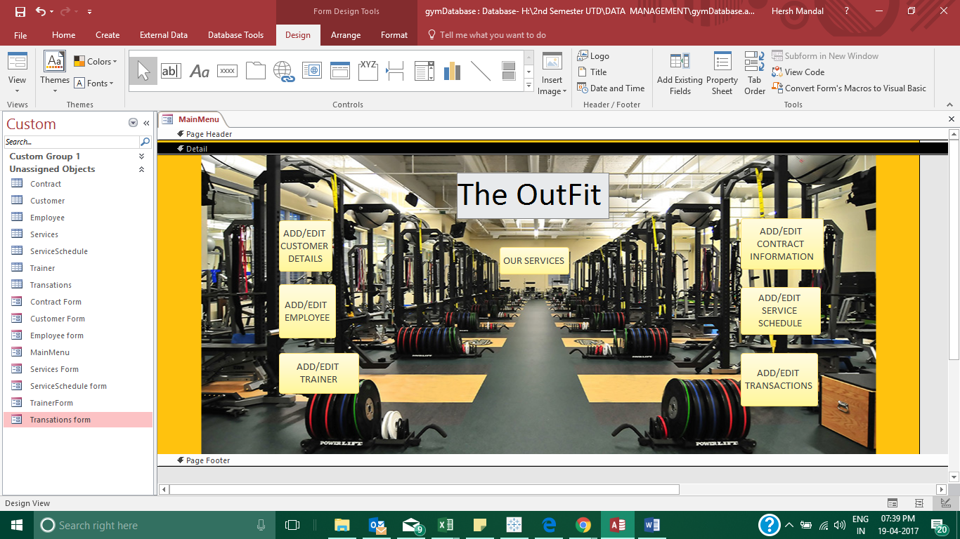

**Customer Form**

This form consists of customer information. Each customer is assigned and identified by a unique number labeled as ID. This form also contains personal information of the customer. This information ranges from their full name, current job, e-mail address, various phone numbers and their address.

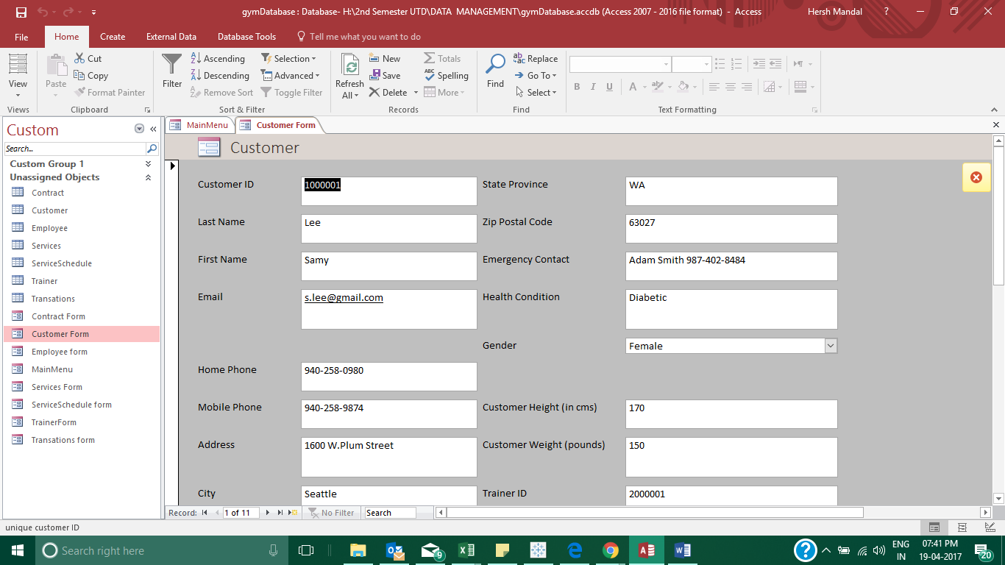

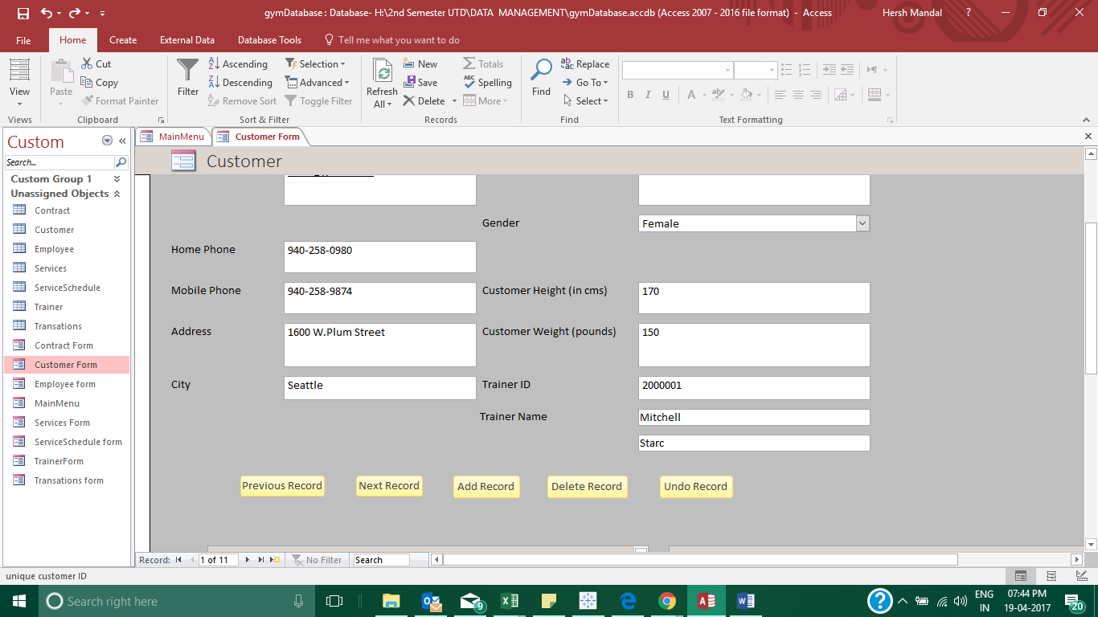

**Customer Sub forms**

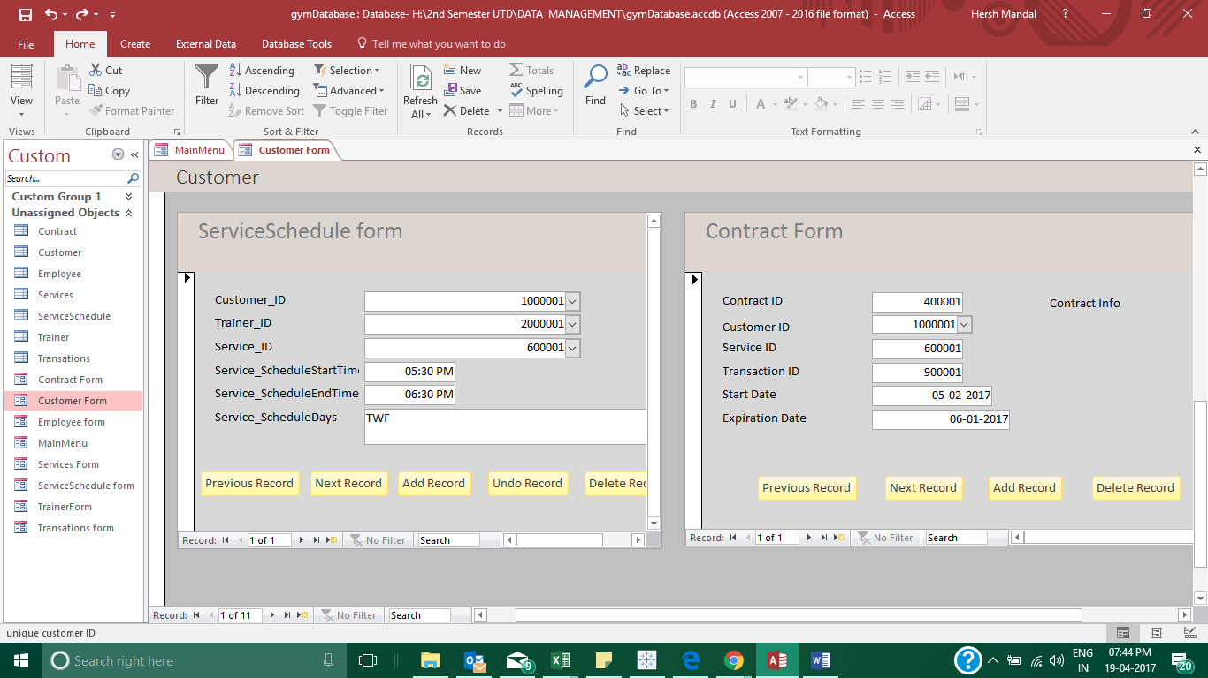

**Employee form: -**

This employee consists of all personal information pertaining to each individual employee employed at The Outfit. Each employee is identified by a unique number labeled as ID. Information ranging from their full name, email address, various phone numbers and address is included in this employee.

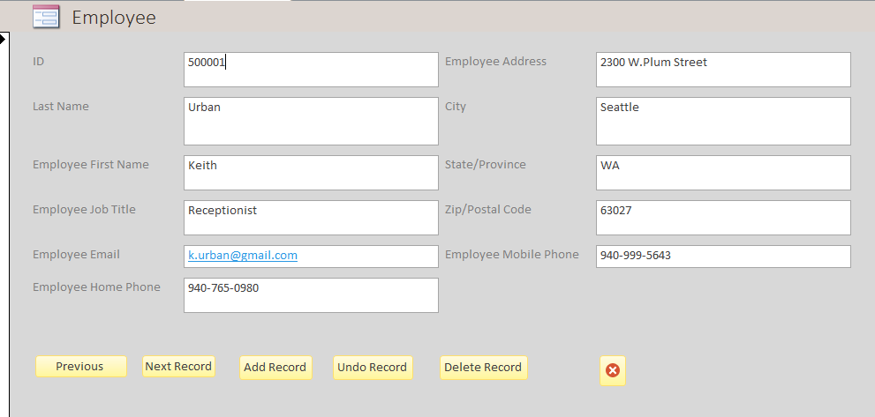

**Trainer form: -**

This form consists of all personal information pertaining to each individual Trainer employed at The Outfit. Each employee is identified by a unique number labeled as ID. Information ranging from their full name, email address, various phone numbers and address is included in this form.

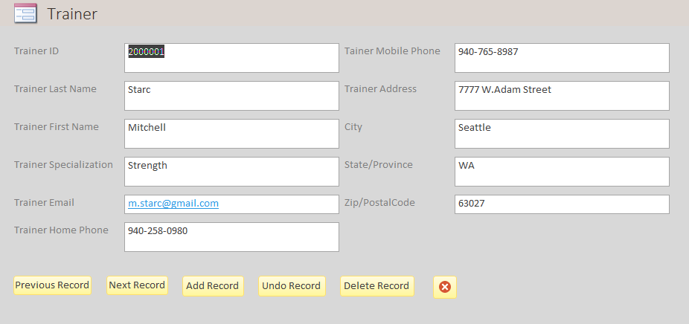

**Services form: -**

This table consists of all information related to the different services and programs provided at The Outfit. Each Service is identified with a unique number labeled as ID. Information included in this table ranges from: Service type or program type, Price and Service Information.

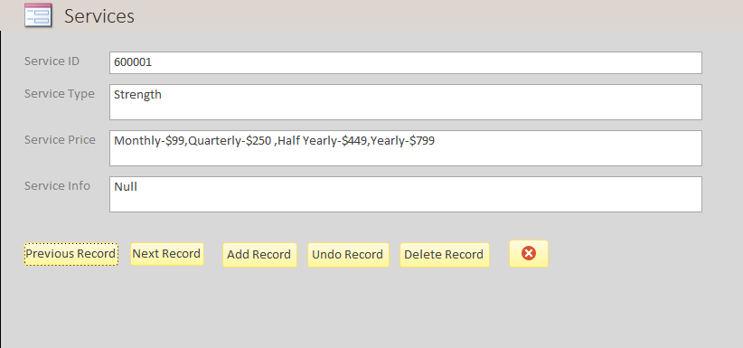

**Contract Form: -**

This form consists of all details pertaining to all contracts made by individual customers. The details for each contract are identified by a unique number labeled as ID. Information like contract start date, expiration date, contract Info and the Customer ID, Service ID, Transaction ID as foreign keys to the Customer Contract.

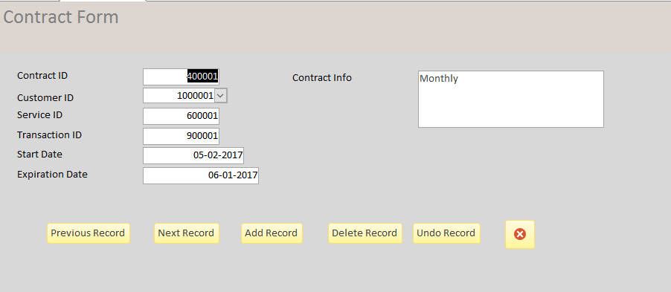

**Service schedule form: -**

This form consists of all information related to the Service Schedule at The Outfit. Each Schedule is identified with a unique number labeled as ID. Information included in this form ranges from: Days of service offered, Start time of service, End time of service, notes for additional comments and we have Customer ID, Service ID, Trainer ID as foreign keys to the Customer Contract.

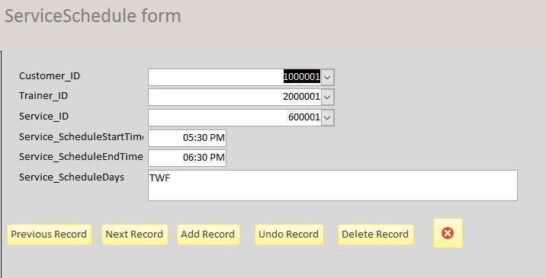

**Transaction: -**

This form consists of various information pertaining to each transation.at The Outfit. Each transaction is identified by a unique number labeled as Order ID. This form also contains various information about each order including: the employee who took the order (Employee ID), the customer who placed the order (Customer ID), transaction date, taxes, payment type, notes related to the transaction.

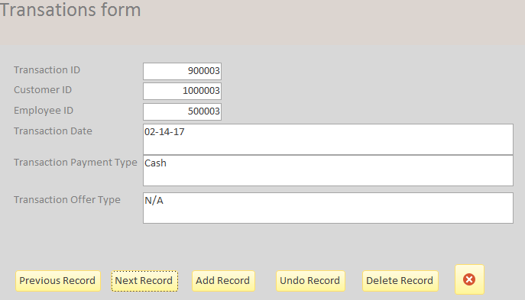

**Report screenshots:**

**CUSTOMER PHONEBOOK REPORT**

We took the details of the customer name, phone details, emergency contact and put them together in one report. This report fetches all the customer contact related details from the database 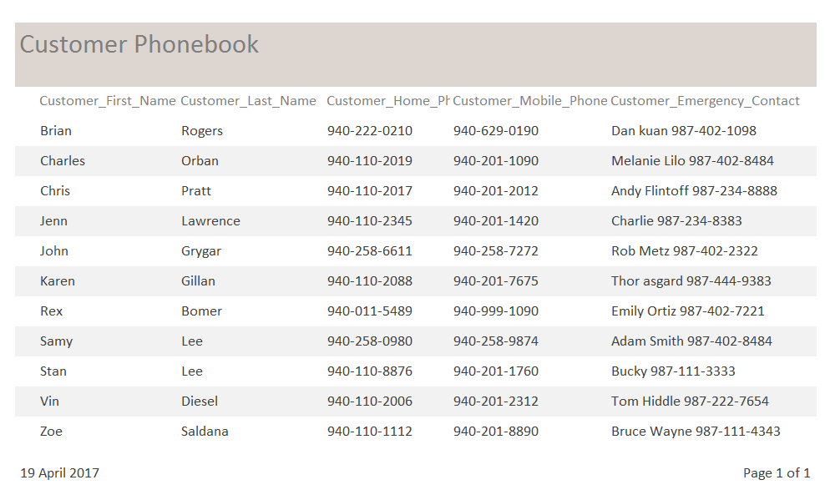

**CUSTOMER CONTRACTS REPORT**

This report fetches the customer contract start date and expiration date from the database and makes it available for instant view. This report gives us information regarding the contract status hence alerting us if their contract has ended with us and need a renewal.

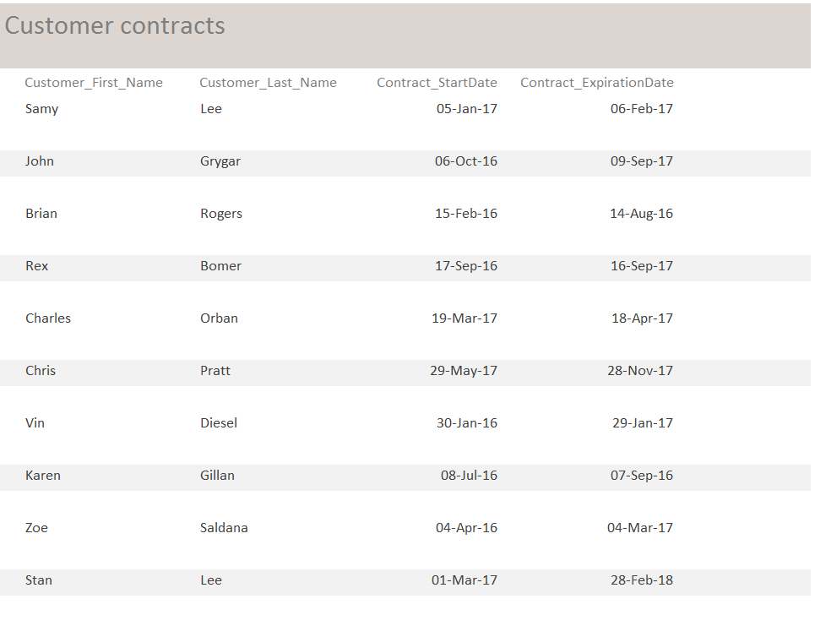

**CUSTOMER LOCATION REPORT**

This report helps us understand and analyses our customer’s location. If many customers concentrate from one particular area, we are planning to open a new a new branch in that area.

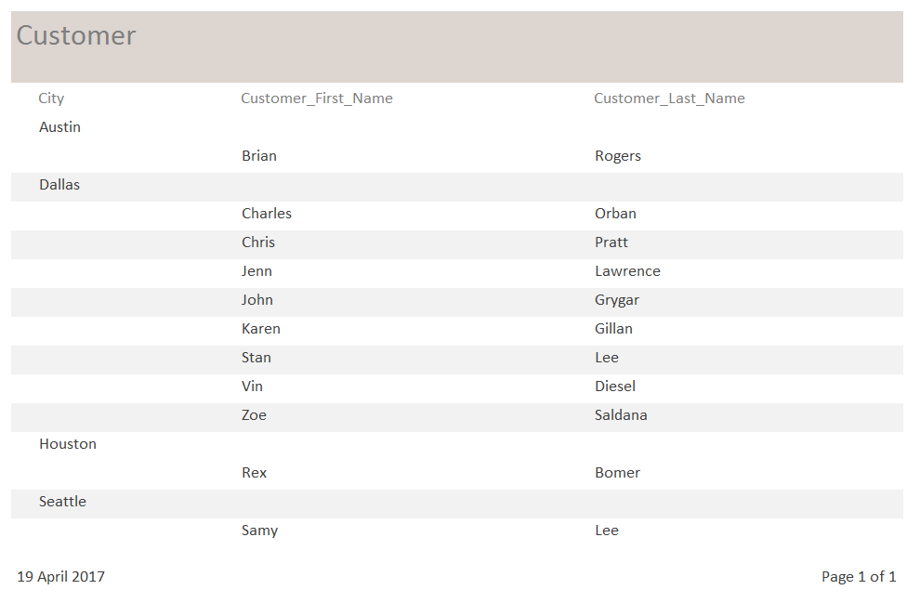

**CUSTOMER SERVICES REPORT**

This report tells us about which gym services are being availed by the customers

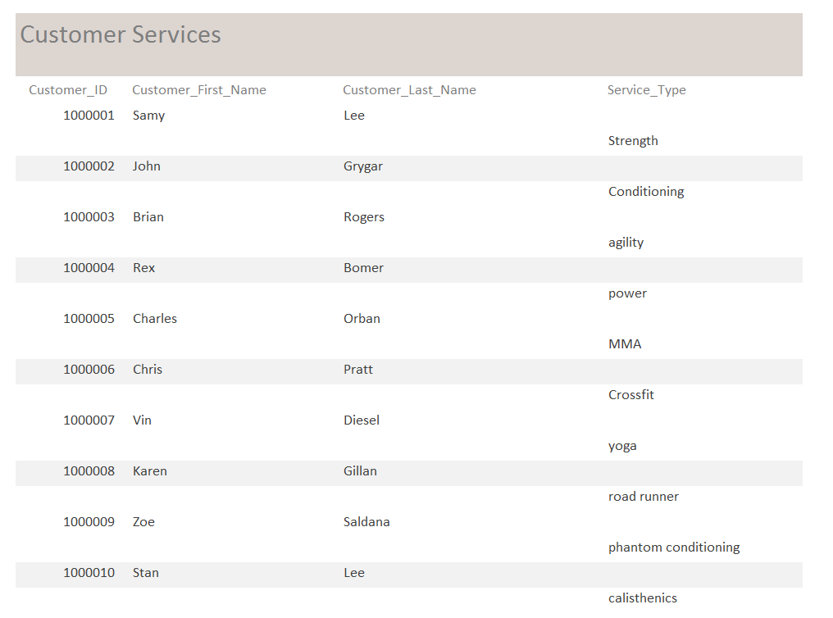

**CUSTOMER-TRAINER REPORT**

This table tells us in detail about which customers are assigned to which trainer

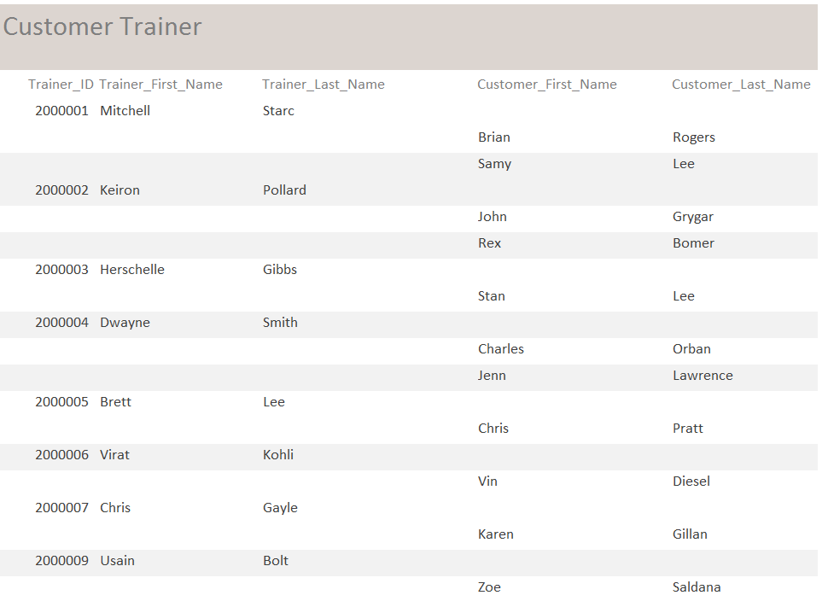

**CUSTOMER TRANSACTION REPORT**

This report tells us about the mode of payment for every customer transactions.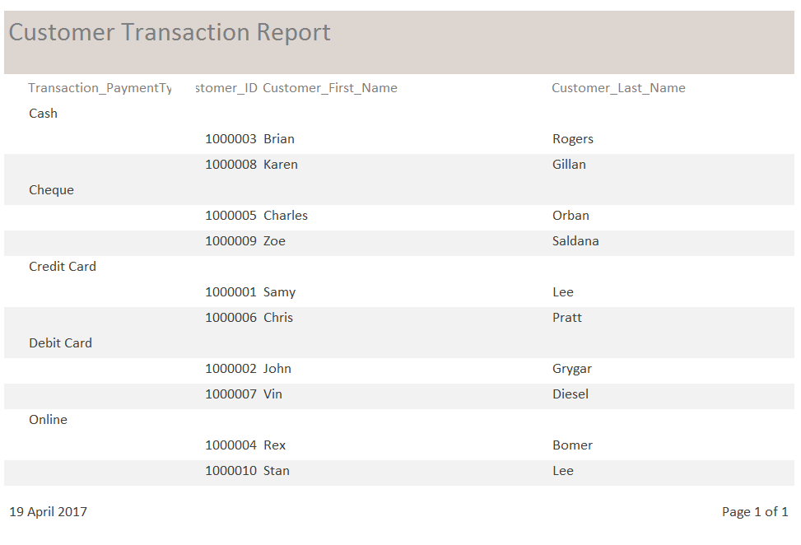

**EMPLOYEE TRANSACTION RECORD**

This record tells us about the transactions handled by each cashier.

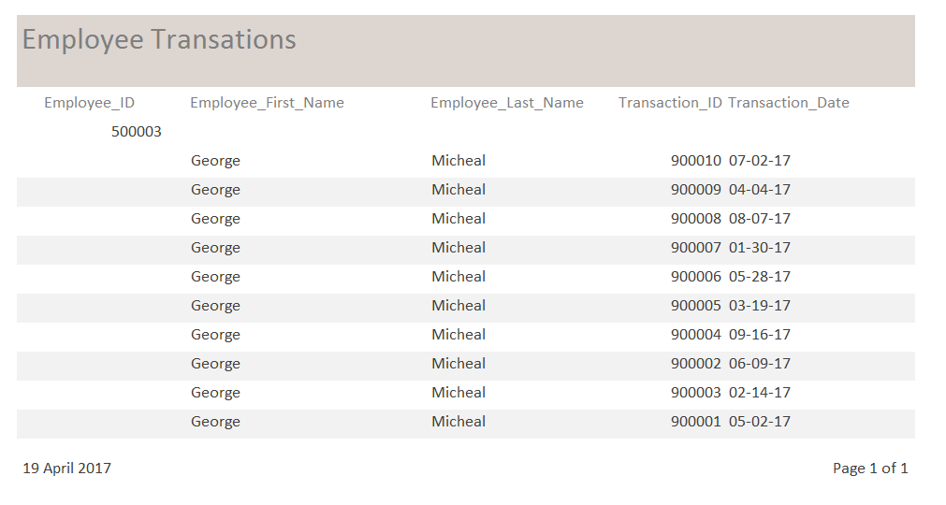

**Contribution Statement**:

Entire team worked together on deciding the tables and relationships for the database. Hersh finalized the ERD. Aditya, Sairam and Lohith inputted the data into the database. Hersh and Lohith created the database in access. Lohith did the Scope of the Database. Aditya and Sairam created the Relational Database Schema. Hersh and Aditya created the Menu Screen. Sairam created reports with help of Hersh. Lohith made the final report document.

## 