Objectives

In these trying times more than ever, being able to keep ourselves healthy and active without leaving the comfort of our homes is essential, although is not always easy. This project might be an additional handy tool for making us momentarily forget the urge to go outside by making our indoor life a little bit more pleasant. RemyTutor is a remote learning platform for anything people might want to teach and transmit to other learning enthusiasts. Ranging from school subjects, like math or history, to more practical things, like yoga or a musical instrument, just find the right teacher and book a lesson!

When it comes to teaching, finding the right person, or even finding someone, can be a challenging task and might often feel like a Russian roulette. Therefore, our goal is to provide an online safe space to bring supply and demand together in a structured way, to ease the flow of teaching and improve its overall quality.

Main functionalities

In order to meet the objectives, RemyTutor comes up with following functionalities:

* Searching the subjects of interest;
* Choosing the teacher based on their rating and price;
* Managing personal profile;
* Talking with each other with chat included in the application;
* Rating a teacher after a lesson;
* Payment from the student to the teacher.

Design choices

Lorem ipsum dolor sit amet, consectetur adipiscing elit. Etiam lacinia scelerisque euismod. Quisque rhoncus feugiat nisl. Pellentesque finibus feugiat tellus. Praesent in sodales lorem, et aliquam elit. Vivamus bibendum in mauris sodales lacinia. Donec et elementum justo. Praesent eget mauris consectetur, luctus massa vel, maximus ipsum. Sed quis quam sit amet magna congue tincidunt. Vivamus vel tortor eros. Nulla massa lacus, maximus quis orci quis, tristique cursus nisl.

Login

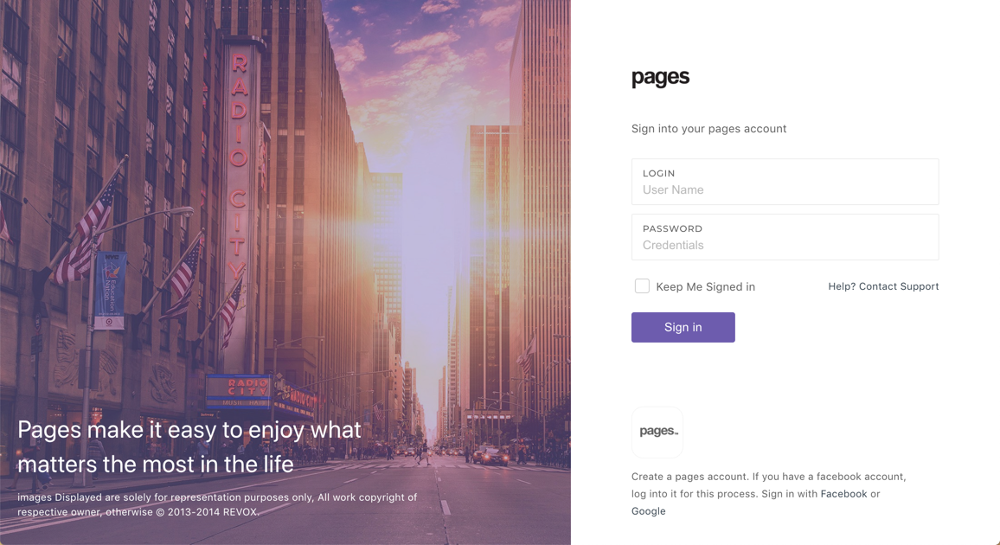

Lorem ipsum dolor sit amet, consectetur adipiscing elit. Etiam lacinia scelerisque euismod. Quisque rhoncus feugiat nisl. Pellentesque finibus feugiat tellus. Praesent in sodales lorem, et aliquam elit. Vivamus bibendum in mauris sodales lacinia. Donec et elementum justo. Praesent eget mauris consectetur, luctus massa vel, maximus ipsum. Sed quis quam sit amet magna congue tincidunt. Vivamus vel tortor eros. Nulla massa lacus, maximus quis orci quis, tristique cursus nisl.



Lorem ipsum dolor sit amet, consectetur adipiscing elit. Etiam lacinia scelerisque euismod. Quisque rhoncus feugiat nisl. Pellentesque finibus feugiat tellus. Praesent in sodales lorem, et aliquam elit. Vivamus bibendum in mauris sodales lacinia. Donec et elementum justo. Praesent eget mauris consectetur, luctus massa vel, maximus ipsum. Sed quis quam sit amet magna congue tincidunt. Vivamus vel tortor eros. Nulla massa lacus, maximus quis orci quis, tristique cursus nisl.

Dashboard

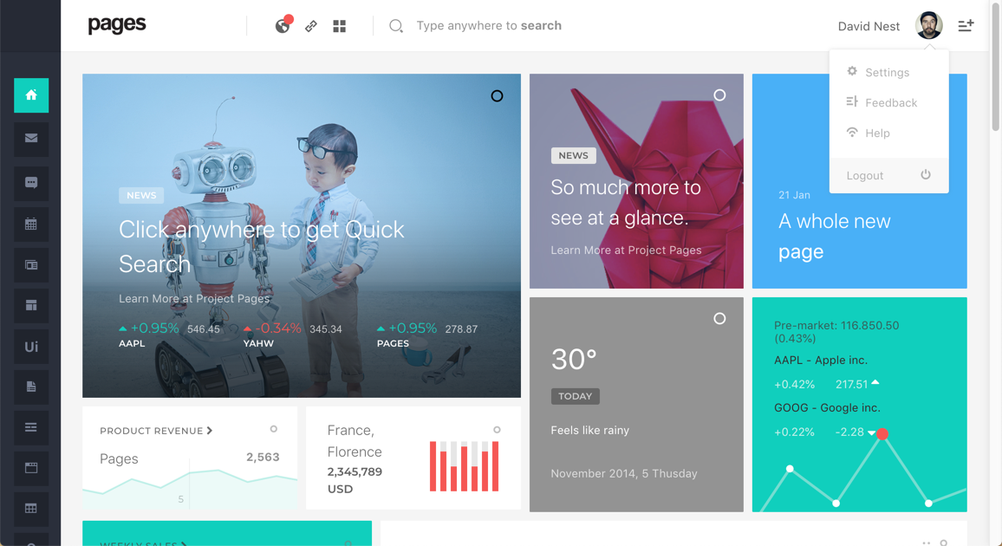

Lorem ipsum dolor sit amet, consectetur adipiscing elit. Etiam lacinia scelerisque euismod. Quisque rhoncus feugiat nisl. Pellentesque finibus feugiat tellus. Praesent in sodales lorem, et aliquam elit. Vivamus bibendum in mauris sodales lacinia. Donec et elementum justo. Praesent eget mauris consectetur, luctus massa vel, maximus ipsum. Sed quis quam sit amet magna congue tincidunt. Vivamus vel tortor eros. Nulla massa lacus, maximus quis orci quis, tristique cursus nisl.



Lorem ipsum dolor sit amet, consectetur adipiscing elit. Etiam lacinia scelerisque euismod. Quisque rhoncus feugiat nisl. Pellentesque finibus feugiat tellus. Praesent in sodales lorem, et aliquam elit. Vivamus bibendum in mauris sodales lacinia. Donec et elementum justo. Praesent eget mauris consectetur, luctus massa vel, maximus ipsum. Sed quis quam sit amet magna congue tincidunt. Vivamus vel tortor eros. Nulla massa lacus, maximus quis orci quis, tristique cursus nisl.



Lorem ipsum dolor sit amet, consectetur adipiscing elit. Etiam lacinia scelerisque euismod. Quisque rhoncus feugiat nisl. Pellentesque finibus feugiat tellus. Praesent in sodales lorem, et aliquam elit. Vivamus bibendum in mauris sodales lacinia. Donec et elementum justo. Praesent eget mauris consectetur, luctus massa vel, maximus ipsum. Sed quis quam sit amet magna congue tincidunt. Vivamus vel tortor eros. Nulla massa lacus, maximus quis orci quis, tristique cursus nisl.

Personal Profile

The profile page provides a complete view about own personal information such as name, surname, gender, birth date, email address and phone number. It includes also other useful information such as profile image, qualification and identity card. Furthermore, all aforementioned information could be updated by the user by filling simple forms or uploading new files. In order to ensure the password strength, the new password should be at least six characters including upper/lowercases and numbers.

On the left side of the page there’s a sidebar which allows user to navigate through the control panel pages.

