1. 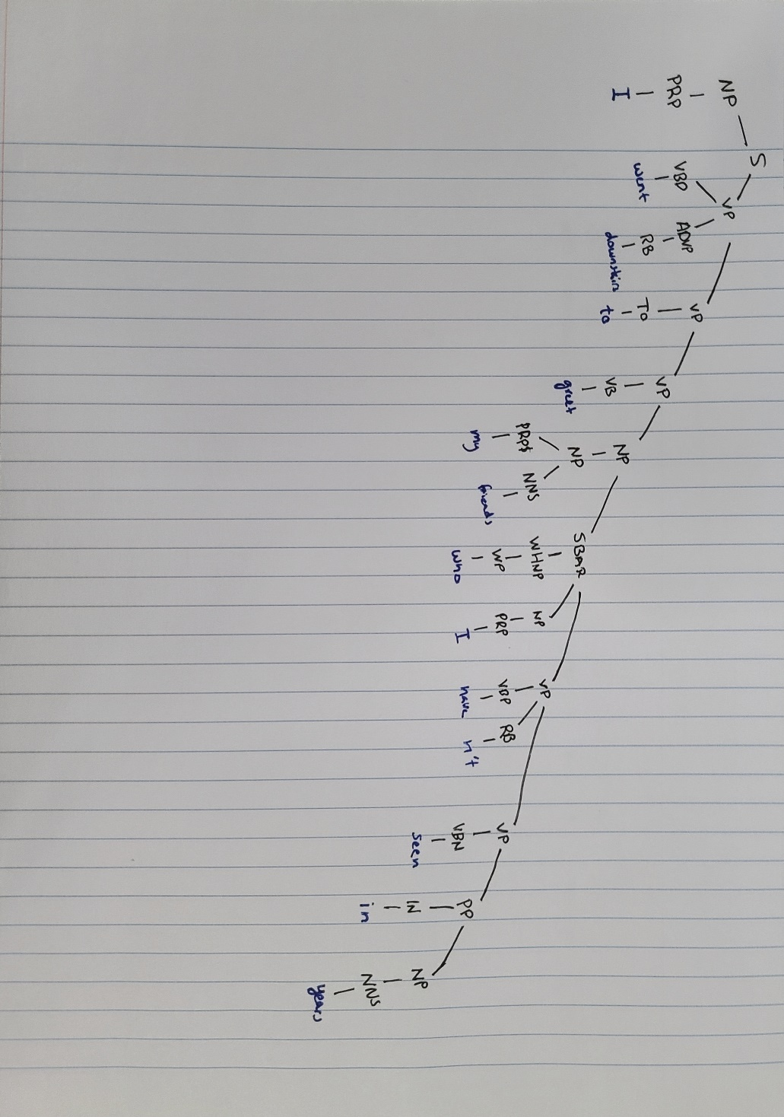The sentence I chose was:

“I went downstairs to greet my friends, who I haven’t seen in years.”

2.

S – A simple declarative clause has a subject and a predicate.

NP – Noun phrase is a phrase that acts as a noun.

PRP – Personal pronouns are a word that we use in place of a noun.

VP – Verb phrase is a phrase that acts as a verb which includes the verb with its linking words.

VBD – Verb past tense, a verb that occurred in the past.

ADVP – Adverb phrase is a phrase that takes the place of an adverb.

RB – Adverbs are words that affect the meaning of verbs, typically ending in -ly.

VB – Verb a word in which an action occurs.

PRP$ - Possessive pronouns are pronouns that convey possession.

NNS – A noun is a word which represents a person, place, or thing.

WHNP – A WH noun phrase is a phrase that takes place of the noun and usually are who, what, where, when, why, or how.

WP – A WH pronoun is a pronoun which takes the place of who, what, where, when, why, or how.

VBP – A verb, non-3rd person is a verb which is non 3rd person and singular.

VBN – A verb past participle is one that takes place in the past.

IN – A preposition which tells you about relative position.

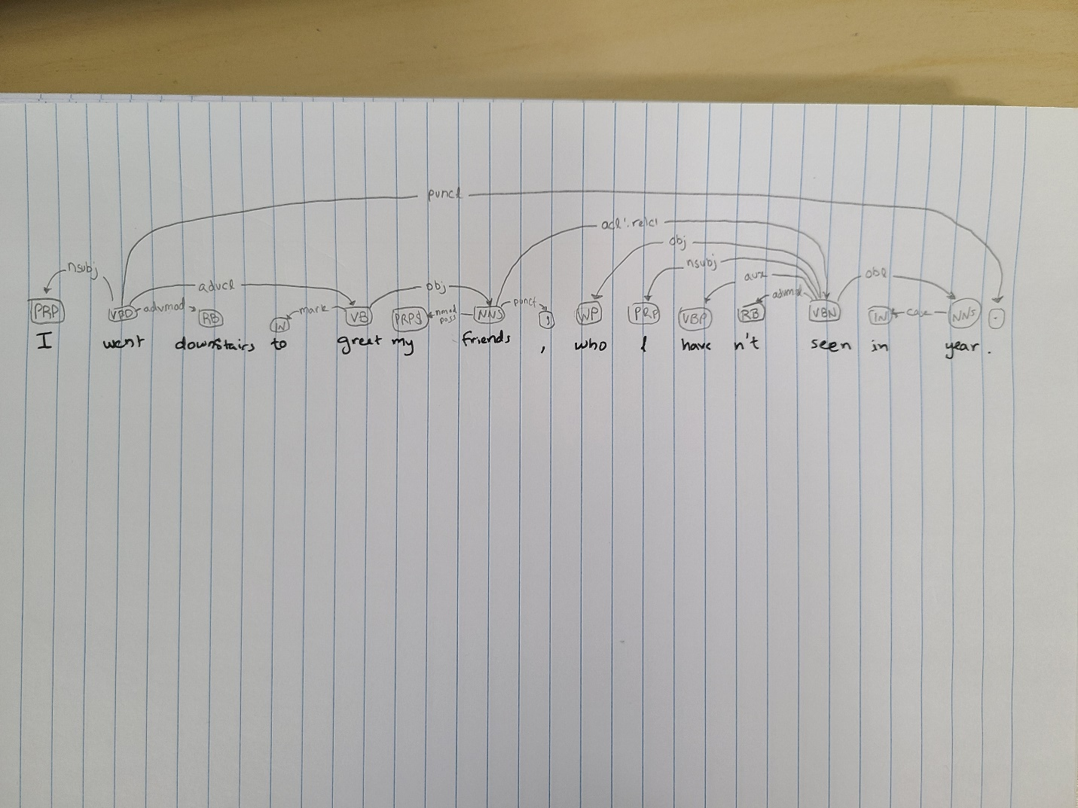3.

Nsubj – A nominal subject is a relation between the verb and subject.

Advmod – An adverbial modifier is a relation an adverb and the verb it modifies.

Advcl – An adverbial clause modifier is a relation between an adverbial clause and the verb it modifies.

Mark – A marker is a relation between two clauses which connects them.

Obj – An object is the relation between the verb and the noun that it’s related to.

Nmod:poss – A possessive nominal modifier is a relation between the noun and the noun it possesses.

Punct – Punctuation is the relation between the clause and its punctuation.

Acl:relcl – Relative clause modifier is the relation between a clause and nominal clause it modifies.

Aux – An auxiliary is a relation between an emotional word and the verb is affects.

Obl – An oblique nominal is the relation between a nominal and the adverbial clause.

Case – A case is a relation between a noun and its preposition.

4.

* For the word “went”
  + The predicate is “went downstairs”
  + Arguments
    - Arg0: “I”
    - Arg4: “downstairs”
  + Modifiers
    - Argm-PRP: “to greet my friends, who I haven’t seen in years”
* For the word “greet”
  + The predicate is “greet my friends, who I haven’t seen in years”
  + Arguments
    - Arg0: “I”
    - Arg1: “my friends, who I haven’t seen in years”
  + Modifiers
    - None
* For the word “have”
  + There is no predicate for “have”
  + Arguments
    - None
  + Modifiers
    - None
* For the word “seen”
  + The predicate is “seen in years”
  + Arguments
    - Arg0: “I”
    - Arg1: “my friends”
    - R-Arg1: “who”
  + Modifiers
    - Argm-NEG: “n’t”
    - Argm-TMP: “in years”

Arg0 - Arg0 is the subject of the sentence it is the noun doing the action.

Arg1 – Arg1 is the passive noun typically the noun having something done to it, like an indirect object.

Arg4 – Arg4 is the ending point for the semantics.

Argm-PRP – Argm-PRP is the modifier which tells us why something is happening.

Argm-NEG: Argm-NEG is the modifier to tell us when we are doing the opposite typically used for words like “not”.

Argm-TMP: Argm-TMP is the modifier which tells us when something is happening.

5.

For constituent parsing one of the biggest pros is that it breaks down the sentences and clauses from the whole down to each individual part of speech. The reason this is helpful is that we can see the greater part of each word. Another pro is that you can see what part of speech everything is which can help with additional analysis. One con is that you can’t really see the relationships between the words, so you can’t tell for example, which verb an adverb is modifying. For dependency parsing, one pro is that you can see the relations between words, so you know which words are affecting one another. Another pro is that you can see the individual parts of speech, so it makes it easier for analysis. One con is that you can’t see the bigger parts of the sentence such as the phrases. For SRL parsing one advantage is that it helps a lot with getting to understand from the sentence in the sense it will help identify what is happening in the sentence and the agents in the scenario. Another pro is that you can frame using each specific verb so you can isolate meaning for different parts of the sentence. One con is that the parts of speech and relationships are not identified so further analysis might be needed on top of SRL parsing.