**AXL – Axial Entertainment Coin White Paper**

**- Contents -**

1. Abstract

2. Vision

3. Background

* 3.1 Market scope
* 3.2 Market issue
  + 3.3 Resolution
  + 3.3.1 AXL Wallet Application

4. Technical feature

* 4.1 Base technology specification
  + 4.1.1 Objective of blockchain technology
  + 4.1.2 Objective & application of the wallet and DAPP
* 4.2 AXL coin wallet platform
  + 4.2.1 Differences from existing platforms
* 4.3 Transaction speed
* 4.4 Database issue
* 4.5 Customer recommendation system using machine learning within DAPP
  + 4.5.1 Description on existing recommendation system
  + 4.5.2 Customer-based contents recommendation of AXL
* 4.6 Ether exchange system
* 4.7 Contents provider
* 4.8 Illegal ticketing prevention solution
* 4.9 Point conversion

5. Distribution plan (Coin issuance)

* 5.1 Coin & management plan
* 5.2 Pre-sales
* 5.3 Fund application plan

6. Team

* Development team
* Advisory

7. Affiliate & affiliation plan

7.1 MOU (e.g.: exchange)

* Current cooperation condition in entertainment business
* Current cooperation condition in sports business
* Current cooperation condition in ticketing business
* Current cooperation condition in exchange business

8. Roadmap

9. License

10. Reference

1. Abstract

Blockchain technology means the opening of decentralized world. Transaction is easy, and there is no regulation. This is the new kind of currency system under the 4th industrial revolution, used in anywhere as the alternative to cash. We can exchange faster through this technology, and can apply this for many fields. Many blockchain project however focuses on the decentralized technology only, and shows several limits in practical use.

Axial Art Coin (hereinafter referred to as AXL Coin) aims to open the new world with firm purpose, while overcoming these limits.

AXL Coin is an ERC-20-based coin, facilitating Ethereum through blockchain assets. AXL Coin is fully dispersed, and guarantees transparency and reliability. Its technology enables things through technology which had been impossible in the past. This will be perfectly used for the way of investment for domestic/foreign pop culture art and performance planning, and the way of consumption for the entertainment markets.

Entertainment Industry Economics (Harold Vogel, 2003) defines the entertainment industry as the cultural activity which brings joy to many people, and which provides related products or service.

The author, Harold Vogel, divided this entertainment industry as a dependent type and a live type. In detail, the former mainly involves media image fields such as movies, music and broadcasting. The latter involves the fields where the entertainment is connected to the specific site, which does not require a tool such as media.

Entertainment industry, becoming the top added value industry in the 21st century, is generally called as the culture contents industry. Within the advanced industry development, each individual is expected to have more interests in intellectual and artistic representation of the future-oriented entertainment industry including theater, movie, music and game, along with the change of perception as seeking quality in his/her life.

Conventional manufacture in the past had been the industry where there was excessive investment cost in the early stage with uniform and standardized production, and where the individual characteristic is ignored. Entertainment industry on the other hand is the high added value industry where the profit is made by fusing one’s desire and another’s capacity to create.

In the ‘strategic view on blockchain’, Boston Consulting Group analyzed that this can be more efficient in reducing the transaction cost compared to existing networks, adding that ‘Coase Therorem’, explaining the transaction cost in economics, can also be applied to the blockchain market.

With this blockchain technology, AXL Coin aims to reduce the unnecessary costs in the entertainment markets, and to resolve many issues within.

2. Vision

AXL Coin, headed with blockchain technology which leads the 4th industrial revolution, engages into comfortable consumption on overall cultural industry contents such as movies, theaters, musical, concerts, songs and sports, while becoming the key currency in consuming all contents above. We have developed the application embedded with distinguished ‘AXL Wallet Application (blockchain payment gateway system)’, with the purpose of protecting the rights of consumers and of increasing the profit ratio. Using this, we introduced AXL Coin as the derivative currency which is comfortable to exchange with the AXL Online Point. Associated products (ticket, album, MD) in the overall entertainment markets are able to be purchased by a discounted price with ease through the application. Moreover, we mean to expand the usage through mobile coupon purchase, and through the crowd funding, which allows official and transparent investment in the entertainment market.

Through the customer-based user-friendly contents recommendation, the customer gets recommendation on the contents chosen by people with similar characteristics to himself or herself. This will lead to further usage and consumption of the contents. Unique contents recommendation algorithm of ABA Lab, based on machine learning, will be applied into this.

This will contribute to enhancing the value of AXL coin, compared to other coins based on other entertainment fields.

This will also lead to the investment criterion for overall development of the culture industry, through investment on performance and planning in the entertainment industry, and through performance and planning for the worldly-renowned pop stars in their Asia tours. Economic system created by AXL Coin will be shared with everyone who contributes its added value. We will make effort in establishing the environment for sustainable growth of this system.

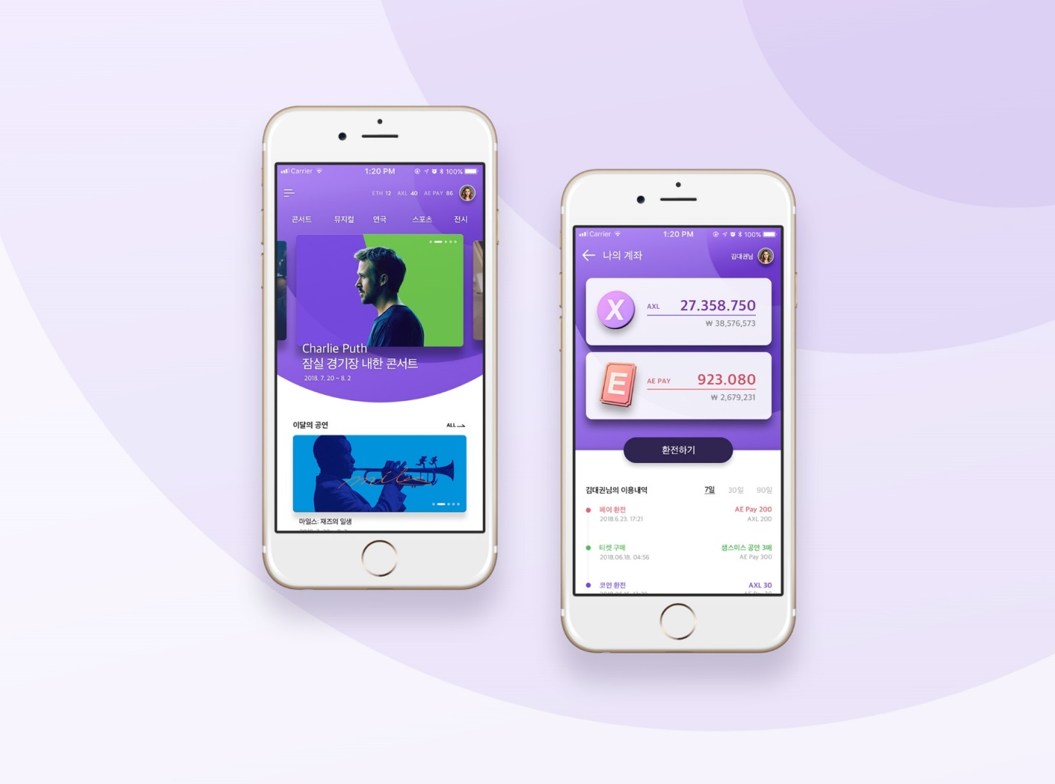‘AXL Wallet Application’, becoming the application platform of AXL Coin under the objectives above, will provide multiple conversion features which involves exchanging many different encrypted currencies and converting them to online points. With transparent and safe payment which is easy to apply toward overall entertainment markets, this includes the function as the ticketing hub which prevents illegal ticket markets, and the tool for contents consumption.

[Application diagram: - application menu]

3. Background

3.1 Market scope

Customers are accustomed to purchasing contents in various fields such as performances, movies, music and sports via digital platform.

Markets for entertainment industries and sports industries worldwide have been sailing with fair wind. Reasons why the entertainment industry is recognized as one of the leading industry fields among other services are as follows:

1. There is a growing tendency of taking more importance in leisure in human lives and of seeking ‘joy’ according to improved economic condition.
2. Since people have begun to work only for 5 weekdays, it is regarded as the ‘blue ocean’ industry.
3. Status of cultural industry, which creates knowledge and information, is getting highlighted due to reinforced protection over intellectual properties. Demand on products from entertainment and sports industries is shown to be rapidly increasing.

* Continuous growth of live performance markets at the moment
* Music consuming culture is being shifted from ‘listening’ to ‘watching’ (idol artists gaining popularity)
* Desire for purchasing visual records is reduced, and it is redirected to watching performances as a different form of need.
* There are more famous pop stars visiting Korea for their performances. Since K-pop is being globalized, Korean artists have more opportunities for the global tours and performance plans.
* Live performance markets worldwide are worth USD 28 billion estimated in 2015. Its CAGR reaches up to 2.7%.
* 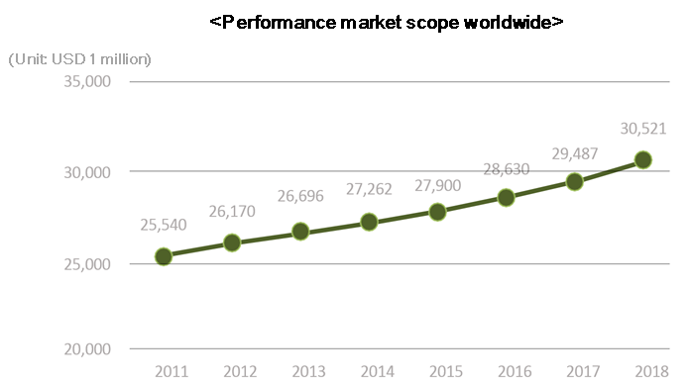Performance industry as the ‘watching music’, providing the value of experience, takes up the major profit in the music industry compared to stagnant records and record markets.

<Figure 1 - Performance market scope worldwide>

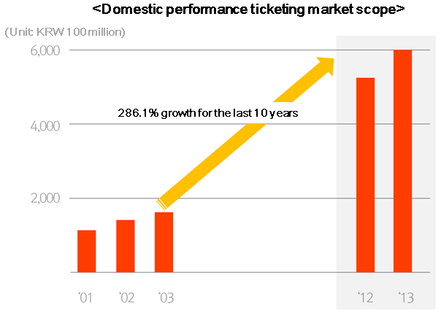

<Figure 2 - Domestic performance ticketing market scope>

* Sports industry market worldwide is in expansion while being fused with different fields such as tourism, fashion, electronics, IT, etc.
* Sports industry market worldwide is growing while being fused with different fields such as tourism, fashion, electronics, IT, etc.
* With more interests and consumption on culture and leisure, the domestic sports industry is one of the high-growth industrial fields with its CAGR of 11.4%.
* Scope of the sports tourism market out of the overall tourism markets is worth USD 600 billion per year, taking up 14% out of the overall tourism markets.
* According to the ‘2015 sports industry white paper’, recently published by Ministry of Culture, Sports and Tourism, the sports industry of Korea is estimated to be worth KRW 43 trillion (in 2015). Korean domestic market has a limited capacity which is about 8% of that of the U.S., however, it is noted that the Korean sports industry has high potential for sure. It explains that “Korean sports industry for the last 5 years has been growing over 5% per year. The number of personnel and companies in the sports industry is also in increase.”
* 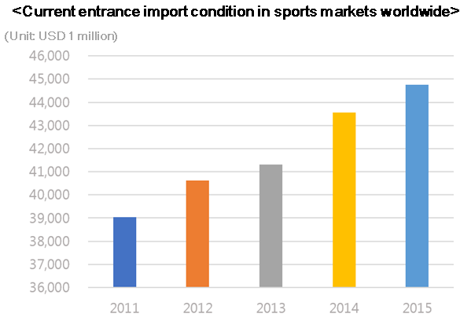KBO, the nation’s most popular sports, is leading the growth of domestic sports industries. 54% of audiences who visited the stadium have seen the other matches also over 5 times. Annual consumption for the audiences is reported to be KRW 340,000 in average.

<Figure 3: Current entrance import condition in sports markets worldwide>

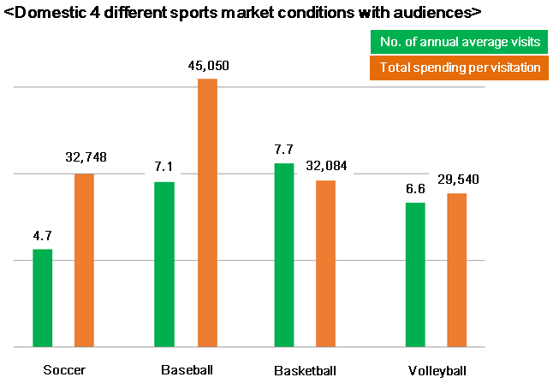<Figure 4: Domestic 4 different sports market condition with audiences>

3.2 Market issue

**Various issues occur on the other side of the entertainment market system.**

* Partial profit distribution between the contents creator and the distribution platform, as well as copyright violation, etc.
* It is described as the ‘Lack of transparency on information’ due to centralization, such as copyright management issues, profit estimation and distribution issues: copyright information leakage, partial profit distribution, late estimation, lack of estimation data.

We believe that the artists have the reason to fairly require their own rights, based on ‘transparent and opened information’. If the artists can directly check the contents usage condition in real time or in a cumulative sense, there could come a society where they receive the right compensation in return.

* Artists have lost the opportunity to focus on creating all along. This works as the opportunity cost for modern people, derived from the centralized information management’. According to the unnecessary spending, there are issues in creating contents with high quality.
* Korea has had some purchase systems only available with Active-X from the Internet Explorer till now, which reduces the desire to consume through complexity in purchase, and frequent errors. There are difficulties from using the separate payment method under different currencies per nation. Currency variation can be tough considering the gaps in exchange rates.
* According to the survey from Stub Hub, the world’s leading ticketing market in June 2017, 61% of respondents have experiences in purchasing tickets illegally. Since the demand and supply are vividly shown online, purchasing the valuable ticket means much more spending compared to the normal price. This threatens both suppliers and consumer in the ticketing market.
* Considering the existing crowd funding with high risk & high return, initial investment cost is high for production. In this condition above, however, fair return on the investment cost becomes potentially risky.

**“What is crowd funding?”**

‘Crowd funding’ stands for: the form in gathering capital from various individual investors, through small-scale sponsorship or investment purpose.

* This has a complex procedure in capital procurement, and there is lack of capital protection solutions for the investors. Crowd funding has an intermediary (business participator) such as central recording institute, investment list management institute, deposition institute, stock firm, etc. Therefore, the investor should take more time in searching the right investment subject, in returning the investment cost through the fair method. Additional cost comes from this accordingly. Also, because there is lack of capacities and performance information of the crowd funding platform companies, aiding the decision-making process of the investors, opportunities in investment, and in entertainment industry development are reduced.

The reason why this blockchain has more interests attracted, which are showing excellent performance in enhancing reliability and transparency of digital transaction in recent entertainment industries, is because it can have a solution of activating further investment in the entertainment market, against: partial profit distribution in the contents industry, copyright violation, participation issues of global fans due to language difference, separate payment methods, market distortion by illegal ticket sellers, etc.

3.3 Resolution

**Solution to the issues: AXL Wallet Application**

“This has the user-friendly interface based on decentralized blockchain, and also enables entertainment investment with the payment method through PG (payment gateway) of impartial and transparent AXL coin. It further provides purchase service on entertainment/sports market contents, and on associated products. It conducts as the peer-to-peer platform, without irrational intermediary commission system.”

* + - AXL Wallet Application

“This is the integrated entertainment platform service, which supplements the issues in existing entertainment markets, and provides all the related services required by consumers, producers and creators in the culture contents market such as performance, sports, movies and exhibitions, into AXL.”

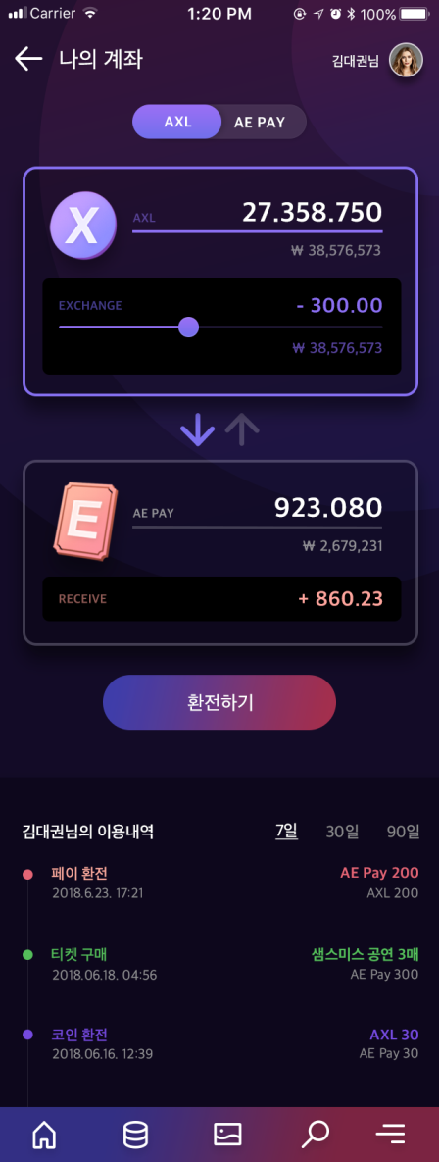

<Figure 5 - AXL Wallet Application web/application image>

**Entertainment market formation based on transparent data disclosure**

AXL Wallet Application does not need the ticketing intermediary or the exchange, which worked as complexity in existing payment procedures. It resolves partial profit distribution and copyright violation issues between the contents creator and the distribution platform, using the transparent transaction verification through the smart contract out of blockchain technology. AXL Wallet Application is also in multiple languages, which lowers the entry barriers against the global fans, and which enables smooth interaction.

**Service cost reduction according to payment system integration**

Through the payment system using PG (payment gateway) of impartial and transparent AXL, the process is easier and simpler, while satisfying desire to consume. It further works as the solution against: exchange rate commission due to different currency values per nation, and foreign-exchange loss of more than 8% according to the exchange rate differences.

Ticketing process in AXL Wallet Application is through the smart contract, and the blockchain technology records every step, so that the ticket cannot have a higher price or cannot be sold illegally. Since the price change is impossible, profit from the ticket therefore solely goes to the artist and the producer. Consumer also prevents unnecessary spending from illegal/expedient ticketing.

**Resolution of crowd funding, using ‘AXL Wallet Application’**

<Characteristics of AXL Wallet Application crowd funding>

1. Entertainment contents investment with high investment entry barrier for common people, can be conducted without having risks through AXL coin.
2. It enables immediate estimation on investment profit, after completing the prioritized ticket reservation and related projects on created contents.
3. Investment return can be maximized, without spending further cost for intermediary commission and estimation.

* Improvement against complexity and inconvenience from crowd funding investment procedures
* Intermediary no longer exists, and the related cost is reduced. Simplified procedures resolve inconvenience.
* Payment is simplified through AXL coin, which makes improvement against complexity and inconvenience.
* Information disclosure based on technology
* There is no intermediary intervention through blockchain distribution ledger technology. Every transaction record is transparently disclosed. Funding reliability is improved through real time estimation.
* Intermediary no longer exists, and the related cost is reduced.
* Crowd funding through the smart contract
* Automatic transfer can be set, so that the contract is fulfilled without having trouble once the contract condition is met.
* Investor’s capital can be protected, since the capital is not shifted without meeting the condition.
* Profit distribution process is simplified, due to no additional cost for monitoring, conducting and estimating the contract.

4. Technical feature

4.1 Base technology specification

* 4.1.1 Objective of blockchain technology

Currently, blockchain technology has passed the ‘blockchain 1.0 era’ along with Bitcoin (initial stage with a simple listing function which recorded movement of goods), and the ‘blockchain 2.0 era’ along with Ethereum (development stage which presented various types of platforms and associated potential using the smart contract). It now desires the hyper-connected society, the keyword for the 4th industrial revolution, by connecting multiple data and contents to blockchain technology with various methods. ‘Blockchain 3.0 era’ is coming, where the high performance and high efficiency blockchain technology is in propagation and acceleration, aiming to improve competitiveness in all industries.

Major features of blockchain technology are decentralization, based on agreements. This is for information security, saved but not subject to certain government or organizations.

Encrypted currency is a certain kind of saved information. This based on blockchain technology does not have any border, compared to legal currencies per nation at the moment. Cost to secure and maintain the system is remarkably low.

It is relatively transparent in transaction, regarding the private or systematic unethical issues likely to occur in existing centralized currency management (bank transaction, financial transaction such as stock).

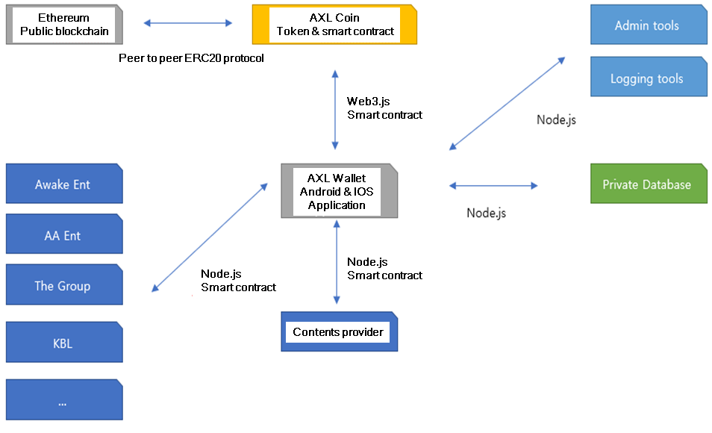

[Platform diagram]

4.1.2 Objective & application of the wallet and DAPP

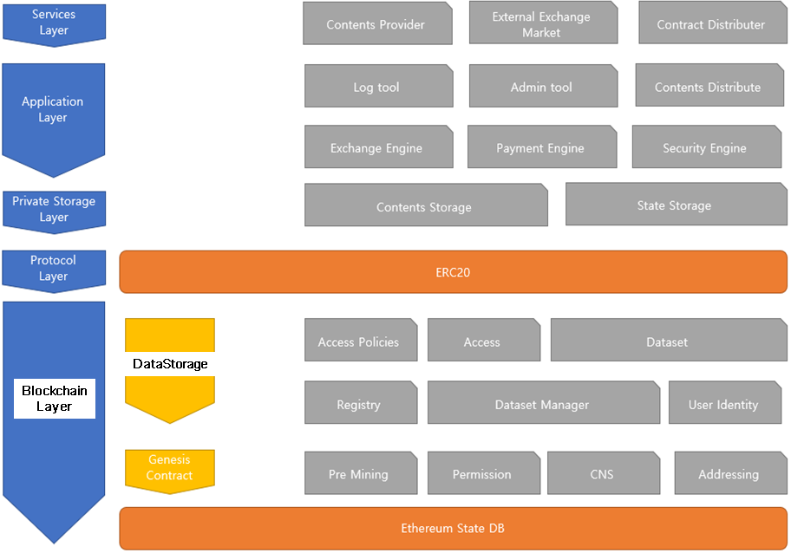

[Application layer diagram]

AXL Coin Wallet is provided as an all-in-one application, with its advantages in usability and security.

Application, operating both in Android and iOS system, prepares and transmits the contract between users and supports synchronized account management through blockchain technology.

Contents are purchased through the prepared contract in advance, and further flexible payment environment is provided through exchanging them with other forms of tokens.

Management tool and log tool are provided also for the contents provider. User shares the interface with limited access.

This will support the contents provider with fair opportunities, and the consumer with compensation, leading to enhanced supply & demand chain.

Private Storage Chain is formed with high usability to make them happen. Application engages its communication through the tunneling channel. All the channels will be covered by the cloud proxy layer, and it will have a high level of response latency anywhere in the world.

4.2 AXL coin wallet platform

* 4.2.1 Differences from existing platforms

Existing coin exchange wallets are generally used for transferring cash, however, it is very dangerous to participate into ICO or to connect to other smart contracts using this coin exchange wallets. Wallets for transfer are likely to be the randomly facilitated by the coin exchange, not to have the personal wallet address. Virtual currencies may be lost if used in the application requiring the control with personal keys. Different from this coin exchange wallet issue, difficult to facilitate except simple transfer, AXL Wallet Application provides the AXL Wallet service optimized through real time P2P (peer to peer) transaction in value exchange (AXL Online Point exchange, exchanges with other virtual currencies), overall contents application in entertainment/sports fields, security and convenience enabling crowd funding service, etc.

4.3 Transaction speed

* Transaction speed is becoming a major issue in the platforms based on Ethereum at the moment. Higher transaction speed leads to lack of security. Higher security leads to reducing transaction speed.
* In case of existing mining systems, block difficulty is lowered to improve transaction speed, which only benefits the specific miners with high computing capacity. AXL Coin is 100% pre-mined on the other hand, leading to fast transaction speed while having no issues above.
* Existing Ethereum controls difficulty and the block size, and sets its objective as 12 seconds (practically about 15 seconds). AXL sets its objective of block creation time as 10 seconds, seeking both transaction speed and difficulty control.

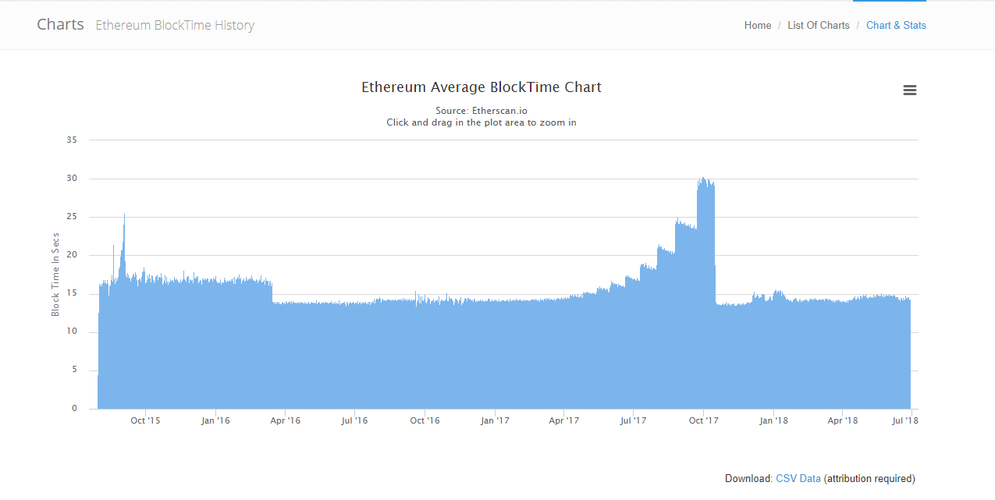

<Ethereum Average Blocktime Chart, 2nd of July, 2018>

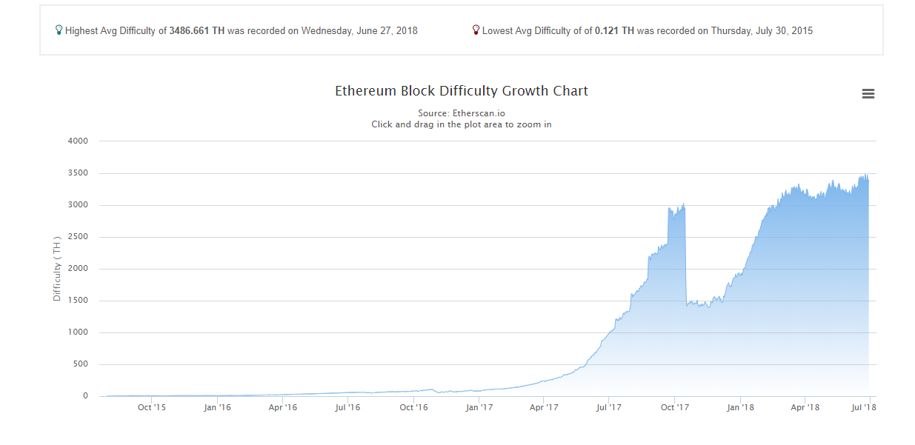

<Ethereum Block Difficulty Chart. 2nd of July, 2018>

4.4 Database issue

* Many Ethereum-based coins and tokens at the moment use the Level Database. This is the database with a simple and short non-SQA type, broadly used in many fields with advantages. Limits of it however are seen clear.
* More block data results in more time taken for searching and creating data. Performance itself gets inefficient accordingly.
* AXL Coin Core forms the specialized database by modifying the existing database, and applies Rocks Database for further application and performance development.
* This will be facilitated as the unique system of ABA Lab only, which enhances the block searching speed and data creating speed, and which enables quick response against the abnormal user attack.

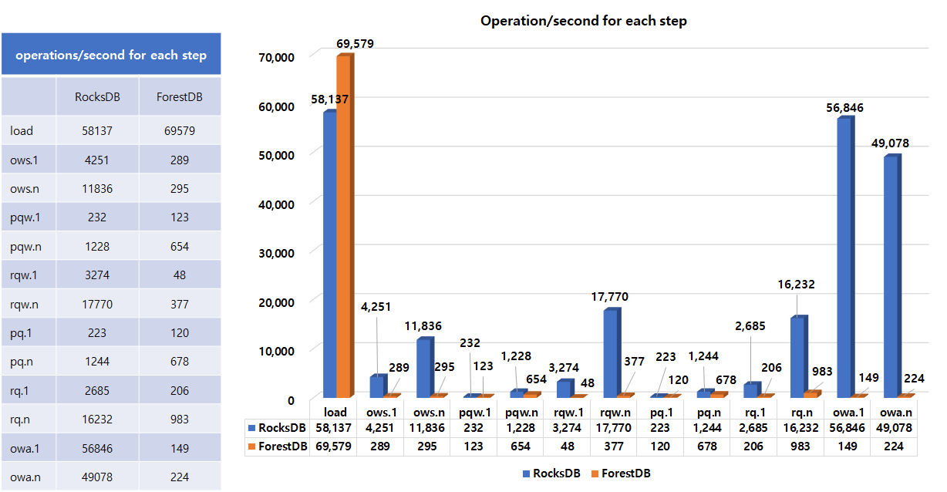

<Performance comparison between Forest DB and Rocks DB>

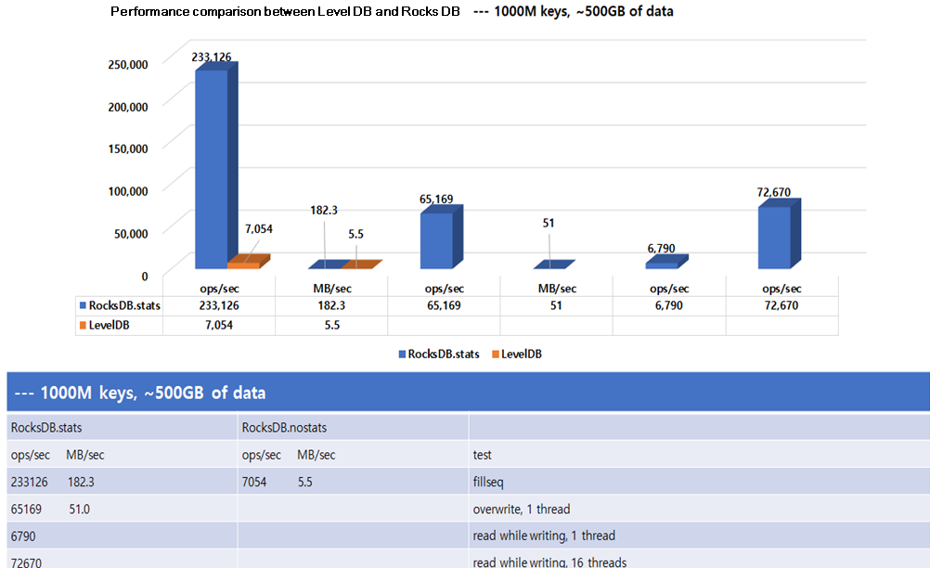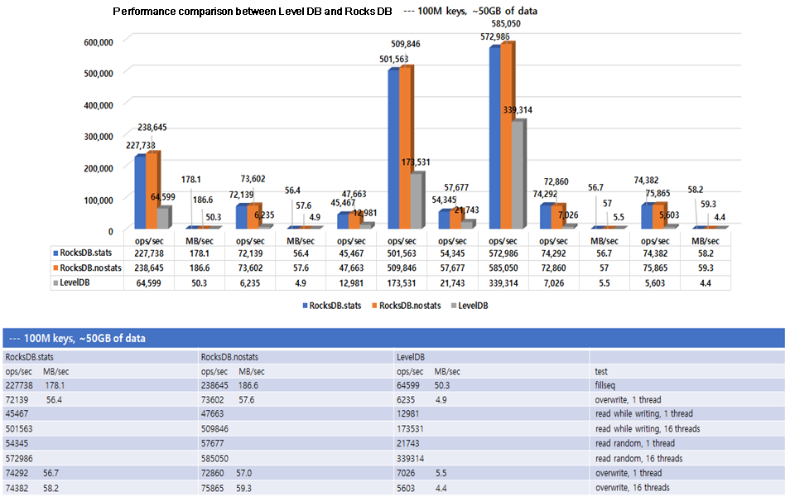

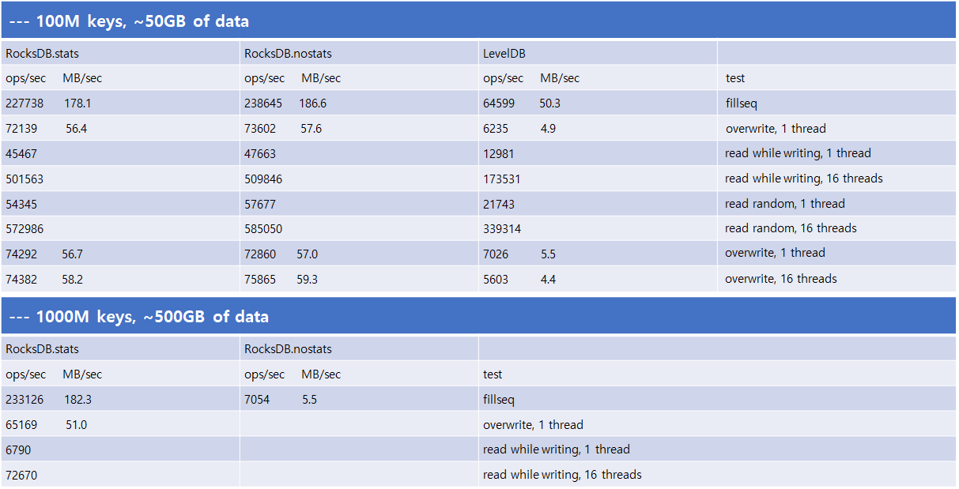

<Performance comparison between Level DB and Rocks DB>

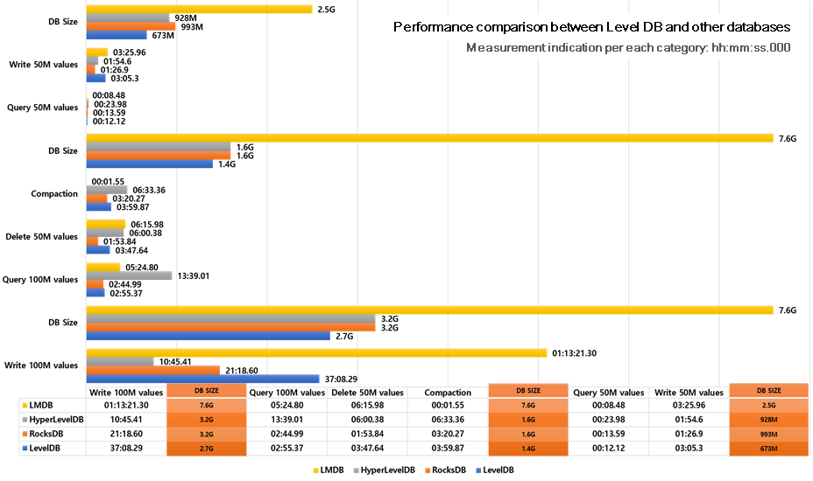

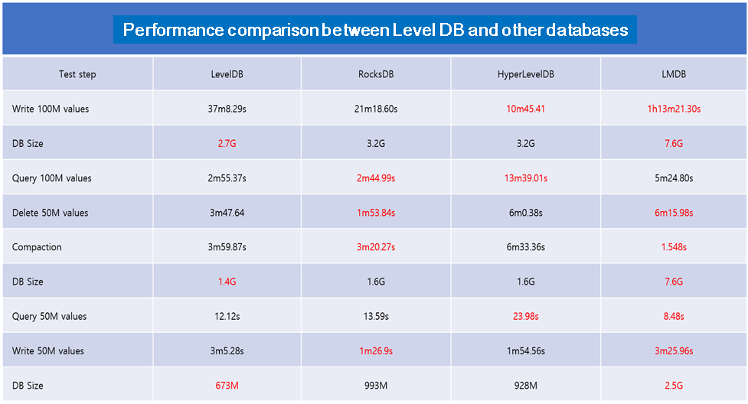<Performance comparison between Level DB and other databases>

4.5 Customer recommendation system using machine learning within DAPP

* AXL Wallet Application provides various contents associating entertainment and sports contents with blockchain technology. Value of AXL Coin will be further enhanced by analyzing the pattern of other users who have similar characteristics with the customer, and by recommending various contents which could be interested to the customer.
* Recommendation algorithm, which considers the preferences of people cheering for the same team, same record, same performance and sports, will show the difference between AXL Coin and other existing blockchain coins based on entertainment fields.
* Recommendation algorithm is applied based on machine learning, the essential part for this recommendation system. This applies the system that analyzes patterns of various users and makes further recommendation.
* 4.5.1 Description on existing recommendation system
* Collaborative filtering
  + - This is the algorithm of creating one decision-making entity by integrating the common group out of the selections made by the customer (performance, record, sports team). This is one of the basic algorithms based on recommendation.
* 4.5.2 Customer-based contents recommendation of AXL
* Machine learning algorithm is applied based on preferences of producers and actors/actresses, not based on the simple sampling from existing performance selectors using the Pearson correlation coefficient and category-based filtering. This is used in a variety of contents businesses (Netflix, Watcha), favored as the advanced method compared to existing simple recommendation methods.
* This applies the algorithm which used the part grouping based on users with similar characteristics also. Contents will be recommended more precisely, while understanding each user characteristic.

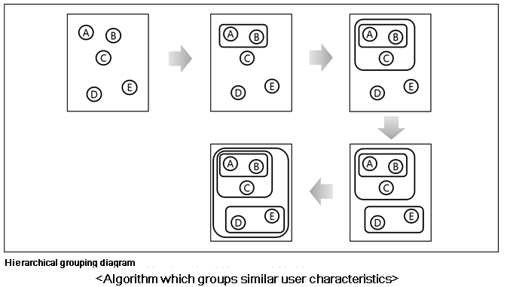

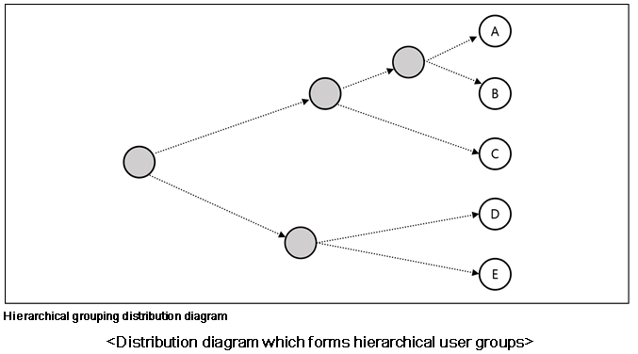

* This will group and segregate entertainment information from various fields involving performance producers, actors/actresses and sports teams, differentiated from other recommendation systems. This will be applied in improving the added value, through its recommendation contents fit to user preference.

4.6 Ether exchange system

AXL Wallet exceeds the boundary of facilitating AXL Coin, but is used as a tool for cultural contents consumption and application.

To play this role as the consumption hub, we provide an online wallet function for other encrypted currencies and an exchange function for other encrypted currencies, different from AXL Coin.

This will lead to wide flexibility, distinguished from other existing currencies.

Since AE PAY only supports AXL Coin and AXL Online Point, we can have an additional effect of inducing the other coins to be converted to AXL Coin.

Enhanced security measures will be included according to the scheduled roadmap. Through using AXL Wallet Application, we will make quick responses to newly brought up security-related issues.

AXL Wallet will have high priority in this AXL Wallet Application market due to these, which is currently dispersed throughout different media. This will provide motivation to use AXL Wallet Application, and to have AXL Coin, even to the users who do not own AXL Coin at the moment.

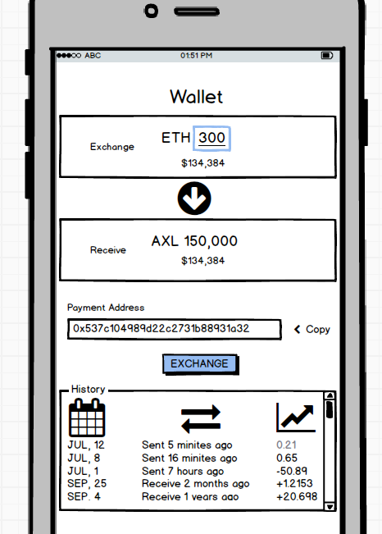

[Exchange system example diagram]

4.7 Contents provider

Most of the contents provision at the moment is through agencies.

Major-scale distribution agencies exist, with formidable market dominance in each record distribution field, performance distribution field and sports contents distribution field. This is natural and comfortable in a way, but causes numerous side effects.

Agencies have too much influence, and the actual contents provider stands not in an equal position but in certain lower hierarchy, sometimes with unfair treatment. Agencies are able to intentionally select the priority of distribution, and also are able to reduce the provided contents with less influence.

AXL Coin means to improve this irrational structure and to expand the cultural contents consumption field. AXL Wallet, the former stage for AE PAY facilitating AXL Coin and AXL Online Point, provides the user experience fit to the contents providers.

AXL Wallet is developed as a platform which consumers and both creators of the contents can share within. Creator can be released from the excessive commission cost pressure, as well as from being subjected to contents provision platforms per nation, which has been pointed out as the main issue for existing platforms. This will further provide fair and advantageous opportunities towards both creators and consumers.

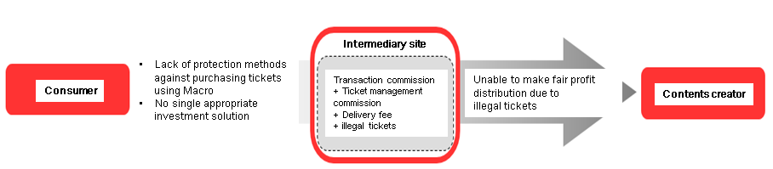

[Diagram for existing subjected contents provision platform]

4.8 Illegal ticketing prevention solution

Through blockchain technology difficult to forge or falsify, under multiple performers, we provide the solution for eradicating illegal tickets and massive sweeping of certain groups.

Ticket purchase is through the smart contract, and its details are recorded into blockchain.

Ticket of the buyer is issued as the encrypted ticket through AXL Wallet Application right before the performance begins, and this in principle prevents the reselling of the ticket.

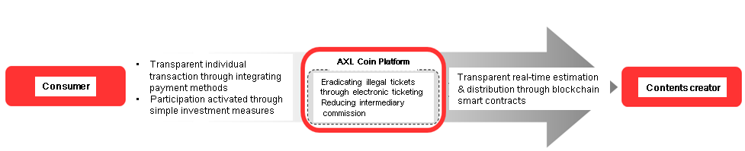

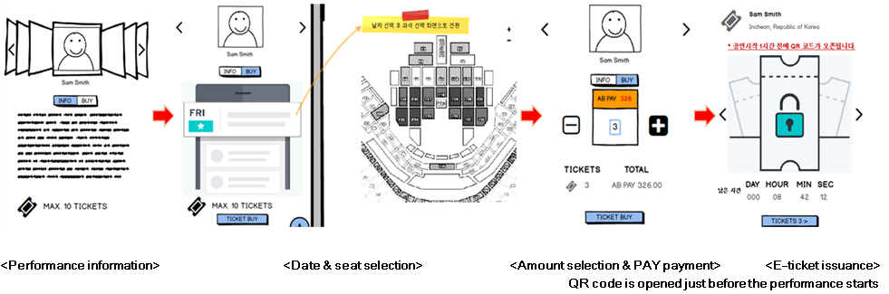

[AXL ticketing process diagram & E-ticket]

4.9 Point conversion

Decentralization is a crucial factor to the encrypted currency, and is one of the biggest differences compared to existing payment methods. Encrypted currency has improved shortages of existing payment methods, with high development potential, however, there are still some issues from the encrypted currency which are unsolved yet.

Part of them is practically unable to be resolved in a short term.

1. Most of the providers accept conventional legal currencies only.

This is associated with other issues also, and can be broadly interpreted as the results of them, too. Encrypted currencies are yet used in convenience stores, in well-known online shopping malls and in car sales markets. This will be gradually resolved nevertheless, no one can be sure if the encrypted currencies would earn its usability as much as the legal currencies.

There are various kinds of encrypted currencies, and their values vary with substantial gaps. This gives the reason why the service and product providers, currently operating the existing payment system, do not facilitate the encrypted currencies as their next payment method. AXL Coin focused on the culture business fields, and partly overcame this issue.

1. Longer transaction confirmation time compared to legal currencies

Many encrypted currencies have been putting their efforts in reducing transaction time competitively. We aim to develop AXL Coin for making it possible in practical use.

In a realistic sense, it is not a good strategy to develop the encrypted currency to have an equivalent or exceeding level over centralized payment systems and cash transaction confirmation time at the moment. This also has many parts against decentralization, and against the decision-making process under participation of many.

We might have to make sacrifice on security which is a much more valuable factor, if we aim to reduce the confirmation steps or to establish a certain reliable network itself, with the purpose of competing against the existing systems where a single confirmation step is enough to approve the transaction in also a single centralized system.

1. Commission system disadvantageous to micropayment

Conventional commission system, generally exposed proportional to the price, is direct and looks fair, and that is what we are accustomed to.

Commission system for the encrypted currencies however is determined proportional to system resource consumption and priority. Therefore, it is complex, difficult to predict, and not familiar.

This is designed for compensation to nodes conducting transactions and for reinforcing security. This is fair to the participating nodes however is very unfair from the user’s point of view in micropayment.

‘AXL Wallet Application’ is to actively resolve this issue above. As the transitional buffer, we use AXL Online Point which is controlled by the central server.

AXL Coin is linked with its value in real time and can be exchanged with AXL Online Point back and forth. To supplement relatively lower security, AXL Online Point has a retention limit. Self-locking device will be additionally provided.

This is apparently against the value for decentralization however, it is regarded as the transitional measure for supplementing the technology limit at the moment.

Transaction with AXL Online Point, converted from AXL Coin, does not have any commission, while having the equivalent value with legal currencies. The maximum number of transactions conducted per second reaches to millions. AXL Online Point will be used as the supplementary currency to AE PAY, providing a better user environment in micropayment and in quick ticket purchase, etc.

5. Distribution plan (Coin issuance)

* 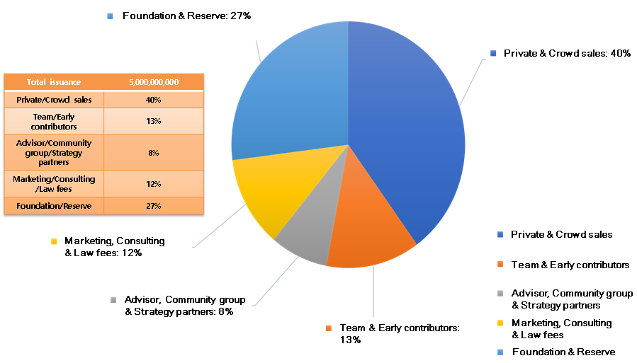5.1 Coin distribution & management plan
* 5.2 Pre-sales plan

1st round pre-sales: July 2018

2nd round pre-sales: August 2018

ICO: September 2018

(Above schedules can be modified.)

* 5.3 Fund application plan

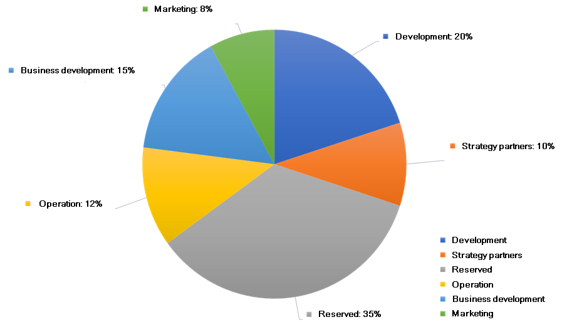

6. Team

* Development team
* Advisory

7. Affiliate & affiliation plan

* 7.1 MOU (e.g.: exchange)
* HONGKONG NINECOIN Crypto Exchange MOU
* MNU Inc. COIN25 P2P Exchange, COIN25EX Exchange MOU
* THE GROUP Marketing Agency Inc. MOU
* Girl’s Generation SEO HYUN Fan meeting performance concert in THAILAND
* Convention on the joint distribution of entertainers in CHUGYE Arts University
* SAE SUNG Inc. Sae Chong Premium Mall P4 Place M&A, MOU
  + KOREA SAMBO ASSOCIATION, RUSSIA M1GROUP MOU / CONDITIONS

1. Global real time relay broadcast and AD promotion

A total of eight countries besides Russia, China, Japan and

South Korea currently under agreement)

2. Host domestic M1 championships and overseas championships

3. AXL Coin Payment for the ticketing of championship

4. AXL Coin promotion for members and visitors of the association

Other agreements

Distribution agreement of AXL Coin to Russia Crypto Exchange

8. Roadmap

2018 1Q - ABA LAB established, its master plan presented

2018 2Q - AXL Coin launched, private sales, Wallet Application 1.0 presented

2018 3Q – AXL White Paper 1.0 presented, Pre-sale, ICO

2018 4Q – Wallet Application 2.0 presented (Biometric authentication, machine learning, ticketing, security reinforcement), ICO, exchange contents Database modification applied & verification conducted (Level DB -> Rocks DB)

2019 1Q – AE PAY presentation, Main network launch preparation & system stabilization verification conducted

2019 2Q – Main network launched (Expected)

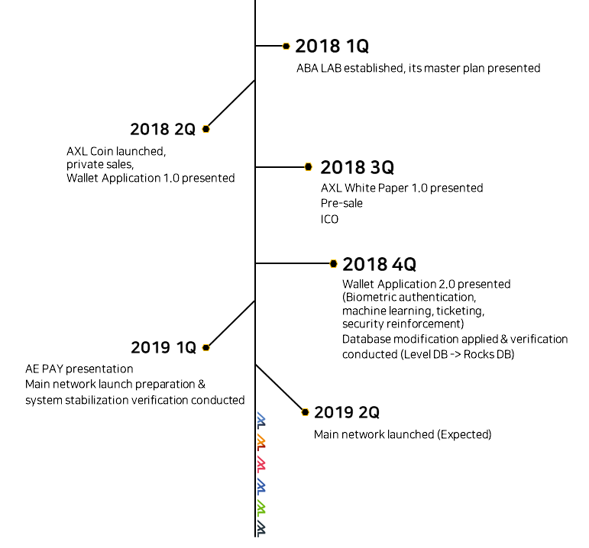

9. License

* LGPL V2.0 (https://www.gnu.org/licenses/old-licenses/lgpl-2.0.html)
* GPL V3.0 (https://www.gnu.org/licenses/gpl-3.0.html)

10. Reference

PWC: Global Entertainment and Media Outlook, 2011-2015

Harold L. Vogel. Entertainment industry economics, 2010

Boston Consulting Group. Blockchain & Digital Tokens: A Strategic Perspective, 2016

Contents industry white paper, Ministry of Culture, Sports and Tourism, 2015

Sports industry white paper, Ministry of Culture, Sports and Tourism, 2015

Using Collaborative filtering to weave an information tapestry, 1992

Programming Collective Intelligence, 2008

Level DB – Fast and Lightweight Key/Value Database From the Authors of MapReduce and BigTable

Rocks DB & Forest DB via the ForestDB benchmark, part 1 by Mark Callaghan. 8th June 2015.

Comparing Level DB and Rocks DB, take 2 by Mark Callaghan. April 27th 2015.

Core Ethereum Programming, 2018

E.B. Authority. Eba opinion on virtual currencies, 2014.

F. Cristian. Understanding fault-tolerant distributed systems. Volume 34, pages 56 - 78. ACM, 1991.

K. Croman, C. Decker, I. Eyal, A. E. Gencer, A. Juels, A. Kosaba, A. Miller, P. Saxena, E. Shi, and E. Gün. On scaling decentralized blockchains. In *3rd Workshop on Bitcoin and Blockchain Research, Financial Cryptography* 16, 2016.

C. Decker and R. Wattenhofer. Information propagation in the bitcoin network. In *Peer-to-Peer Computing(P2P), 13th International Conference on*, pages 1- 10. IEEE, 2013.

K. Krombholz, A. Judmayer, M. Gusenbauer, and E. Weippl. The other side of the coin: User experiences with bitcoin security and privacy. *In international Conference on Financial Cryptography and Data Security (FC)*, 2016.

A. Narayanan, J. Bonneau, E. Felten, A. Miller, and S. Goldfeder. Bitcoin and cryptocurrency technologies, 2016.

F. B. Schneider. Implementing fault-tolerant services using the state machine approach :

A tutorial. Volume 22, pages 299 - 319. ACM, 1990.