Expedia Hotel Recommendation - Initial Analysis

Anandan Balaji

12 May 2016

## R Markdown

This R Markdown doucment illustrates the different plots for some of the data fields related to the Capstone Project - Expedia Hotel Recommendation.

The train data is huge - roughly 4GB. So, inorder to load and render fast, first 25K records were extracted and the following plots are generated for initial data analysis process.

# read 25 K  
train_df <- read.csv(file = "train.25000.csv")  
  
library(ggplot2)

## site_name

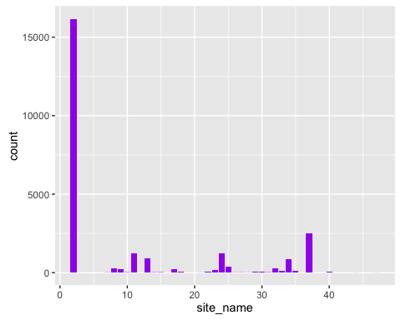

## posa_continent - current user location

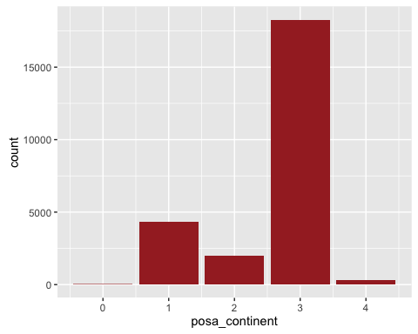

## hotel_continent - destination location

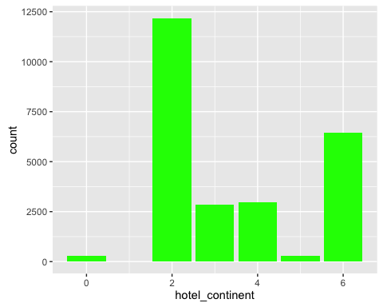

## user_id

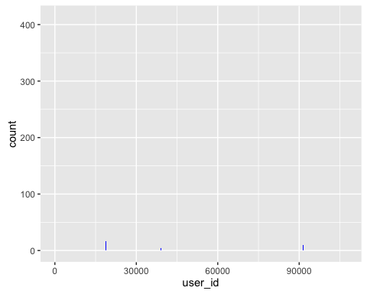

## is_mobile

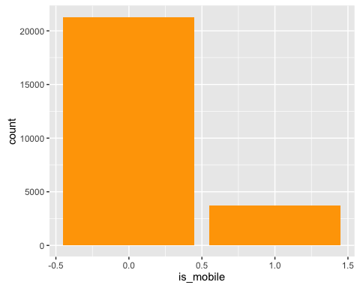

## is_package - hotel / hotel + air

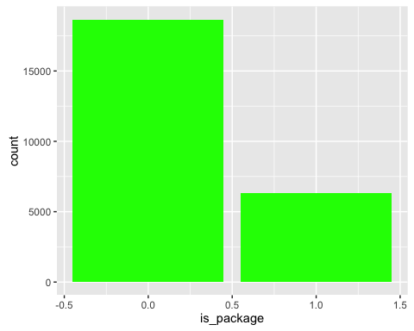

## srch_adults_cnt

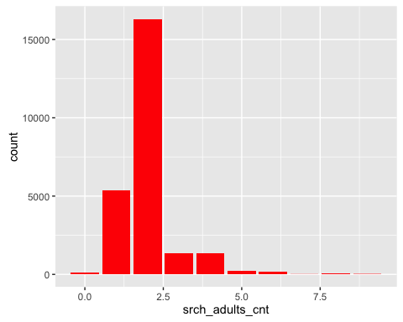

## srch_children_cnt

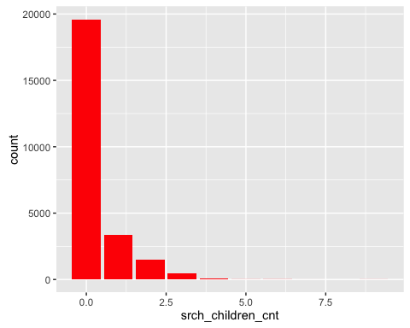

## srch_rm_cnt

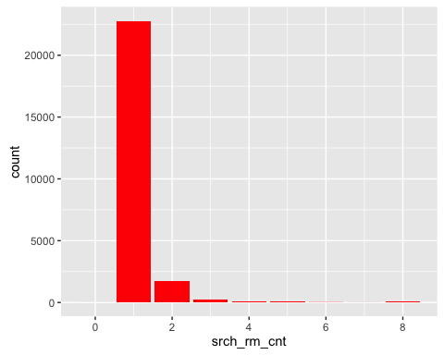

## hotel_cluster

