expediaEDA2

Anandan Balaji

13 May 2016

## Expedia Hotel Recommendation - Data Anyalysis

This document shows the charts related to different fields in the training data set.

# read 25 K  
train_df <- read.csv(file = "train.25000.csv")  
  
library(ggplot2)

## posa_continent (user location) and hotel_continent (desitnation location)

The below chart shows that the people from continent #3 travel a lot and prefer visiting continent #2.

ggplot(train_df, aes(posa_continent, fill = factor(hotel_continent))) + geom_bar(position = "dodge")

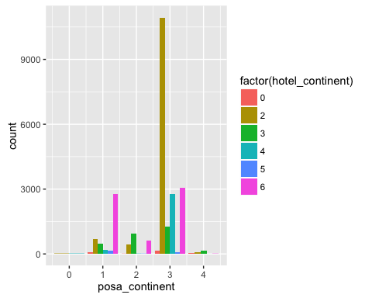

## srch_adults_cnt, srch_children_cnt

keys <- c("date_time", "user_id")  
  
adult_df <- train_df[keys]  
adult_df$count <- train_df$srch_adults_cnt  
adult_df$type <- "Adult"  
  
child_df <- train_df[keys]  
child_df$count <- train_df$srch_children_cnt  
child_df$type <- "Children"  
  
adult_child_df <- rbind(adult_df, child_df)  
  
#ggplot(adult_child_df, aes(x = user_id, y = count, col = factor(type))) +  
# geom_line()  
  
# how to change the scale in x-axis to 0, 1, 2, 3 etc.?  
ggplot(adult_child_df, aes(count, col = factor(type))) + geom_freqpoly()

## `stat_bin()` using `bins = 30`. Pick better value with `binwidth`.

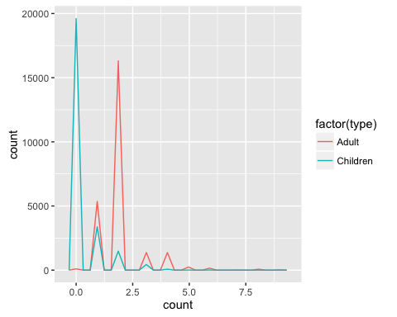

## source and destination country

src_df <- train_df[keys]  
src_df$country <- train_df$user_location_country  
src_df$ctype <- "User Country"  
  
dest_df <- train_df[keys]  
dest_df$country <- train_df$hotel_country  
dest_df$ctype <- "Dest Country"  
  
country_df <- rbind(src_df, dest_df)  
  
ggplot(country_df, aes(country, col = factor(ctype))) +   
 geom_freqpoly()

## `stat_bin()` using `bins = 30`. Pick better value with `binwidth`.

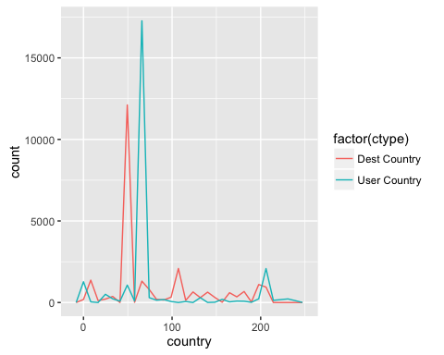

## number of days stay : srch_co - srch_ci (checkout - checkin date)

ggplot(train_df,   
 aes(factor(as.Date(as.character(train_df$srch_co), format = "%Y-%m-%d") - as.Date(as.character(train_df$srch_ci), format = "%Y-%m-%d")))) +  
 geom_bar(col = "blue") +  
 xlab("hotel stay in days")

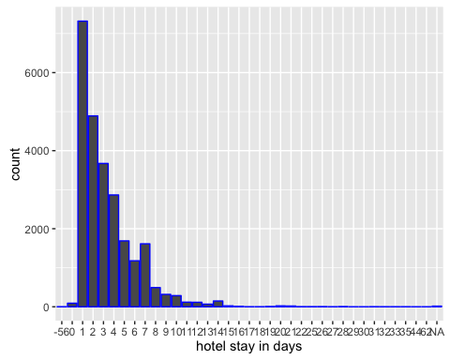

## hotel_continent & hotel_cluster

There are more number of hotel_clusters in the continent #2 and #6.

ggplot(train_df,   
 aes(x = hotel_cluster, y = hotel_continent, col = factor(hotel_continent))) + # to avoid over plotting   
 geom_jitter(alpha = 0.7) +  
 geom_smooth(method = "lm", se = F)

