Expedia Hotel Recommendation - Initial Analysis

Anandan Balaji

12 May 2016

## R Markdown

This R Markdown doucment illustrates the different plots for some of the data fields related to the Capstone Project - Expedia Hotel Recommendation.

The train data is huge - roughly 4GB. So, inorder to load and render fast, first 25K records were extracted and the following plots are generated for initial data analysis process.

# read complete data  
train_df <- read.csv(file = "train.csv")  
  
library(ggplot2)

## Warning: package 'ggplot2' was built under R version 3.2.4

## site_name

ggplot(train_df, aes(site_name)) + geom_bar(fill = "purple")

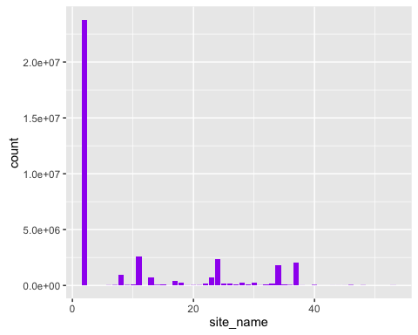

## posa_continent - current user location

ggplot(train_df, aes(posa_continent)) + geom_bar(fill = "brown")

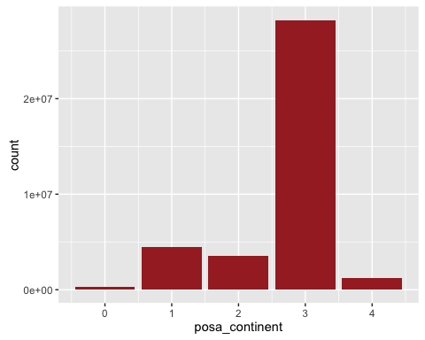

## hotel_continent - destination location

ggplot(train_df, aes(hotel_continent)) + geom_bar(fill = "green")

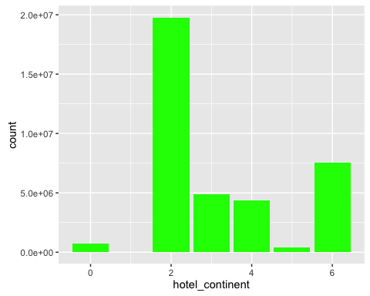

## user_id

ggplot(train_df, aes(user_id)) + geom_bar(fill = "blue")

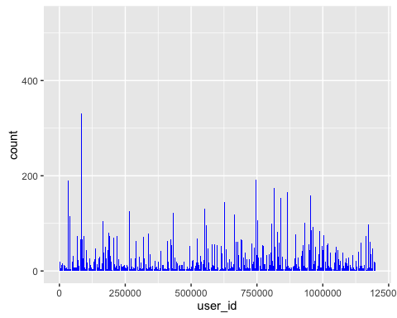

## is_mobile

ggplot(train_df, aes(is_mobile)) + geom_bar(fill = "orange")

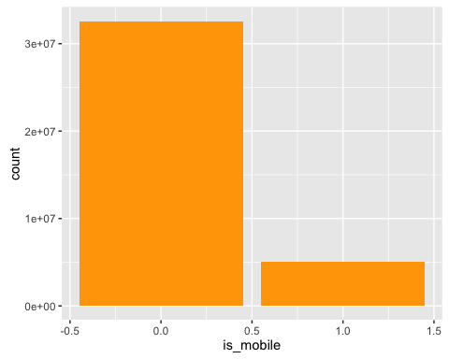

## is_package - hotel / hotel + air

ggplot(train_df, aes(is_package)) + geom_bar(fill = "green")

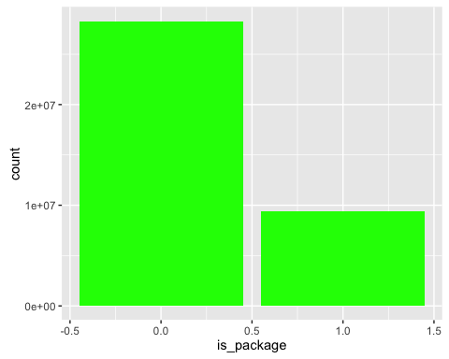

## srch_adults_cnt

ggplot(train_df, aes(srch_adults_cnt)) + geom_bar(fill = "red")

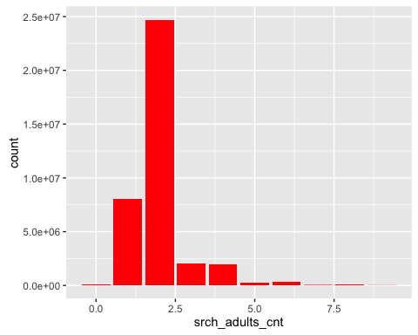

## srch_children_cnt

ggplot(train_df, aes(srch_children_cnt)) + geom_bar(fill = "red")

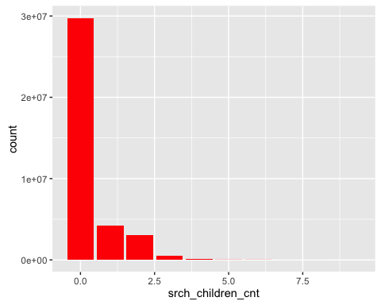

## srch_rm_cnt

ggplot(train_df, aes(srch_rm_cnt)) + geom_bar(fill = "red")

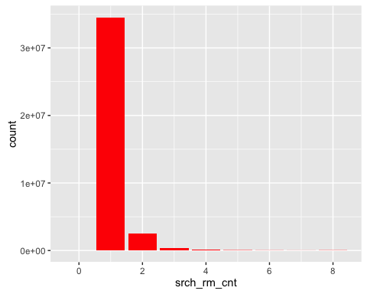

## hotel_cluster

ggplot(train_df, aes(hotel_cluster)) + geom_bar(fill = "blue")

