expediaEDA_ext

Anandan Balaji

18 May 2016

## Expedia Hotel Recommendation - Data Anyalysis

This document shows the charts related to different fields in the training data set.

# read 25 K  
#system.time(train_df <- read.csv(file = "train.25000.csv"))  
  
# read complete data  
library(data.table)

## Warning: package 'data.table' was built under R version 3.2.3

system.time(train_df <- fread("train.csv"))

##   
Read 0.0% of 37670293 rows  
Read 1.0% of 37670293 rows  
Read 1.5% of 37670293 rows  
Read 2.1% of 37670293 rows  
Read 2.8% of 37670293 rows  
Read 3.7% of 37670293 rows  
Read 4.8% of 37670293 rows  
Read 6.2% of 37670293 rows  
Read 7.8% of 37670293 rows  
Read 8.8% of 37670293 rows  
Read 9.7% of 37670293 rows  
Read 11.6% of 37670293 rows  
Read 12.1% of 37670293 rows  
Read 13.9% of 37670293 rows  
Read 15.1% of 37670293 rows  
Read 16.8% of 37670293 rows  
Read 18.2% of 37670293 rows  
Read 18.7% of 37670293 rows  
Read 20.6% of 37670293 rows  
Read 22.4% of 37670293 rows  
Read 23.2% of 37670293 rows  
Read 25.0% of 37670293 rows  
Read 26.7% of 37670293 rows  
Read 28.5% of 37670293 rows  
Read 28.9% of 37670293 rows  
Read 30.5% of 37670293 rows  
Read 32.2% of 37670293 rows  
Read 33.8% of 37670293 rows  
Read 35.4% of 37670293 rows  
Read 36.0% of 37670293 rows  
Read 37.6% of 37670293 rows  
Read 39.2% of 37670293 rows  
Read 41.0% of 37670293 rows  
Read 42.9% of 37670293 rows  
Read 44.7% of 37670293 rows  
Read 45.3% of 37670293 rows  
Read 47.1% of 37670293 rows  
Read 48.9% of 37670293 rows  
Read 50.7% of 37670293 rows  
Read 52.5% of 37670293 rows  
Read 54.2% of 37670293 rows  
Read 56.0% of 37670293 rows  
Read 57.3% of 37670293 rows  
Read 59.1% of 37670293 rows  
Read 60.8% of 37670293 rows  
Read 62.5% of 37670293 rows  
Read 64.2% of 37670293 rows  
Read 65.9% of 37670293 rows  
Read 67.6% of 37670293 rows  
Read 69.3% of 37670293 rows  
Read 71.0% of 37670293 rows  
Read 72.6% of 37670293 rows  
Read 73.5% of 37670293 rows  
Read 75.2% of 37670293 rows  
Read 76.8% of 37670293 rows  
Read 78.4% of 37670293 rows  
Read 80.1% of 37670293 rows  
Read 81.8% of 37670293 rows  
Read 83.4% of 37670293 rows  
Read 85.0% of 37670293 rows  
Read 86.6% of 37670293 rows  
Read 88.3% of 37670293 rows  
Read 89.9% of 37670293 rows  
Read 91.5% of 37670293 rows  
Read 93.1% of 37670293 rows  
Read 94.1% of 37670293 rows  
Read 95.8% of 37670293 rows  
Read 97.7% of 37670293 rows  
Read 99.3% of 37670293 rows  
Read 37670293 rows and 24 (of 24) columns from 3.791 GB file in 00:03:00

## user system elapsed   
## 169.029 10.547 197.427

library(ggplot2)

## Warning: package 'ggplot2' was built under R version 3.2.4

## posa_continent (user location) and hotel_continent (desitnation location)

The below chart shows that the people from continent #3 travel a lot and prefer visiting continent #2.

ggplot(train_df, aes(posa_continent, fill = factor(hotel_continent))) + geom_bar(position = "dodge")

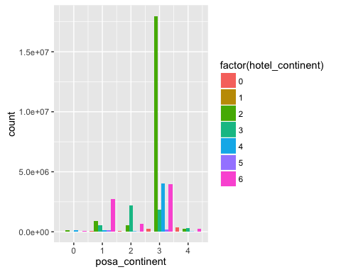

## srch_adults_cnt, srch_children_cnt

keys <- c("date_time", "user_id")  
setkeyv(train_df, keys)  
  
#adult_df <- train_df[keys]  
adult_df <- train_df[keys]  
adult_df$count <- train_df$srch_adults_cnt

## Warning in `[<-.data.table`(x, j = name, value = value): Supplied 37670293  
## items to be assigned to 2 items of column 'count' (37670291 unused)

adult_df$type <- "Adult"  
  
child_df <- train_df[keys]  
child_df$count <- train_df$srch_children_cnt

## Warning in `[<-.data.table`(x, j = name, value = value): Supplied 37670293  
## items to be assigned to 2 items of column 'count' (37670291 unused)

child_df$type <- "Children"  
  
adult_child_df <- rbind(adult_df, child_df)  
  
#ggplot(adult_child_df, aes(x = user_id, y = count, col = factor(type))) +  
# geom_line()  
  
# how to change the scale in x-axis to 0, 1, 2, 3 etc.?  
ggplot(adult_child_df, aes(count, col = factor(type))) + geom_freqpoly()

## `stat_bin()` using `bins = 30`. Pick better value with `binwidth`.

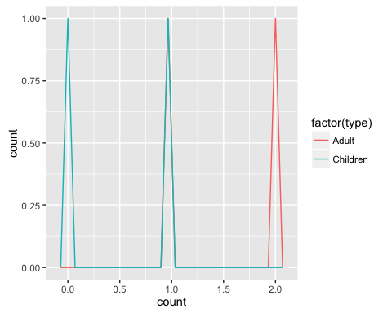

## source and destination country

src_df <- train_df[keys]  
src_df$country <- train_df$user_location_country

## Warning in `[<-.data.table`(x, j = name, value = value): Supplied 37670293  
## items to be assigned to 2 items of column 'country' (37670291 unused)

src_df$ctype <- "User Country"  
  
dest_df <- train_df[keys]  
dest_df$country <- train_df$hotel_country

## Warning in `[<-.data.table`(x, j = name, value = value): Supplied 37670293  
## items to be assigned to 2 items of column 'country' (37670291 unused)

dest_df$ctype <- "Dest Country"  
  
country_df <- rbind(src_df, dest_df)  
  
ggplot(country_df, aes(country, col = factor(ctype))) +   
 geom_freqpoly()

## `stat_bin()` using `bins = 30`. Pick better value with `binwidth`.

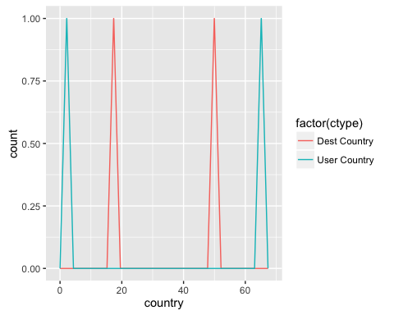

## number of days stay : srch_co - srch_ci (checkout - checkin date)

ggplot(train_df,   
 aes(factor(abs(as.Date(as.character(train_df$srch_co), format = "%Y-%m-%d") - as.Date(as.character(train_df$srch_ci), format = "%Y-%m-%d"))))) +  
 geom_bar(col = "blue") +  
 xlab("hotel stay in days")

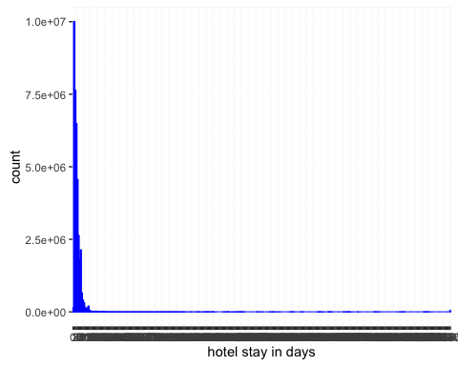

## hotel_continent & hotel_cluster

ggplot(train_df,   
 aes(x = hotel_cluster, y = hotel_continent, col = factor(hotel_continent))) + # to avoid over plotting   
 geom_jitter(alpha = 0.7) +  
 geom_smooth(method = "lm", se = F)

