Screenshots

Version 1: Shows only cards dealt to the player and dealer

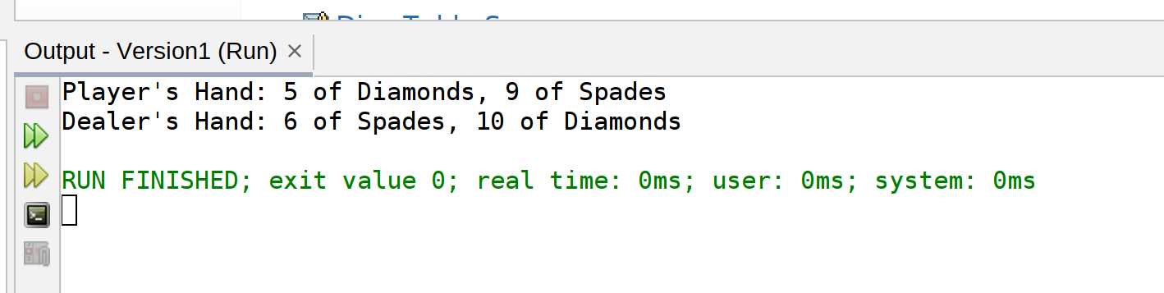

Version 2: Allows game to progress multiple times

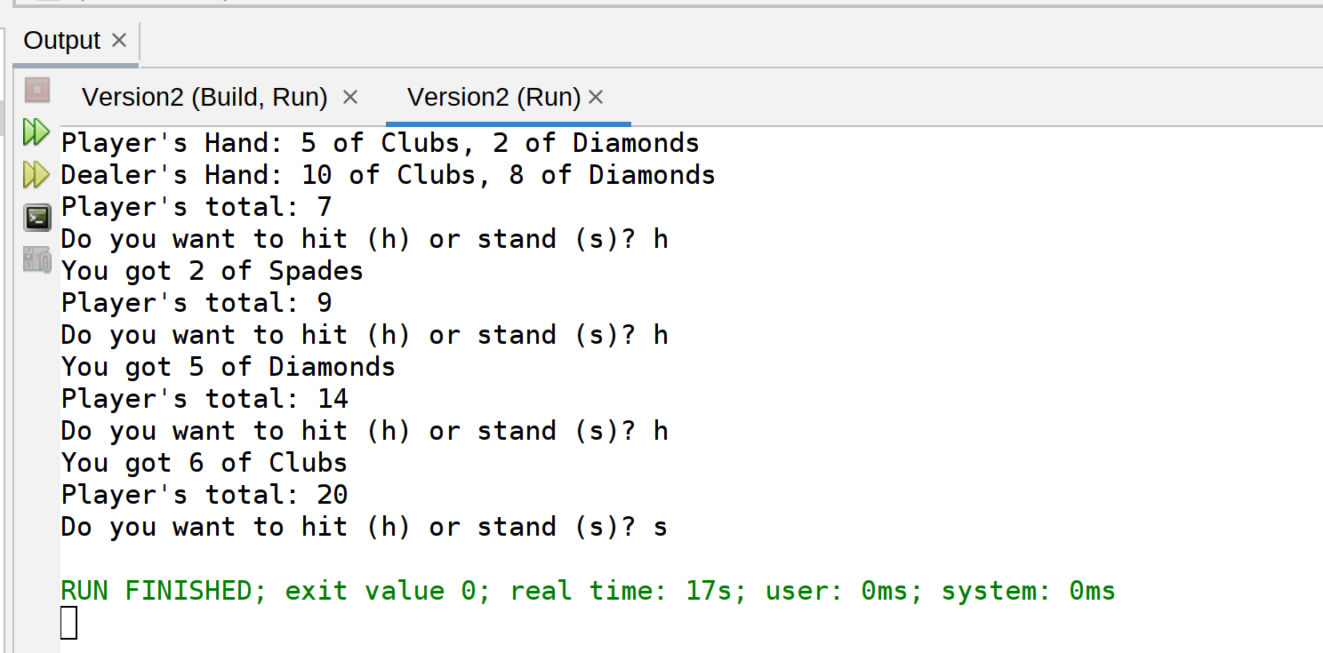

Version 3: Checking after each card dealt for who wins!

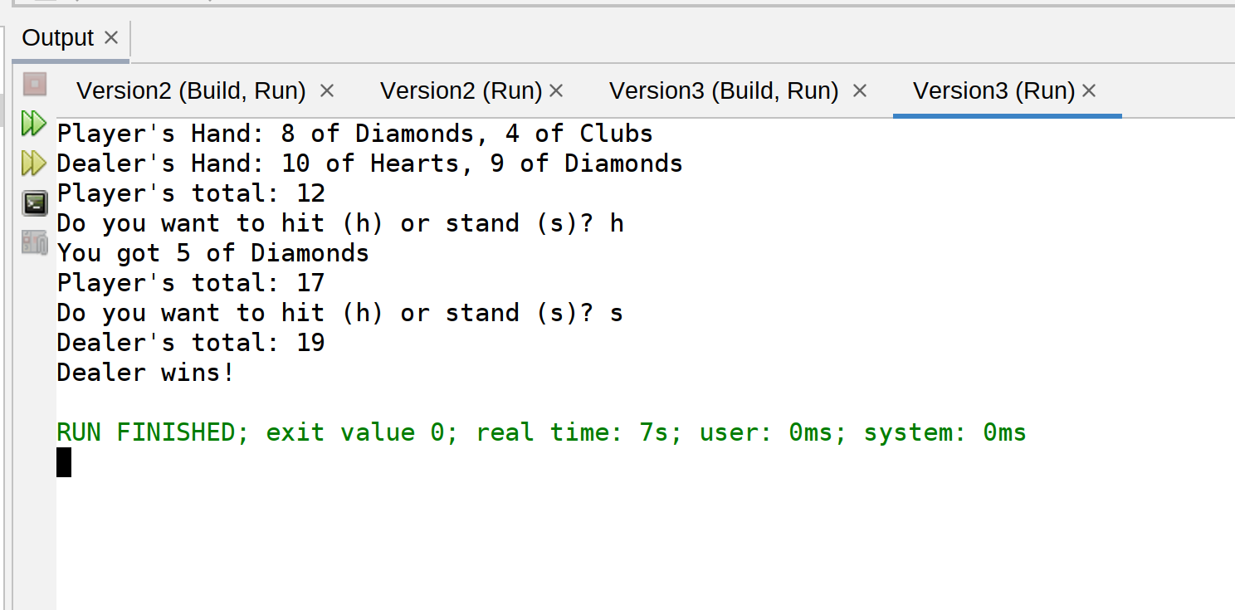

Final Version: Checking after each card dealt for who wins! Also, the data is written out to the disk.

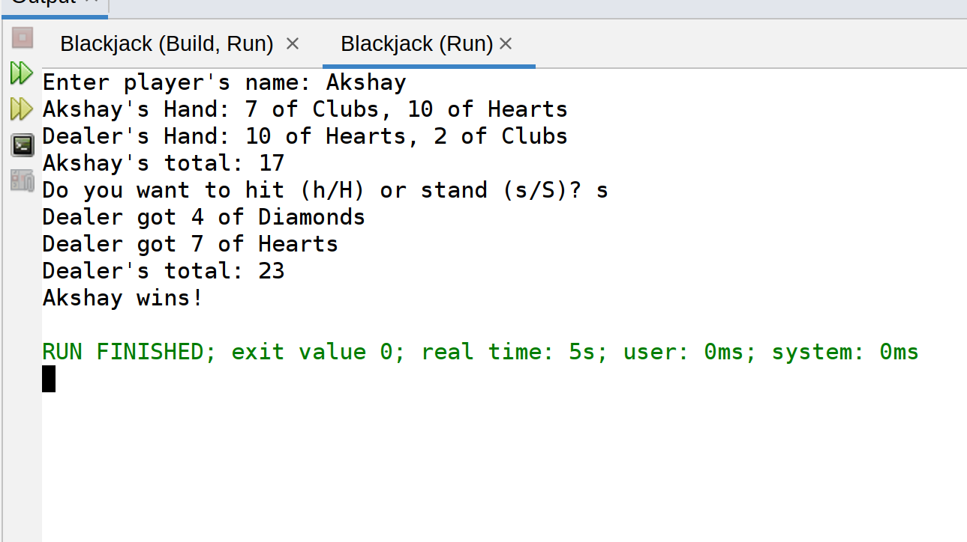

Card.dat file created in the final version.

