Duplicate Calendar Events

# What problem are we solving?

We are an outsourcing company developing some software for a client. Our client has their own Exchange and we need to use that for everything related to our work for them. This means Email, Calendar, SharePoint, Teams etc. We also need to use our own Exchange for anything not directly related to our client.

For easy reading I’m defining the following terms in that regards

* Account in our own network is Default account
* Account in our client’s network is Secondary account

This gets especially annoying when it comes to keeping our calendars current. For example, if I want to schedule a meeting using my Default account, to make sure everyone is available there are two options

* Option 1: I need to also check schedule of the invitees in their secondary account Additional problem whit this is that not everybody in our organization has a secondary account for this client, so it is not always possible
* Option 2: Everybody needs to manually add a corresponding appointment in their default calendar reflecting their secondary account

And this needs to happen both ways

This is what we are currently doing (or should be doing), but this often gets overlooked.

Also, it becomes really hard to track when an update to an appointment is made (especially change in a specific occurrence of a recurring appointment).

# The Solution

Option 2 is really annoying to be done by hand, but it can be automated relatively easy.

So, this is what we’re doing here.

Automation is implemented using macros in Outlook

The solution is based on Outlook 2016 (Version 1803 - Build 9126.2259) and is not tested on any other version.

# How to install

1. Enable Macros

Use this guide to do so [https://support.office.com/](https://support.office.com/en-us/article/enable-or-disable-macros-in-office-files-12b036fd-d140-4e74-b45e-16fed1a7e5c6)

There are some changes to be made in code - mostly configurational, but you may also want to change the logic in some way.

It is recommended to set either warn or no security for now and once you are happy with the solution, you can [sign it](https://support.office.com/en-us/article/Digitally-sign-your-macro-project-956e9cc8-bbf6-4365-8bfa-98505ecd1c01) with a self-certificate and set macros to signed-only.

1. Open vb editor

In outlook press Alt+F11

You’ll see the following by default (if you have anything else here, you probably know what you are doing and do not need that much detail 😊)

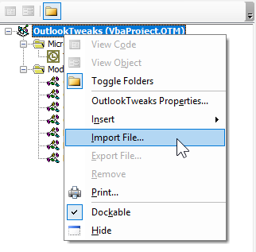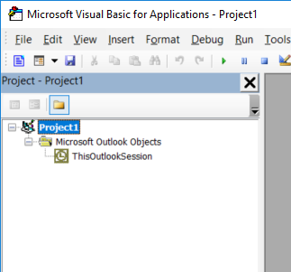

1. Import modules

Right click on the project and select Import module

You need to import each of the following modules:

* CalendarAccountsConstants.bas
* CalendarActionsCommons.bas
* CleanUpDeletedByCategory.bas
* CopyApptItemsInitial.bas
* DeleteAllCopiedAppts.bas
* DuplicateCalendarEventsManual.docx
* LoopCopiedAppts.bas
* ReadMe.bas

And also:

* ThisOutlookSession.cls

This is the expected view after you’re done (Project has been renamed in this screen which is not necessary)

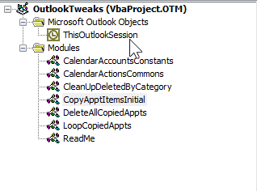

1. Some customization
   1. Define account names

Open *CalendarAccountsConstants* and fill in correct email addresses.

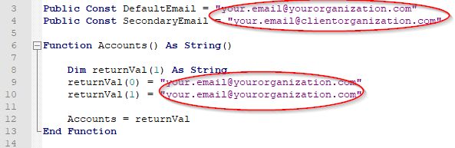

* 1. Personal customization (not mandatory)

Open *CalendarActionsCommons* module

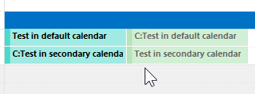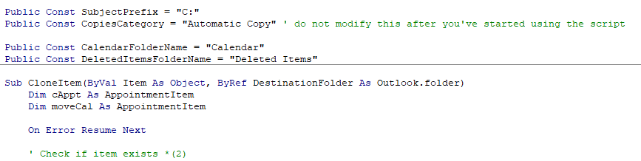

You can customize Subject Prefix and Copies Category

**SubjectPrefix** will help you visually distinguish copied from original Items in your calendar view.

**CopiesCategory** is used that code can distinguish between original and copied items

*Important: It is recommended that you do not change this value after you start using this solution, as it would lead to unexpected behavior*

1. Initialize (You can skip that if you only want to apply to appointments created from this point on)

Once you’re done with the customization go to module *CopyApptItemsInitial.*

Run ***CopyApptItemsInitial*** sub (position the cursor in the Sub body)*.* 

This will copy your currently existing calendar items.

***Important*** *Make sure that Application_Startup from the next point is NOT RUNNING when you execute this*

1. Start

Go to *ThisOutlookSession*

Position the cursor in the body of ***Application_Startup*** sub

Run

After this any new/changed/deleted item would be reflected to both calendars

1. Additional modules

You can go through the other modules as well – You may find them useful.

I.e. if you get bored of this you can delete all copied items from module *DeleteAllCopiedAppts*

# Additional improvement

You will notice that after you do that your calendar becomes overloaded with doubled information.

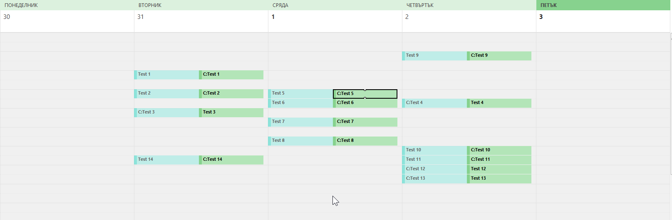

Here is something you can do about it.

* + - 1. Go to View tab
      2. Click on Change View
      3. Select Save Current view as new View

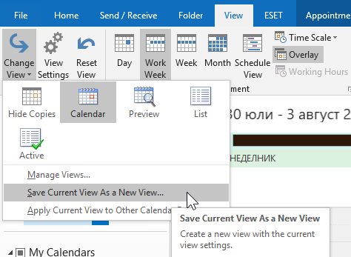

* + - 1. You can name your new view “Hide copies”
      2. Modify the newly created view in the following way, adding filter

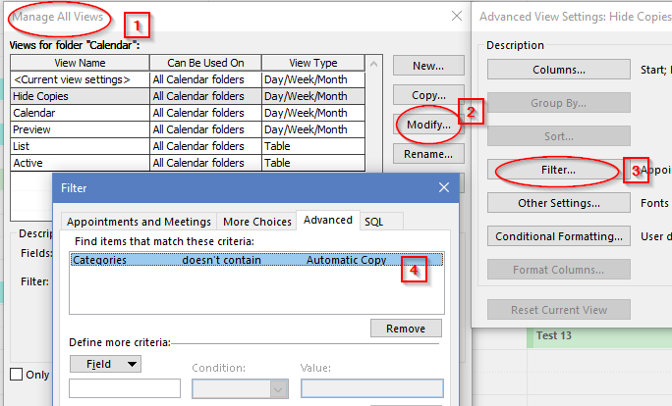

* + - 1. You ca switch back and forth between “Hide copies” and “Calendar” views depending on your needs