Spotify Music Recommendation System
Empirical Evaluation of Popularity and Content Based Recommendations

Final White Paper
Anil Bammidi
DSC680 Applied Data Science
Bellevue University
Professor Xu Ashton
October 2, 2026
Main conclusion: The executed evidence supports a popularity baseline and a content-based KNN recommender. The data do not support empirical claims about collaborative filtering or a hybrid model.

Executive Summary
Music platforms must help listeners discover relevant tracks within very large catalogs. This project evaluates two reproducible methods using Spotify track metadata: a popularity baseline for cold start and a content-based K-nearest-neighbors model. The executed notebook retains 89,740 unique tracks after deduplication and required-field filtering. The popularity layer produces an immediate ranking, while the KNN layer uses ten scaled audio features and cosine distance to retrieve similar tracks.
The results establish technical feasibility, not individual preference accuracy. The source contains no user IDs, plays, skips, saves, ratings, timestamps, or listening duration. The final project therefore removes simulated SVD and hybrid RMSE comparisons and limits performance claims to methods actually implemented. The recommended next step is to deploy the content model as a baseline, retain popularity as a fallback, and collect consented interactions before testing collaborative or hybrid ranking.

Business Problem and Research Questions
A useful recommender must serve a new listener immediately and improve as evidence about preferences becomes available. The current dataset supports catalog-level similarity but cannot measure whether a specific listener will save, complete, or repeatedly play a recommendation. The analysis addresses the following questions.
- How does a popularity-based layer support listeners with no interaction history?
- Can K-nearest-neighbor retrieval using scaled audio features and cosine distance produce plausible similar-track recommendations?
- What evidence is available now, and what additional data are required before collaborative or hybrid performance claims can be made?

Data and Preparation
The Spotify Tracks dataset published by Maharshi Pandya on Kaggle contains approximately 114,000 rows. The notebook removes duplicate track identifiers and records without a track name or artist, then resets the index. The resulting catalog contains 89,740 unique tracks. Resetting the index prevents position mismatches between the DataFrame and the scaled feature matrix.
Field group | Examples | Purpose
Identity | track_id, track_name, artists | Deduplication, lookup, and display
Cold start | popularity | Global baseline ranking
Audio features | danceability, energy, valence, tempo | KNN similarity vector
Context | track_genre | Interpretation of returned neighbors

Methods

Popularity Baseline
The baseline sorts the retained catalog by the observed popularity field and returns the highest-ranked tracks. It requires no listener history and provides a transparent cold-start benchmark. Because the method repeatedly favors established tracks, it can amplify popularity bias and reduce long-tail exposure.

Content Based KNN
The content model uses danceability, energy, key, loudness, speechiness, acousticness, instrumentalness, liveness, valence, and tempo. MinMaxScaler converts each feature to a zero-to-one range. A brute-force NearestNeighbors model then retrieves the five nearest tracks with cosine distance after excluding the query track. KNN was selected because it is interpretable, requires no labeled outcome, and directly supports catalog exploration.

Evaluation Strategy
Current validation includes successful execution, descriptive analysis, inspection of ranked outputs, and qualitative review of the KNN example. The revised notebook adds reproducible KNN diagnostics for average neighbor distance, sampled catalog coverage, and genre variety. These measures describe retrieval behavior but cannot replace listener relevance judgments. Rating-prediction RMSE is not reported because the project has no authentic rating target and does not fit an SVD estimator.
Figure 1 Distribution of Track Popularity
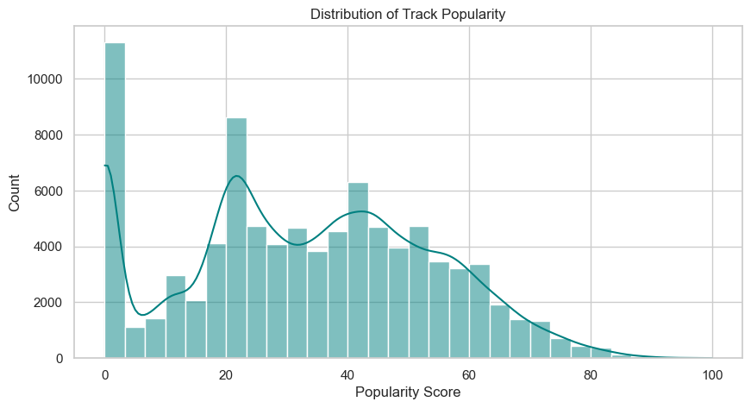
The executed distribution has a long tail. Popularity offers an immediate benchmark but concentrates exposure among a smaller set of high-popularity tracks.

Results

Popularity Output
The baseline returned the following five tracks. The output verifies the ranking logic but does not measure personalization or causal engagement.
Track | Artist | Popularity
Unholy (feat. Kim Petras) | Sam Smith; Kim Petras | 100
Quevedo: Bzrp Music Sessions, Vol. 52 | Bizarrap; Quevedo | 99
I'm Good (Blue) | David Guetta; Bebe Rexha | 98
La Bachata | Manuel Turizo | 98
Me Porto Bonito | Bad Bunny; Chencho Corleone | 97

Content Retrieval Output
For the query Comedy, KNN returned tracks spanning five genre labels. This cross-genre result is consistent with retrieval based on audio characteristics rather than a simple genre match. It remains a qualitative example because no listener relevance label is available.
Track | Artist | Genre
Sometimes | Ed Solo and collaborators | breakbeat
JAMAICA | Feid; Sech | pop
Skylight | Gramatik | trip-hop
Look For The Good | Jason Mraz | acoustic
En El Coche | Aitana | spanish

Exploratory Evidence
The correlation heatmap reports a strong positive relationship of approximately 0.76 between energy and loudness. The relationship may indicate redundancy, but correlation alone does not establish that either feature should be removed. The danceability-energy plot also shows wide variation across popularity levels.
Figure 2 Correlation Among Numeric Track Features
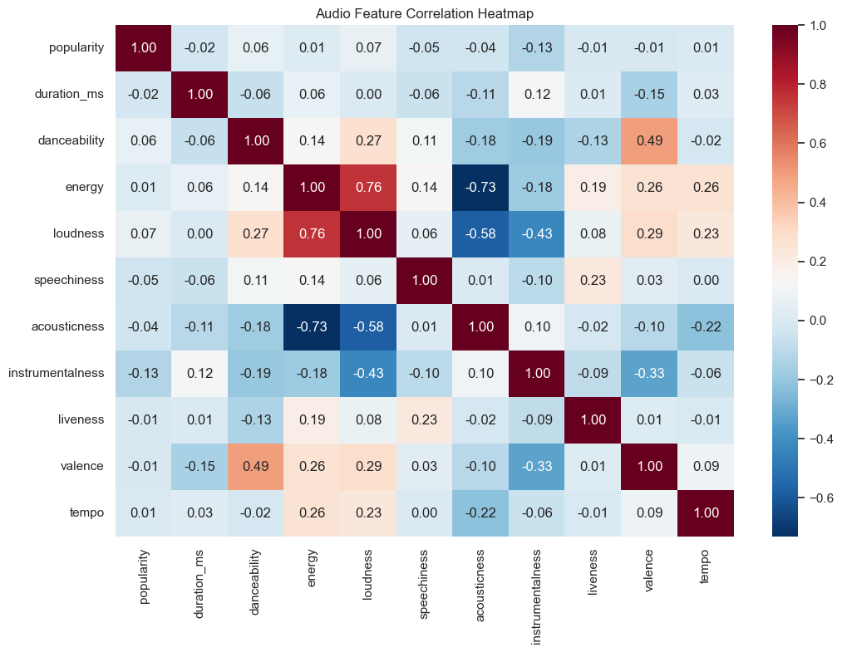

Limitations and Ethical Assessment
The source lacks listener identity, interaction history, session context, time, location, subscription status, and listening-duration outcomes. The system cannot estimate individual preference, evaluate retention, or prove that recommendations increase listening time. A title substring may also match several tracks, and the current lookup returns the first match. Brute-force KNN will require approximate-neighbor indexing as the catalog grows.
Risk | Why it matters | Mitigation
Privacy | Listening histories can reveal routines and sensitive interests | Consent, minimization, retention limits, and access controls
Popularity bias | Established artists can receive repeated exposure | Track exposure by artist and popularity tier
Filter bubbles | Similarity can narrow discovery | Exploration slots, diversity constraints, and user controls
Misleading evidence | Simulated scores can appear empirical | Report only fitted-model results and label future work
Licensing | Metadata and platform use may have restrictions | Verify dataset license and current platform terms

The final analysis follows the ACM expectation to avoid harm and communicate system limitations honestly. No real user identities appear in the present dataset. Future interaction logging should collect only the events needed for evaluation and should not infer sensitive personal traits from listening behavior.

Recommendation and Implementation Plan
Adopt content-based KNN as the reproducible initial recommendation model and retain popularity as the cold-start fallback. Do not claim collaborative or hybrid improvement until real interactions support held-out testing.
- Collect consented plays, skips, saves, completions, and timestamps with clear retention rules.
- Evaluate ranking quality with Precision at K, Recall at K, NDCG at K, coverage, novelty, and diversity.
- Fit collaborative filtering only after a user-aware or time-aware split prevents leakage.
- Tune hybrid weights on validation data and keep privacy, explicit-content safety, latency, and exposure concentration as guardrails.
- Run a controlled A/B test against the popularity baseline before measuring listening time, saves, skips, and retention.

Conclusion
The project demonstrates two practical catalog-level methods. Popularity supplies a simple cold-start ranking, and scaled audio features with cosine-distance KNN provide a functioning similarity recommender. The long-tail distribution and cross-genre example show why the two layers serve different purposes. The available evidence does not validate collaborative filtering, a hybrid score, or engagement improvement. Those claims require consented user behavior, appropriate holdout design, and offline and online evaluation.

References
Association for Computing Machinery. (2018). ACM code of ethics and professional conduct. https://www.acm.org/code-of-ethics
Koren, Y., Bell, R., & Volinsky, C. (2009). Matrix factorization techniques for recommender systems. Computer, 42(8), 30-37. https://doi.org/10.1109/MC.2009.263
Pandya, M. (n.d.). Spotify tracks dataset [Data set]. Kaggle. https://www.kaggle.com/datasets/maharshipandya/-spotify-tracks-dataset/data
Pazzani, M. J., & Billsus, D. (2007). Content-based recommendation systems. In The adaptive web (pp. 325-341). Springer. https://doi.org/10.1007/978-3-540-72079-9_10
Pedregosa, F., et al. (2011). Scikit-learn: Machine learning in Python. Journal of Machine Learning Research, 12, 2825-2830.
Resnick, P., Iacovou, N., Suchak, M., Bergstrom, P., & Riedl, J. (1994). GroupLens: An open architecture for collaborative filtering of netnews. Proceedings of CSCW, 175-186. https://doi.org/10.1145/192844.192905

