Getpapers –q ABSTRACT: anti-depressant effect fluoxetine –o CMdeptesting –x –p –s

Returned 717 results –

Had a quick look at the full text pdfs of a couple to see if the results returned were relevant:

PMC1291406 – respiratory depression, abstract contained term “anti-“ but in relation to anti-remodelling.

PMC2809039 – systematic review and meta-analysis on CBT for cardiac defibrillator – outcomes included effect of CBT on depression

PMC4082426 – anti-leukaemia – not very relevant

PMC4776097 – antidepressant effects of different drugs in a rodent model of depression – Very relevant!

PMC4883068 – about alcohol addiction, an experiment in rodents – not relevant

Getpapers –q ABSTRACT: rodent model antidepressant fluoxetine moclobemide behaviour –o CMDEPtested –p –x –s

* Error: did not get a response from euPMC within 20000ms
* Decided to stick with the smaller dataset of CMdeptesting

Norma

Ran: norma –project CMdeptesting –I fulltext.xml –o scholarly.html –transform n1m2html

Ami

Ran: ami2-species --project CMdeptesting/ -i scholarly.html --sp.species --sp.type binomial

* Many errors: cannot parse/read file:
* 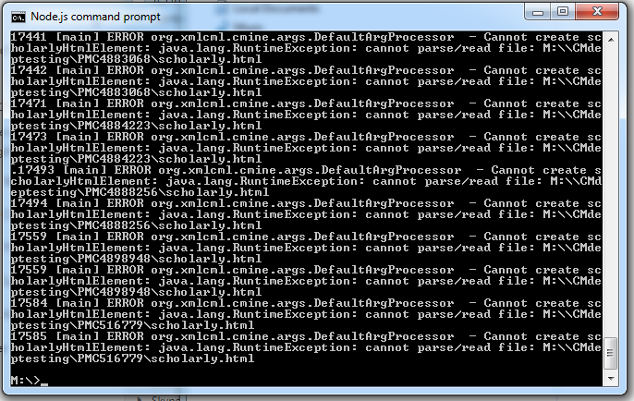

Ran: ami2-gene –project CMdeptesting/ -i scholarly.html --g.gene --g.type human

* Many errors as above – same error e.g. 33438 [main] ERROR org.xmlcml.cmine.args.DefaultArgProcessor – Cannot create scholarlyHtmlElement:java.lang.RuntimeException: cannot parse/read file: M: etc

Used:

Ami2-species –project M:\CMdeptesting –i scholarly.html –sp.species –sp.type binomial

Ami2-species –project M:\CMdeptesting –i scholarly.html –sp.species –sp.type genus

Ami2-species –project M:\CMdeptesting –i scholarly.html –sp.species –sp.type genussp

* All ran out of memory however some results were achieved – I moved on for the sake of completing the task

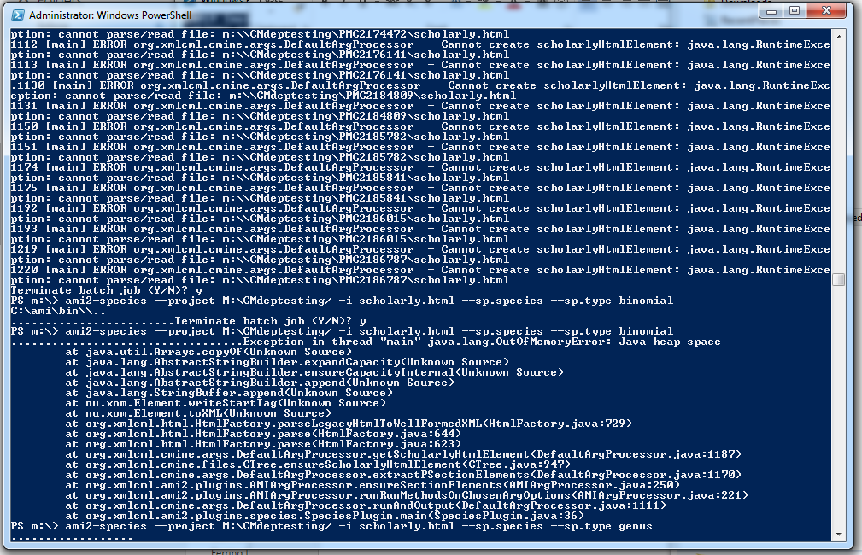

ami2-gene --project M:\CMdeptesting -i scholarly.html --g.gene --g.type human

* Also retrieved out of memory error but some results were retrieved.

for type in dna rna prot prot3 carb3; do

ami2-sequence --project M:\CMdeptesting -i scholarly.html --sq.sequence --sq.type $type;

done

* Using the for loop created an error

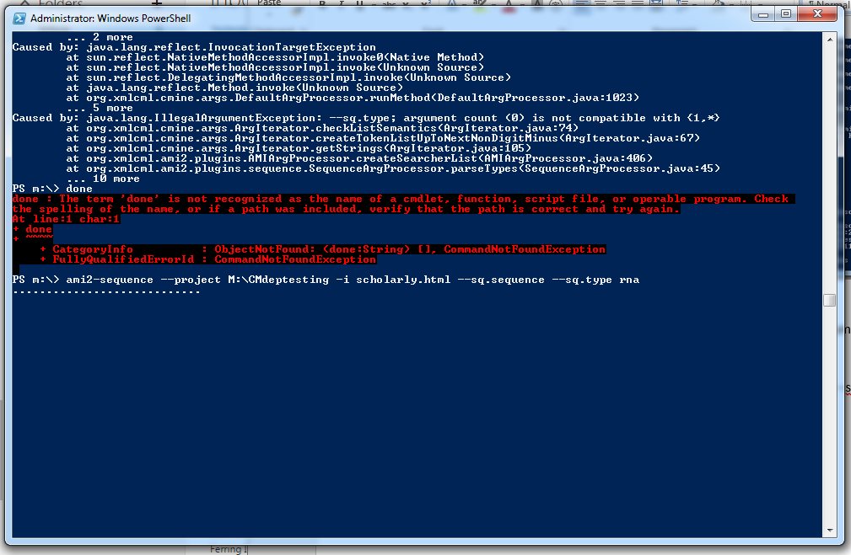

ami2-sequence --project M:\CMdeptesting -i scholarly.html --sq.sequence --sq.type rna

ami2-sequence --project M:\CMdeptesting -i scholarly.html --sq.sequence --sq.type dna

ami2-sequence --project M:\CMdeptesting -i scholarly.html --sq.sequence --sq.type prot

ami2-sequence --project M:\CMdeptesting -i scholarly.html --sq.sequence --sq.type prot3

ami2-sequence --project M:\CMdeptesting -i scholarly.html --sq.sequence --sq.type carb3

REGex

ami2-regex --project CPROJECTFOLDER -i INPUTFILE --context PRE POST --r.regex REGEXFILE.xml

ami2-regex --project M:\CMdeptesting -i INPUTFILE --context 20 20 --r.regex REGEXFILE.xml

ami2-regex --project M:\CMdeptesting -i scholarly.html --r.regex M:\CMdeptesting/depressionbehaviour.xml --context 50 50

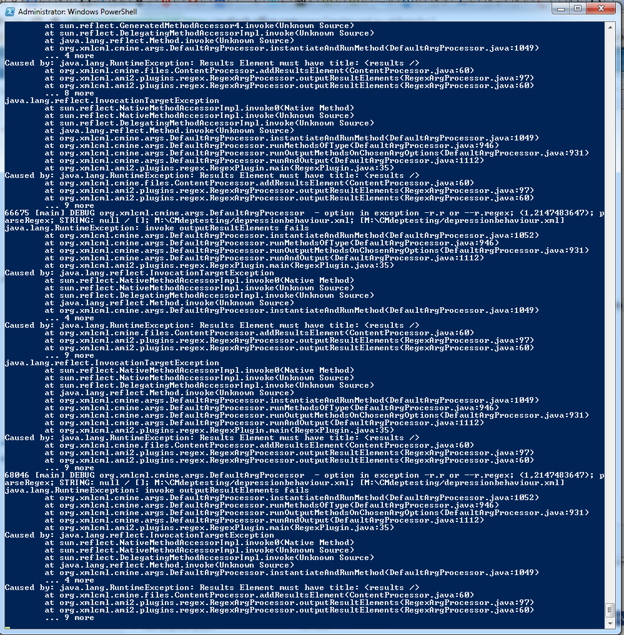

Quickscrape

* Unable to make directory for plos url – because of illegal characters in the url

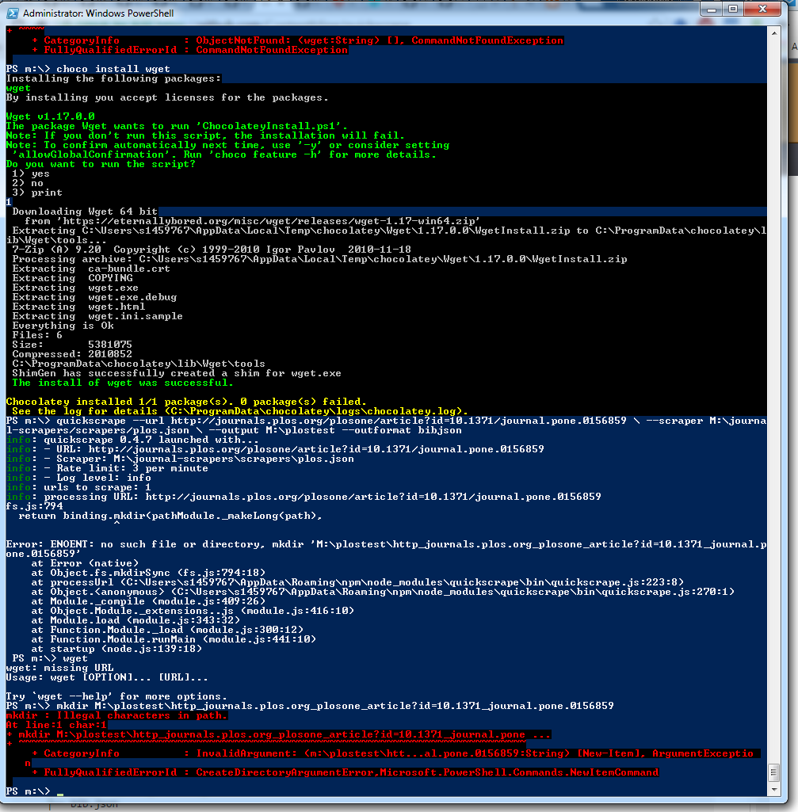

quickscrape \ --url https://peerj.com/articles/384 \ --scraper M:\journal-scrapers/scrapers/peerj.json \ --output M:\peerj-384 --outformat bibjson

* Test – 6 captures failed

Quickscrape --url [https://elifesciences.org/content/4/e04803 \](https://elifesciences.org/content/4/e04803%20\) --scraper M:\journal-scrapers/scrapers/elife.json \ --output M:\elifetest –outformat bib.json

* Unable to retrieve 7 captures (elements) including supplementary methods

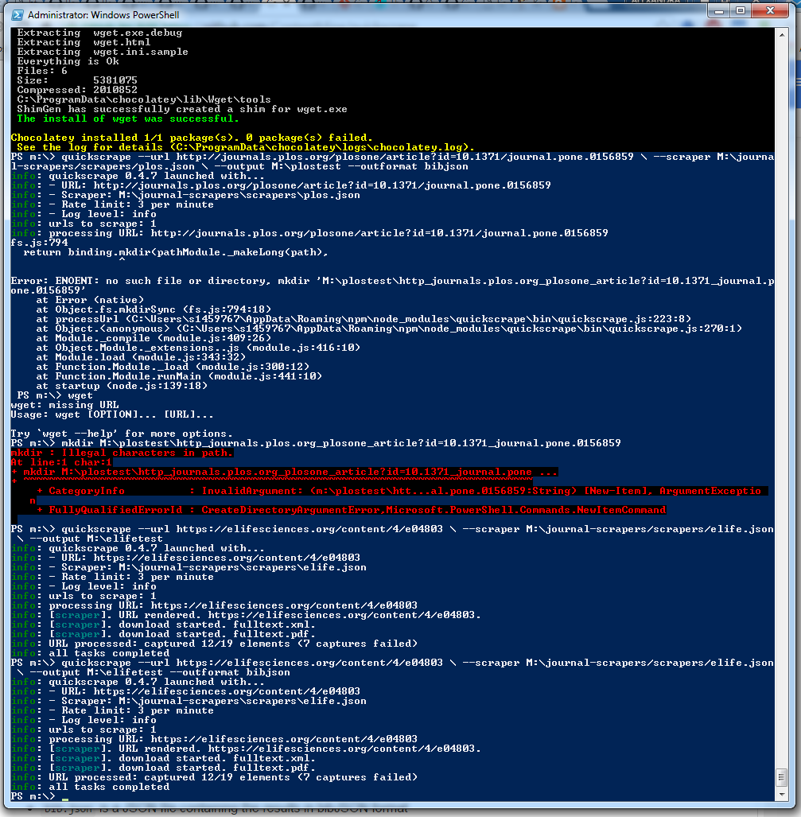

quickscrape \ --url <http://bmcmedicine.biomedcentral.com/articles/10.1186/1741-7015-12-73> \ --scraper M:\journal-scrapers/scrapers/bmc.json \ --output bmctest --outformat bibjson

* Loading infinitely

quickscrape \ --url <http://annals-general-psychiatry.biomedcentral.com/articles/10.1186/1744-859X-5-S1-S245> / --scraper M:\journal-scrapers/scrapers/bmc.json \ --output bmctest --outformat bibjson

quickscrape \ --url <http://jneuroinflammation.biomedcentral.com/articles/10.1186/1742-2094-8-151> / --scraper M:\journal-scrapers/scrapers/bmc.json \ --output bmctest --outformat bibjson

* Loading infinitely

<https://peerj.com/articles/1611/>

quickscrape \ --url <https://peerj.com/articles/1611/> \ --scraper M:\journal-scrapers/scrapers/peerj.json \ --output peerjtest --outformat bibjson