**Database Design**

This section displays the relationship of each table through its key data. Every database design table has relating keys which will be utilized to recover the contents of the tables. In relational databases' condition, primary key is an unique identifier, and can't contain a null value.

**Table #**

**USER HEADER PROFILE**

|  |  |
| --- | --- |
| UHFile | |
| Primary Key | UHCode |
|  | UHUsername  UHPassword  UHStatus |

Table # shows the primary information of the user which includes the user code, username, user password and status. The primary key of this table, UHCode, will be compared to the primary key of CarHeadearFile table, CHOwner, for verification if the user owns a car for rent. Also, the primary key will be compared to the primary key of ResFile table, ResUserCode, for verification if the user wants to rent a car.

**Table #**

**USER DETAIL PROFILE**

|  |  |
| --- | --- |
| UDFile | |
| Primary Key | UDCode |
|  | UHFname  UHLname  UHMname  UDAddr  UDGender  UDAge  UDPhoto  UDContactNo  UDEmail  UDStatus |

Table # shows the personal information of the user, specifically contact information, which includes the user code, user first name, user last name, user middle name, address, gender, age, photo, contact number and email address. The primary key of this table, UDCode, will be compared to the primary key of UHFile table, UHCode , for user verification.

**Table #**

**CAR HEADER FILE**

|  |  |
| --- | --- |
| CHFile | |
| Primary Key | CHCode |
|  | CHOwner  CHStatus |

Table # show the car header where it shows the listed cars for rent, car owners and car status. The primary key, CHCode, is compared to the CDFile’s CDCode field to identify the details of a specific car.

**Table #**

**CAR HEADER FILE**

|  |  |
| --- | --- |
| CDFile | |
| Primary Key | CDCode |
|  | CDSched  CDDesc  CDPhoto  CDStatus |

Table # shows the car details for reference data. The primary key of the table, CDCode, will be compared to the primary key of CHFile table, CHCode, for verification.

**Table #**

**RESERVATION FILE**

|  |  |
| --- | --- |
| ResFile | |
| Primary Key | ResTime  ResCarCode |
|  | ResOwnerCode  ResStatus |

Table # holds the information or reservation schedules of all cars which includes beginning reservation. The first primary key, ResTime, of the table will be compared to the CDSched field in CDFile to verify if the car is available on the chosen time while the other primary key, ResCarCode, will be compared to the primary key of the table CHFile, CHCode, for car existence verification.

**Entity Relationship Diagram**

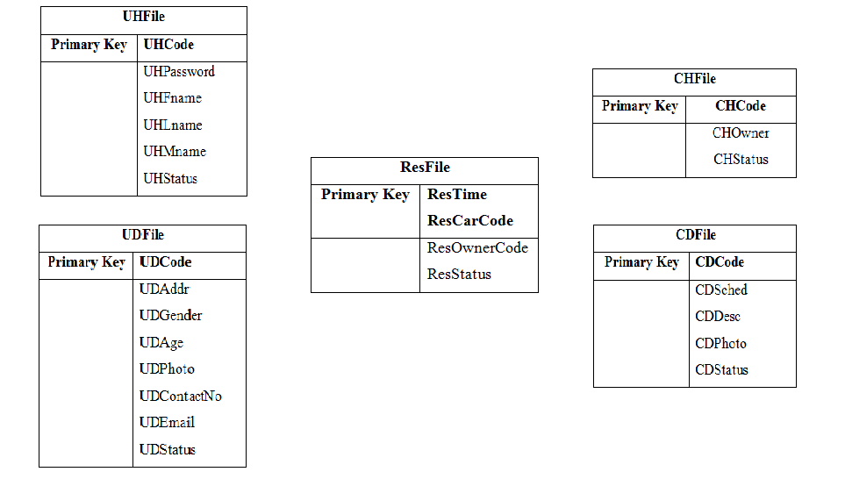

1..m

1..1

1..1

1..1

**Data Dictionary**

This section comprise the several fields and properties as a descriptive collection of data in the database which includes the table name, column name, data type, size, null column, and description respectively.

Table #

USER HEADER PROFILE

|  |  |  |  |  |  |
| --- | --- | --- | --- | --- | --- |
| **Table Name** | **Column Name** | **Data Type** | **Size** | **Null** | **Description** |
| UHFile | UHCode | VarChar | 15 | No | User’s unique identifier and the table’s primary key |
| UHPassword | VarChar | 15 | No | User’s password |
| UHFname | VarChar | 30 | No | User’s first name |
| UHLname | VarChar | 30 | No | User’s last name |
| UHMname | VarChar | 30 | No | User’s middle name |
| UHStatus | VarChar | 2 | No | User’s Status  AC - Active  IN - Inactive |

Table # shows the field names of the user header profile database table. It consists of UHCode, UHPassword, UHFname, UHLname, UHLname and UHStatus. These are the fields needed to store the values of all registered users.

Table #

USER DETAIL PROFILE

|  |  |  |  |  |  |
| --- | --- | --- | --- | --- | --- |
| **Table Name** | **Column Name** | **Data Type** | **Size** | **Null** | **Description** |
| UDFile | UDCode | VarChar | 15 | No | User’s unique identifier and the table’s primary key |
| UHFname | VarChar | 30 | No | User’s first name |
| UHLname | VarChar | 30 | No | User’s last name |
| UHMname | VarChar | 30 | No | User’s middle name |
| UDAddr | VarChar | 50 | No | User’s address |
| UDGender | VarChar | 6 | No | User’s gender |
| UDPhoto | Image | Fixed | No | User’s picture |
| UDContactNo | VarChar | 30 | No | User’s contact number |
| UDEmail | VarChar | 2 | No | User’s email address |
| UDStatus | VarChar |  | No | User’s Status  AC - Active  IN – Inactive |

Table # shows the field names of the user detail profile database table. It consists of UDCode, UDFname, UDLname, UDMname, UDAddr, UDGender, UDPhoto, UDContactNo, UDEmail and UDStatus. These are the fields needed to store the values of all registered users.

Table #

CAR HEADER FILE

|  |  |  |  |  |  |
| --- | --- | --- | --- | --- | --- |
| **Table Name** | **Column Name** | **Data Type** | **Size** | **Null** | **Description** |
| CHFile | CHCode | VarChar | 15 | No | Car’s unique identifier and the table’s primary key |
| CHOwner | VarChar | 15 | No | Car owner’s identifier |
| CHStatus | VarChar | 2 | No | Car’s status  AV - Available  NA- Not available |

Table # shows the field names of the car header file database table. It consists of CHCode, CHOwner and CHStatus. These are the fields needed to store the values of all approved rental cars.

Table #

CAR DETAIL FILE

|  |  |  |  |  |  |
| --- | --- | --- | --- | --- | --- |
| **Table Name** | **Column Name** | **Data Type** | **Size** | **Null** | **Description** |
| CDFile | CDCode | VarChar | 15 | No | Car’s unique identifier and the table’s primary key |
| CDSched | Date | Fixed | No | Car’s rental schedule |
| CDDesc | VarChar | 50 | No | Car’s description. |
| CDPhoto | Image | Fixed | No | Car’s picture. |
| CDStatus | VarChar | 2 | No | Car’s status  AV - Available  NA- Not available |

Table # shows the field names of the car detail file database table. It consists of CDCode, CDSched, CDDesc, CDPhoto and CDStatus. These are the fields needed to store the values of all approved rental cars.

Table #

RESERVATION FILE

|  |  |  |  |  |  |
| --- | --- | --- | --- | --- | --- |
| **Table Name** | **Column Name** | **Data Type** | **Size** | **Null** | **Description** |
| ResFile | ResTime | Date | Fixed | No | Unique car rental date and primary key of the table |
| ResCarCode | VarChar | 15 | No | Car’s identifier code |
| ResOwnerCode | VarChar | 30 | No | Car owner’s identifier code |
| ResStatus | VarChar | 30 | No | Reservation’s status  AC – Active  CA - Cancelled |

Table # shows the field names of the reservation file database table. It consists of ResTime, ResCarCode, ResOwnerCode and ResStatus. These are the fields needed to store the values of all approved cars’ schedule.