README

CS 558: Systems Lab : Assignment – 1

Question-1: Introduction to basic shell scripting

Question-2: Create a Shell of your own.

Gully Shell

GULLY SHELL

A Simulation of Bash Shell in Linux

Gully Shell is a C program to simulate a bash shell  which runs in terminal. It consists of following Linux commands: 
1. pwd
2. mv
3. grep
4. split

Demo
 Starting Gully Shell

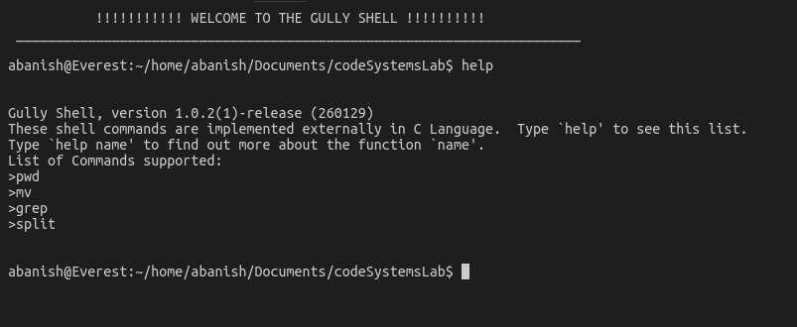
PWD & MV demo
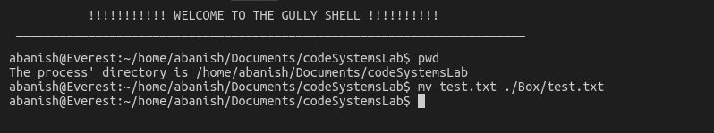

GREP demo
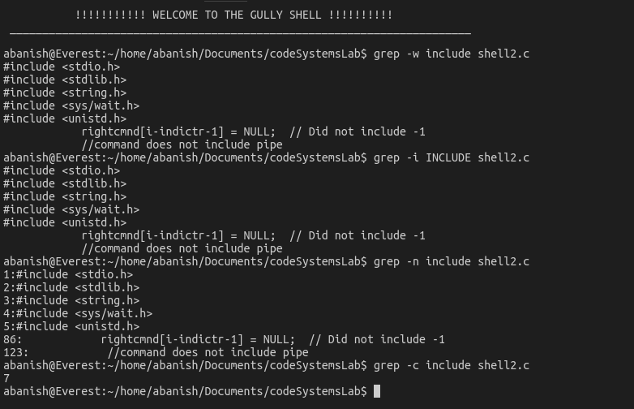

Installation

OS X
- Download Foco-osx.x.x.x.dmg or Foco-osx.x.x.x.zip
- Open or unzip the file and drag the app into the Applications folder
- Done!

Windows
coming soon 

Linux
Ubuntu, Debian 8+ (deb package):
- Download Foco-linux.x.x.x.deb
- Double click and install, or run dpkg -i Foco-linux.x.x.x.deb in the terminal
- Start the app with your app launcher or by running foco in a terminal

For developers
Clone the source locally:
$ git clone https://github.com/akashnimare/foco/
$ cd foco
If you're on Debian or Ubuntu, you'll also need to install nodejs-legacy:
Use your package manager to install npm.
$ sudo apt-get install npm nodejs-legacy
Install project dependencies:
$ npm install
Start the app:
$ npm start

Build installers
Build app for OSX
$ npm run build:osx
Build app for Linux
$ npm run build:linux

Features
- Offline support
- Cross-platform
- Awesome sounds
- No singup/login required
- Auto launch
- Auto updates

Usage
Command/ctrl + R - Reload
command + q - Quit App (while window is open).

Built with
- Electron
- Menubar

Related

License
IITG © Abhijeet Pandey
IITG © Abanish Chaudhary

