NON-FATAL OVERDOSE
BIOSURVEILLANCE

2026 QUARTER 1


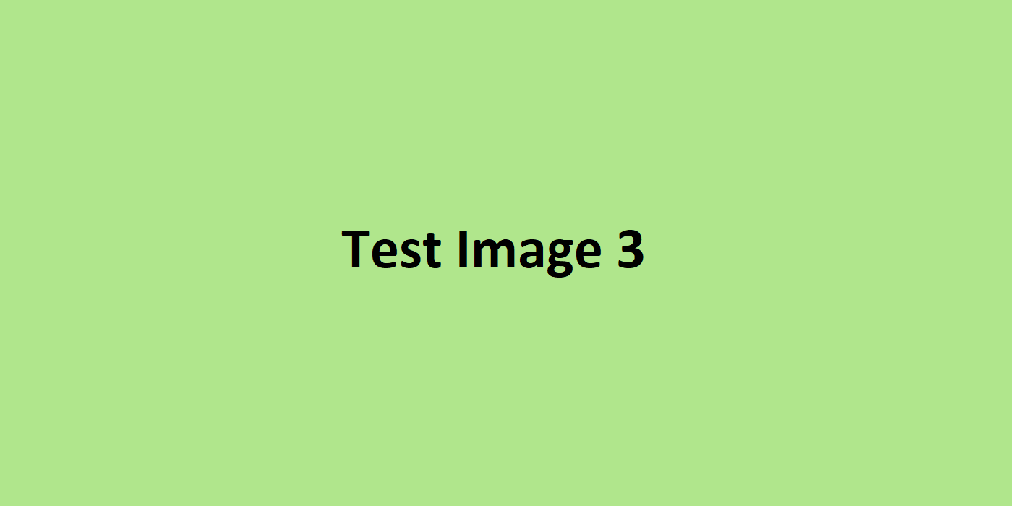


Here is some text.
Here is some text.
Here is some text.
Here is some text.
Here is some text.
Here is some text.
Here is some text.
Here is some text.

5 MOST COMMONLY DETECTED SUBSTANCES

NOVEL SUBSTANCES

