CS 340 Project Two README
Austin Banks

About the Project/Project Title
This project was developed as part of a software development assignment for Global Rain, a software engineering company contracted by Grazioso Salvare. They are an animal rescue training organization that identifies dogs that have potential to be trained for search and rescue operations.
The goal of this project is to develop a web application dashboard that allows their employees to search, filter, and view animal records to find potential candidates for their rescue training. It includes a Python CRUD (Create, Read, Update, Delete) module that connects to the dashboard and MongoDB. The module provides the logic needed to retrieve animal records and supports CRUD operations. The dashboard also includes a bar chart displaying the top animal breeds represented in each filtered group.
Challenges in this project included implementing the filtering options so users could view animals that matched the requirements for each rescue type category. I also had to make sure that the data table, bar chart, and map updated based on the filter that was selected. I overcame these challenges by utilizing course resources and testing the dashboard when I thought I had made the needed changes.

Motivation
This project was developed to make the animal shelter data easier to access and navigate when finding dogs suitable for search and rescue training. Different breeds are suited for different rescue activities such as water rescue, mountain or wilderness rescue, and disaster response. It allows users to filter what they need rather than search the entire dataset. The project also shows how databases and Python programming can be combined to support an organization’s needs.

Getting Started
This project consists of two main parts: The Python CRUD Module contains the AnimalShelter class, which connects to MongoDB and implements the create, read, update, and delete operations. The Project Two Dashboard contains the dashboard layout, drop down menu, data table, geolocation map, and the breed bar chart. The database uses the aac database and animals collection. The dashboard gets the dataset through the CRUD module and is able to present it in a table that can be interacted with. Users can select the rescue category they’d like to view from the dropdown menu.

Installation
List the tools you need to use the software and how to install them.
MongoDB was used as the database because the animal shelter records are stored there in a collection.

Python was used to develop the dashboard and the logic that connects the dashboard to MongoDB.

PyMongo was used to connect Python to MongoDB and perform operations through the AnimalShelter CRUD module.

Jupyter Notebook was used to create the web application dashboard

The CRUD Python Module file was imported into the dashboard using from CRUD_Python_Module import AnimalShelter

Pandas was used to organize the retrieved animal records into DataFrames and Plotly Express was used for the bar chart

Dash Leaflet was used to create the geolocation map

Usage.

Code Example
The dashboard uses the AnimalShelter class from the CRUD module to retrieve animal records from MongoDB.

From CRUD_Python_Module import AnimalShelter
Import pandas as pd

#Connect to MongoDB
Db = AimalShelter(username,password)

This code example shows how the dashboard uses the CRUD module to query MongoDB and use matching animal records to make a display.

#Water Rescue
elif filter_type == "Water Rescue":
query = {
"breed": {
"$regex": "Labrador Retriever Mix|Chesapeake Bay Retriever|Newfoundland",
"$options": "i"},
"sex_upon_outcome": "Intact Female",
"age_upon_outcome_in_weeks":{
"$gte": 26,
"$lte": 156}
}

records = db.read(query)

filtered_df = pd.DataFrame.from_records(records)

if "_id" in filtered_df.columns:
filtered_df.drop(columns=["_id"], inplace=True)

return filtered_df.to_dict("records")

Tests
The CRUD module was tested using the ModuleFourTestScript.ipynb Jupyter Notebook. The testing script imported and instantiated the AnimalShelter class and then tested the Create Read, Update, and Delete methods.

The test returned: Create result: True
Read result:
[{'_id': ObjectId('6abbd540d3e41e46f9b25521'), 'animal_id': 'Test1', 'animal_type': 'Dog', 'breed': 'German Shepherd', 'name': 'Test', 'age_upon_outcome': '3 years'}]

Update result: 1

Read after update:
{'_id': ObjectId('6abbd540d3e41e46f9b25521'), 'animal_id': 'Test1', 'animal_type': 'Dog', 'breed': 'German Shepherd', 'name': 'Updated Test Dog', 'age_upon_outcome': '3 years'}

Delete result: 1

Read after delete:
[]
The Poject Two dashboard was tested by verifying that the dashboard connected to MongoDB to display the animal shelter dataset, making sure that each rescue type dropdown filter displayed the correct results, and that selecting reset returned all widgets to their unfiltered state.

Screenshots
Provide screenshots that demonstrate your work.
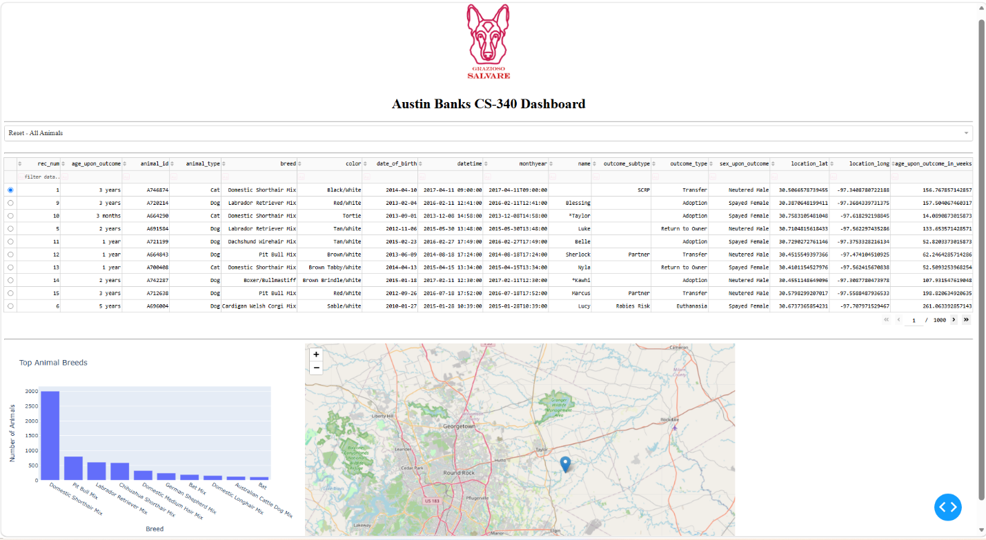

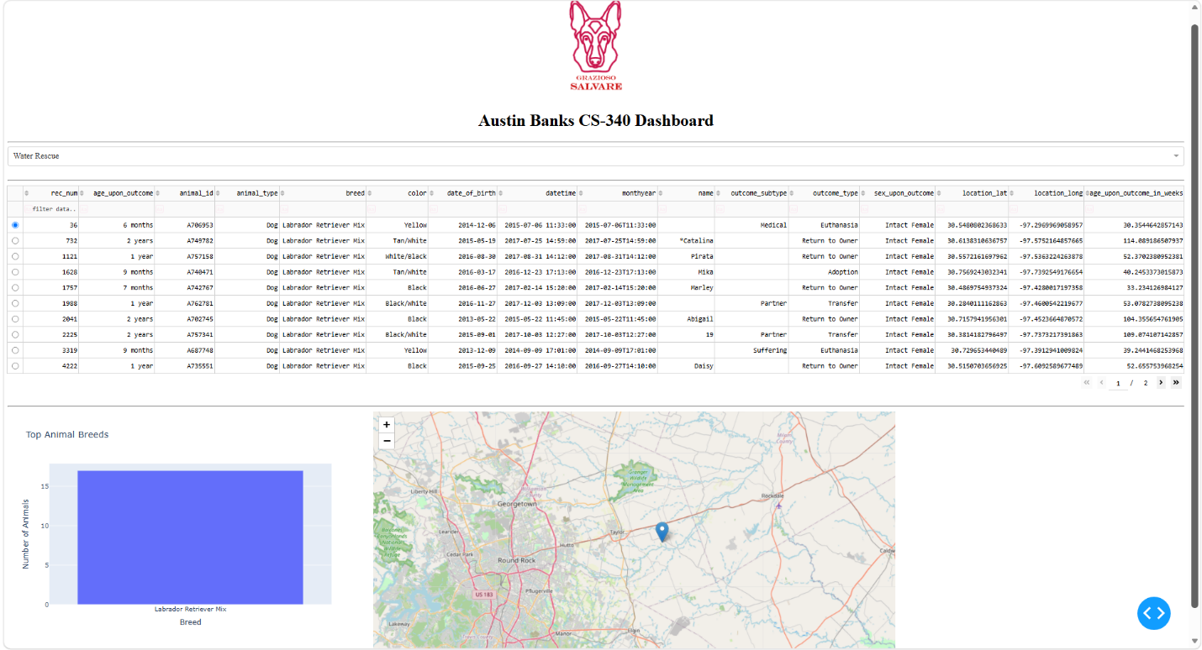

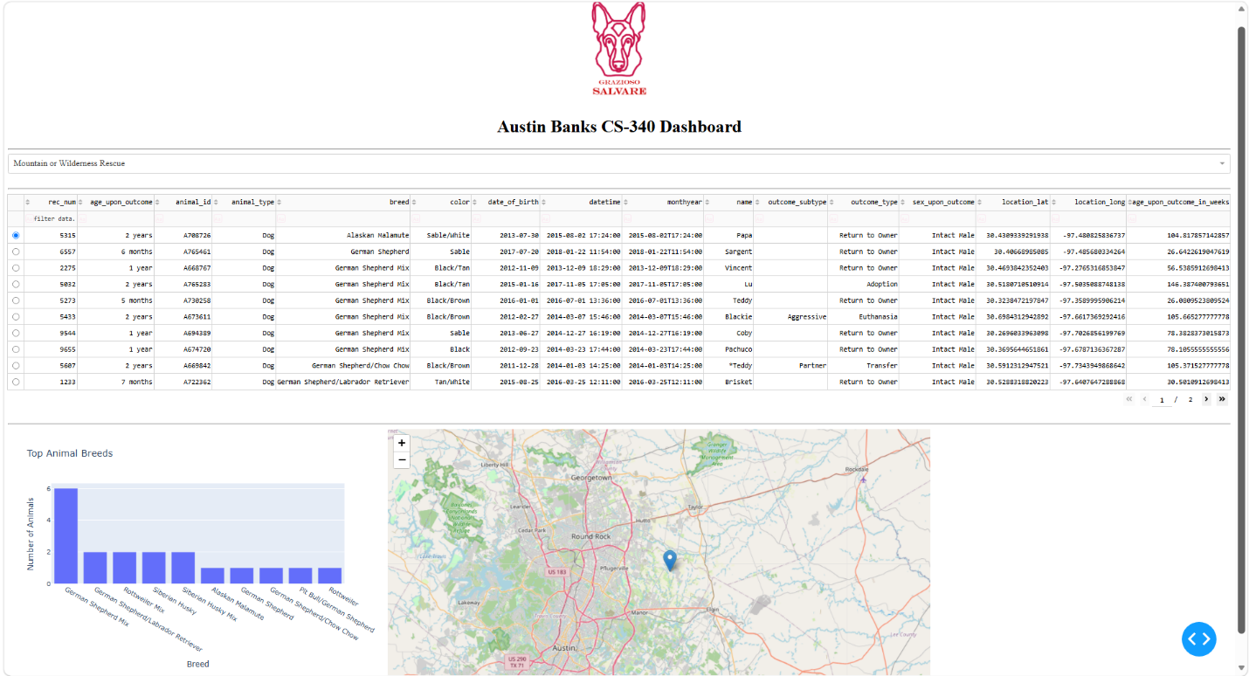

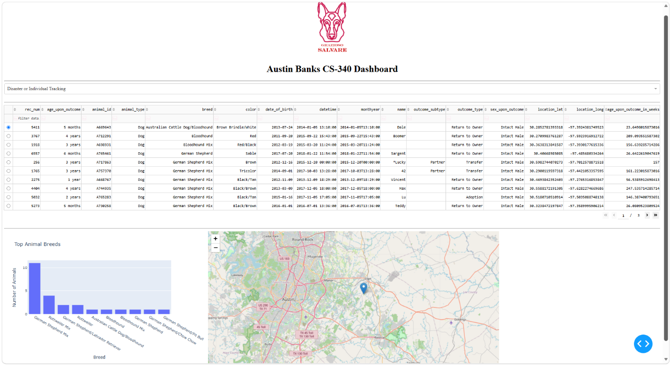

Contact
Your name: Austin Banks

