Analysis

ABB

22 June, 2023

## Plan of analysis to be carried out

for simple diagrams,

for complex connections - sankey diagram - for the link between printing methods + printing model with a link to the bioink type (+ origin)?

first things first, to give numbers of studies that report e.g. A or B

# Printing Techniques

Give an overview of the different printing techniques, - method - printer model - printer source - forms - software

## Kind of Printer Method

table(reconciled$`4.1 What kind of printing method is used?_ae684e28-4f90-44ad-9de2-731d076de0b0_Answer`)

##   
## Extrusion based Extrusion based|Unclear Inject based   
## 37 1 4   
## Other Stereolithography Unclear   
## 9 2 10

##  
 # Extrusion based Extrusion based|Unclear Inject based   
 # 37 1 4   
 # Other Stereolithography Unclear   
 # 9 2 10  
  
# proportions instead of absolute value of number of studies   
prop.table(table(reconciled$`4.1 What kind of printing method is used?_ae684e28-4f90-44ad-9de2-731d076de0b0_Answer`))

##   
## Extrusion based Extrusion based|Unclear Inject based   
## 0.58730159 0.01587302 0.06349206   
## Other Stereolithography Unclear   
## 0.14285714 0.03174603 0.15873016

barplot(table(reconciled$`4.1 What kind of printing method is used?_ae684e28-4f90-44ad-9de2-731d076de0b0_Answer`), ylab = "Number of studies", cex.names=.5 , col = "green")

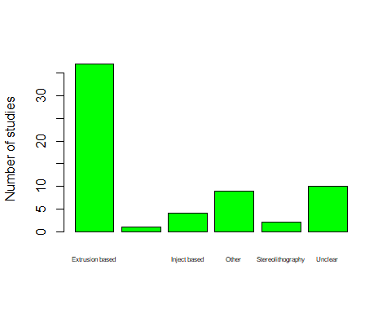

## Reporting of Printer Model

#### Reporting of Printer Model  
  
table(reconciled$`4.1.1 Do the authors report the printer model name/number?_a3e72486-56d3-4154-a45f-9fb87b8612fc_Answer`)

##   
## Not reported Not reported|Reported Reported   
## 22 1 40

# Not reported Not reported|Reported Reported   
 # 22 1 4  
  
  
barplot(table(reconciled$`4.1.1 Do the authors report the printer model name/number?_a3e72486-56d3-4154-a45f-9fb87b8612fc_Answer`), ylab = "Number of studies")

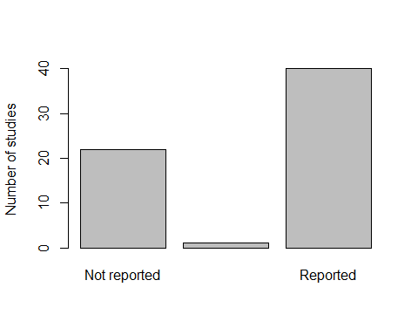

## Printer Source

#### Reporting of Printer Source  
  
table(reconciled$`4.1.2 What is the source of the printer?_102ba965-5234-4b3e-8b23-bd70cf4e074d_Answer`)

##   
## commercial modified commercial not reported self-made   
## 36 4 4 13   
## unclear unclear|commercial   
## 5 1

# commercial modified commercial not reported   
 # 36 4 4   
 # self-made unclear unclear|commercial   
 # 13 5 1  
  
barplot(table(reconciled$`4.1.2 What is the source of the printer?_102ba965-5234-4b3e-8b23-bd70cf4e074d_Answer`), ylab = "Number of studies", cex.names=.5, col = "green")

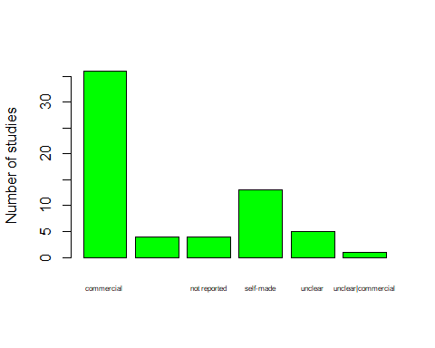

## Printer Forms

#### Reporting of Printer forms  
# split is based on the ink  
  
table(reconciled$`4.1.4 What kind of forms are printed with this ink?_01d3ca37-1e2f-4087-8f39-c183f98f0c4e_Answer`)

##   
## Grid Grid;Other   
## 19 1   
## Grid|Grid lobular liver   
## 2 7   
## lobular liver;Other lobular liver|lobular liver   
## 1 2   
## Other Other|Other   
## 25 5   
## Toroids   
## 1

# Grid Grid;Other   
 # 19 1   
 # Grid|Grid lobular liver   
 # 2 7   
 # lobular liver;Other lobular liver|lobular liver   
 # 1 2   
 # Other Other|Other   
 # 25 5   
 # Toroids   
 # 1  
  
# ABB to clean these responses  
# Those with a semicolon response ; should now be called "combo"  
# responses separate with a pipe should be merged when they are saying the same thing.   
  
printer_forms <- reconciled %>%   
 mutate(`4.1.4 What kind of forms are printed with this ink?_01d3ca37-1e2f-4087-8f39-c183f98f0c4e_Answer`= recode(`4.1.4 What kind of forms are printed with this ink?_01d3ca37-1e2f-4087-8f39-c183f98f0c4e_Answer`, "Grid|Grid" = "Grid")) %>%   
 mutate(`4.1.4 What kind of forms are printed with this ink?_01d3ca37-1e2f-4087-8f39-c183f98f0c4e_Answer`= recode(`4.1.4 What kind of forms are printed with this ink?_01d3ca37-1e2f-4087-8f39-c183f98f0c4e_Answer`, "lobular liver|lobular liver" = "lobular liver")) %>%   
 mutate(`4.1.4 What kind of forms are printed with this ink?_01d3ca37-1e2f-4087-8f39-c183f98f0c4e_Answer`= recode(`4.1.4 What kind of forms are printed with this ink?_01d3ca37-1e2f-4087-8f39-c183f98f0c4e_Answer`, "Other|Other" = "Other")) %>%   
 mutate(`4.1.4 What kind of forms are printed with this ink?_01d3ca37-1e2f-4087-8f39-c183f98f0c4e_Answer`= recode(`4.1.4 What kind of forms are printed with this ink?_01d3ca37-1e2f-4087-8f39-c183f98f0c4e_Answer`, "Grid;Other" = "Combination")) %>%   
 mutate(`4.1.4 What kind of forms are printed with this ink?_01d3ca37-1e2f-4087-8f39-c183f98f0c4e_Answer`= recode(`4.1.4 What kind of forms are printed with this ink?_01d3ca37-1e2f-4087-8f39-c183f98f0c4e_Answer`, "lobular liver;Other" = "Combination"))  
  
  
  
barplot(table(printer_forms$`4.1.4 What kind of forms are printed with this ink?_01d3ca37-1e2f-4087-8f39-c183f98f0c4e_Answer`), ylab = "Number of studies", cex.names=.5 , col = "green")

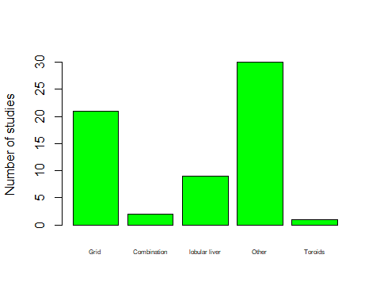

## Printer Software

#### Reporting of Printer software  
  
table(reconciled$`4.1.5 Do the authors report the name of the 3D modelling software?_f88d82a9-410c-4118-ad6a-4535d12c4aca_Answer`)

##   
## No No|No Not applicable Yes   
## 39 1 1 22

# No No|No Not applicable Yes   
 # 39 1 1 22  
  
## ABB combine No|No into the "No" group   
  
printer_soft <- reconciled %>%   
 mutate(`4.1.5 Do the authors report the name of the 3D modelling software?_f88d82a9-410c-4118-ad6a-4535d12c4aca_Answer` = recode(`4.1.5 Do the authors report the name of the 3D modelling software?_f88d82a9-410c-4118-ad6a-4535d12c4aca_Answer`, "No|No" = "No") )  
  
barplot(table(printer_soft$`4.1.5 Do the authors report the name of the 3D modelling software?_f88d82a9-410c-4118-ad6a-4535d12c4aca_Answer`), ylab = "Number of studies", cex.names=.5, col = "green")

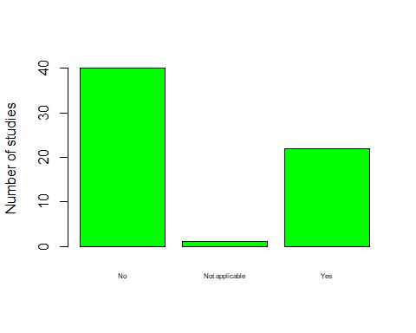

## Slicing Software  
  
# - since the review started, many cases - not applicable   
# merge NA with No and merge No|No with NO  
table(reconciled$`4.1.6 Do the authors report the name of slicing software?_bc07fc45-10aa-441f-9bdf-b32f5037389f_Answer`)

##   
## No No|No Not applicable Yes   
## 53 1 1 8

# No No|No Not applicable Yes   
 # 53 1 1 8   
  
## ABB to clean No|No and Not applicable into the No option.   
  
printer_slice <- reconciled %>%   
 mutate(`4.1.6 Do the authors report the name of slicing software?_bc07fc45-10aa-441f-9bdf-b32f5037389f_Answer` = recode(`4.1.6 Do the authors report the name of slicing software?_bc07fc45-10aa-441f-9bdf-b32f5037389f_Answer`, "No|No" = "No")) %>%   
 mutate(`4.1.6 Do the authors report the name of slicing software?_bc07fc45-10aa-441f-9bdf-b32f5037389f_Answer` = recode(`4.1.6 Do the authors report the name of slicing software?_bc07fc45-10aa-441f-9bdf-b32f5037389f_Answer`, "Not applicable" = "No"))  
  
barplot(table(printer_slice$`4.1.6 Do the authors report the name of slicing software?_bc07fc45-10aa-441f-9bdf-b32f5037389f_Answer`), ylab = "Number of studies", cex.names=.5, col = "green")

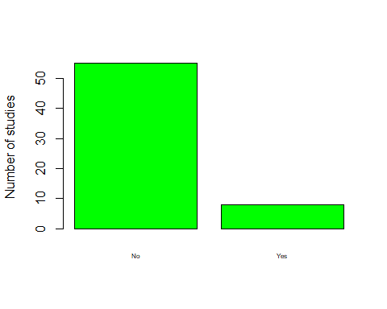

# BioInks

Give an overview of the different inks used with these techniques. - type - origin - additives - density

## Type of BioInk  
table(reconciled$`4.1.3 What type of bioink was used?_92421414-c597-4e9c-b720-9bb4318b5483_Answer`)

##   
## Natural Natural|Natural Natural|Synthetic   
## 43 3 5   
## Not reported Not reported|Natural Synthetic   
## 2 1 4   
## Unclear   
## 5

# clean?   
  
 # Natural Natural|Natural Natural|Synthetic   
 # 43 3 5   
 # Not reported Not reported|Natural Synthetic   
 # 2 1 4   
 # Unclear   
 # 5   
  
barplot(table(reconciled$`4.1.3 What type of bioink was used?_92421414-c597-4e9c-b720-9bb4318b5483_Answer`), ylab = "Number of studies", cex.names=.5, col = "blue")

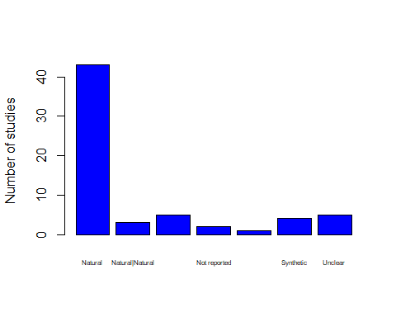

## If natural - what is the type type  
table(reconciled$`4.1.3.1.1 If natural bioink, please choose the type._66b761ad-6630-4323-b423-c848a717aae4_Answer`)

##   
## Other   
## 1   
## Polysaccharide based   
## 10   
## Polysaccharide based;dECM based   
## 1   
## Protein based   
## 14   
## Protein based;dECM based   
## 8   
## Protein based;Polysaccharide based   
## 13   
## Protein based;Polysaccharide based;dECM based   
## 1   
## Protein based;Polysaccharide based;Other   
## 1   
## Protein based;Polysaccharide based|Protein based;Polysaccharide based   
## 1   
## Protein based|dECM based   
## 1   
## Protein based|Protein based   
## 1

# output needs cleaning   
  
  
  
## Origin of BioInk   
table(reconciled$`4.1.3.2.Â What is the origin of the bioink?_34ef46b6-34ac-4ddb-a5de-07bc74272fca_Answer`)

##   
## commercial (ready-to-use) custom formulated   
## 6 44   
## custom formulated|custom formulated Not reported   
## 8 2   
## Unclear Unclear|Unclear   
## 2 1

# needs cleaning  
  
# commercial (ready-to-use) custom formulated   
# 6 44   
# custom formulated|custom formulated Not reported   
# 8 2   
# Unclear Unclear|Unclear   
# 2 1   
  
barplot(table(reconciled$`4.1.3.2.Â What is the origin of the bioink?_34ef46b6-34ac-4ddb-a5de-07bc74272fca_Answer`), ylab = "Number of studies", cex.names=.5, col = "blue")

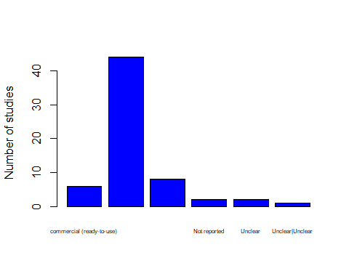

### Additives  
# -- needs cleaning   
table(reconciled$`4.1.3.3Â Which information is provided on the additives in the ink or culture?Â _4c2b5908-9c3c-4ba8-91f2-dd9771ac2ad4_Answer`)

##   
## Concentration   
## 9   
## Concentration;Manufacturer   
## 25   
## Concentration;Manufacturer;Order number   
## 8   
## Concentration;Manufacturer;Order number|Concentration;Manufacturer;Order number   
## 2   
## Concentration;Manufacturer|Concentration;Manufacturer   
## 4   
## Concentration|Concentration;Manufacturer   
## 1   
## Manufacturer   
## 1   
## None   
## 11   
## None|Concentration;Manufacturer   
## 1   
## None|None   
## 1

# needs cleaning  
  
  
  
## Cell density of bioInk  
table(reconciled$`4.1.3.4 Is the cell density of the bioinkÂ provided in the study?Â _d03a497a-c8ab-49a6-8fa7-5eca0d168c94_Answer`)

##   
## No No|No No|Yes Yes Yes|No Yes|Yes   
## 11 1 1 43 1 6

# needs cleaning   
  
 # No No|No No|Yes Yes Yes|No Yes|Yes   
 # 11 1 1 43 1 6

# Liver Cells

And then it is liver specific variables. - main type of liver cells - info about liver cells

AND - Main type of liver cells

if comments from reconciled - print out for all to see.

if any of reviewer comments say HepG2

table(reconciled$`2.2Â What is the main type of liver cells included?_9bea404f-a75c-401f-af5b-8fd020306538_Answer`)

##   
## Hepatoma cells Hepatoma cells;Other   
## 34 2   
## Induced pluripotent stem cells Induced pluripotent stem cells;Other   
## 3 1   
## Other Primary cells   
## 7 14   
## Primary cells;Hepatoma cells Primary cells;Other   
## 1 1

# clean? - Maren to clean   
  
 # Hepatoma cells Hepatoma cells;Other   
 # 28 2   
 # Induced pluripotent stem cells Induced pluripotent stem cells;Other   
 # 3 1   
 # Other Primary cells   
 # 12 14   
 # Primary cells;Hepatoma cells Primary cells;Other   
 # 2 1   
  
barplot(table(reconciled$`2.2Â What is the main type of liver cells included?_9bea404f-a75c-401f-af5b-8fd020306538_Answer`), ylab = "Number of studies", cex.names=.5, col = "turquoise")

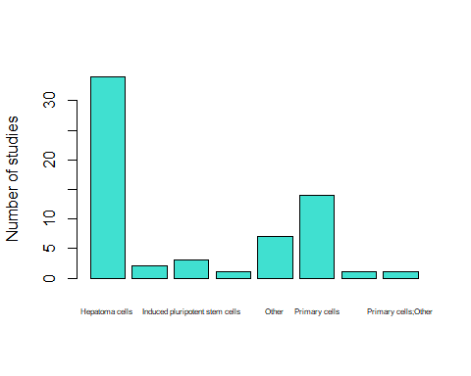

# ABB bring in the "other" from comments box   
  
table(reconciled$`2.2Â What is the main type of liver cells included?_9bea404f-a75c-401f-af5b-8fd020306538_Comments`)

##   
## AML12 hepatic parenchymal cells (murine)   
## 1   
## bone marrow mesenchymal cells   
## 1   
## cells isolated from cholangiocarinoma   
## 1   
## cryopreserved primary human hepatocytes   
## 1   
## from healthy liver biopsies   
## 1   
## Heb3B   
## 1   
## Hep3B   
## 1   
## Hep3B\n   
## 1   
## HepaRG   
## 3   
## HepaRG cells, LX-2 (hepatic stellate cell line)   
## 1   
## hepatocyte-like cells differentiated from adipose-derived mesenchymal stem cells   
## 1   
## hepatocyte-like cells directly converted from murine embryonic fibroblasts   
## 1   
## Hepatoma cells: derived from collagenase digestion of human HCC samples\n   
## 1   
## HepG2   
## 18   
## HepG2 C3A   
## 1   
## HepG2\n   
## 1   
## HepG2/C3A   
## 4   
## HepG2; human bone marrow-derived mesenchymal stem cells (BMMSCs)   
## 1   
## hiHep cells\n   
## 1   
## HMCS1SA   
## 1   
## Huh-7   
## 1   
## Huh-7 and HepaRG   
## 1   
## human adipose-derived stem cells (hASCs) differentiated towards hepatocyte-like cells (AHLCs)\n   
## 1   
## human adipose-derived stem cells were differntiated into hepatocytes   
## 1   
## Human induced pluripotent stem (hiPS) cell lines\nRCi-22 and RCi-50 and hESC lines RC-6 and RC-10, hESC-HLCs were printed.   
## 1   
## Human iPSC-derived hepatocytes   
## 1   
## Mouse primary hepatocyte   
## 1   
## Organoids from biopsies; immortalized cell line - HepG2   
## 1   
## primary cell liver spheroids   
## 1   
## primary cryopreserved human hepatocytes   
## 1   
## primary hepatocytes from murine livers   
## 1   
## primary human hepatocytes, other cells from liver: hepatic stellate cells; (HUVECs)   
## 1   
## primary human hepatocytes; human hepatic stellate cell line (LX2); primary fetal activated hepatic stellate cells (aHSC)\n   
## 1   
## primary mouse hepatocytes   
## 1   
## primary rat hepatocytes\n   
## 1

## clean the type of liver cells comments  
  
liverType <- tibble(  
   
 study_ID = reconciled$study_ID,   
 liverCells = reconciled$`2.2Â What is the main type of liver cells included?_9bea404f-a75c-401f-af5b-8fd020306538_Answer`,   
 liverCellsComment = reconciled$`2.2Â What is the main type of liver cells included?_9bea404f-a75c-401f-af5b-8fd020306538_Comments`  
   
)  
  
  
# remove line breaks  
library(stringr)  
liverType$liverCellsComment <- str_replace_all(liverType$liverCellsComment, "[\n]" , "")  
  
# create categories  
liverType$liverCellsComment <- as.factor(liverType$liverCellsComment)  
  
commentsLiver <- liverType %>% group_by(liverCellsComment) %>% summarise(n_unique = length(unique(study_ID))) %>% arrange(desc(n_unique))  
  
  
#install.packages("formattable")  
library(formattable)  
  
formattable(commentsLiver,  
 align =c("l", "r"),  
 list(`Indicator Name` = formatter(  
 "span", style = ~ style(color = "grey",font.weight = "bold")),   
 `n_unique`= color_bar("turquoise")  
))

liverCellsComment

n_unique

HepG2

19

NA

6

HepG2/C3A

4

HepaRG

3

Hep3B

2

AML12 hepatic parenchymal cells (murine)

1

bone marrow mesenchymal cells

1

cells isolated from cholangiocarinoma

1

cryopreserved primary human hepatocytes

1

from healthy liver biopsies

1

Heb3B

1

HepaRG cells, LX-2 (hepatic stellate cell line)

1

hepatocyte-like cells differentiated from adipose-derived mesenchymal stem cells

1

hepatocyte-like cells directly converted from murine embryonic fibroblasts

1

Hepatoma cells: derived from collagenase digestion of human HCC samples

1

HepG2 C3A

1

HepG2; human bone marrow-derived mesenchymal stem cells (BMMSCs)

1

hiHep cells

1

HMCS1SA

1

Huh-7

1

Huh-7 and HepaRG

1

human adipose-derived stem cells (hASCs) differentiated towards hepatocyte-like cells (AHLCs)

1

human adipose-derived stem cells were differntiated into hepatocytes

1

Human induced pluripotent stem (hiPS) cell linesRCi-22 and RCi-50 and hESC lines RC-6 and RC-10, hESC-HLCs were printed.

1

Human iPSC-derived hepatocytes

1

Mouse primary hepatocyte

1

Organoids from biopsies; immortalized cell line - HepG2

1

primary cell liver spheroids

1

primary cryopreserved human hepatocytes

1

primary hepatocytes from murine livers

1

primary human hepatocytes, other cells from liver: hepatic stellate cells; (HUVECs)

1

primary human hepatocytes; human hepatic stellate cell line (LX2); primary fetal activated hepatic stellate cells (aHSC)

1

primary mouse hepatocytes

1

primary rat hepatocytes

1

#### how is LIVER model Cultered?   
  
table(reconciled$`2.2.1Â How is the presented liver model cultured?_b6e561ab-c358-47fa-b9db-61e363b73223_Answer`)

##   
## Co-culture Monoculture Unclear   
## 33 29 1

# Co-culture Monoculture Unclear   
 # 33 29 1   
  
  
barplot(table(reconciled$`2.2.1Â How is the presented liver model cultured?_b6e561ab-c358-47fa-b9db-61e363b73223_Answer`), ylab = "Number of studies", cex.names=.7, col = "turquoise")

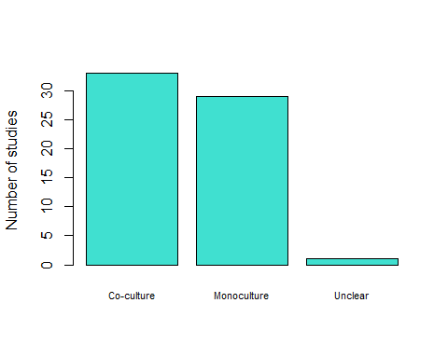

# If co-culter - what type of non-parenchymal cells   
# - need to clean  
table(reconciled$`2.2.1.1 If co-cultured, what type of non-parenchymal cells are included?_b729a62f-2dc7-47b6-ada7-e1ed8e363918_Answer`)

##   
## Endothelial cells   
## 7   
## Endothelial cells;Hepatic stellate cells   
## 5   
## Endothelial cells;Other   
## 6   
## Hepatic stellate cells   
## 2   
## Immune cells;Endothelial cells;Hepatic stellate cells   
## 1   
## Immune cells;Hepatic stellate cells   
## 2   
## Other   
## 10

# Maren to clean manually - bring in "other" responses from comments box  
  
  
  
# LIVER Model  
  
table(reconciled$`3.1 Does the study present a vascularization of the model?_3b31a6ff-4233-4f24-9e7e-2d2eb3c83420_Answer`)

##   
## No Yes, with perfusion Yes, without perfusion   
## 52 5 6

# No Yes, with perfusion Yes, without perfusion   
 # 52 5 6  
  
  
barplot(table(reconciled$`3.1 Does the study present a vascularization of the model?_3b31a6ff-4233-4f24-9e7e-2d2eb3c83420_Answer`), ylab = "Number of studies", cex.names=.7, col = "turquoise")

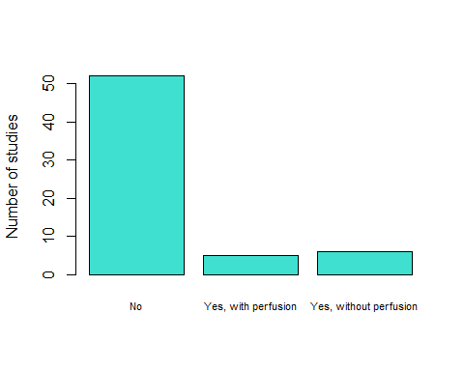

## hypoxia   
table(reconciled$`3.2 Do the authors address hypoxia/normoxia/oxygenation of the liver model?_5b050ea7-da29-4a47-bdea-23edda5877f2_Answer`)

##   
## No Yes, by measurement Yes, descriptive   
## 59 1 3

# No Yes, by measurement Yes, descriptive   
 # 59 1 3  
barplot(table(reconciled$`3.2 Do the authors address hypoxia/normoxia/oxygenation of the liver model?_5b050ea7-da29-4a47-bdea-23edda5877f2_Answer`), ylab = "Number of studies", cex.names=.7, col = "turquoise")

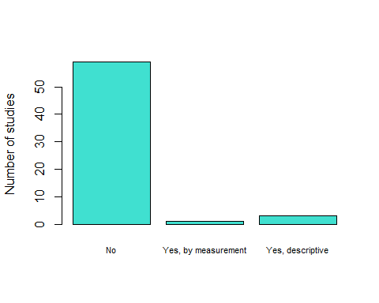

# Liver Cell Meta-Data

# Meta-data for Liver cells  
  
table(reconciled$`2.4 Which kind of meta data is available for the used liver cells?_2868ee50-2c4c-47e8-a040-427e4f882632_Answer`)

##   
## Age Common cell line Common cell line;None   
## 2 33 4   
## Health status None Sex;Age   
## 1 16 2   
## Sex;Age;Common cell line Sex;Age;Health status   
## 2 3

## common cell line; None should get merged with Common Cell line option   
# re-shape data to can number of bits of info?   
  
liverCell_meta <- reconciled %>% mutate(`2.4 Which kind of meta data is available for the used liver cells?_2868ee50-2c4c-47e8-a040-427e4f882632_Answer` = recode(`2.4 Which kind of meta data is available for the used liver cells?_2868ee50-2c4c-47e8-a040-427e4f882632_Answer`, "Common cell line;None" = "Common cell line"))  
  
liverMetaData <- separate_rows(liverCell_meta, `2.4 Which kind of meta data is available for the used liver cells?_2868ee50-2c4c-47e8-a040-427e4f882632_Answer` ,sep=";")  
  
  
liverMetaData_heat <- liverMetaData[,c(1, 58)]  
  
colnames(liverMetaData_heat) <- c("study_ID", "metaData")  
  
countsMetaDat <- liverMetaData_heat %>% group_by(study_ID) %>% summarize(n_unique = length(unique(metaData)))  
  
table(countsMetaDat$n_unique)

##   
## 1 2 3   
## 56 2 5

# 1 2 3   
# 56 2 5   
  
hist(countsMetaDat$n_unique, xlab = "Number of Meta-Data Items Reported", ylab = "Number of Papers", main = "Meta-Data Items about the Cell Lines Peformed per Paper", breaks = 3)

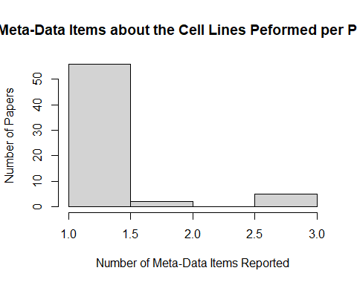

# Cells

What types of included cells? - human, animal, both

table(reconciled$`2.1 What is the origin of the cells in the liver model?_d2a55b1d-f869-4fa4-83a1-94eeb126c6fb_Answer`)

##   
## Animal Both Human   
## 4 14 45

#  
# Animal Both Human   
# 4 14 45   
  
barplot(table(reconciled$`2.1 What is the origin of the cells in the liver model?_d2a55b1d-f869-4fa4-83a1-94eeb126c6fb_Answer`), ylab = "Number of studies", cex.names=.7, col = "pink")

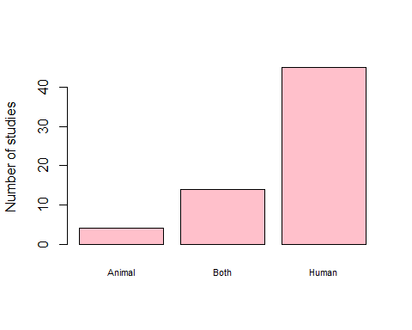

## If human, is it Xeno-free?

table(reconciled$`2.1.1 If human, is the described liver model xeno-free/animal-free?_7b2396a2-218d-462b-b71f-0c68bc5e9911_Answer`)

##   
## No Unclear   
## 43 2

barplot(table(reconciled$`2.1.1 If human, is the described liver model xeno-free/animal-free?_7b2396a2-218d-462b-b71f-0c68bc5e9911_Answer`)  
, ylab = "Number of studies", cex.names=.7, col = "pink")

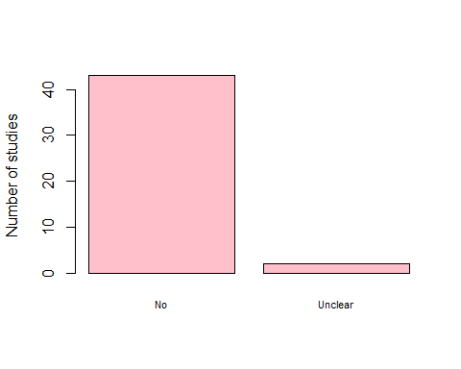

# Culture Conditions

What type of culture conditions? Liver Markers- what measurements?

table(reconciled$`5.2 How long were the liver models cultured after printing?_1f136f0a-786b-4e17-a97d-e5cf32f47b26_Answer`)

##   
## < 72 hours 2 weeks - 3 months 3 days - 2 weeks not reported   
## 2 16 42 3

# < 72 hours 2 weeks - 3 months 3 days - 2 weeks not reported   
 # 2 16 42 3   
barplot(table(reconciled$`5.2 How long were the liver models cultured after printing?_1f136f0a-786b-4e17-a97d-e5cf32f47b26_Answer`), ylab = "Number of studies", cex.names=.5, col = "purple")

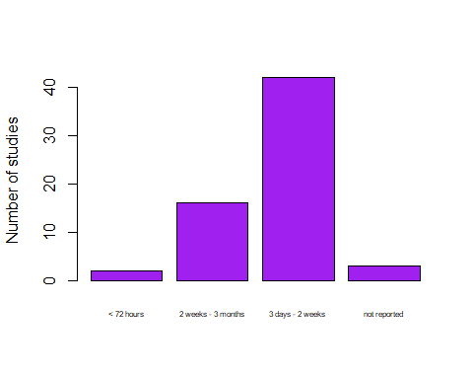

## ABB to order these in time order

# Liver Markers

# WHICH  
t <- table(reconciled$`6.1 Which liver markers were analysed in the presented model?_1844378b-1400-4d7a-b9f5-5538df7c7b76_Answer`)  
# clean?   
  
  
liverMarkers <- separate_rows(reconciled, `6.1 Which liver markers were analysed in the presented model?_1844378b-1400-4d7a-b9f5-5538df7c7b76_Answer` ,sep=";")  
  
markers_heat <- liverMarkers[,c(1, 94)]  
  
colnames(markers_heat) <- c("study_ID", "marker")  
  
new_marker <- markers_heat %>% group_by(marker) %>% summarize(n_unique = length(unique(study_ID)))  
  
new_marker$n_unique <- as.numeric(new_marker$n_unique)  
  
sort_new_marker <- new_marker %>% arrange(desc(n_unique))  
  
  
#install.packages("formattable")  
library(formattable)  
  
formattable(sort_new_marker,  
 align =c("l", "r"),  
 list(`Indicator Name` = formatter(  
 "span", style = ~ style(color = "grey",font.weight = "bold")),   
 `n_unique`= color_bar("yellow")  
))

marker

n_unique

Other

40

None

19

Lactate dehydrogenase (LDH)

9

Alanine aminotransferase (ALT)

2

Alkaline phosphatase (ALP)

1

Aspartate aminotransferase (AST)

1

Gamma-glutamyl transferase (GGT)

1

######################  
# liver marker "Other"  
  
t <- table(reconciled$`6.1 Which liver markers were analysed in the presented model?_1844378b-1400-4d7a-b9f5-5538df7c7b76_Comments`)  
  
## clean the type of liver cells comments  
  
  
liverMarkerComments_rows <- separate_rows(reconciled, `6.1 Which liver markers were analysed in the presented model?_1844378b-1400-4d7a-b9f5-5538df7c7b76_Comments`  
 ,sep=";")  
  
liverMarkerComments <- tibble(  
   
 study_ID = liverMarkerComments_rows$study_ID,   
 liverMarker = liverMarkerComments_rows$`6.1 Which liver markers were analysed in the presented model?_1844378b-1400-4d7a-b9f5-5538df7c7b76_Answer`,   
 liverMarkerComment = liverMarkerComments_rows$`6.1 Which liver markers were analysed in the presented model?_1844378b-1400-4d7a-b9f5-5538df7c7b76_Comments`  
   
)  
  
# remove line breaks  
library(stringr)  
liverMarkerComments$liverMarkerComment <- str_replace_all(liverMarkerComments$liverMarkerComment, "[\n]" , "")  
  
# liverMarkerComments$liverMarker <- as.character(liverMarkerComments$liverMarker)  
  
  
# create categories  
# liverMarkerComments$liverMarkerComment <- as.factor(liverMarkerComments$liverMarkerComment)  
  
commentsLiver <- liverMarkerComments %>% group_by(liverMarkerComment) %>% summarise(n_unique = length(unique(study_ID))) %>% arrange(desc(n_unique))  
  
  
#install.packages("formattable")  
library(formattable)  
  
formattable(commentsLiver,  
 align =c("l", "r"),  
 list(`Indicator Name` = formatter(  
 "span", style = ~ style(color = "grey",font.weight = "bold")),   
 `n_unique`= color_bar("yellow")  
))

liverMarkerComment

n_unique

NA

23

Albumin

7

Urea

3

Albumin, Urea

3

albumin, urea

2

ALB

1

Albumin

1

Alpha 1 antitrypsin

1

CD31

1

CYP

1

CYP4A4 activity and secretion

1

Cytochromes 1A2, 3A4, and 2C19

1

Glutathione S-transferase alpha 1

1

HFN4alpha

1

NMDA receptor 1 iso- form NR1-2 variant

1

albumin and MRP2

1

alpha-fetoprotein (AFP)

1

asialoglycoprotein receptor 1, alpha-fetoprotein, cytokeratin 19, tyrosine amino-transferase

1

cytokeratin 19 (CK19)

1

glutathione s-transferase alpha (alpha-GST)

1

multidrug resist- ance-associated protein 2 (MRP2)

1

organic anion transporter protein 1B3 (OATP1B3)

1

staning for MRP2

1

transthyre- tin (TTR)

1

transthyretin TTR

1

ALB, AFP

1

ALB, AFP and CYP3A4

1

ATP

1

Albumin and Urea

1

Albumin, AFP, ASGPR1, HNF4a

1

Albumin, CYP, MRP2, Urea

1

Albumin, Cyp3A4, HNF4alpha, Zo-1, MDR1, CK-19, E-cadherin, glutamate dehydrogenase

1

Albumin, HNF4a

1

Albumin, Urea, HNF4alpha, TTR, AFP, CYP3A4, CYP2C9, CYP2C19, CYP2B6, CYP1A2

1

Albumin, Urea, OCT

1

Albumin, tryptophan 2,3-dioxygenase

1

Albumin, urea, CYP3A4

1

Alpha-fetoprotein AFP

1

CD31

1

HNF4a, albumin, Foxa3, ASGR1, CK18

1

MRP2

1

Urea

1

albumin

1

albumin (ALB)

1

albumin (ALB), Î±-fetoprotein (AFP), transthyretin (TTR), cytokeratin 18 (CK18), hepatocyte nuclear factor 1Î± (HNF1A), hepatocyte nuclear factor 3Î² (HNF3B), hepatocyte nuclear factor 4Î± (HNF4A), and hepatocyte nuclear factor 6 (HNF6)

1

albumin ELISA

1

albumin, AFP, GST

1

albumin, ceruloplasmin, alpha-1 antitrypsin (A1AT) and transferrin

1

albumin, urea, AFP, CK18, CYP1A2, ASGR1

1

alpha-1 antitrypsin (AAT)

1

alpha-fetoprotein levels (HCC marker)

1

alpha-smooth muscle actin (Î±-SMA)

1

beta-Catenin

1

hepatic markers ATP-binding cassette super-family G member 2 (G6PC), bile salt export pump (BSEP), glucose_x0002_6-phosphatase catalytic subunit (ABCG2), and cytochrome P450 3A4 (CYP3A4), s HNF4a

1

human albumin, alpha-fetoprotein, alpha-1 antitrypsin and urea

1

qPCR: albumin, Collagen A1, ACTA2,COLA1,MMP2,TIMP1, CYP1A1, CYP1A2,CYP2B6,CYP2C19,CYP2C9,CYP2E1,CYP3A4,ALDOB,HFN4A,NR1H4(FXR),NR1/2(PXR),SERPINA1, ABCC2

1

total protein, total bile acids

1

## trying 6.4   
# which metabolites were analysed   
t <- table(reconciled$`6.4 Which metabolites were analyzed in the study?_5652d702-1441-4234-b37d-f0b44d64c5e9_Answer`)  
  
liverMetabolite <- separate_rows(reconciled, `6.4 Which metabolites were analyzed in the study?_5652d702-1441-4234-b37d-f0b44d64c5e9_Answer`  
 ,sep=";")  
  
liverMetabolite$`6.4 Which metabolites were analyzed in the study?_5652d702-1441-4234-b37d-f0b44d64c5e9_Comments` <- str_replace_all(liverMetabolite$`6.4 Which metabolites were analyzed in the study?_5652d702-1441-4234-b37d-f0b44d64c5e9_Comments`, "[\n]" , "")  
  
liverMetabolite_comments <- liverMetabolite %>% select(c(study_ID, `6.4 Which metabolites were analyzed in the study?_5652d702-1441-4234-b37d-f0b44d64c5e9_Answer`, `6.4 Which metabolites were analyzed in the study?_5652d702-1441-4234-b37d-f0b44d64c5e9_Comments`))  
  
  
commentsLiverMetabolite <- liverMetabolite_comments %>% group_by(`6.4 Which metabolites were analyzed in the study?_5652d702-1441-4234-b37d-f0b44d64c5e9_Answer`) %>% summarise(n_unique = length(unique(study_ID))) %>% arrange(desc(n_unique))  
  
  
otherLiverMetabolite <- liverMetabolite_comments %>% group_by(`6.4 Which metabolites were analyzed in the study?_5652d702-1441-4234-b37d-f0b44d64c5e9_Comments`) %>% summarise(n_unique = length(unique(study_ID))) %>% arrange(desc(n_unique))  
  
# print(otherLiverMetabolite)  
  
#install.packages("formattable")  
library(formattable)  
  
formattable(commentsLiverMetabolite,  
 align =c("l", "r"),  
 list(`Indicator Name` = formatter(  
 "span", style = ~ style(color = "grey",font.weight = "bold")),   
 `n_unique`= color_bar("yellow")  
))

6.4 Which metabolites were analyzed in the study?_5652d702-1441-4234-b37d-f0b44d64c5e9_Answer

n_unique

Albumin

47

Urea

24

None

15

Other

7

Bile acid

3

#####################  
  
  
# WHERE  
table(reconciled$`6.1.1 Where were the liver markers measured?_a70225ae-f529-4b91-bcc9-8081d7efc6e2_Answer`)

##   
## Cells Media Media;Cells Not reported   
## 10 15 19 19

# Cells Media Media;Cells Not reported   
 # 10 15 19 19   
barplot(table(reconciled$`6.1.1 Where were the liver markers measured?_a70225ae-f529-4b91-bcc9-8081d7efc6e2_Answer`), ylab = "Number of studies", cex.names=.7, col = "yellow")

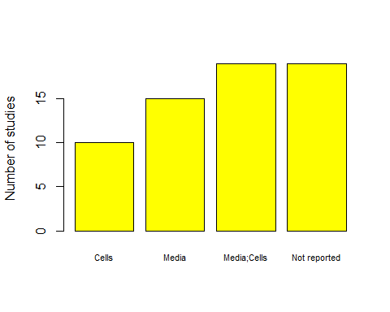

# CYP450   
table(reconciled$`6.2 Does the study analyse the Cytochrome P450 CYP450 level in the print?_3c21cc1f-1431-49c7-ad8f-bda83956828a_Answer`)

##   
## No Yes   
## 33 30

# No Yes   
 # 33 30   
  
barplot(table(reconciled$`6.2 Does the study analyse the Cytochrome P450 CYP450 level in the print?_3c21cc1f-1431-49c7-ad8f-bda83956828a_Answer`), ylab = "Number of studies", cex.names=.7, col = "yellow")

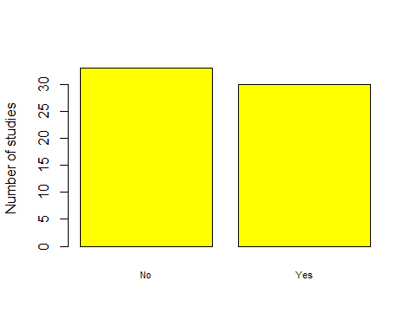

table(reconciled$`6.2.1 If yes, which cytochrome isoforms were analysed?_62bdffd7-d9c7-4646-9f66-9510f5bf2649_Answer`)

##   
## Cytochrome P450 1A2 (CYP1A)   
## 4   
## Cytochrome P450 1A2 (CYP1A);Cytochrome P450 2E1 (CYP2E)   
## 1   
## Cytochrome P450 1A2 (CYP1A);Cytochrome P450 3A4 (CYP3A)   
## 1   
## Cytochrome P450 1A2 (CYP1A);Cytochrome P450 3A4 (CYP3A);Cytochrome P450 2B6 (CYP2B)   
## 1   
## Cytochrome P450 1A2 (CYP1A);Cytochrome P450 3A4 (CYP3A);Cytochrome P450 2B6 (CYP2B);Cytochrome P450 2C9 (CYP2C)   
## 1   
## Cytochrome P450 1A2 (CYP1A);Cytochrome P450 3A4 (CYP3A);Cytochrome P450 2B6 (CYP2B);Cytochrome P450 2C9 (CYP2C);Cytochrome P450 2D6 (CYP2D)   
## 2   
## Cytochrome P450 1A2 (CYP1A);Cytochrome P450 3A4 (CYP3A);Cytochrome P450 2B6 (CYP2B);Cytochrome P450 2C9 (CYP2C);Cytochrome P450 2E1 (CYP2E)   
## 1   
## Cytochrome P450 1A2 (CYP1A);Cytochrome P450 3A4 (CYP3A);Cytochrome P450 2C9 (CYP2C);Cytochrome P450 2D6 (CYP2D)   
## 1   
## Cytochrome P450 1A2 (CYP1A);Cytochrome P450 3A4 (CYP3A);Other   
## 3   
## Cytochrome P450 2C9 (CYP2C)   
## 1   
## Cytochrome P450 2E1 (CYP2E)   
## 1   
## Cytochrome P450 3A4 (CYP3A)   
## 9   
## Cytochrome P450 3A4 (CYP3A);Cytochrome P450 2D6 (CYP2D)   
## 1   
## Cytochrome P450 3A4 (CYP3A);Cytochrome P450 2D6 (CYP2D);Cytochrome P450 2E1 (CYP2E)   
## 1   
## Not reported   
## 2

## output needs cleaning  
  
  
## agonists  
table(reconciled$`6.3 Have agonists of the receptors for the inducibility of CYPs been applied?_ac9f38a8-8fe2-44de-a180-24fddd78fb59_Answer`)

##   
## No Yes   
## 54 9

# No Yes   
 # 54 9   
barplot(table(reconciled$`6.3 Have agonists of the receptors for the inducibility of CYPs been applied?_ac9f38a8-8fe2-44de-a180-24fddd78fb59_Answer`), ylab = "Number of studies", cex.names=.7, col = "yellow")

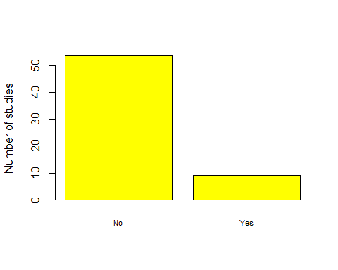

# Quality

* Quality Assays
* storage conditions
* application
* time

## Does the study describe quality assurance?

table(reconciled$`5.3 Does the study describe quality-assuring assays for the printed model?_09745b80-9723-4e5c-8a47-dfc8a9c71a6d_Answer`)

##   
## Yes   
## 63

# Yes   
# 63

## Which assays were performed?

library(tidyverse)  
### messy - needs cleaning  
messy_assay <- table(reconciled$`5.3.1 Which assays were performed to assure the quality of the liver model?_8a415412-28c6-48ff-840a-538ea69a068f_Answer`)  
# needs cleaning   
  
  
assays <- separate_rows(reconciled, `5.3.1 Which assays were performed to assure the quality of the liver model?_8a415412-28c6-48ff-840a-538ea69a068f_Answer` ,sep=";")  
  
assays_heat <- assays[,c(1, 91)]  
  
colnames(assays_heat) <- c("study_ID", "assay")  
  
new <- assays_heat %>% group_by(assay) %>% summarize(n_unique = length(unique(study_ID)))  
  
new$n_unique <- as.numeric(new$n_unique)  
  
sort_new <- new %>% arrange(desc(n_unique))  
  
  
#install.packages("formattable")  
library(formattable)  
  
formattable(sort_new,  
 align =c("l", "r"),  
 list(`Indicator Name` = formatter(  
 "span", style = ~ style(color = "grey",font.weight = "bold")),   
 `n_unique`= color_bar("lightgreen")  
))

assay

n_unique

Viability test

47

Histological characterization

45

Live/Dead Cell Staining

44

Enzyme linked immunosorbent Assay (ELISA) of liver markers

30

Real-time quantitative PCR of liver markers

28

Rheological test

23

Mechanical stiffness

15

Size measurement

13

Biodegradation

4

Biocompatibility

3

### 10 different tests are used across 63 papers, a total of 252 tests were used.   
# the most popular are listed below  
  
  
  
  
  
  
  
  
## also how many assay were performed? 1, 2, 3, 4, 5, or more.   
  
  
counts <- assays_heat %>% group_by(study_ID) %>% summarize(n_unique = length(unique(assay)))  
  
table(counts$n_unique)

##   
## 1 2 3 4 5 6 7   
## 4 10 6 17 16 8 2

# 1 2 3 4 5 6 7   
 # 4 10 6 17 16 8 2  
  
hist(counts$n_unique, xlab = "Number of Assays Reported", ylab = "Number of Papers", main = "Number of Assays Peformed per Paper",)

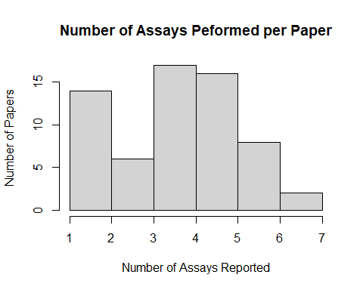

## Applications in the paper

# Application   
table(reconciled$`7.1 Do the authors apply the model in the study?_a6895d38-a9ed-4605-a092-4f06ebbd9e2b_Answer`)

##   
## No Yes   
## 35 28

# No Yes   
 # 35 28   
  
barplot(table(reconciled$`7.1 Do the authors apply the model in the study?_a6895d38-a9ed-4605-a092-4f06ebbd9e2b_Answer`), ylab = "Number of studies", cex.names=.7, col = "gray")

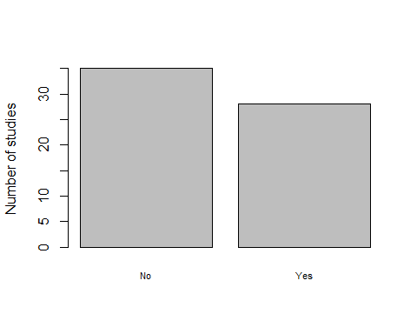

# field of application   
table(reconciled$`7.1.1 please select the field of application. _d332c2ee-9864-434f-8595-90305808e32d_Answer`)

##   
## Disease modeling   
## 3   
## Drug dosage testing   
## 2   
## Drug dosage testing;Disease modeling   
## 1   
## Drug dosage testing;Xenograft (implantation into animal);Disease modeling   
## 1   
## Implant / Medical surgery   
## 1   
## Other   
## 3   
## Toxicity testing   
## 10   
## Toxicity testing;Drug dosage testing   
## 4   
## Toxicity testing;Drug dosage testing;Other   
## 1   
## Xenograft (implantation into animal)   
## 2