Bimuno Analysis with Data Averaged per Cage

# Import Data

library(ggplot2)  
library(plyr)  
library(dplyr)

##   
## Attaching package: 'dplyr'

## The following objects are masked from 'package:plyr':  
##   
## arrange, count, desc, failwith, id, mutate, rename, summarise,  
## summarize

## The following objects are masked from 'package:stats':  
##   
## filter, lag

## The following objects are masked from 'package:base':  
##   
## intersect, setdiff, setequal, union

library(tidyr)  
library(naniar)  
library(car)

## Loading required package: carData

##   
## Attaching package: 'car'

## The following object is masked from 'package:dplyr':  
##   
## recode

library(ggpubr)

## Loading required package: magrittr

##   
## Attaching package: 'magrittr'

## The following object is masked from 'package:tidyr':  
##   
## extract

##   
## Attaching package: 'ggpubr'

## The following object is masked from 'package:plyr':  
##   
## mutate

theme_set(theme_pubclean())  
  
  
# reading in data  
# set working directory   
full_data <- read.csv("~/Downloads/bimuno/full_data.csv")  
  
# grouping data to average per cage  
  
full_data_group <- group_by(full_data, cage.code)   
  
full_data_nested <- summarise(full_data_group,  
 cagecode=first(cage.code),  
 model=first(model),  
 drug=first(drug),  
 Weight_W1=mean(Weight_W1),  
 Weight_W2=mean(Weight_W2),  
 Weight_W3=mean(Weight_W3),  
 Weight_W4=mean(Weight_W4),  
 weight_euth=mean(Euthanisation_Weight),  
 OF_Distance_totalcm=mean(OF_Distance_totalcm),  
 OF_Velocity_meancms=mean(OF_Velocity_meancms),  
 FST_preswim_strug=mean(FST_preswim_strug),   
 FST_preswim_swim=mean(FST_preswim_swim),  
 FST_preswim_imm=mean(FST_preswim_imm),  
 FST_swim_strug=mean(FST_swim_strug),  
 FST_swim_swim=mean(FST_swim_swim),  
 FST_swim_imm=mean(FST_swim_imm),  
 EPM_close_freq=mean(EPM_close_freq),  
 EPM_close_secs=mean(EPM_close_secs),  
 EPM_open_freq=mean(EPM_open_freq),  
 EPM_open_secs=mean(EPM_open_secs),  
 EPM_open_latency=mean(EPM_open_latency),  
 EPM_fullopen_freq=mean(EPM_fullopen_freq),  
 EPM_fullopen_secs=mean(EPM_fullopen_secs),  
 EPM_fullopen_latency=mean(EPM_fullopen_latency)  
 )  
  
# remove NA columns  
full_data_nested <- full_data_nested[rowSums(is.na(full_data_nested)) != ncol(full_data_nested), ]  
  
  
  
# Variable names:   
# [1] "Cage.Code" "animal.code" "model" "drug"   
# "Weight_W1" "Weight_W2" "Weight_W3" "Weight_W4" "Euthanisation_Weight" "OF_Distance_totalcm" "OF_Velocity_meancms"   
# [7] "FST_preswim_strug" "FST_preswim_swim" "FST_preswim_imm" "FST_swim_strug" "FST_swim_swim" "FST_swim_imm"   
# [13] "EPM_close_freq" "EPM_close_secs" "EPM_open_freq" "EPM_open_secs" "EPM_open_latency" "EPM_fullopen_freq"   
# [19] "EPM_fullopen_secs" "EPM_fullopen_latency"

# Testing Assumptions

###This experiment has two Factors (i.e., types of manipulations: Phenotype and Invasiveness), and the experiment has data for all 4 possible combinations of these two Factors. We should try to analyze it as a 2-way ANOVA.  
  
###Plot the data:  
full_data_nested$group <- factor(paste(full_data_nested$model,full_data_nested$drug))  
  
boxplot(FST_swim_imm ~ group, data=full_data_nested,cex.axis = 1.2)  
stripchart(FST_swim_imm ~ group, data=full_data_nested,  
vertical = TRUE, method = "jitter",  
pch = 21, col = "maroon", bg = "bisque",  
add = TRUE)  
mtext("immobility",2,line=2.5,cex=1.5)

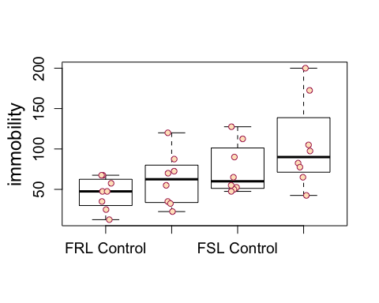

###Model the data  
p <- aov(FST_swim_imm ~ group, data=full_data_nested)  
  
###Check the assumptions:  
plot(p)

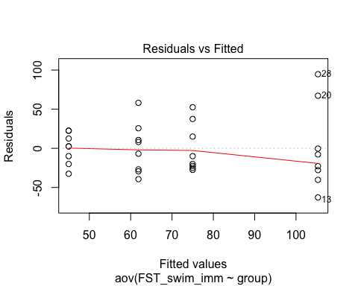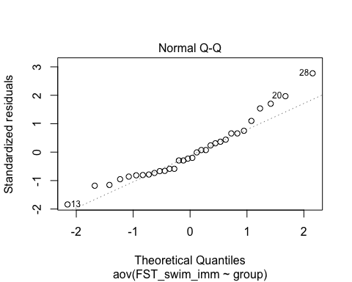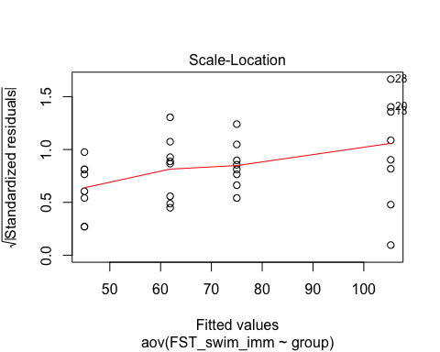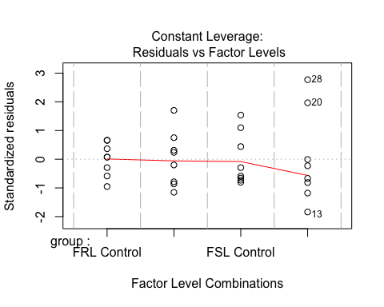

#### R identified case 13, 20 and 20 as outliers and have heterogeneity of residuals.. - all from Gin - Red group.   
  
leveneTest(full_data_nested$FST_swim_imm ~ full_data_nested$model * full_data_nested$drug)

## Levene's Test for Homogeneity of Variance (center = median)  
## Df F value Pr(>F)  
## group 3 1.1862 0.3328  
## 28

# Levene's Test for Homogeneity of Variance (center = median)  
# Df F value Pr(>F)  
# group 3 1.1862 0.3328  
# 28   
  
# so no significant differences in equal variances - therefore heterogeneity  
  
shapiro.test(p$residuals)

##   
## Shapiro-Wilk normality test  
##   
## data: p$residuals  
## W = 0.94601, p-value = 0.1109

# Shapiro-Wilk normality test  
#   
# data: p$residuals  
# W = 0.94601, p-value = 0.1109  
  
# both not significant so no vioaltion of assumptions  
  
hist(resid(p))

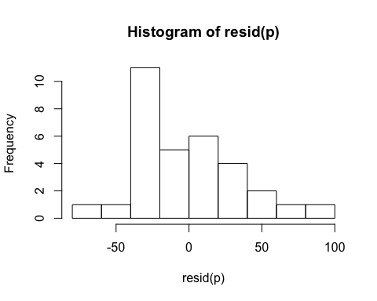

# redisuals are somewhat normally distributed

# Results for FST Immobility:

## All error bars throughout document are SD

## fst immobility  
anova(lm(FST_swim_imm ~ model * drug, full_data_nested))

## Analysis of Variance Table  
##   
## Response: FST_swim_imm  
## Df Sum Sq Mean Sq F value Pr(>F)   
## model 1 10786 10786.1 8.0936 0.008213 **  
## drug 1 4453 4453.3 3.3416 0.078221 .   
## model:drug 1 361 361.1 0.2710 0.606765   
## Residuals 28 37315 1332.7   
## ---  
## Signif. codes: 0 '***' 0.001 '**' 0.01 '*' 0.05 '.' 0.1 ' ' 1

sum_data_fst_imm <- ddply(full_data_nested, c("model", "drug"), summarise,  
 N = length(FST_swim_imm),  
 mean = mean(FST_swim_imm),  
 sd = sd(FST_swim_imm),  
 se = sd / sqrt(N)  
)  
  
# p1 <- ggplot(sum_data_fst_imm, aes(x=model, y=mean, fill=drug)) +   
# geom_bar(position=position_dodge(), stat="identity") +  
# geom_errorbar(aes(ymin=mean-sd, ymax=mean+sd),  
# width=.2, # Width of the error bars  
# position=position_dodge(.9))+  
# labs(x = "", fill= "Drug")  
  
# full_data_nested$dist_cat_n[full_data_nested$model == "Gin"] <- 1  
# full_data_nested$dist_cat_n[full_data_nested$model == "Whisky"] <- 2  
#   
# full_data_nested$scat_adj[full_data_nested$drug == "Blue"] <- -0.2  
# full_data_nested$scat_adj[full_data_nested$drug == "Red"] <- 0.2  
#   
# min.mean.sd.max <- function(x) {  
# r <- c(min(x), mean(x) - sd(x), mean(x), mean(x) + sd(x), max(x))  
# names(r) <- c("ymin", "lower", "middle", "upper", "ymax")  
# r  
# }  
  
  
# p1 <- ggplot(full_data_nested, aes(x=model, y=FST_swim_imm, fill=drug))  
# p1 + geom_boxplot(  
# aes(color = drug), width = 0.5, size = 0.4,  
# position = position_dodge(0.8)  
# ) +  
# geom_dotplot(  
# aes(fill = drug, color = drug),  
# #trim = FALSE,  
# binaxis='y', stackdir='center', dotsize = 0.8,  
# position = position_dodge(0.8)  
# )+  
# scale_fill_manual(values = c("#0000FF", "#FF0000"))+  
# scale_color_manual(values = c("#0000FF", "#FF0000"))  
  
#install.packages("Hmisc")  
#library(Hmisc)  
p_test <- ggplot(full_data_nested, aes(x=model, y=FST_swim_imm, fill=drug)) +   
 geom_dotplot(binaxis='y', stackdir='center', position=position_dodge(0.8))  
p_test + stat_summary(fun.data="mean_sdl", fun.args = list(mult=1),   
 geom="errorbar", color="black", position=position_dodge(0.8), width=0.2 )+  
 stat_summary(fun.y=mean, geom="point", color="black",position=position_dodge(0.8))+  
 scale_fill_manual(values = c("#0000FF", "#FF0000"))+  
 ylab("FST Immobility (secs)")+  
 labs(x = "", fill= "Intervention")

## `stat_bindot()` using `bins = 30`. Pick better value with `binwidth`.

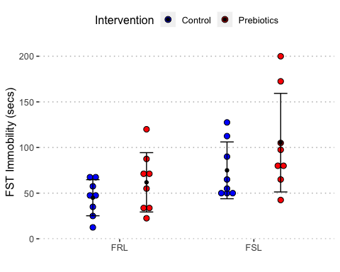

#   
# p1 <- ggplot(full_data_nested, aes(x=model, y=FST_swim_imm, fill=drug)) +   
# geom_boxplot(outlier.size=0)+  
# labs(x = "", fill= "Drug")+   
# geom_jitter(aes(dist_cat_n + scat_adj,FST_swim_imm),  
# # position=position_jitter(width=0.1,height=0),  
# # alpha=0.6,  
# # size=3,  
# show.legend = FALSE)+  
# ylab("FST Immobility (secs)")+ stat_summary(fun.y=mean, geom="point", size=2, position=0.2) +  
# stat_summary(fun.data = mean_se, geom = "errorbar", position=-0.2)  
#   
# p1+scale_fill_manual(values=c("#0000FF", "#FF0000"))  
  
  
# effect of model - expect to see difference between FSL and FRL in immobility time   
# no effect of drug - which is different to the non-averaged data

Results for FST Swimming:

## fst swimming  
anova(lm(FST_swim_swim ~ model * drug, full_data_nested))

## Analysis of Variance Table  
##   
## Response: FST_swim_swim  
## Df Sum Sq Mean Sq F value Pr(>F)   
## model 1 2236.1 2236.13 3.9288 0.05736 .  
## drug 1 2153.3 2153.32 3.7833 0.06187 .  
## model:drug 1 164.3 164.26 0.2886 0.59537   
## Residuals 28 15936.7 569.17   
## ---  
## Signif. codes: 0 '***' 0.001 '**' 0.01 '*' 0.05 '.' 0.1 ' ' 1

sum_data_fst_swim <- ddply(full_data_nested, c("model", "drug"), summarise,  
 N = length(FST_swim_swim),  
 mean = mean(FST_swim_swim),  
 sd = sd(FST_swim_swim),  
 se = sd / sqrt(N)  
)  
  
p1<- ggplot(sum_data_fst_swim, aes(x=model, y=mean, fill=drug)) +   
 geom_bar(position=position_dodge(), stat="identity") +  
 geom_errorbar(aes(ymin=mean-sd, ymax=mean+sd),  
 width=.2, # Width of the error bars  
 position=position_dodge(.9))+  
 labs(x = "", fill= "Intervention")  
  
  
  
p1+scale_fill_manual(values=c("#0000FF", "#FF0000"))

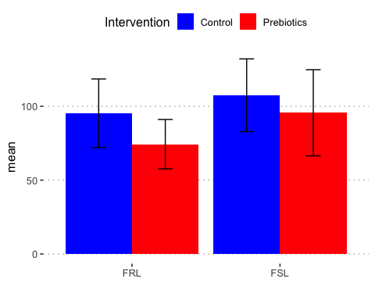

library(Hmisc)

## Loading required package: lattice

## Loading required package: survival

## Loading required package: Formula

##   
## Attaching package: 'Hmisc'

## The following objects are masked from 'package:dplyr':  
##   
## src, summarize

## The following objects are masked from 'package:plyr':  
##   
## is.discrete, summarize

## The following objects are masked from 'package:base':  
##   
## format.pval, units

p_swim <- ggplot(full_data_nested, aes(x=model, y=FST_swim_swim, fill=drug)) +   
 geom_dotplot(binaxis='y', stackdir='center', position=position_dodge(0.8))  
p_swim + stat_summary(fun.data="mean_sdl", fun.args = list(mult=1),   
 geom="errorbar", color="black", position=position_dodge(0.8), width=0.2 )+  
 stat_summary(fun.y=mean, geom="point", color="black",position=position_dodge(0.8))+  
 scale_fill_manual(values = c("#0000FF", "#FF0000"))+  
 ylab("FST Swimming (secs)")+  
 labs(x = "", fill= "Intervention")

## `stat_bindot()` using `bins = 30`. Pick better value with `binwidth`.

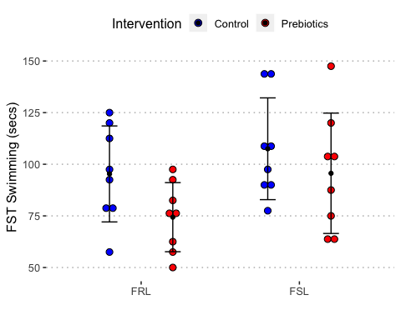

# no effect

# Results for FST Struggling

## fst struggling  
  
anova(lm(FST_swim_strug ~ model * drug, full_data_nested))

## Analysis of Variance Table  
##   
## Response: FST_swim_strug  
## Df Sum Sq Mean Sq F value Pr(>F)   
## model 1 22845 22844.5 18.0540 0.0002148 ***  
## drug 1 413 413.3 0.3266 0.5722185   
## model:drug 1 1012 1012.5 0.8002 0.3786659   
## Residuals 28 35430 1265.3   
## ---  
## Signif. codes: 0 '***' 0.001 '**' 0.01 '*' 0.05 '.' 0.1 ' ' 1

sum_data_fst_strug <- ddply(full_data_nested, c("model", "drug"), summarise,  
 N = length(FST_swim_strug),  
 mean = mean(FST_swim_strug),  
 sd = sd(FST_swim_strug),  
 se = sd / sqrt(N)  
)  
  
p1<-ggplot(sum_data_fst_strug, aes(x=model, y=mean, fill=drug)) +   
 geom_bar(position=position_dodge(), stat="identity") +  
 geom_errorbar(aes(ymin=mean-sd, ymax=mean+sd),  
 width=.2, # Width of the error bars  
 position=position_dodge(.9))+  
 labs(x = "", fill= "Intervention")  
  
p1+scale_fill_manual(values=c("#0000FF", "#FF0000"))

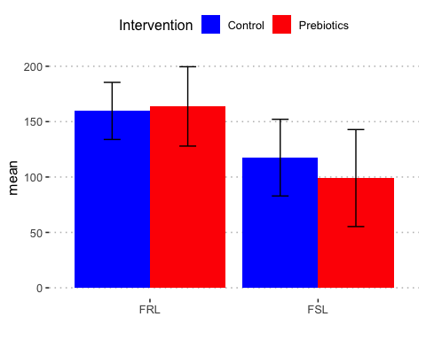

p_strug <- ggplot(full_data_nested, aes(x=model, y=FST_swim_strug, fill=drug)) +   
 geom_dotplot(binaxis='y', stackdir='center', position=position_dodge(0.8))  
p_strug + stat_summary(fun.data="mean_sdl", fun.args = list(mult=1),   
 geom="errorbar", color="black", position=position_dodge(0.8), width=0.2 )+  
 stat_summary(fun.y=mean, geom="point", color="black",position=position_dodge(0.8))+  
 scale_fill_manual(values = c("#0000FF", "#FF0000"))+  
 ylab("FST Struggling (secs)")+  
 labs(x = "", fill= "Intervention")

## `stat_bindot()` using `bins = 30`. Pick better value with `binwidth`.

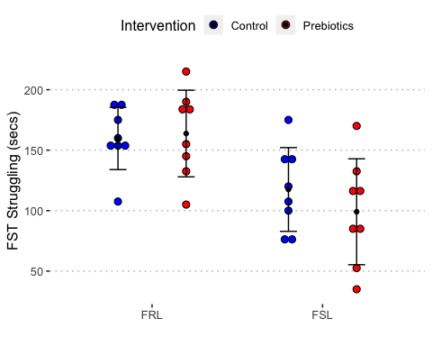

#model differences - no effect of drug

# attempt to create stacked bar chart of time spent in FST  
  
# Activity <- c("Immobility", "Swimming", "Struggling")  
# Model <- c("Gin Blue", "Gin Red", "Whisky Blue", "Whisky Red")  
#   
# fst_stacked <- data.frame(full_data_nested$model, full_data_nested$drug, full_data_nested$FST_swim_imm, full_data_nested$FST_swim_swim, full_data_nested$FST_swim_strug)  
#   
# fst_stacked$full_data_nested.model<- as.factor(fst_stacked$full_data_nested.model)  
# fst_stacked$full_data_nested.drug<- as.factor(fst_stacked$full_data_nested.drug)  
# fst_stacked$full_data_nested.FST_swim_imm<- as.numeric(fst_stacked$full_data_nested.FST_swim_imm)  
# fst_stacked$full_data_nested.FST_swim_swim <- as.numeric(fst_stacked$full_data_nested.FST_swim_swim)  
# fst_stacked$full_data_nested.FST_swim_strug <- as.numeric(fst_stacked$full_data_nested.FST_swim_strug)  
  
# barplot(fst_stacked, main="Distribution of Amount of Time Spent in FST",  
# xlab="Groups", col=c("darkblue","red"),  
# legend = rownames(counts))  
  
# library(lattice)   
# barchart(fst_stacked, scales = list(x = "free"),   
# auto.key = list(title = "Time Spent in FST"), horizontal=FALSE)

# Results for Open Field Total Distance:

#open field total distance  
  
anova(lm(OF_Distance_totalcm ~ model * drug, full_data_nested))

## Analysis of Variance Table  
##   
## Response: OF_Distance_totalcm  
## Df Sum Sq Mean Sq F value Pr(>F)   
## model 1 1786232 1786232 29.8951 7.736e-06 ***  
## drug 1 202 202 0.0034 0.95408   
## model:drug 1 210284 210284 3.5194 0.07112 .   
## Residuals 28 1673000 59750   
## ---  
## Signif. codes: 0 '***' 0.001 '**' 0.01 '*' 0.05 '.' 0.1 ' ' 1

sum_OF_Distance_totalcm <- ddply(full_data_nested, c("model", "drug"), summarise,  
 N = length(OF_Distance_totalcm),  
 mean = mean(OF_Distance_totalcm),  
 sd = sd(OF_Distance_totalcm),  
 se = sd / sqrt(N)  
)  
  
p1 <- ggplot(sum_OF_Distance_totalcm, aes(x=model, y=mean, fill=drug)) +   
 geom_bar(position=position_dodge(), stat="identity") +  
 geom_errorbar(aes(ymin=mean-sd, ymax=mean+sd),  
 width=.2, # Width of the error bars  
 position=position_dodge(.9))+  
 labs(x = "", fill= "Intervention")  
  
p1+scale_fill_manual(values=c("#0000FF", "#FF0000"))

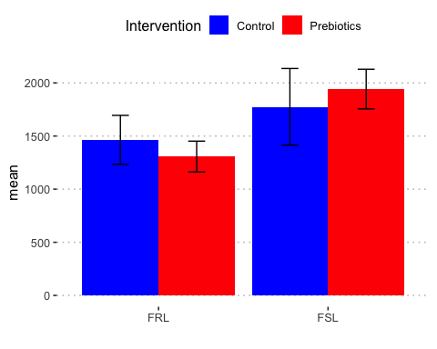

p_OF <- ggplot(full_data_nested, aes(x=model, y=OF_Distance_totalcm, fill=drug)) +   
 geom_dotplot(binaxis='y', stackdir='center', position=position_dodge(0.8))  
p_OF + stat_summary(fun.data="mean_sdl", fun.args = list(mult=1),   
 geom="errorbar", color="black", position=position_dodge(0.8), width=0.2 )+  
 stat_summary(fun.y=mean, geom="point", color="black",position=position_dodge(0.8))+  
 scale_fill_manual(values = c("#0000FF", "#FF0000"))+  
 ylab("OF Total Distance Travelled (cm)")+  
 labs(x = "", fill= "Intervention")

## `stat_bindot()` using `bins = 30`. Pick better value with `binwidth`.

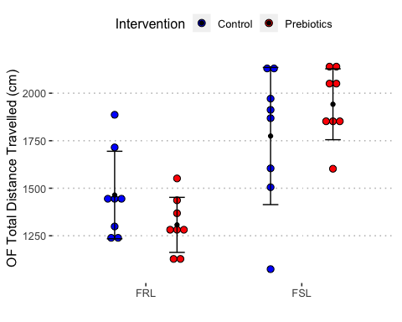

# model differences

# Results for Open Field Speed/Velocity (m/s):

#open field speed velocity m/s  
  
anova(lm(OF_Velocity_meancms ~ model * drug, full_data_nested))

## Analysis of Variance Table  
##   
## Response: OF_Velocity_meancms  
## Df Sum Sq Mean Sq F value Pr(>F)   
## model 1 22.0110 22.0110 31.0170 5.867e-06 ***  
## drug 1 0.0029 0.0029 0.0041 0.94919   
## model:drug 1 3.3168 3.3168 4.6739 0.03932 *   
## Residuals 28 19.8700 0.7096   
## ---  
## Signif. codes: 0 '***' 0.001 '**' 0.01 '*' 0.05 '.' 0.1 ' ' 1

sum_data_of_velo <- ddply(full_data_nested, c("model", "drug"), summarise,  
 N = length(OF_Velocity_meancms),  
 mean = mean(OF_Velocity_meancms),  
 sd = sd(OF_Velocity_meancms),  
 se = sd / sqrt(N)  
)  
  
p1 <- ggplot(sum_data_of_velo, aes(x=model, y=mean, fill=drug)) +   
 geom_bar(position=position_dodge(), stat="identity") +  
 geom_errorbar(aes(ymin=mean-sd, ymax=mean+sd),  
 width=.2, # Width of the error bars  
 position=position_dodge(.9))+  
 labs(x = "", fill= "Intervention")  
  
p1+scale_fill_manual(values=c("#0000FF", "#FF0000"))

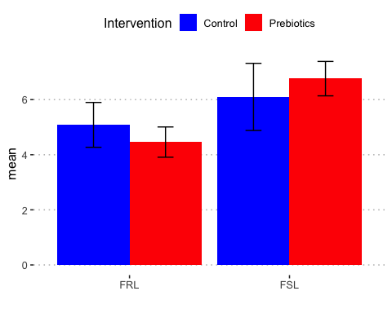

# model differences - and model x drug interaction

# Results for EPM Frequency of Full Body Entries to Open Arms:

#EPM full body to enter open arms frequency  
  
  
anova(lm(EPM_fullopen_freq ~ model * drug, full_data_nested))

## Analysis of Variance Table  
##   
## Response: EPM_fullopen_freq  
## Df Sum Sq Mean Sq F value Pr(>F)   
## model 1 34.031 34.031 8.5221 0.006852 **  
## drug 1 0.125 0.125 0.0313 0.860841   
## model:drug 1 2.000 2.000 0.5008 0.484981   
## Residuals 28 111.812 3.993   
## ---  
## Signif. codes: 0 '***' 0.001 '**' 0.01 '*' 0.05 '.' 0.1 ' ' 1

sum_data_epm_fullopen_freq <- ddply(full_data_nested, c("model", "drug"), summarise,  
 N = length(EPM_fullopen_freq),  
 mean = mean(EPM_fullopen_freq),  
 sd = sd(EPM_fullopen_freq),  
 se = sd / sqrt(N)  
)  
  
p1 <- ggplot(sum_data_epm_fullopen_freq, aes(x=model, y=mean, fill=drug)) +   
 geom_bar(position=position_dodge(), stat="identity") +  
 geom_errorbar(aes(ymin=mean-sd, ymax=mean+sd),  
 width=.2, # Width of the error bars  
 position=position_dodge(.9))+  
 labs(x = "", fill= "Intervention")  
  
p1+scale_fill_manual(values=c("#0000FF", "#FF0000"))

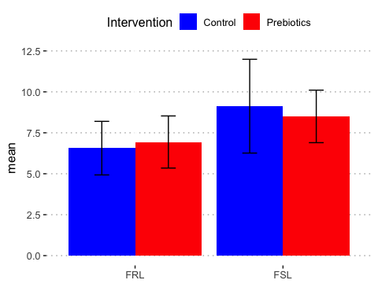

p_EPM_full <- ggplot(full_data_nested, aes(x=model, y=EPM_fullopen_freq, fill=drug)) +   
 geom_dotplot(binaxis='y', stackdir='center', position=position_dodge(0.8))  
p_EPM_full + stat_summary(fun.data="mean_sdl", fun.args = list(mult=1),   
 geom="errorbar", color="black", position=position_dodge(0.8), width=0.2 )+  
 stat_summary(fun.y=mean, geom="point", color="black",position=position_dodge(0.8))+  
 scale_fill_manual(values = c("#0000FF", "#FF0000"))+  
 ylab("EPM Frequency of Full Entries to Open Arms")+  
 labs(x = "", fill= "Intervention")

## `stat_bindot()` using `bins = 30`. Pick better value with `binwidth`.

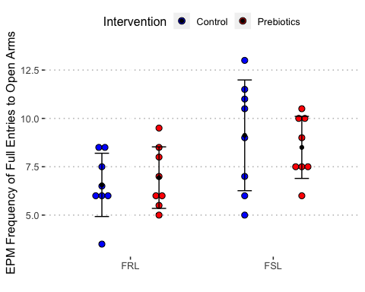

# only model differences

# Results for EPM Frequency of Entries to Closed Arms:

# EPM closed arms frequency to enter  
  
anova(lm(EPM_close_freq ~ model * drug, full_data_nested))

## Analysis of Variance Table  
##   
## Response: EPM_close_freq  
## Df Sum Sq Mean Sq F value Pr(>F)   
## model 1 118.195 118.195 34.1733 2.773e-06 ***  
## drug 1 18.758 18.758 5.4234 0.02731 *   
## model:drug 1 2.820 2.820 0.8154 0.37422   
## Residuals 28 96.844 3.459   
## ---  
## Signif. codes: 0 '***' 0.001 '**' 0.01 '*' 0.05 '.' 0.1 ' ' 1

sum_data_epm_closed_freq <- ddply(full_data_nested, c("model", "drug"), summarise,  
 N = length(EPM_close_freq),  
 mean = mean(EPM_close_freq),  
 sd = sd(EPM_close_freq),  
 se = sd / sqrt(N)  
)  
  
p1 <- ggplot(sum_data_epm_closed_freq, aes(x=model, y=mean, fill=drug)) +   
 geom_bar(position=position_dodge(), stat="identity") +  
 geom_errorbar(aes(ymin=mean-sd, ymax=mean+sd),  
 width=.2, # Width of the error bars  
 position=position_dodge(.9))+  
 labs(x = "", fill= "Intervention")  
  
p1+scale_fill_manual(values=c("#0000FF", "#FF0000"))

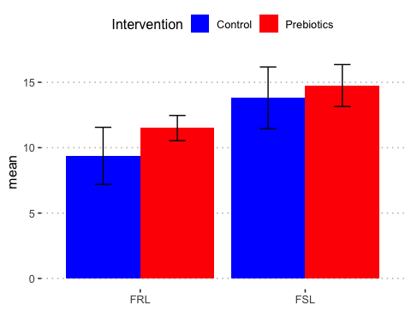

#model and drug differences

# Proportion time spent in open arms:

## make new variable time spent open / time spent open + closed arms  
full_data_nested <- mutate(full_data_nested, EPM_proportion = (EPM_open_secs/(EPM_open_secs + EPM_close_secs)))  
  
  
full_data_nested <- mutate(full_data_nested, EPM_proportion_total = (EPM_open_secs/300))  
  
anova(lm(EPM_proportion ~ model * drug, full_data_nested))

## Analysis of Variance Table  
##   
## Response: EPM_proportion  
## Df Sum Sq Mean Sq F value Pr(>F)  
## model 1 0.01498 0.0149846 0.7037 0.4087  
## drug 1 0.01367 0.0136674 0.6418 0.4298  
## model:drug 1 0.00773 0.0077304 0.3630 0.5517  
## Residuals 28 0.59626 0.0212950

sum_EPM_proportion <- ddply(full_data_nested, c("model", "drug"), summarise,  
 N = length(EPM_proportion),  
 mean = mean(EPM_proportion),  
 sd = sd(EPM_proportion),  
 se = sd / sqrt(N)  
)  
  
p1 <- ggplot(sum_EPM_proportion, aes(x=model, y=mean, fill=drug)) +   
 geom_bar(position=position_dodge(), stat="identity") +  
 geom_errorbar(aes(ymin=mean-sd, ymax=mean+sd),  
 width=.2, # Width of the error bars  
 position=position_dodge(.9))+  
 labs(x = "", fill= "Intervention")  
  
p1+scale_fill_manual(values=c("#0000FF", "#FF0000"))

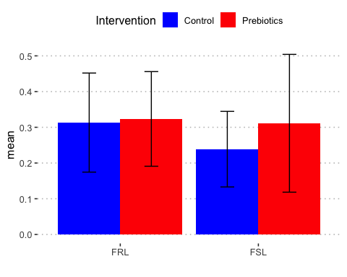

p_EPM_prop <- ggplot(full_data_nested, aes(x=model, y=EPM_proportion_total, fill=drug)) +   
 geom_dotplot(binaxis='y', stackdir='center', position=position_dodge(0.8))  
p_EPM_prop + stat_summary(fun.data="mean_sdl", fun.args = list(mult=1),   
 geom="errorbar", color="black", position=position_dodge(0.8), width=0.2 )+  
 stat_summary(fun.y=mean, geom="point", color="black",position=position_dodge(0.8))+  
 scale_fill_manual(values = c("#0000FF", "#FF0000"))+  
 ylab("EPM Proportion of Time Spent in Open Arm (%)")+  
 labs(x = "", fill= "Intervention")

## `stat_bindot()` using `bins = 30`. Pick better value with `binwidth`.

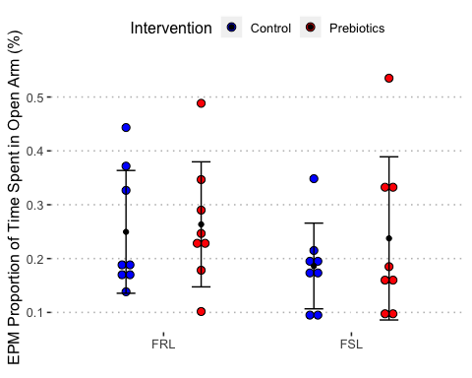

## no sig differences  
  
  
anova(lm(EPM_proportion_total ~ model * drug, full_data_nested))

## Analysis of Variance Table  
##   
## Response: EPM_proportion_total  
## Df Sum Sq Mean Sq F value Pr(>F)  
## model 1 0.01598 0.0159758 1.1460 0.2935  
## drug 1 0.00850 0.0085043 0.6100 0.4413  
## model:drug 1 0.00278 0.0027813 0.1995 0.6585  
## Residuals 28 0.39033 0.0139405

sum_EPM_proportion_total <- ddply(full_data_nested, c("model", "drug"), summarise,  
 N = length(EPM_proportion_total),  
 mean = mean(EPM_proportion_total),  
 sd = sd(EPM_proportion_total),  
 se = sd / sqrt(N)  
)  
  
p1 <- ggplot(sum_EPM_proportion_total, aes(x=model, y=mean, fill=drug)) +   
 geom_bar(position=position_dodge(), stat="identity") +  
 geom_errorbar(aes(ymin=mean-sd, ymax=mean+sd),  
 width=.2, # Width of the error bars  
 position=position_dodge(.9))+  
 labs(x = "", fill= "Intervention")  
  
p1+scale_fill_manual(values=c("#0000FF", "#FF0000"))

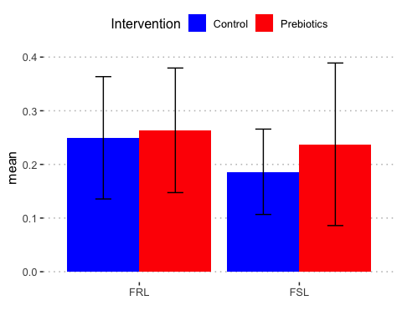

# Results for EPM Frequency of Entries to Open Arms:

# EPM open arms frequency to enter  
  
anova(lm(EPM_open_freq ~ model * drug, full_data_nested))

## Analysis of Variance Table  
##   
## Response: EPM_open_freq  
## Df Sum Sq Mean Sq F value Pr(>F)   
## model 1 13.133 13.1328 3.4477 0.07389 .  
## drug 1 2.258 2.2578 0.5927 0.44781   
## model:drug 1 6.570 6.5703 1.7249 0.19973   
## Residuals 28 106.656 3.8092   
## ---  
## Signif. codes: 0 '***' 0.001 '**' 0.01 '*' 0.05 '.' 0.1 ' ' 1

sum_data_epm_open_freq <- ddply(full_data_nested, c("model", "drug"), summarise,  
 N = length(EPM_open_freq),  
 mean = mean(EPM_open_freq),  
 sd = sd(EPM_open_freq),  
 se = sd / sqrt(N)  
)  
  
p1 <- ggplot(sum_data_epm_open_freq, aes(x=model, y=mean, fill=drug)) +   
 geom_bar(position=position_dodge(), stat="identity") +  
 geom_errorbar(aes(ymin=mean-sd, ymax=mean+sd),  
 width=.2, # Width of the error bars  
 position=position_dodge(.9))+  
 labs(x = "", fill= "Intervention")  
  
p1+scale_fill_manual(values=c("#0000FF", "#FF0000"))

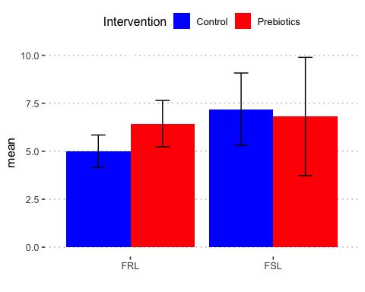

# no significant differences

# Results for EPM Time Spent with Full Body in Open Arms:

# EPM time spent full body in open arms in secs  
  
anova(lm(EPM_fullopen_secs ~ model * drug, full_data_nested))

## Analysis of Variance Table  
##   
## Response: EPM_fullopen_secs  
## Df Sum Sq Mean Sq F value Pr(>F)  
## model 1 1770 1770.1 1.3293 0.2587  
## drug 1 1540 1540.1 1.1566 0.2914  
## model:drug 1 128 128.0 0.0961 0.7588  
## Residuals 28 37286 1331.6

sum_data_epm_fullopen_secs <- ddply(full_data_nested, c("model", "drug"), summarise,  
 N = length(EPM_fullopen_secs),  
 mean = mean(EPM_fullopen_secs),  
 sd = sd(EPM_fullopen_secs),  
 se = sd / sqrt(N)  
)  
  
p1 <- ggplot(sum_data_epm_fullopen_secs, aes(x=model, y=mean, fill=drug)) +   
 geom_bar(position=position_dodge(), stat="identity") +  
 geom_errorbar(aes(ymin=mean-sd, ymax=mean+sd),  
 width=.2, # Width of the error bars  
 position=position_dodge(.9))+  
 labs(x = "", fill= "Intervention")  
  
p1+scale_fill_manual(values=c("#0000FF", "#FF0000"))

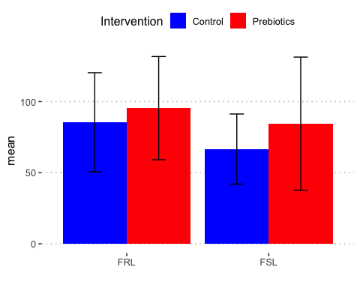

p_EPM_total_open <- ggplot(full_data_nested, aes(x=model, y=EPM_fullopen_secs, fill=drug)) +   
 geom_dotplot(binaxis='y', stackdir='center', position=position_dodge(0.8))  
p_EPM_total_open + stat_summary(fun.data="mean_sdl", fun.args = list(mult=1),   
 geom="errorbar", color="black", position=position_dodge(0.8), width=0.2 )+  
 stat_summary(fun.y=mean, geom="point", color="black",position=position_dodge(0.8))+  
 scale_fill_manual(values = c("#0000FF", "#FF0000"))+  
 ylab("EPM Time spent in Open Arms")+  
 labs(x = "", fill= "Intervention")

## `stat_bindot()` using `bins = 30`. Pick better value with `binwidth`.

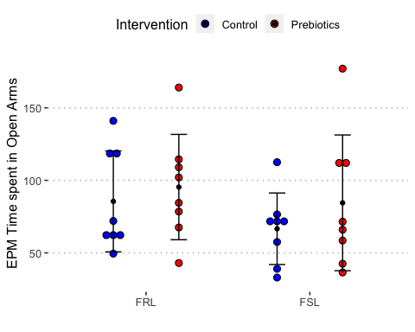

# no significant differences

# Results for EPM Time Spent with in Open Arms:

# EPM time spent in open arms in secs  
  
anova(lm(EPM_open_secs ~ model * drug, full_data_nested))

## Analysis of Variance Table  
##   
## Response: EPM_open_secs  
## Df Sum Sq Mean Sq F value Pr(>F)  
## model 1 1438 1437.82 1.1460 0.2935  
## drug 1 765 765.38 0.6100 0.4413  
## model:drug 1 250 250.32 0.1995 0.6585  
## Residuals 28 35130 1254.64

sum_data_epm_open_secs <- ddply(full_data_nested, c("model", "drug"), summarise,  
 N = length(EPM_open_secs),  
 mean = mean(EPM_open_secs),  
 sd = sd(EPM_open_secs),  
 se = sd / sqrt(N)  
)  
  
p1 <- ggplot(sum_data_epm_open_secs, aes(x=model, y=mean, fill=drug)) +   
 geom_bar(position=position_dodge(), stat="identity") +  
 geom_errorbar(aes(ymin=mean-sd, ymax=mean+sd),  
 width=.2, # Width of the error bars  
 position=position_dodge(.9))+  
 labs(x = "", fill= "Intervention")  
  
p1+scale_fill_manual(values=c("#0000FF", "#FF0000"))

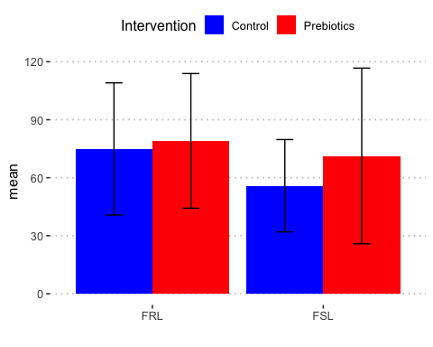

# no significant differences

# Results for EPM Time Spent in Closed Arms:

# EPM closed arms time spent in seconds  
  
anova(lm(EPM_close_secs ~ model * drug, full_data_nested))

## Analysis of Variance Table  
##   
## Response: EPM_close_secs  
## Df Sum Sq Mean Sq F value Pr(>F)  
## model 1 75 75.03 0.0551 0.8162  
## drug 1 800 800.00 0.5871 0.4499  
## model:drug 1 1188 1188.28 0.8721 0.3584  
## Residuals 28 38152 1362.56

sum_data_epm_closed_secs <- ddply(full_data_nested, c("model", "drug"), summarise,  
 N = length(EPM_close_secs),  
 mean = mean(EPM_close_secs),  
 sd = sd(EPM_close_secs),  
 se = sd / sqrt(N)  
)  
  
p1 <- ggplot(sum_data_epm_closed_secs, aes(x=model, y=mean, fill=drug)) +   
 geom_bar(position=position_dodge(), stat="identity") +  
 geom_errorbar(aes(ymin=mean-sd, ymax=mean+sd),  
 width=.2, # Width of the error bars  
 position=position_dodge(.9))+  
 labs(x = "", fill= "Intervention")  
  
p1+scale_fill_manual(values=c("#0000FF", "#FF0000"))

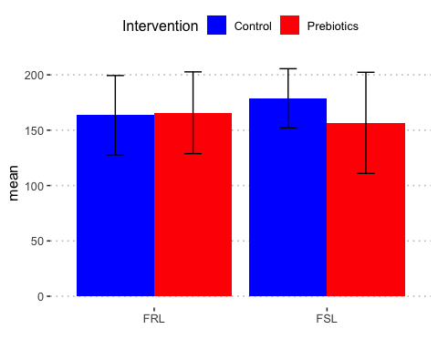

# no significant group differences

# Results for EPM Latency to Enter Open Arms:

# EPM latency to enter open arms   
  
full_data_nested$EPM_open_latency <- as.numeric(full_data_nested$EPM_open_latency)  
  
anova(lm(EPM_open_latency ~ model * drug, full_data_nested))

## Analysis of Variance Table  
##   
## Response: EPM_open_latency  
## Df Sum Sq Mean Sq F value Pr(>F)  
## model 1 300.1 300.12 0.3157 0.5786  
## drug 1 225.8 225.78 0.2375 0.6298  
## model:drug 1 1300.5 1300.50 1.3682 0.2520  
## Residuals 28 26614.8 950.53

sum_data_epm_open_latency <- ddply(full_data_nested, c("model", "drug"), summarise,  
 N = length(EPM_open_latency),  
 mean = mean(EPM_open_latency),  
 sd = sd(EPM_open_latency),  
 se = sd / sqrt(N)  
)  
  
p1 <- ggplot(sum_data_epm_open_latency, aes(x=model, y=mean, fill=drug)) +   
 geom_bar(position=position_dodge(), stat="identity") +  
 geom_errorbar(aes(ymin=mean-sd, ymax=mean+sd),  
 width=.2, # Width of the error bars  
 position=position_dodge(.9))+  
 labs(x = "", fill= "Intervention")  
  
p1+scale_fill_manual(values=c("#0000FF", "#FF0000"))

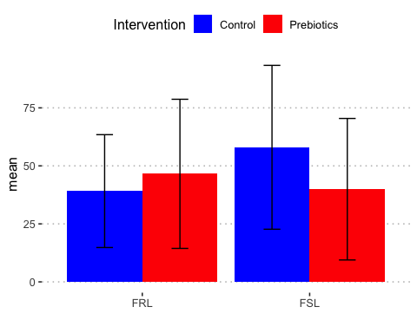

# no significant differences

# Results for EPM Latency to enter Open Arms with Full Body

# EPM latency to enter open arms with full body  
  
  
anova(lm(EPM_fullopen_latency ~ model * drug, full_data_nested))

## Analysis of Variance Table  
##   
## Response: EPM_fullopen_latency  
## Df Sum Sq Mean Sq F value Pr(>F)  
## model 1 182.9 182.88 0.2683 0.6085  
## drug 1 130.0 130.01 0.1907 0.6656  
## model:drug 1 1098.6 1098.63 1.6119 0.2147  
## Residuals 28 19084.1 681.57

sum_data_epm_fullopen_latency <- ddply(full_data_nested, c("model", "drug"), summarise,  
 N = length(EPM_fullopen_latency),  
 mean = mean(EPM_fullopen_latency),  
 sd = sd(EPM_fullopen_latency),  
 se = sd / sqrt(N)  
)  
  
p1 <- ggplot(sum_data_epm_fullopen_latency, aes(x=model, y=mean, fill=drug)) +   
 geom_bar(position=position_dodge(), stat="identity") +  
 geom_errorbar(aes(ymin=mean-sd, ymax=mean+sd),  
 width=.2, # Width of the error bars  
 position=position_dodge(.9))+  
 labs(x = "", fill= "Intervention")  
  
p1+scale_fill_manual(values=c("#0000FF", "#FF0000"))

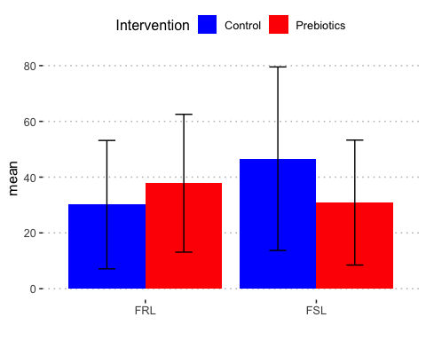

## no significant differences

# Weight:

anova(lm(Weight_W1 ~ model * drug, full_data_nested))

## Analysis of Variance Table  
##   
## Response: Weight_W1  
## Df Sum Sq Mean Sq F value Pr(>F)   
## model 1 7595.3 7595.3 11.0173 0.002514 **  
## drug 1 5671.1 5671.1 8.2262 0.007763 **  
## model:drug 1 1785.0 1785.0 2.5893 0.118808   
## Residuals 28 19303.1 689.4   
## ---  
## Signif. codes: 0 '***' 0.001 '**' 0.01 '*' 0.05 '.' 0.1 ' ' 1

sum_data_Weight_W1 <- ddply(full_data_nested, c("model", "drug"), summarise,  
 N = length(Weight_W1),  
 mean = mean(Weight_W1),  
 sd = sd(Weight_W1),  
 se = sd / sqrt(N)  
)  
  
p1 <- ggplot(sum_data_Weight_W1, aes(x=model, y=mean, fill=drug)) +   
 geom_bar(position=position_dodge(), stat="identity") +  
 geom_errorbar(aes(ymin=mean-sd, ymax=mean+sd),  
 width=.2, # Width of the error bars  
 position=position_dodge(.9))+  
 labs(x = "", fill= "Intervention")  
  
p1+scale_fill_manual(values=c("#0000FF", "#FF0000"))

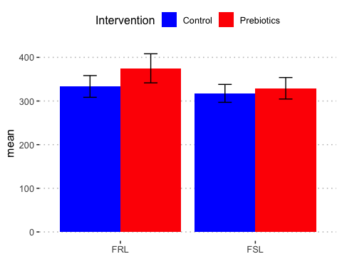

p_weight1 <- ggplot(full_data_nested, aes(x=model, y=Weight_W1, fill=drug)) +   
 geom_dotplot(binaxis='y', stackdir='center', position=position_dodge(0.8))  
p_weight1 + stat_summary(fun.data="mean_sdl", fun.args = list(mult=1),   
 geom="errorbar", color="black", position=position_dodge(0.8), width=0.2 )+  
 stat_summary(fun.y=mean, geom="point", color="black",position=position_dodge(0.8))+  
 scale_fill_manual(values = c("#0000FF", "#FF0000"))+  
 ylab("Weight Week 1 (g)")+  
 labs(x = "", fill= "Intervention")

## `stat_bindot()` using `bins = 30`. Pick better value with `binwidth`.

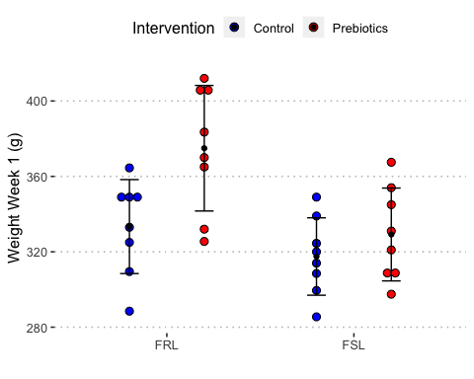

# Week 2

anova(lm(Weight_W2 ~ model * drug, full_data_nested))

## Analysis of Variance Table  
##   
## Response: Weight_W2  
## Df Sum Sq Mean Sq F value Pr(>F)   
## model 1 18408.0 18408.0 30.8383 6.129e-06 ***  
## drug 1 5791.6 5791.6 9.7024 0.00422 **   
## model:drug 1 2476.3 2476.3 4.1485 0.05123 .   
## Residuals 28 16713.8 596.9   
## ---  
## Signif. codes: 0 '***' 0.001 '**' 0.01 '*' 0.05 '.' 0.1 ' ' 1

sum_data_Weight_W2 <- ddply(full_data_nested, c("model", "drug"), summarise,  
 N = length(Weight_W2),  
 mean = mean(Weight_W2),  
 sd = sd(Weight_W2),  
 se = sd / sqrt(N)  
)  
  
p1 <- ggplot(sum_data_Weight_W2, aes(x=model, y=mean, fill=drug)) +   
 geom_bar(position=position_dodge(), stat="identity") +  
 geom_errorbar(aes(ymin=mean-sd, ymax=mean+sd),  
 width=.2, # Width of the error bars  
 position=position_dodge(.9))+  
 labs(x = "", fill= "Intervention")  
  
p1+scale_fill_manual(values=c("#0000FF", "#FF0000"))

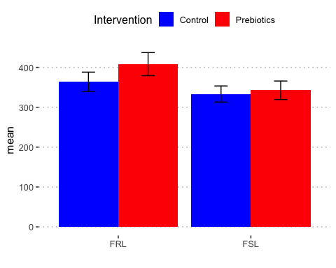

p_weight2 <- ggplot(full_data_nested, aes(x=model, y=Weight_W2, fill=drug)) +   
 geom_dotplot(binaxis='y', stackdir='center', position=position_dodge(0.8))  
p_weight2 + stat_summary(fun.data="mean_sdl", fun.args = list(mult=1),   
 geom="errorbar", color="black", position=position_dodge(0.8), width=0.2 )+  
 stat_summary(fun.y=mean, geom="point", color="black",position=position_dodge(0.8))+  
 scale_fill_manual(values = c("#0000FF", "#FF0000"))+  
 ylab("Weight Week 2 (g)")+  
 labs(x = "", fill= "Intervention")

## `stat_bindot()` using `bins = 30`. Pick better value with `binwidth`.

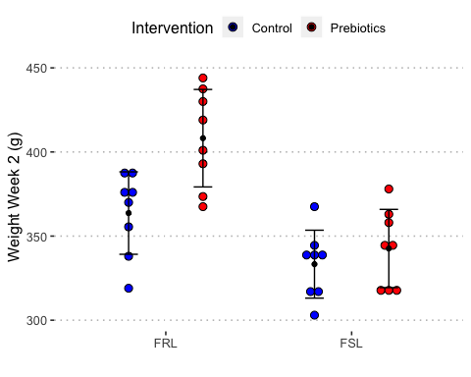

# Week 3

anova(lm(Weight_W3 ~ model * drug, full_data_nested))

## Analysis of Variance Table  
##   
## Response: Weight_W3  
## Df Sum Sq Mean Sq F value Pr(>F)   
## model 1 23247.1 23247.1 33.4939 3.248e-06 ***  
## drug 1 6146.6 6146.6 8.8560 0.005962 **   
## model:drug 1 2269.7 2269.7 3.2701 0.081304 .   
## Residuals 28 19433.9 694.1   
## ---  
## Signif. codes: 0 '***' 0.001 '**' 0.01 '*' 0.05 '.' 0.1 ' ' 1

sum_data_Weight_W3 <- ddply(full_data_nested, c("model", "drug"), summarise,  
 N = length(Weight_W3),  
 mean = mean(Weight_W3),  
 sd = sd(Weight_W3),  
 se = sd / sqrt(N)  
)  
  
p1 <- ggplot(sum_data_Weight_W3, aes(x=model, y=mean, fill=drug)) +   
 geom_bar(position=position_dodge(), stat="identity") +  
 geom_errorbar(aes(ymin=mean-sd, ymax=mean+sd),  
 width=.2, # Width of the error bars  
 position=position_dodge(.9))+  
 labs(x = "", fill= "Intervention")  
  
p1+scale_fill_manual(values=c("#0000FF", "#FF0000"))

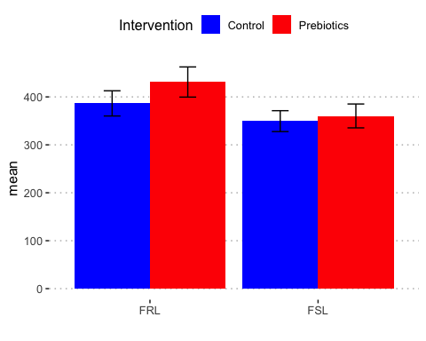

p_weight3 <- ggplot(full_data_nested, aes(x=model, y=Weight_W3, fill=drug)) +   
 geom_dotplot(binaxis='y', stackdir='center', position=position_dodge(0.8))  
p_weight3 + stat_summary(fun.data="mean_sdl", fun.args = list(mult=1),   
 geom="errorbar", color="black", position=position_dodge(0.8), width=0.2 )+  
 stat_summary(fun.y=mean, geom="point", color="black",position=position_dodge(0.8))+  
 scale_fill_manual(values = c("#0000FF", "#FF0000"))+  
 ylab("Weight Week 3 (g)")+  
 labs(x = "", fill= "Intervention")

## `stat_bindot()` using `bins = 30`. Pick better value with `binwidth`.

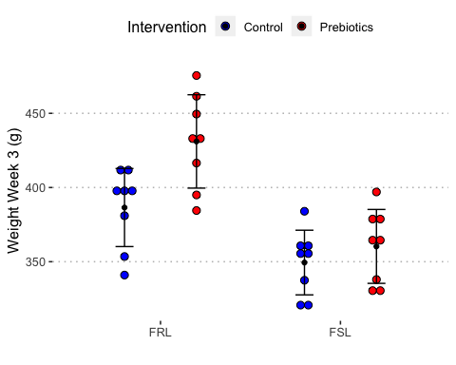

# Week 4

anova(lm(Weight_W4 ~ model * drug, full_data_nested))

## Analysis of Variance Table  
##   
## Response: Weight_W4  
## Df Sum Sq Mean Sq F value Pr(>F)   
## model 1 26363.8 26363.8 41.0895 6.115e-07 ***  
## drug 1 6626.9 6626.9 10.3284 0.003288 **   
## model:drug 1 2354.7 2354.7 3.6699 0.065666 .   
## Residuals 28 17965.3 641.6   
## ---  
## Signif. codes: 0 '***' 0.001 '**' 0.01 '*' 0.05 '.' 0.1 ' ' 1

sum_data_Weight_W4 <- ddply(full_data_nested, c("model", "drug"), summarise,  
 N = length(Weight_W4),  
 mean = mean(Weight_W4),  
 sd = sd(Weight_W4),  
 se = sd / sqrt(N)  
)  
  
p1 <- ggplot(sum_data_Weight_W4, aes(x=model, y=mean, fill=drug)) +   
 geom_bar(position=position_dodge(), stat="identity") +  
 geom_errorbar(aes(ymin=mean-sd, ymax=mean+sd),  
 width=.2, # Width of the error bars  
 position=position_dodge(.9))+  
 labs(x = "", fill= "Intervention")  
  
p1+scale_fill_manual(values=c("#0000FF", "#FF0000"))

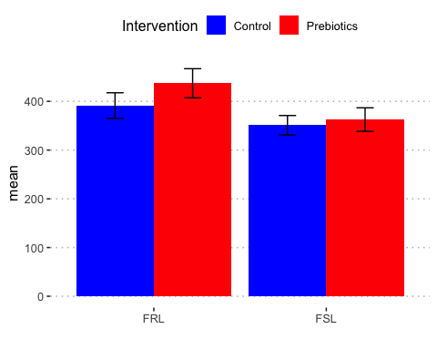

p_weight4 <- ggplot(full_data_nested, aes(x=model, y=Weight_W4, fill=drug)) +   
 geom_dotplot(binaxis='y', stackdir='center', position=position_dodge(0.8))  
p_weight4 + stat_summary(fun.data="mean_sdl", fun.args = list(mult=1),   
 geom="errorbar", color="black", position=position_dodge(0.8), width=0.2 )+  
 stat_summary(fun.y=mean, geom="point", color="black",position=position_dodge(0.8))+  
 scale_fill_manual(values = c("#0000FF", "#FF0000"))+  
 ylab("Weight Week 4 (g)")+  
 labs(x = "", fill= "Intervention")

## `stat_bindot()` using `bins = 30`. Pick better value with `binwidth`.

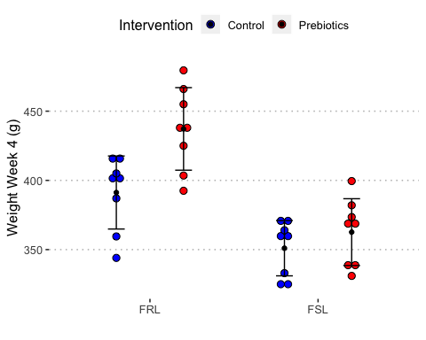

# Weight at Euthanisation

anova(lm(weight_euth ~ model * drug, full_data_nested))

## Analysis of Variance Table  
##   
## Response: weight_euth  
## Df Sum Sq Mean Sq F value Pr(>F)   
## model 1 25679.4 25679.4 40.0749 7.557e-07 ***  
## drug 1 4548.2 4548.2 7.0978 0.01266 *   
## model:drug 1 3270.4 3270.4 5.1037 0.03185 *   
## Residuals 28 17942.0 640.8   
## ---  
## Signif. codes: 0 '***' 0.001 '**' 0.01 '*' 0.05 '.' 0.1 ' ' 1

interaction.plot(full_data_nested$model, full_data_nested$drug, full_data_nested$weight_euth)

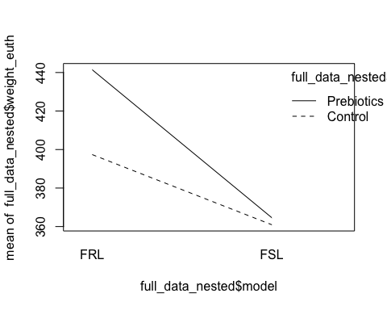

interaction.plot(full_data_nested$drug, full_data_nested$model, full_data_nested$weight_euth)

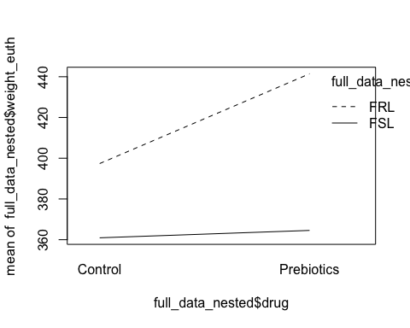

sum_data_weight_euth <- ddply(full_data_nested, c("model", "drug"), summarise,  
 N = length(weight_euth),  
 mean = mean(weight_euth),  
 sd = sd(weight_euth),  
 se = sd / sqrt(N)  
)  
  
p1<- ggplot(sum_data_weight_euth, aes(x=model, y=mean, fill=drug)) +   
 geom_bar(position=position_dodge(), stat="identity") +  
 geom_errorbar(aes(ymin=mean-sd, ymax=mean+sd),  
 width=.2, # Width of the error bars  
 position=position_dodge(.9))+  
 labs(x = "", fill= "Intervention")  
  
p1+scale_fill_manual(values=c("#0000FF", "#FF0000"))

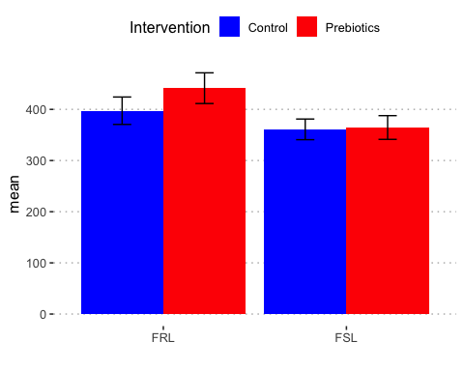

# p1 <- ggplot(full_data_nested, aes(x=model, y=weight_euth, fill=drug)) +   
# geom_boxplot(outlier.size=0)+  
# labs(x = "", fill= "Drug")+   
# geom_jitter(aes(dist_cat_n + scat_adj,weight_euth),  
# # position=position_jitter(width=0.1,height=0),  
# # alpha=0.6,  
# # size=3,  
# show.legend = FALSE)+  
# ylab("Weight (g) at Euthanisation")  
#   
#   
# p1+scale_fill_manual(values=c("#0000FF", "#FF0000"))  
  
  
  
p_weight_euth <- ggplot(full_data_nested, aes(x=model, y=weight_euth, fill=drug)) +   
 geom_dotplot(binaxis='y', stackdir='center', position=position_dodge(0.8))  
p_weight_euth + stat_summary(fun.data="mean_sdl", fun.args = list(mult=1),   
 geom="errorbar", color="black", position=position_dodge(0.8), width=0.2 )+  
 stat_summary(fun.y=mean, geom="point", color="black",position=position_dodge(0.8))+  
 scale_fill_manual(values = c("#0000FF", "#FF0000"))+  
 ylab("Weight (g) at Euthanisation")+  
 labs(x = "", fill= "Intervention")

## `stat_bindot()` using `bins = 30`. Pick better value with `binwidth`.

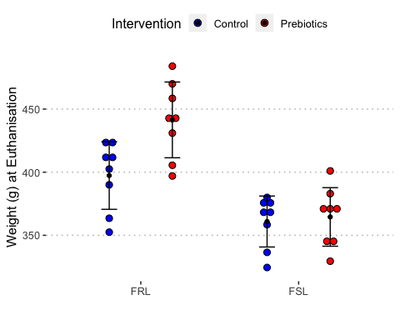

# Weight Increase over 4 Weeks

# graph for showing weight increase over the 4 weeks  
  
  
sum_data_Weight_W1$Week=1  
sum_data_Weight_W2$Week=2  
sum_data_Weight_W3$Week=3  
sum_data_Weight_W4$Week=4  
sum_data_weight_euth$Week=5  
  
all_weight_sum <- rbind(sum_data_Weight_W1, sum_data_Weight_W2, sum_data_Weight_W3, sum_data_Weight_W4, sum_data_weight_euth)  
  
library(ggplot2)  
library(plotly)

##   
## Attaching package: 'plotly'

## The following object is masked from 'package:Hmisc':  
##   
## subplot

## The following objects are masked from 'package:plyr':  
##   
## arrange, mutate, rename, summarise

## The following object is masked from 'package:ggplot2':  
##   
## last_plot

## The following object is masked from 'package:stats':  
##   
## filter

## The following object is masked from 'package:graphics':  
##   
## layout

w <- ggplot(all_weight_sum, aes(x = Week, y = mean, fill = drug)) +  
 geom_bar(stat = "identity",position=position_dodge())+  
 facet_wrap(~model, nrow = 1)+  
 labs(x = "", fill= "Intervention")  
  
w+scale_fill_manual(values=c("#0000FF", "#FF0000"))

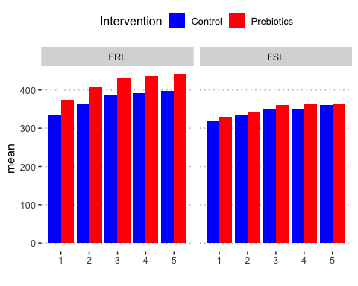

# Difference in Weight (Euth - W1)

# weight difference   
  
full_data_nested$weight_diff <- full_data_nested$weight_euth - full_data_nested$Weight_W1  
anova(lm(weight_diff ~ model * drug, full_data_nested))

## Analysis of Variance Table  
##   
## Response: weight_diff  
## Df Sum Sq Mean Sq F value Pr(>F)   
## model 1 5343.2 5343.2 37.5706 1.293e-06 ***  
## drug 1 61.9 61.9 0.4351 0.5149   
## model:drug 1 223.1 223.1 1.5690 0.2207   
## Residuals 28 3982.1 142.2   
## ---  
## Signif. codes: 0 '***' 0.001 '**' 0.01 '*' 0.05 '.' 0.1 ' ' 1

p_weight_diff <- ggplot(full_data_nested, aes(x=model, y=weight_diff, fill=drug)) +   
 geom_dotplot(binaxis='y', stackdir='center', position=position_dodge(0.8))  
p_weight_diff + stat_summary(fun.data="mean_sdl", fun.args = list(mult=1),   
 geom="errorbar", color="black", position=position_dodge(0.8), width=0.2 )+  
 stat_summary(fun.y=mean, geom="point", color="black",position=position_dodge(0.8))+  
 scale_fill_manual(values = c("#0000FF", "#FF0000"))+  
 ylab("Weight (g) Gain across the study")+  
 labs(x = "", fill= "Intervention")

## `stat_bindot()` using `bins = 30`. Pick better value with `binwidth`.

