# Import the provided excel sheet into any relational database

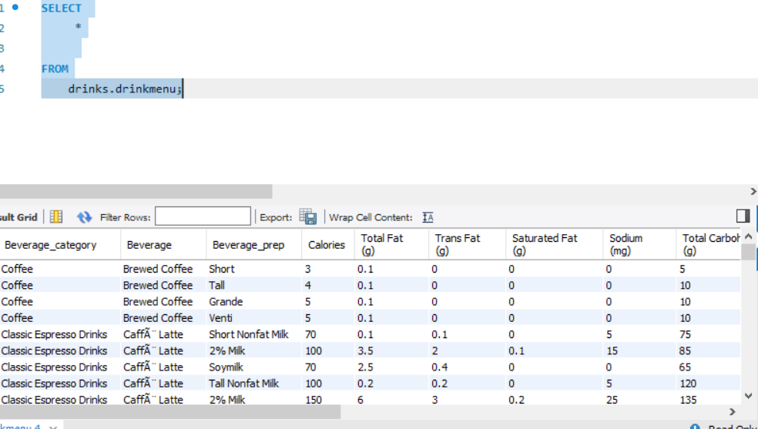Here an image from MySql workbench after importing the data I selected everything from the DB

# 2. Answers these questions:

# 1. Which drink has the highest calories from the dataset?

SELECT

Beverage_category,

Beverage,

Calories

FROM

drinks.drinkmenu

ORDER BY Calories

DESC LIMIT 1;

# What is the average calorie amount for each drink category?

SELECT

Beverage_category,

AVG(Calories) as average_Calories

FROM

drinks.drinkmenu

GROUP BY Beverage_category;

# Which drinks have below average calorie amount?

SELECT

Beverage_category,

Beverage,

Calories

FROM

drinks.drinkmenu

WHERE

Calories < (SELECT

AVG(Calories)

FROM

drinks.drinkmenu);