Database task:

1. Import the provided excel sheet into any relational database

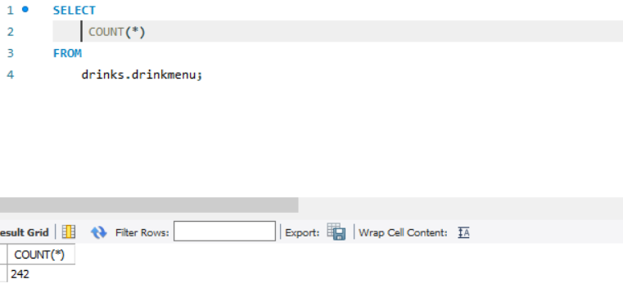

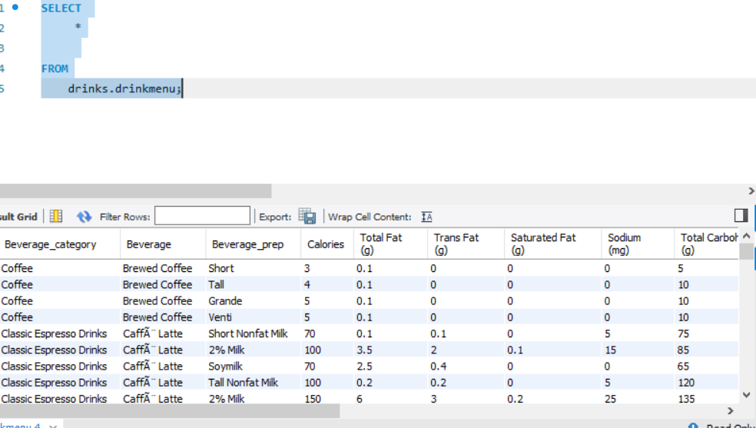

2. Answers these questions:

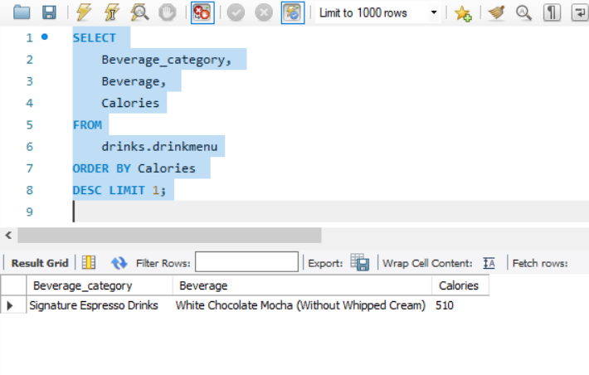 1. Which drink has the highest calories from the dataset?

1. What is the average calorie amount for each drink category?

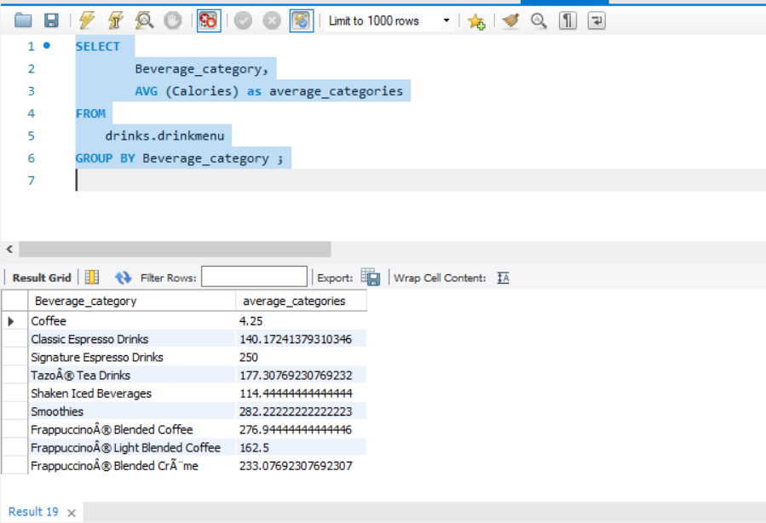

1. 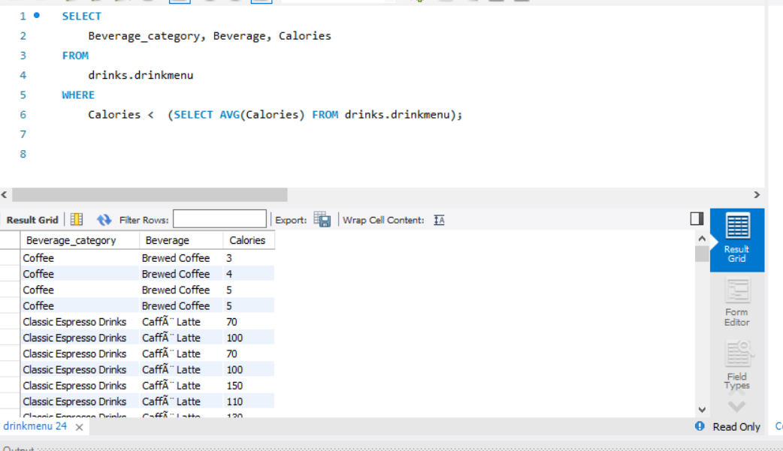Which drinks have below average calorie amount?