**PERSONAL INFORMATION**  
Name: Abanob Adel William   
Address: villa 112 quarter 11 next to 2 - El Shiekh Zaied - Giza  
Cell Phone: 01226220121  
Email: [abanob.2013g@gmail.com](mailto:abanob.2013g@gmail.com)

Anather Email: [abanob.2013f@yahoo.com](mailto:abanob.2013f@yahoo.com)

Date of Birth: 1/7/1995

College Egyption E-learing University. (Ain Shams)  
Nationality: Egyptian  
Sex: male

Marital Status: Single

**COMPUTER SKILLS:**

1. **web design languge : Html5 - css3 - Javascript (JQuety)**

**Bootstrap - php (MVC)**

1. **Database : MySQL (PDO) .**

**My Works**

**WwW. StyleMedical.net**

**WwW. StyleMedical.net/Abanob**

**WwW. StyleMedical.net/Abanob/treehouse**

**QUALIFICATIONS**

**1- Web Design**

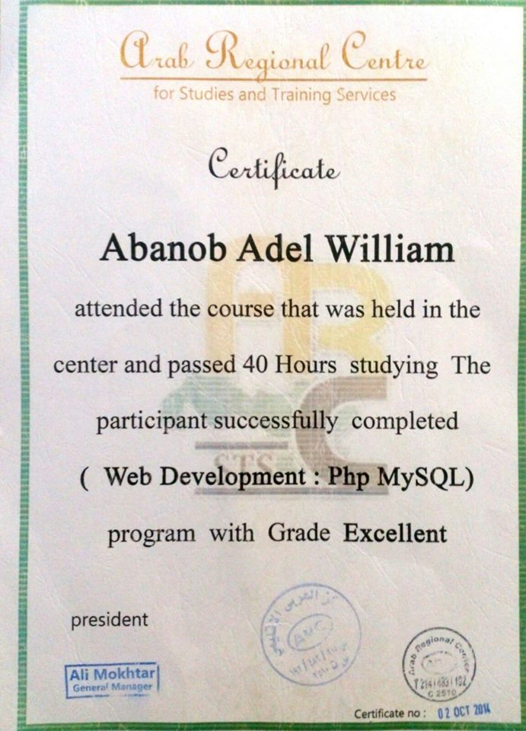

**2 – Web Development**

