Project 2
Cluedo Game

Abanob Tanous

CS670: Artificial Intelligence
Professor Arashdeep Kaur
December 8, 2024

Abstract
The purpose of this project was to design and develop of digital adaptation of the classic murder mystery board game, Cluedo. The game is set in a mansion where players must deduce the culprit of a murder along with the weapon they used and the room where it happened. This digital implementation of the game involved game setup, player movement, and core game play mechanics. Game setup included elements such as creating the mansion layout, defining characters and weapons, and selecting a solution. Player movement enables the players to navigate between rooms. Along with movement, the other two core game play mechanics are suggestion and accusation. In a suggestion, the player suggests a possible solution and a player, going in clockwise order, must refute they suggestion with one of their cards if able. Accusation is the mechanic which allows the player to put in a final guess at the solution, if they are right they win, if they are wrong they are disqualified from the rest of the game.
This implementation was written in python 3. The pygame library was used to provide windowing and graphics capabilities. The pygame_gui library was used to provide user interface capabilities which work on top of pygame. Some modifications were made to the base game to make it more congruent with this project’s requirements and the implementation restrictions.

Introduction
Cluedo, known as Clue in North America, is a classic murder mystery board game which, through its combination of strategy, deduction, and simplicity, has made itself a timeless favorite among many players of all ages. The premise of the game is simple and engaging, use clues gathered through suggestions to deduce the murderer, his weapon, and the murder location. With this context in mind, the motivations for a digital implementation of this game are as follows:
1. Digitize a timeless classic: As previously mentioned, Cluedo is a timeless classic and many people continue to enjoy even today. By bringing this game into the digital world, access to the game will broaden out to a much larger potential audience. Many people might not have the opportunity to purchase a physical board game, or many not consider purchasing a physical board game. A digital version of the game will allow those people the opportunity to enjoy Cluedo. Furthermore, it will remove some restraints that come with a physical board game. For example, players will be able to play anywhere anytime so long as they have a digital device, like phones which are very prolific.
2. Demonstrate and sharpen technical skills: Given the premise and core mechanics of the game, it is clear that a digital implementation would depend on important programming concepts and skills, especially those relevant to Artificial Intelligence. For example, game setup requires randomization and state management. The non-user players require an AI agent controlling their moves. Such an agent must be able to keep track of the game state, record learned clues in its knowledge base, and use is knowledge base to make informed game play decisions. Processing the game play will require logic handling, such as handling the suggestion, refutation, and accusation mechanics. Evidently, it is clear that this project will showcase and sharpen programming skills, especially those pertaining to Artificial Intelligence.

Game Rules
This implementation of Cluedo is based on the 1949 version of Cluedo, using its characters, weapons, and mansion layout as well as a slightly modified version of its rules.
Characters:
1. Miss. Scarlett
2. Colonel Mustard
3. Mrs. White
4. Rev. Green
5. Mrs. Peacock
6. Professor Plum
Above are the iconic original characters who serve as the murder suspects in this game.
Weapons:
1. Candlestick
2. Spanner
3. Rope
4. Lead Piping
5. Dagger
6. Revolver
Above are the weapons which serve as the murder instrument.

Layout:
Room | Connects to | 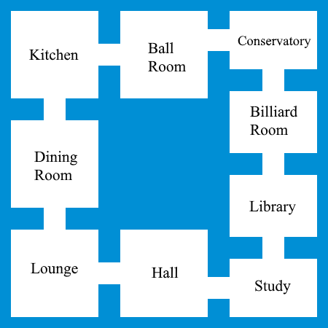
Ballroom | Kitchen, Conservatory
Billiard Room | Conservatory, Library
Conservatory | Billiard room, Ballroom
Dining Room | Kitchen, Lounge
Hall | Lounge, Study
Kitchen | Dining room, Ballroom
Library | Study, Billiard room
Lounge | Hall, Dining room
Study | Hall, Library
Figure 1: Layout of the Mansion (game board)
Above is the layout of the mansion and all its rooms. This serves as the setting of the game, and players are situated in and navigate between rooms.
Players:
1. Red
2. Yellow
3. White
4. Green
5. Blue
6. Purple
Setup:
1. There are six players, five AI and one user.
2. All of the above mentioned items (rooms, characters, and weapons) are treated as cards. From these cards one of each type is selected, in secret, prior to the start of the game. These will serve as the solution, the answer which the players seek to deduce.
3. The remaining cards are shuffled and distributed to the players. Each one of the six players will receive a total of three cards. These cards are kept in secret and are used in the refutation mechanic. Furthermore, each player should record their cards in their knowledge base since they know those cards cannot be the solution.
4. Players are assigned a color from the above list. Starting from the Red player, players will take turns following the above order. The refutations will also follow that order.
Mechanics:
1. During each players turn they can do three things: movement, suggestion, accusation.
2. A player can elect to move by choosing and adjacent room (see layout above) and their token will move to it. Movement happens first before suggestion and accusation.
3. A player can make a suggestion by selecting a character, a weapon, and a room (it must be the room they are currently in). The suggestion prompts the refutation mechanic.
4. When a player makes a suggestion then starting with the next player in clockwise order (see player order above) players must make a refutation if they are able. A refutation involves showing one of their cards, which are a part of the suggestion, to the suggesting player. For example, if Red suggests Candlestick, Professor Plum, and Ballroom then Yellow will refute with Candlestick (or any of the other cards if they have it).
5. If the next player cannot refute (they don’t have any of the cards), then the player after them must refute if able. This continues down the line until a player has refuted the suggestion or no one is able to refute it.
6. When a player feels they know the solution, they may make an accusation with the room (they must be present in it), the weapon, and the character they think is the solution. If they are correct, they win, if they are incorrect, they are disqualified.
7. Disqualified players no longer play except for the purpose of refuting suggestions.

Thorough Testing
Include screenshots demonstrating testing scenarios.

Challenges Faced
Discuss any obstacles encountered during development.

Stability and Reliability
Evaluate the game’s stability and reliability.

Additional Details
Modifications:
Some modifications were made to the base game to make it more congruent with this project’s requirements and the implementation restrictions. They are:
1. The replacement of the tiles with just rooms and movement being between rooms rather than between tiles.
2. Players no longer assume the identity of one of the characters and are identified with colors, as a result players are no longer moved around when a suggestion is made.

