

**Faculty of engineering - Shoubra**

**Benha University**

**Research Article / Research Project / Literature Review**

in fulfillment of the requirements of

|  |  |
| --- | --- |
| **Department** | **Engineering Mathematics and Physics.** |
| **Division** | **Preparatory** |
| **Academic Year** | **2019-2020 Preparatory** |
| **Course name** | **Computer.** |
| **Course code** | **ECE001** |

**Title: -**

**programming languages**

By:

|  |  |  |  |
| --- | --- | --- | --- |
|  | **Name** | **Edu mail** | **B.N** |
| **1** | **ابانوب فرحان نصحي جريس** | **Abanoub195002@feng.bu.edu.eg** | **3** |

**Approved by:**

|  |  |
| --- | --- |
| **Examiners committee** | **Signature** |
| **Dr.Ahmed Bayoumi** |  |
| **Dr.Shady Elmashad** |  |
| **Dr. Abdelhamid Attaby** |  |

**Student data**

***Name:* Abanoub Farhan Noshi**

***B.N:* 3**

***Topic:* programming languages**

***GitHub link:***

***GitHub page:***

**Application brief:** A programming language is a jargon for writing programs that are requirements of a calculation or algorithm Several scholars limit the phrase "programming language" to certain languages that can convey all potential algorithms, Programming languages typically provide abstractions to describe and modify data structures, or to monitor the execution flow. The abstraction theory communicates the functional imperative that a programming language accepts sufficient abstractions. This principle is sometimes formulated as a recommendation to the programmer to make proper use of such abstractions. A computer programming language is a language used to write computer programs, involving a machine performing any form of computation or algorithm and probably controlling external devices such as printers, disk drives, robots and so on. For starters, PostScript scripts are sometimes generated for the use of a computer printer or show by another application. More generally, a programming On some, possibly abstract, machine, language can describe the computation. It is widely agreed that a full specification for a programming language requires a definition, probably idealized, of a system or processor for that language. A programming language implies a device in most functional contexts; accordingly, programming languages are usually described and researched in this way, this research was chosen to clarify a very important field in our daily life and is the basis for most electronic devices. The programming language is the technology of the present and the future, and its importance in many areas of life

Screenshots

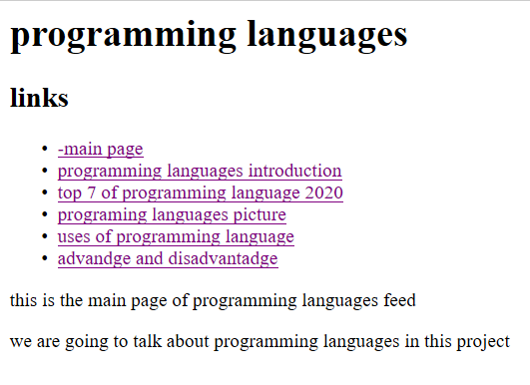

**Fig 1: main page**

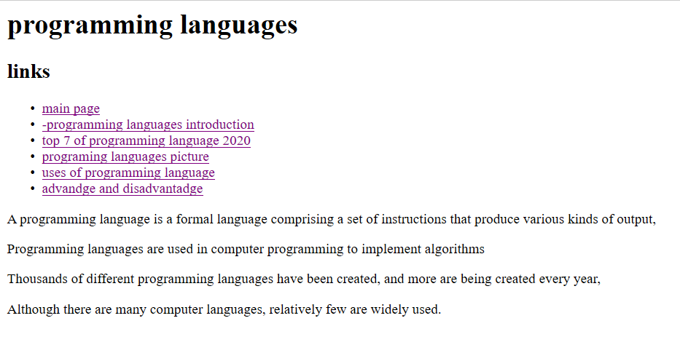

**Fig 2: introduction to programming languages**

**Fig 3: top 7 of programming language 2020**

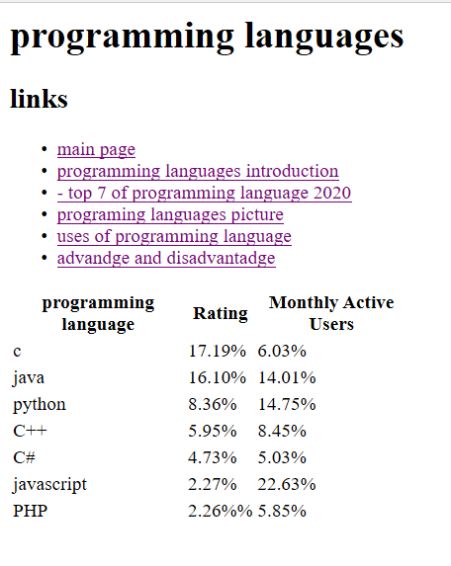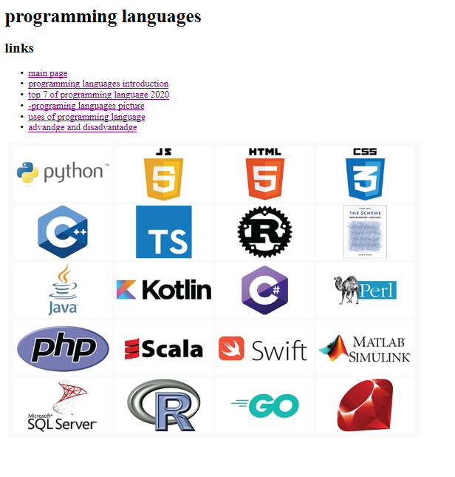

**Fig 4: programing languages picture**

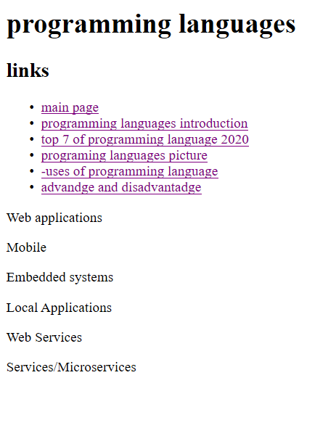

**Fig 5: uses of programming language**

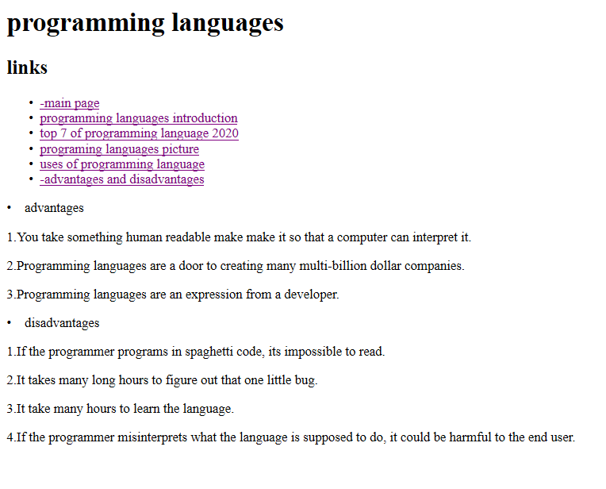

**Fig 6: advantages and disadvantages**

Source code

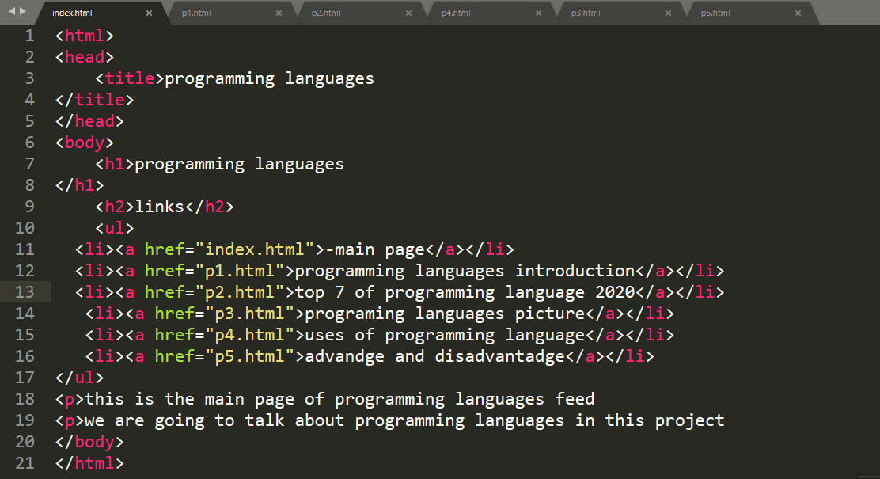

**Fig 7: main page code**

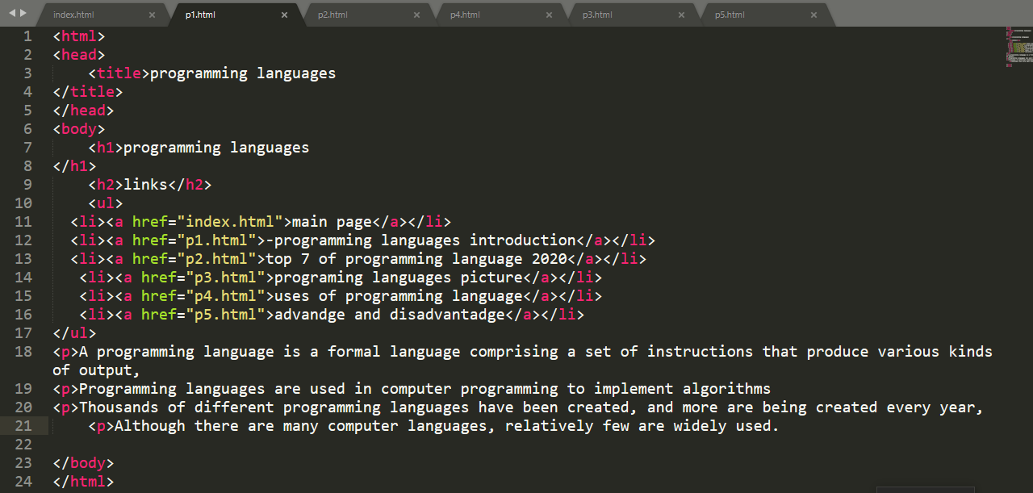

**Fig 8: programming languages introduction code**

**Fig 9: table code**

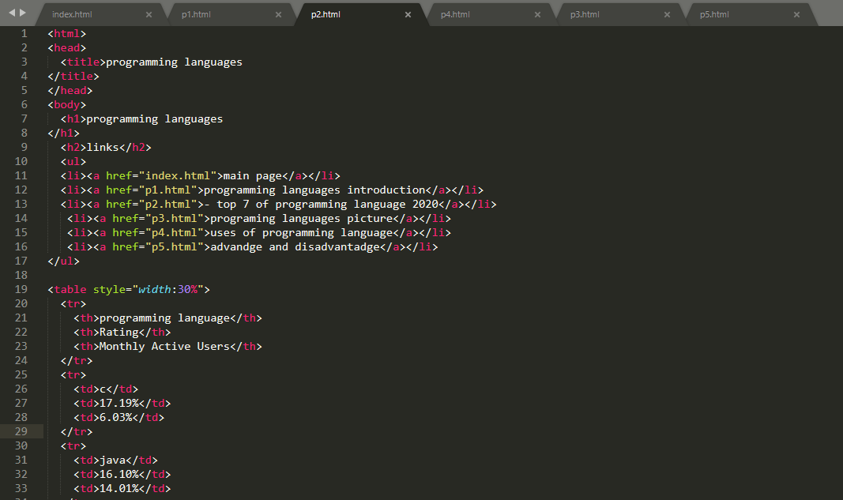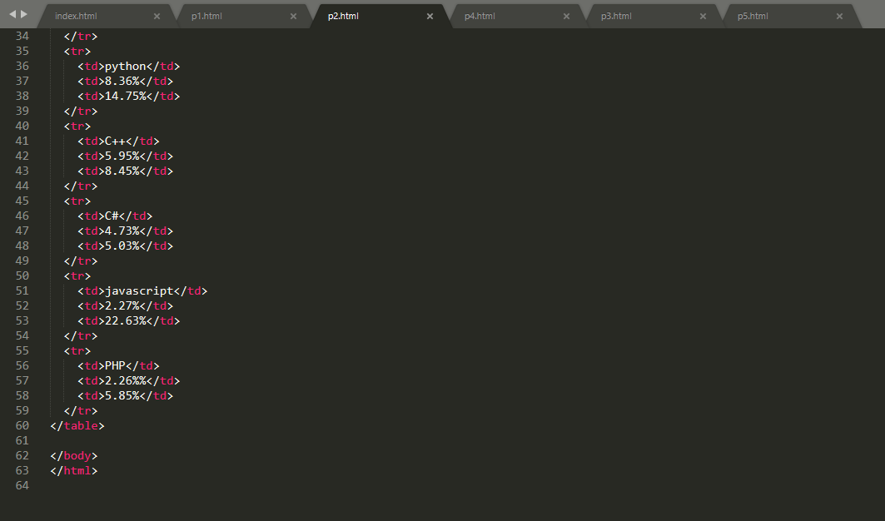

**Fig 10: continuo table code**

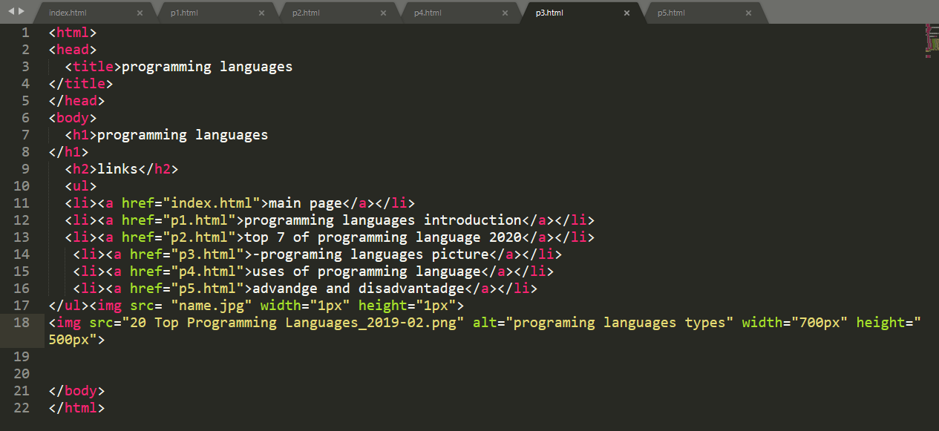

**programming languages picture code**

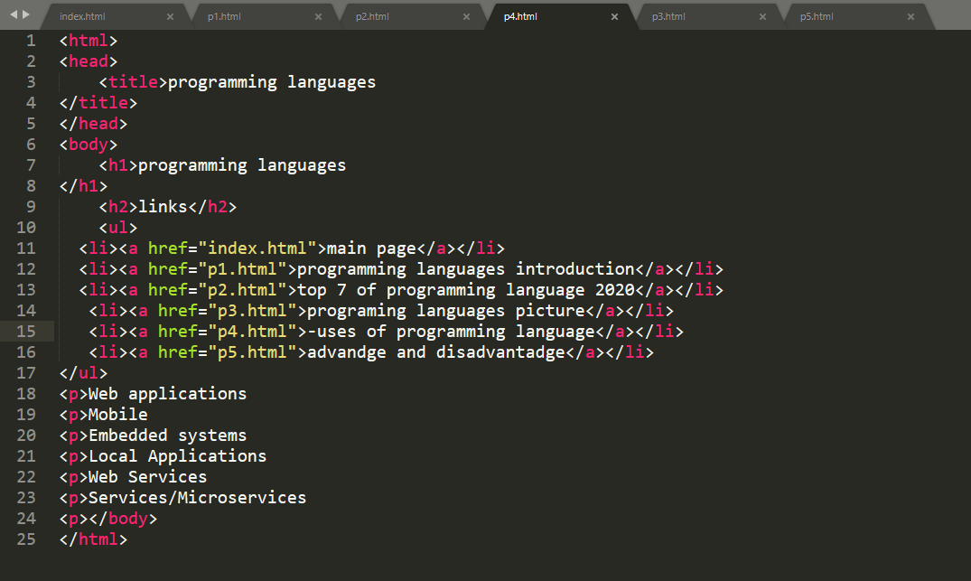

**Fig 12: uses of programming language code**

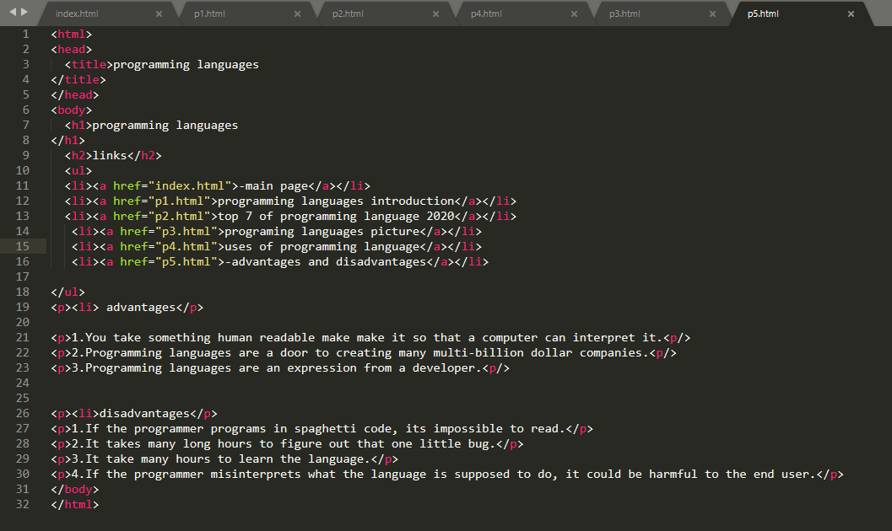

**Fig 13: advantages and disadvantages code**