**Event-Driven Programming Language**

**Prepared by :**

**Abanoub Ragheb**

**Gym Management**

**Summary:**

It helps gym officials know customer data easily and remove it without effort and find any customer in the least time, and it positively affects the security and arrangement of the place, in our gym project we have six forms , the first the project shows the user the small form that can let him go on the project in this form we ask the user to put two things the first thing is his name and the second is the password and this is the important part in the project to save the gym data and privacy, the second form lets the user see the options in the gym project and the photo of the gym and the top of the form we put years , month and the date of the day so in this form we have some option like add member, view member ,payment and delete member and every option take us in a new form, the third form lets the user add any member register in the gum so the owner put some of the information about the member like the name, the age, phone number, the time he wants to train in it, the gender and the number of months he will take to training, the fourth will show the user every information that the user put when he add the member so this form be easy to the user to know the members in the gum, the fifth is called payment it helps the user to calculate how much costs the member takes from the protein package , creatine package and in month, the sixth form helps user to delete any member leave the gym so he click on the name in the list member and the information appear to the user and he can delete it.

**Forms:**

Log In:

The first form is to register the gym manager and add his name and password, these things no one can know if someone else tries to log in, the program will send him that he needs the correct data so in GUI put one labels and two textboxes the first to put the name of the owner of the gym and the second to put the password that only admin know eventually we put the button called login to make this operation work so when user click on the button if he put the correct name and password the project will open to him but when he put the wrong name and password the warning message in the message box tells him this is the wrong information so if he the real owner he will repeat typing the correct information if he doesn't the real owner he can't goes to in the second button called reset help to repeat the filling in the information and the third button called exit and close the applications . and three picture box.

Main Form:  
The second form is to open the options in the program, for example, add a member, remove a member, or list of members so in this form we put Seven buttons the first button is the add member and when clicking on it the third form will open, the second button is the view member and when clicking on it the fifth form will open, the third button is delete members and when clicking on it the fourth form will open, the fourth button is add customer when click on it form six will open, the fifth button is view customer when click on it form seven will open, the sixth button is delete customer when click on it form eighth will open, the seventh is log out when click on it form 1 will open ,and we have two labels ,the first is called memberships , the second is products and we have one date time picker.

Add Member:  
The third form is to add a member, and the program asks the member to enter his name, gender, number, age, time attendance, number of months, amount and so that it shows us all the data we filled in while adding it so we have seven labels and seven text boxes and four buttons, the first label is the Member name, the second label is the age, the third label is phone number, the fourth label is the time attendance, the fifth label is the gender and the sixth label is number of month , the seventh label is amount ,so when the user fill this information the three buttons make the operation, the first button is called add so when we fill all the information we click on the button and the project will send the user message in message box tell he the information of member added successfully, the second button is called reset so when the user puts the wrong information it helps him to repeat write them, the third and last button is called back it helps the user to go to the second form, the fourth is price and shows the price in a textbox .

Delete Member:  
The fourth form is called delete, this form has two buttons the first button is called refresh it helps the user when the user deletes a member the database becomes without the member who delete, and the second button is called back and it helps to go to the second form, and we have data grid view is divided into rows and columns and all of this contains the information about the members so when the user clicks on the information member who wants to delete the project show the user message in box message to tell the user the member successfully delete and we have two labels ,first label is called delete member and the second label is called click on the member that you want to delete .

View Members :

The Fifth form is the view members, and it helps us to easily find any member we filled his data before so that it shows us all the data that we filled in while adding it so it has one button and it called back and when the form and we have data grid view, it is divided into rows and Columns and all of that contains the information about the member like his name, his age, the time he wants to train in it, his gender and the pay is by month it will take to training him and every person the user add it shows on this list and we have one label called member list.

Add Customer :

in this form we have seven labels, first label is called products, the second is customer name, the third number of protein packages, the fourth is number of creatine packages, the fifth is number of multivitamins packages, the sixth is number of glutamine packages, the seventh is total cost . and we have four buttons , the first button is called add so when we fill all the information we click on the button and the project will send the user message in message box tell he the information of member added successfully, the second button is called cost and it shows the total cost in the textbox, the third button is called reset so when the user puts the wrong information it helps him to repeat write them, the third and last button is called back it helps the user to go to the second form.

View customer :

The Seventh form is the view customers , and it helps us to easily find any customer we filled his data before so that it shows us all the data that we filled in while adding it so it has one button and it called back and when the form and we have data grid view, it is divided into rows and Columns and all of that contains the information about the customer and the products ,and we have one label called customer list and we have one label is called customer list .

Delete Customers:

The eighth form is called delete customers, this form has two buttons the first button is called refresh it helps the user when the user deletes a customer the database becomes without the member who delete, and the second button is called back and it helps to go to the second form, and we have data grid view is divided into rows and columns and all of this contains the information about the customers and the products so when the user clicks on the information customer who wants to delete the project show the user message in box message to tell the user the customer successfully delete and we have two labels, first label is called delete customers and the second label is called click on the customer that you want to delete.

**Database:**

First one called MemberTb1 and takes user’s name, phone, age, amount, timing and gender and store them as follow:

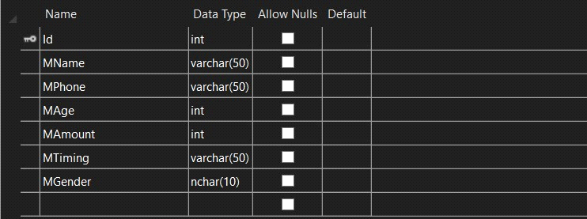

Second one called Payment and takes user’s name and number of and store them as follow:

