**Gradient Descent and Hessian Matrix:**

**Implementation of Gradient Decent Method**:

Learning Rate: 0.01

Values of Coefficients θ: [-2.62051097 0.7603714 1.1719467 ]

Iterations to Converge: 873

Plot:

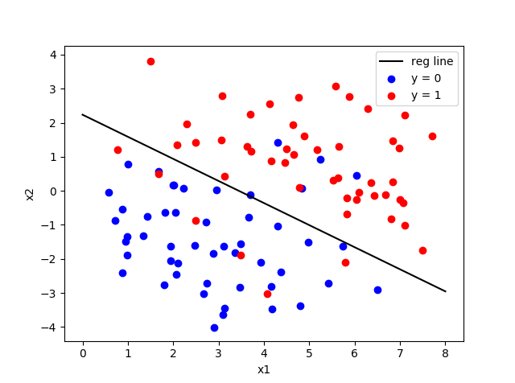

**Implementation of Newton Method**:

Values of Coefficients W: [-2.6205116 0.76037154 1.17194674]

Iterations to Converge: 8

Plot:



**Comparison of Newton Method and Gradient Method:**

Overall time taken by Gradient Method: **0.031242847442626953 seconds**

Overall time taken by Newton Method: **0.015625 seconds**

Number of iterations taken by Gradient to Converge: **873**

Number of iterations taken by Newton to Converge: **8**