**Q1) Discuss your observation. Is smaller or larger margin better for this dataset (need to explain which C values are likely to produce smaller v.s. larger values and then which end up being better in cross validation**

Answer-1

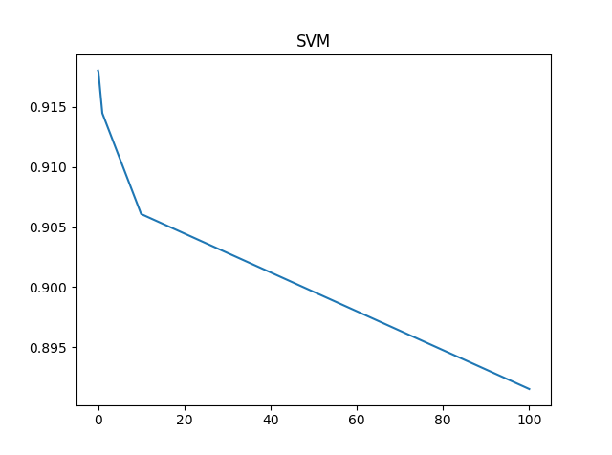

F-Measure is maximum for C=0.01 so therefore, the smaller the C the better the Margin (in our case).

As the C values decrease the margin increases and for our case f measure also increases.

**Q-2) Discuss your observations from the figures. Does larger tree mean better F-measure? Which criterion is better?**

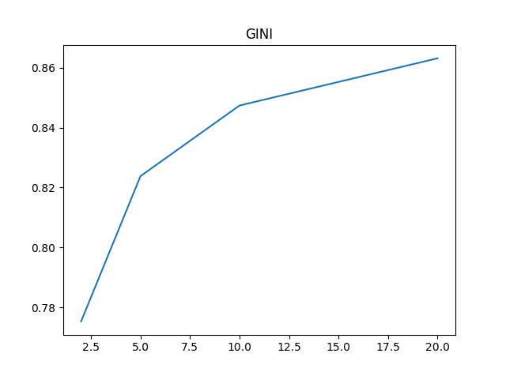

For Decision Tree with Criterion Gini maximum F-Measure is for K=20.

Therefore, Larger the tree better the F-Measure for GINI.

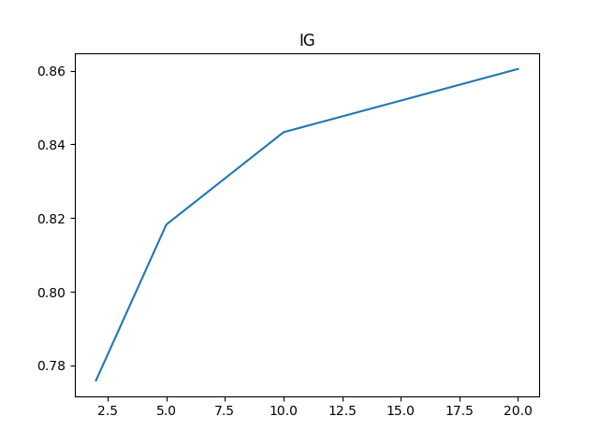

For Decision Tree with Criterion Information Gain maximum F-Measure is for K=20.

Therefore, Larger the tree better the F-Measure for Information GAIN.

**Criterion Gini is better since it has higher F-measure.**

Q3) Discuss your findings. Which are the best classifiers when you consider the different metrics? Is there a single winner for this dataset.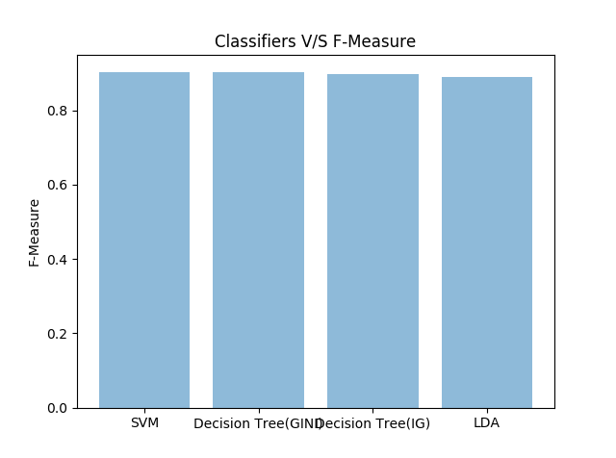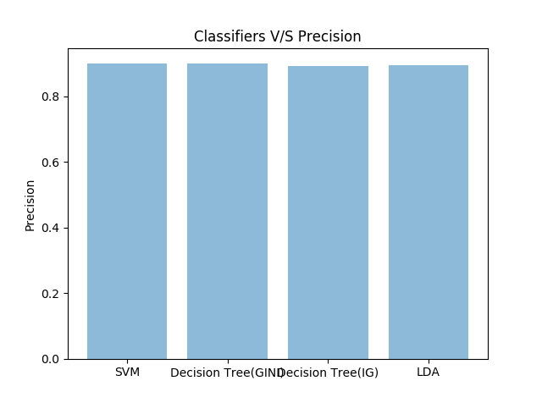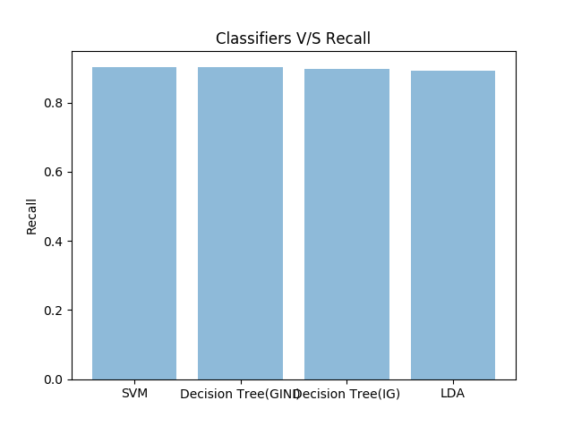

For F-Measure: SVM is proved to be the best classifier.

For Precision: SVM is proved to be best classifier.

For Recall: SVM is proved to be the best classifier.

Therefore, SVM is the single winner.

Q-4) Consider a classifier that is implemented in scikit-learn but we have not discussed in class: RandomForestClassifier. Learn how to create and train it in scikit-learn and add it to the comparison from the previous part (c). Explain the results.

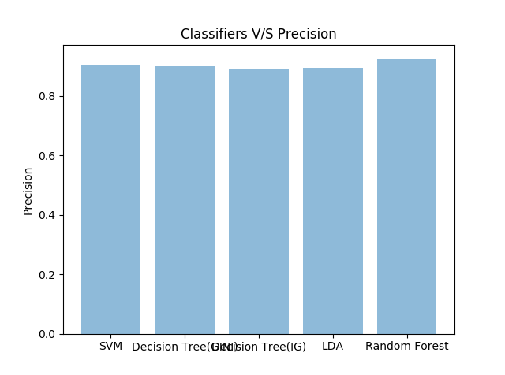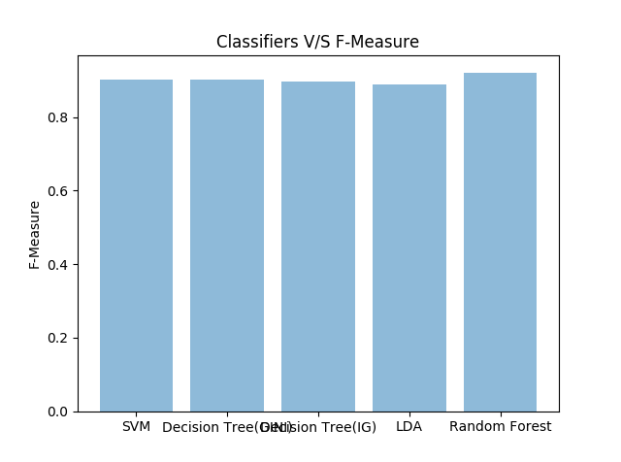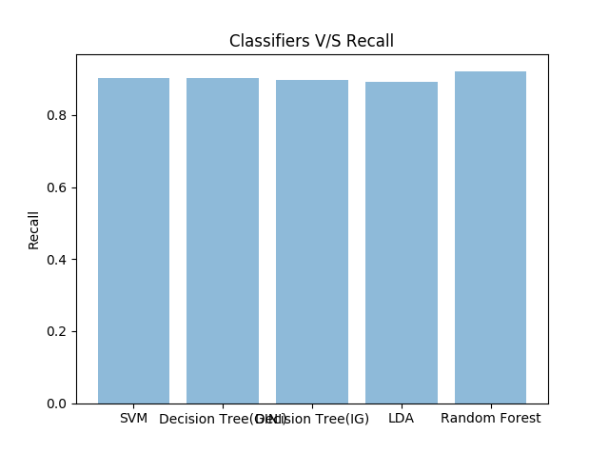

For all the measures RandomForestClassifier is the winner.

Therefore, RandomForestCLassifier is the best classifier for our dataset.