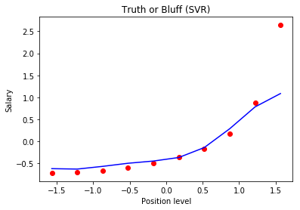

Salary predicted at 6.5 : print(sc_y.inverse_transform(regressor.predict(sc_X.transform(np.array([[6.5]])))))

= **170370**