**LAPORAN PRAKTIKUM**

**BAHASA PEMROGRAMAN 1**

(**DOSEN PENGAMPU : DEDE HUSEN., M.KOM)**

**Modul 6**



DISUSUN OLEH :

NAMA : MOHAMAD ABAN SY’BANA

NIM : 20230810012

KELAS : TINFC-2023-04

**TEKNIK INFORMATIKA**

**FAKULTAS ILMU KOMPUTER**

**UNIVERSITAS KUNINGAN**

**2024**

**PRETES**

1. Apa Itu Database ?

**Jawab :** Database Adalah Kumpulan Data Yang Terorganisir Dan Tersimpan Secara Elektronik. Basis Data Dirancang Untuk Memungkinkan Penyimpanan, Pengelolaan, Dan Pengambilan Data Dengan Efisien Dan Terstruktur. Data Dalam Basis Data Biasanya Diatur Dalam Bentuk Tabel, Yang Memungkinkan Akses Dan Manipulasi Yang Cepat Dan Efisien.

1. Apa itu query ?

**Jawab :** Query adalah permintaan atau perintah yang diberikan ke sistem manajemen basis data (DBMS) untuk mengambil, menambah, memperbarui, atau menghapus data dari basis data. Query biasanya ditulis dalam bahasa SQL (Structured Query Language).

1. Tuliskan script koneksi untuk database bp1 dengan DBMS Mysql

**Jawab :**

import java.sql.Connection;

import java.sql.DriverManager;

import javax.swing.JOptionPane;

public class koneksi {

public Connection con;

public koneksi (){

String id, pass, driver, url;

id = "root";

pass ="";

driver = "com.mysql.jdbc.Driver";

url = "jdbc:mysql://localhost:3306/form_mahasiswa";

try{

Class.forName(driver).newInstance();

con=DriverManager.getConnection(url,id,pass);

JOptionPane.showMessageDialog(null, "Koneksi Berhasil");

}

catch(Exception e){

System.out.println("" + e.getLocalizedMessage());

}

}

public static void main(String []args){

koneksi kon=new koneksi();

}

}

**PRAKTIKUM**

1. Program 1
   1. buat database dengan nama db_mhs di DBMS Mysql seperti berikut:

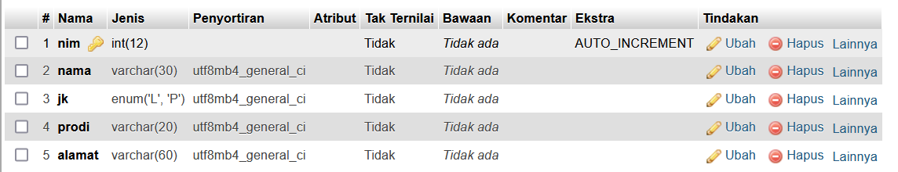

b. isi table seperti :

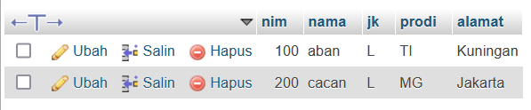

1. program-2 (Koneksi)
   1. Buat file java class dengan nama koneksi.java
   2. Lengkapi script program seperti :

import java.sql.Connection;

import java.sql.DriverManager;

import javax.swing.JOptionPane;

/**

*

* @author Suci Indah Lestari

*/

public class koneksi {

public Connection con;

public koneksi (){

String id, pass, driver, url;

id = "root";

pass ="";

driver = "com.mysql.jdbc.Driver";

url = "jdbc:mysql://localhost:3306/form_mahasiswa";

try{

Class.forName(driver).newInstance();

con=DriverManager.getConnection(url,id,pass);

JOptionPane.showMessageDialog(null, "Koneksi Berhasil");

}

catch(Exception e){

System.out.println("" + e.getLocalizedMessage());

}

}

public static void main(String []args){

koneksi kon=new koneksi();

}

}

1. Program-3(Menambahkan Library Mysql JDBC Driver
   1. Klik kanan pada Libraries project yang di buat -> add Library

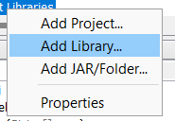

* 1. pilih Mysql JDBC Driver -> add Library

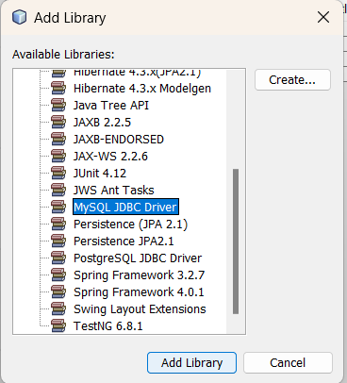

* 1. Jalankan file koneksi.java
  2. Amati hasilnya
  3. jika ada kesalahan silahkan perbaiki

1. PROGRAM-4 (CRUD)
   1. buat file JFram From dengan nama BP1_M6_P1_nama
   2. buat tampilan berikut:

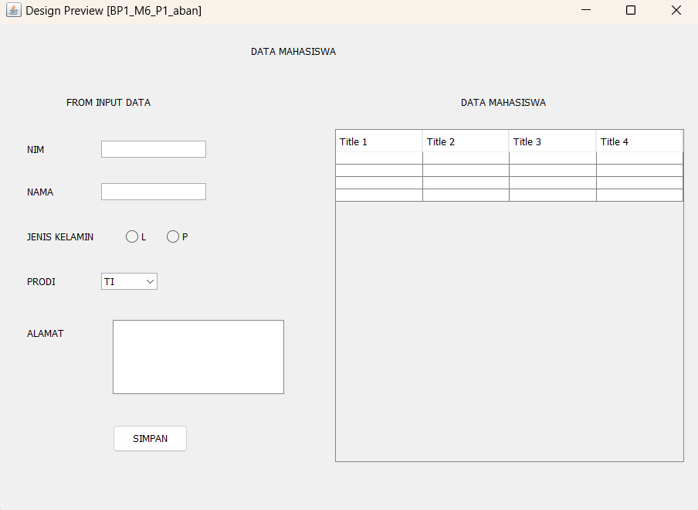

* 1. Lengkapi Script Program

import java.sql.ResultSet;

import java.sql.Statement;

import javax.swing.JOptionPane;

import javax.swing.table.DefaultTableModel;

/**

*

* @author Suci Indah Lestari

*/

public class BP1_M6_P1_aban extends javax.swing.JFrame {

private Object JTable1;

Statement st;

ResultSet rs;

Koneksi koneksi;

/**

* Creates new form BP1_M6_P1_aban

*/

public BP1_M6_P1_aban() {

koneksi = new Koneksi();

initComponents();

load_data();

}

private void load_data() {

Object header[] = {"NIM", "NAMA", "JENIS KELAMIN", "PRODI", "ALAMAT"};

DefaultTableModel data = new DefaultTableModel(null, header);

jTable1.setModel(data);

String sql = "SELECT nim, nama, jk, prodi, alamat FROM mhs";

try (Statement st = koneksi.con.createStatement();

ResultSet rs = st.executeQuery(sql)) {

while (rs.next()) {

String k1 = rs.getString("nim");

String k2 = rs.getString("nama");

String k3 = rs.getString("jk");

String k4 = rs.getString("prodi");

String k5 = rs.getString("alamat");

String k[] = {k1, k2, k3, k4, k5};

data.addRow(k);

}

} catch (Exception e) {

JOptionPane.showMessageDialog(this, "Error: " + e.getMessage(), "Load Data Error", JOptionPane.ERROR_MESSAGE);

}

}

**Class Koneksi**

import java.sql.Connection;

import java.sql.DriverManager;

import java.sql.SQLException;

public class Koneksi {

public Connection con;

public Koneksi() {

try {

// Sesuaikan URL, username, dan password

String url = "jdbc:mysql://localhost:3306/mahasiswa_db";

String user = "root"; // Default user di XAMPP

String password = ""; // Password kosong untuk XAMPP

con = DriverManager.getConnection(url, user, password);

System.out.println("Koneksi berhasil!");

} catch (SQLException e) {

System.out.println("Koneksi gagal: " + e.getMessage());

}

}

}

2.

/*

* To change this license header, choose License Headers in Project Properties.

* To change this template file, choose Tools | Templates

* and open the template in the editor.

*/

d. RUN, amati hasilnya -> jika ada kesalahan, Silahkan di perbaiki

**PostTest**

* + 1. lengkapi form data mahasiswa dengan menambahkan kelas,Angkatan,no hp, kartu mahasiswa

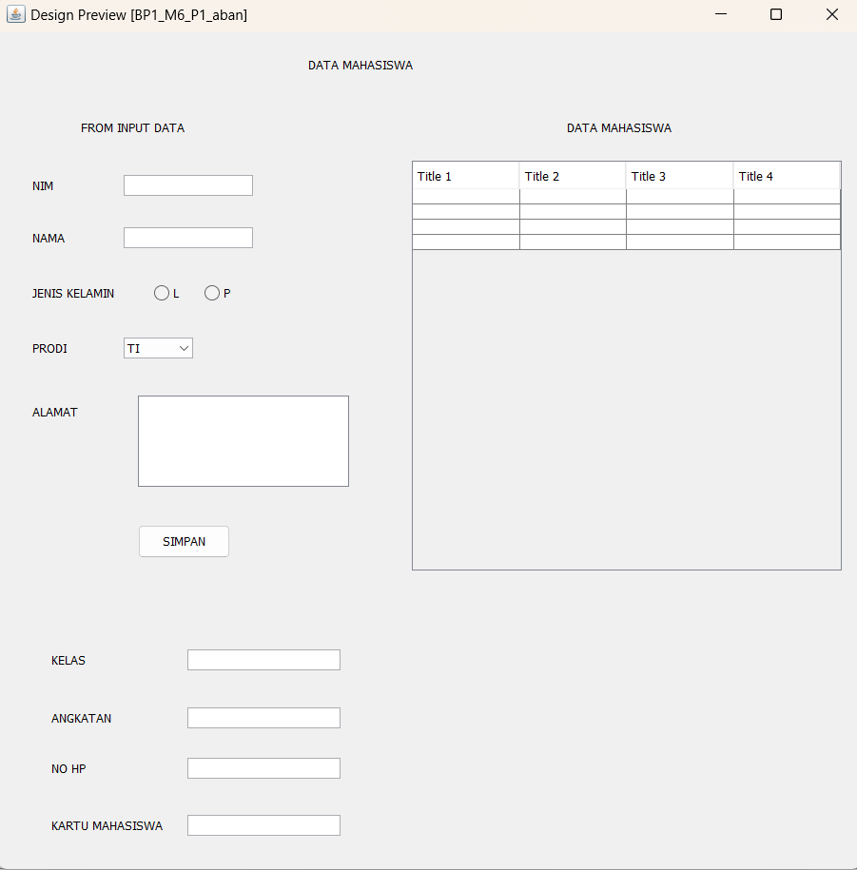

* + 1. lengkapi database mhs sesuai dengan penambahan pada no.1

import java.sql.ResultSet;

import java.sql.Statement;

import javax.swing.JOptionPane;

import javax.swing.table.DefaultTableModel;

/**

*

* @author Suci Indah Lestari

*/

public class BP1_M6_P1_aban extends javax.swing.JFrame {

private Object JTable1;

Statement st;

ResultSet rs;

koneksi koneksi;

/**

* Creates new form BP1_M6_P1_aban

*/

public BP1_M6_P1_aban() {

koneksi = new koneksi();

initComponents();

load_data();

}

private void load_data() {

Object header[] = {"NIM", "NAMA", "JENIS KELAMIN", "PRODI", "ALAMAT", "KELAS", "ANGKATAN", "NO HP", "KARTU MAHASISWA"};

DefaultTableModel data = new DefaultTableModel(null, header);

jTable1.setModel(data);

String sql = "SELECT nim, nama, jk, prodi, alamat, kelas, angkatan, noHp, ktm FROM form_mhs";

try (Statement st = koneksi.con.createStatement();

ResultSet rs = st.executeQuery(sql)) {

while (rs.next()) {

String k1 = rs.getString("nim");

String k2 = rs.getString("nama");

String k3 = rs.getString("jk");

String k4 = rs.getString("prodi");

String k5 = rs.getString("alamat");

String k6 = rs.getString("kelas");

String k7 = rs.getString("angkatan");

String k8 = rs.getString("noHp");

String k9 = rs.getString("ktm");

String k[] = {k1, k2, k3, k4, k5, k6, k7, k8, k9};

data.addRow(k);

}

} catch (Exception e) {

JOptionPane.showMessageDialog(this, "Error: " + e.getMessage(), "Load Data Error", JOptionPane.ERROR_MESSAGE);

}

}

/**

* This method is called from within the constructor to initialize the form.

* WARNING: Do NOT modify this code. The content of this method is always

* regenerated by the Form Editor.

*/

@SuppressWarnings("unchecked")

// <editor-fold defaultstate="collapsed" desc="Generated Code">

private void initComponents() {

jLabel1 = new javax.swing.JLabel();

jLabel2 = new javax.swing.JLabel();

jLabel3 = new javax.swing.JLabel();

jLabel4 = new javax.swing.JLabel();

jLabel5 = new javax.swing.JLabel();

jLabel6 = new javax.swing.JLabel();

jLabel7 = new javax.swing.JLabel();

jTextField1 = new javax.swing.JTextField();

jTextField2 = new javax.swing.JTextField();

jRadioButton1 = new javax.swing.JRadioButton();

jRadioButton2 = new javax.swing.JRadioButton();

jScrollPane1 = new javax.swing.JScrollPane();

jTextArea1 = new javax.swing.JTextArea();

jButton1 = new javax.swing.JButton();

jLabel8 = new javax.swing.JLabel();

jScrollPane2 = new javax.swing.JScrollPane();

jTable1 = new javax.swing.JTable();

jComboBox1 = new javax.swing.JComboBox<>();

jLabel9 = new javax.swing.JLabel();

jLabel10 = new javax.swing.JLabel();

jLabel11 = new javax.swing.JLabel();

jLabel12 = new javax.swing.JLabel();

jTextField3 = new javax.swing.JTextField();

jTextField4 = new javax.swing.JTextField();

jTextField5 = new javax.swing.JTextField();

jTextField6 = new javax.swing.JTextField();

setDefaultCloseOperation(javax.swing.WindowConstants.EXIT_ON_CLOSE);

jLabel1.setText("DATA MAHASISWA");

jLabel2.setText("FROM INPUT DATA");

jLabel3.setText("NIM");

jLabel4.setText("NAMA");

jLabel5.setText("JENIS KELAMIN");

jLabel6.setText("PRODI");

jLabel7.setText("ALAMAT");

jRadioButton1.setText("L");

jRadioButton2.setText("P");

jTextArea1.setColumns(20);

jTextArea1.setRows(5);

jScrollPane1.setViewportView(jTextArea1);

jButton1.setText("SIMPAN");

jLabel8.setText("DATA MAHASISWA");

jTable1.setModel(new javax.swing.table.DefaultTableModel(

new Object [][] {

{null, null, null, null},

{null, null, null, null},

{null, null, null, null},

{null, null, null, null}

},

new String [] {

"Title 1", "Title 2", "Title 3", "Title 4"

}

));

jScrollPane2.setViewportView(jTable1);

jComboBox1.setModel(new javax.swing.DefaultComboBoxModel<>(new String[] { "TI", "DKV", "SI", "TS", "MI" }));

jLabel9.setText("KELAS");

jLabel10.setText("ANGKATAN");

jLabel11.setText("NO HP");

jLabel12.setText("KARTU MAHASISWA");

javax.swing.GroupLayout layout = new javax.swing.GroupLayout(getContentPane());

getContentPane().setLayout(layout);

layout.setHorizontalGroup(

layout.createParallelGroup(javax.swing.GroupLayout.Alignment.LEADING)

.addGroup(layout.createSequentialGroup()

.addGap(87, 87, 87)

.addComponent(jLabel2)

.addPreferredGap(javax.swing.LayoutStyle.ComponentPlacement.RELATED, javax.swing.GroupLayout.DEFAULT_SIZE, Short.MAX_VALUE)

.addComponent(jLabel8)

.addGap(199, 199, 199))

.addGroup(layout.createSequentialGroup()

.addGap(36, 36, 36)

.addGroup(layout.createParallelGroup(javax.swing.GroupLayout.Alignment.LEADING)

.addComponent(jLabel6)

.addGroup(layout.createParallelGroup(javax.swing.GroupLayout.Alignment.TRAILING, false)

.addGroup(layout.createSequentialGroup()

.addComponent(jLabel3)

.addGap(74, 74, 74)

.addComponent(jTextField1, javax.swing.GroupLayout.PREFERRED_SIZE, 136, javax.swing.GroupLayout.PREFERRED_SIZE))

.addGroup(layout.createSequentialGroup()

.addGroup(layout.createParallelGroup(javax.swing.GroupLayout.Alignment.LEADING)

.addComponent(jLabel4)

.addComponent(jLabel5))

.addPreferredGap(javax.swing.LayoutStyle.ComponentPlacement.RELATED, javax.swing.GroupLayout.DEFAULT_SIZE, Short.MAX_VALUE)

.addGroup(layout.createParallelGroup(javax.swing.GroupLayout.Alignment.LEADING)

.addComponent(jTextField2, javax.swing.GroupLayout.PREFERRED_SIZE, 136, javax.swing.GroupLayout.PREFERRED_SIZE)

.addGroup(layout.createSequentialGroup()

.addGap(28, 28, 28)

.addComponent(jRadioButton1)

.addGap(18, 18, 18)

.addComponent(jRadioButton2))

.addComponent(jComboBox1, javax.swing.GroupLayout.PREFERRED_SIZE, 73, javax.swing.GroupLayout.PREFERRED_SIZE))))

.addGroup(layout.createSequentialGroup()

.addComponent(jLabel7)

.addGap(63, 63, 63)

.addGroup(layout.createParallelGroup(javax.swing.GroupLayout.Alignment.LEADING)

.addComponent(jButton1, javax.swing.GroupLayout.PREFERRED_SIZE, 97, javax.swing.GroupLayout.PREFERRED_SIZE)

.addComponent(jScrollPane1, javax.swing.GroupLayout.PREFERRED_SIZE, 222, javax.swing.GroupLayout.PREFERRED_SIZE))))

.addPreferredGap(javax.swing.LayoutStyle.ComponentPlacement.RELATED, 66, Short.MAX_VALUE)

.addComponent(jScrollPane2, javax.swing.GroupLayout.PREFERRED_SIZE, javax.swing.GroupLayout.DEFAULT_SIZE, javax.swing.GroupLayout.PREFERRED_SIZE)

.addGap(20, 20, 20))

.addGroup(layout.createSequentialGroup()

.addGroup(layout.createParallelGroup(javax.swing.GroupLayout.Alignment.LEADING)

.addGroup(layout.createSequentialGroup()

.addGap(326, 326, 326)

.addComponent(jLabel1))

.addGroup(layout.createSequentialGroup()

.addGap(56, 56, 56)

.addGroup(layout.createParallelGroup(javax.swing.GroupLayout.Alignment.LEADING, false)

.addGroup(layout.createSequentialGroup()

.addComponent(jLabel12)

.addPreferredGap(javax.swing.LayoutStyle.ComponentPlacement.RELATED, javax.swing.GroupLayout.DEFAULT_SIZE, Short.MAX_VALUE)

.addComponent(jTextField6, javax.swing.GroupLayout.PREFERRED_SIZE, 161, javax.swing.GroupLayout.PREFERRED_SIZE))

.addGroup(javax.swing.GroupLayout.Alignment.TRAILING, layout.createSequentialGroup()

.addComponent(jLabel11)

.addPreferredGap(javax.swing.LayoutStyle.ComponentPlacement.RELATED, javax.swing.GroupLayout.DEFAULT_SIZE, Short.MAX_VALUE)

.addComponent(jTextField5, javax.swing.GroupLayout.PREFERRED_SIZE, 161, javax.swing.GroupLayout.PREFERRED_SIZE))

.addGroup(javax.swing.GroupLayout.Alignment.TRAILING, layout.createSequentialGroup()

.addComponent(jLabel10)

.addPreferredGap(javax.swing.LayoutStyle.ComponentPlacement.RELATED, javax.swing.GroupLayout.DEFAULT_SIZE, Short.MAX_VALUE)

.addComponent(jTextField4, javax.swing.GroupLayout.PREFERRED_SIZE, 161, javax.swing.GroupLayout.PREFERRED_SIZE))

.addGroup(layout.createSequentialGroup()

.addComponent(jLabel9)

.addGap(107, 107, 107)

.addComponent(jTextField3, javax.swing.GroupLayout.PREFERRED_SIZE, 161, javax.swing.GroupLayout.PREFERRED_SIZE)))))

.addContainerGap(javax.swing.GroupLayout.DEFAULT_SIZE, Short.MAX_VALUE))

);

layout.setVerticalGroup(

layout.createParallelGroup(javax.swing.GroupLayout.Alignment.LEADING)

.addGroup(layout.createSequentialGroup()

.addGap(26, 26, 26)

.addComponent(jLabel1)

.addGap(50, 50, 50)

.addGroup(layout.createParallelGroup(javax.swing.GroupLayout.Alignment.BASELINE)

.addComponent(jLabel2)

.addComponent(jLabel8))

.addGroup(layout.createParallelGroup(javax.swing.GroupLayout.Alignment.LEADING)

.addGroup(layout.createSequentialGroup()

.addGap(42, 42, 42)

.addGroup(layout.createParallelGroup(javax.swing.GroupLayout.Alignment.BASELINE)

.addComponent(jLabel3)

.addComponent(jTextField1, javax.swing.GroupLayout.PREFERRED_SIZE, javax.swing.GroupLayout.DEFAULT_SIZE, javax.swing.GroupLayout.PREFERRED_SIZE))

.addGap(33, 33, 33)

.addGroup(layout.createParallelGroup(javax.swing.GroupLayout.Alignment.BASELINE)

.addComponent(jLabel4)

.addComponent(jTextField2, javax.swing.GroupLayout.PREFERRED_SIZE, javax.swing.GroupLayout.DEFAULT_SIZE, javax.swing.GroupLayout.PREFERRED_SIZE))

.addGap(35, 35, 35)

.addGroup(layout.createParallelGroup(javax.swing.GroupLayout.Alignment.BASELINE)

.addComponent(jLabel5)

.addComponent(jRadioButton1)

.addComponent(jRadioButton2))

.addGap(34, 34, 34)

.addGroup(layout.createParallelGroup(javax.swing.GroupLayout.Alignment.BASELINE)

.addComponent(jLabel6)

.addComponent(jComboBox1, javax.swing.GroupLayout.PREFERRED_SIZE, javax.swing.GroupLayout.DEFAULT_SIZE, javax.swing.GroupLayout.PREFERRED_SIZE))

.addGap(39, 39, 39)

.addGroup(layout.createParallelGroup(javax.swing.GroupLayout.Alignment.LEADING)

.addComponent(jScrollPane1, javax.swing.GroupLayout.PREFERRED_SIZE, javax.swing.GroupLayout.DEFAULT_SIZE, javax.swing.GroupLayout.PREFERRED_SIZE)

.addGroup(layout.createSequentialGroup()

.addGap(9, 9, 9)

.addComponent(jLabel7)))

.addGap(40, 40, 40)

.addComponent(jButton1, javax.swing.GroupLayout.PREFERRED_SIZE, 35, javax.swing.GroupLayout.PREFERRED_SIZE))

.addGroup(layout.createSequentialGroup()

.addGap(27, 27, 27)

.addComponent(jScrollPane2, javax.swing.GroupLayout.PREFERRED_SIZE, javax.swing.GroupLayout.DEFAULT_SIZE, javax.swing.GroupLayout.PREFERRED_SIZE)))

.addPreferredGap(javax.swing.LayoutStyle.ComponentPlacement.RELATED, 83, Short.MAX_VALUE)

.addGroup(layout.createParallelGroup(javax.swing.GroupLayout.Alignment.BASELINE)

.addComponent(jLabel9)

.addComponent(jTextField3, javax.swing.GroupLayout.PREFERRED_SIZE, javax.swing.GroupLayout.DEFAULT_SIZE, javax.swing.GroupLayout.PREFERRED_SIZE))

.addGap(39, 39, 39)

.addGroup(layout.createParallelGroup(javax.swing.GroupLayout.Alignment.BASELINE)

.addComponent(jLabel10)

.addComponent(jTextField4, javax.swing.GroupLayout.PREFERRED_SIZE, javax.swing.GroupLayout.DEFAULT_SIZE, javax.swing.GroupLayout.PREFERRED_SIZE))

.addGap(31, 31, 31)

.addGroup(layout.createParallelGroup(javax.swing.GroupLayout.Alignment.BASELINE)

.addComponent(jLabel11)

.addComponent(jTextField5, javax.swing.GroupLayout.PREFERRED_SIZE, javax.swing.GroupLayout.DEFAULT_SIZE, javax.swing.GroupLayout.PREFERRED_SIZE))

.addGap(38, 38, 38)

.addGroup(layout.createParallelGroup(javax.swing.GroupLayout.Alignment.BASELINE)

.addComponent(jLabel12)

.addComponent(jTextField6, javax.swing.GroupLayout.PREFERRED_SIZE, javax.swing.GroupLayout.DEFAULT_SIZE, javax.swing.GroupLayout.PREFERRED_SIZE))

.addGap(35, 35, 35))

);

pack();

}// </editor-fold>

/**

* @param args the command line arguments

*/

public static void main(String args[]) {

/* Set the Nimbus look and feel */

//<editor-fold defaultstate="collapsed" desc=" Look and feel setting code (optional) ">

/* If Nimbus (introduced in Java SE 6) is not available, stay with the default look and feel.

* For details see http://download.oracle.com/javase/tutorial/uiswing/lookandfeel/plaf.html

*/

try {

for (javax.swing.UIManager.LookAndFeelInfo info : javax.swing.UIManager.getInstalledLookAndFeels()) {

if ("Nimbus".equals(info.getName())) {

javax.swing.UIManager.setLookAndFeel(info.getClassName());

break;

}

}

} catch (ClassNotFoundException ex) {

java.util.logging.Logger.getLogger(BP1_M6_P1_aban.class.getName()).log(java.util.logging.Level.SEVERE, null, ex);

} catch (InstantiationException ex) {

java.util.logging.Logger.getLogger(BP1_M6_P1_aban.class.getName()).log(java.util.logging.Level.SEVERE, null, ex);

} catch (IllegalAccessException ex) {

java.util.logging.Logger.getLogger(BP1_M6_P1_aban.class.getName()).log(java.util.logging.Level.SEVERE, null, ex);

} catch (javax.swing.UnsupportedLookAndFeelException ex) {

java.util.logging.Logger.getLogger(BP1_M6_P1_aban.class.getName()).log(java.util.logging.Level.SEVERE, null, ex);

}

//</editor-fold>

/* Create and display the form */

java.awt.EventQueue.invokeLater(new Runnable() {

public void run() {

new BP1_M6_P1_aban().setVisible(true);

}

});

}

// Variables declaration - do not modify

private javax.swing.JButton jButton1;

private javax.swing.JComboBox<String> jComboBox1;

private javax.swing.JLabel jLabel1;

private javax.swing.JLabel jLabel10;

private javax.swing.JLabel jLabel11;

private javax.swing.JLabel jLabel12;

private javax.swing.JLabel jLabel2;

private javax.swing.JLabel jLabel3;

private javax.swing.JLabel jLabel4;

private javax.swing.JLabel jLabel5;

private javax.swing.JLabel jLabel6;

private javax.swing.JLabel jLabel7;

private javax.swing.JLabel jLabel8;

private javax.swing.JLabel jLabel9;

private javax.swing.JRadioButton jRadioButton1;

private javax.swing.JRadioButton jRadioButton2;

private javax.swing.JScrollPane jScrollPane1;

private javax.swing.JScrollPane jScrollPane2;

private javax.swing.JTable jTable1;

private javax.swing.JTextArea jTextArea1;

private javax.swing.JTextField jTextField1;

private javax.swing.JTextField jTextField2;

private javax.swing.JTextField jTextField3;

private javax.swing.JTextField jTextField4;

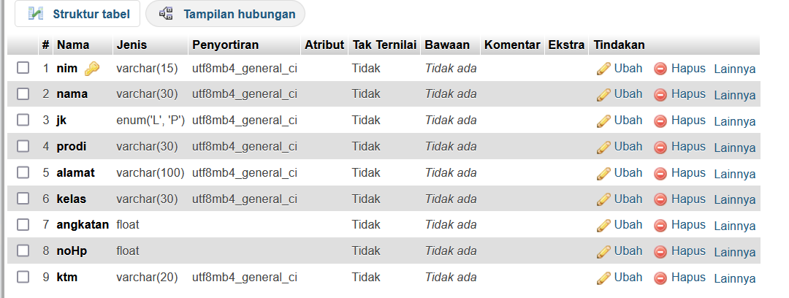 private javax.swing.JTextField jTextField5;

private javax.swing.JTextField jTextField6;

// End of variables declaration

}

**Tugas**

1. Buat database admin (level terdiri dari admin dan user)

**Database admin**

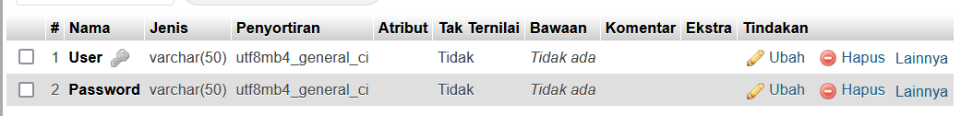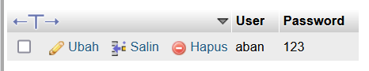

**Database user**

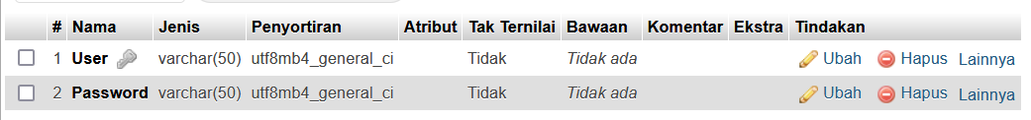

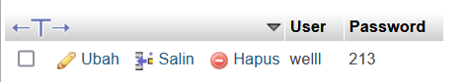

1. Koneksikan form login pada praktikum modul 4, jika login berhasil maka akan tampil form data mahasiswa (praktikum 6)

**Code**

import javax.swing.JOptionPane;

import java.sql.ResultSet;

import java.sql.Statement;

import javax.swing.JOptionPane;

import javax.swing.table.DefaultTableModel;

/*

* To change this license header, choose License Headers in Project Properties.

* To change this template file, choose Tools | Templates

* and open the template in the editor.

*/

/**

*

* @author Suci Indah Lestari

*/

public class BP1_M6_tugas_aban extends javax.swing.JFrame {

Statement st;

ResultSet rs;

Koneksi1 koneksi;

/**

* Creates new form BP1_M6_tugas_aban

*/

public BP1_M6_tugas_aban() {

initComponents();

koneksi = new Koneksi1();

}

private void LoginUser(){

String User = jTextField1.getText();

String Pass = jTextField2.getText();

boolean loginSuccess = false;

try {

st = koneksi.con.createStatement();

rs = st.executeQuery("SELECT User, Password FROM user");

while (rs.next()) {

String Username = rs.getString("User");

String Password = rs.getString("Password");

if (User.equals(Username) && Pass.equals(Password)) {

loginSuccess = true;

break;

}

}

} catch (Exception e) {

JOptionPane.showMessageDialog(null, e);

}

if (User.isEmpty()) {

JOptionPane.showMessageDialog(null, "Username harus diisi", "Login", JOptionPane.ERROR_MESSAGE);

} else if (Pass.isEmpty()) {

JOptionPane.showMessageDialog(null, "Password harus diisi", "Login", JOptionPane.ERROR_MESSAGE);

} else if (loginSuccess) {

BP1_M6_P1_aban Login = new BP1_M6_P1_aban();

Login.setVisible(true);

setVisible(false);

JOptionPane.showMessageDialog(null, "Login Sukses " + User, "Login", JOptionPane.INFORMATION_MESSAGE);

} else {

JOptionPane.showMessageDialog(null, "Login Gagal", "Login", JOptionPane.ERROR_MESSAGE);

}

}

private void LoginAdmin(){

String User = jTextField1.getText();

String Pass = jTextField2.getText();

boolean loginSuccess = false;

try {

st = koneksi.con.createStatement();

rs = st.executeQuery("SELECT User, Password FROM admin");

while (rs.next()) {

String Username = rs.getString("User");

String Password = rs.getString("Password");

if (User.equals(Username) && Pass.equals(Password)) {

loginSuccess = true;

break;

}

}

} catch (Exception e) {

JOptionPane.showMessageDialog(null, e);

}

if (User.isEmpty()) {

JOptionPane.showMessageDialog(null, "Username harus diisi", "Login", JOptionPane.ERROR_MESSAGE);

} else if (Pass.isEmpty()) {

JOptionPane.showMessageDialog(null, "Password harus diisi", "Login", JOptionPane.ERROR_MESSAGE);

} else if (loginSuccess) {

BP1_M6_P1_aban Login = new BP1_M6_P1_aban();

Login.setVisible(true);

setVisible(false);

JOptionPane.showMessageDialog(null, "Login Sukses " + User, "Login", JOptionPane.INFORMATION_MESSAGE);

} else {

JOptionPane.showMessageDialog(null, "Login Gagal", "Login", JOptionPane.ERROR_MESSAGE);

}

}

private void Login() {

String level = (String) jComboBox1.getSelectedItem();

if (level.equals("Admin")) {

LoginAdmin();

} else {

LoginUser();

}

}

/**

* This method is called from within the constructor to initialize the form.

* WARNING: Do NOT modify this code. The content of this method is always

* regenerated by the Form Editor.

*/

@SuppressWarnings("unchecked")

// <editor-fold defaultstate="collapsed" desc="Generated Code">

private void initComponents() {

jLabel1 = new javax.swing.JLabel();

jLabel2 = new javax.swing.JLabel();

jLabel3 = new javax.swing.JLabel();

jLabel4 = new javax.swing.JLabel();

jLabel5 = new javax.swing.JLabel();

jComboBox1 = new javax.swing.JComboBox<>();

jButton1 = new javax.swing.JButton();

jButton2 = new javax.swing.JButton();

jTextField1 = new javax.swing.JTextField();

jTextField2 = new javax.swing.JTextField();

setDefaultCloseOperation(javax.swing.WindowConstants.EXIT_ON_CLOSE);

jLabel1.setIcon(new javax.swing.ImageIcon(getClass().getResource("/download.jpeg"))); // NOI18N

jLabel1.setText("jLabel1");

jLabel2.setFont(new java.awt.Font("Tahoma", 1, 14)); // NOI18N

jLabel2.setText("FORM LOGIN");

jLabel3.setText("Username");

jLabel4.setText("Password");

jLabel5.setText("Level");

jComboBox1.setModel(new javax.swing.DefaultComboBoxModel<>(new String[] { "Admin", "User" }));

jButton1.setText("LOGIN");

jButton1.addMouseListener(new java.awt.event.MouseAdapter() {

public void mouseClicked(java.awt.event.MouseEvent evt) {

jButton1MouseClicked(evt);

}

});

jButton2.setText("REGISTER");

javax.swing.GroupLayout layout = new javax.swing.GroupLayout(getContentPane());

getContentPane().setLayout(layout);

layout.setHorizontalGroup(

layout.createParallelGroup(javax.swing.GroupLayout.Alignment.LEADING)

.addGroup(layout.createSequentialGroup()

.addGap(328, 328, 328)

.addComponent(jLabel2, javax.swing.GroupLayout.PREFERRED_SIZE, 131, javax.swing.GroupLayout.PREFERRED_SIZE)

.addContainerGap(javax.swing.GroupLayout.DEFAULT_SIZE, Short.MAX_VALUE))

.addGroup(layout.createSequentialGroup()

.addGap(8, 8, 8)

.addComponent(jLabel1, javax.swing.GroupLayout.PREFERRED_SIZE, 224, javax.swing.GroupLayout.PREFERRED_SIZE)

.addGap(18, 18, 18)

.addGroup(layout.createParallelGroup(javax.swing.GroupLayout.Alignment.LEADING)

.addGroup(layout.createSequentialGroup()

.addGap(42, 42, 42)

.addGroup(layout.createParallelGroup(javax.swing.GroupLayout.Alignment.LEADING)

.addGroup(layout.createSequentialGroup()

.addComponent(jLabel3)

.addGap(47, 47, 47)

.addComponent(jTextField1))

.addGroup(layout.createSequentialGroup()

.addGroup(layout.createParallelGroup(javax.swing.GroupLayout.Alignment.LEADING)

.addComponent(jLabel4)

.addComponent(jLabel5))

.addGap(50, 50, 50)

.addGroup(layout.createParallelGroup(javax.swing.GroupLayout.Alignment.LEADING)

.addComponent(jTextField2)

.addComponent(jComboBox1, 0, javax.swing.GroupLayout.DEFAULT_SIZE, Short.MAX_VALUE))))

.addGap(39, 39, 39))

.addGroup(layout.createSequentialGroup()

.addGap(0, 94, Short.MAX_VALUE)

.addComponent(jButton1, javax.swing.GroupLayout.PREFERRED_SIZE, 97, javax.swing.GroupLayout.PREFERRED_SIZE)

.addGap(29, 29, 29)

.addComponent(jButton2, javax.swing.GroupLayout.PREFERRED_SIZE, 101, javax.swing.GroupLayout.PREFERRED_SIZE)

.addGap(97, 97, 97))))

);

layout.setVerticalGroup(

layout.createParallelGroup(javax.swing.GroupLayout.Alignment.LEADING)

.addGroup(javax.swing.GroupLayout.Alignment.TRAILING, layout.createSequentialGroup()

.addContainerGap(62, Short.MAX_VALUE)

.addComponent(jLabel2, javax.swing.GroupLayout.PREFERRED_SIZE, 25, javax.swing.GroupLayout.PREFERRED_SIZE)

.addGroup(layout.createParallelGroup(javax.swing.GroupLayout.Alignment.LEADING)

.addGroup(layout.createSequentialGroup()

.addGap(37, 37, 37)

.addGroup(layout.createParallelGroup(javax.swing.GroupLayout.Alignment.BASELINE)

.addComponent(jLabel3)

.addComponent(jTextField1, javax.swing.GroupLayout.PREFERRED_SIZE, javax.swing.GroupLayout.DEFAULT_SIZE, javax.swing.GroupLayout.PREFERRED_SIZE))

.addGap(29, 29, 29)

.addGroup(layout.createParallelGroup(javax.swing.GroupLayout.Alignment.TRAILING)

.addComponent(jLabel4)

.addComponent(jTextField2, javax.swing.GroupLayout.PREFERRED_SIZE, javax.swing.GroupLayout.DEFAULT_SIZE, javax.swing.GroupLayout.PREFERRED_SIZE))

.addGap(36, 36, 36)

.addGroup(layout.createParallelGroup(javax.swing.GroupLayout.Alignment.BASELINE)

.addComponent(jLabel5)

.addComponent(jComboBox1, javax.swing.GroupLayout.PREFERRED_SIZE, javax.swing.GroupLayout.DEFAULT_SIZE, javax.swing.GroupLayout.PREFERRED_SIZE))

.addGap(44, 44, 44)

.addGroup(layout.createParallelGroup(javax.swing.GroupLayout.Alignment.BASELINE)

.addComponent(jButton1)

.addComponent(jButton2)))

.addGroup(javax.swing.GroupLayout.Alignment.TRAILING, layout.createSequentialGroup()

.addPreferredGap(javax.swing.LayoutStyle.ComponentPlacement.RELATED)

.addComponent(jLabel1)))

.addGap(89, 89, 89))

);

pack();

}// </editor-fold>

private void jButton1MouseClicked(java.awt.event.MouseEvent evt) {

// TODO add your handling code here:

Login();

}

/**

* @param args the command line arguments

*/

public static void main(String args[]) {

/* Set the Nimbus look and feel */

//<editor-fold defaultstate="collapsed" desc=" Look and feel setting code (optional) ">

/* If Nimbus (introduced in Java SE 6) is not available, stay with the default look and feel.

* For details see http://download.oracle.com/javase/tutorial/uiswing/lookandfeel/plaf.html

*/

try {

for (javax.swing.UIManager.LookAndFeelInfo info : javax.swing.UIManager.getInstalledLookAndFeels()) {

if ("Nimbus".equals(info.getName())) {

javax.swing.UIManager.setLookAndFeel(info.getClassName());

break;

}

}

} catch (ClassNotFoundException ex) {

java.util.logging.Logger.getLogger(BP1_M6_tugas_aban.class.getName()).log(java.util.logging.Level.SEVERE, null, ex);

} catch (InstantiationException ex) {

java.util.logging.Logger.getLogger(BP1_M6_tugas_aban.class.getName()).log(java.util.logging.Level.SEVERE, null, ex);

} catch (IllegalAccessException ex) {

java.util.logging.Logger.getLogger(BP1_M6_tugas_aban.class.getName()).log(java.util.logging.Level.SEVERE, null, ex);

} catch (javax.swing.UnsupportedLookAndFeelException ex) {

java.util.logging.Logger.getLogger(BP1_M6_tugas_aban.class.getName()).log(java.util.logging.Level.SEVERE, null, ex);

}

//</editor-fold>

/* Create and display the form */

java.awt.EventQueue.invokeLater(new Runnable() {

public void run() {

new BP1_M6_tugas_aban().setVisible(true);

}

});

}

// Variables declaration - do not modify

private javax.swing.JButton jButton1;

private javax.swing.JButton jButton2;

private javax.swing.JComboBox<String> jComboBox1;

private javax.swing.JLabel jLabel1;

private javax.swing.JLabel jLabel2;

private javax.swing.JLabel jLabel3;

private javax.swing.JLabel jLabel4;

private javax.swing.JLabel jLabel5;

private javax.swing.JTextField jTextField1;

private javax.swing.JTextField jTextField2;

// End of variables declaration

}

Jika login berhasil maka akan menampilkan gambar di bawah ini

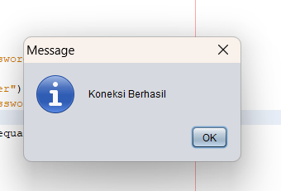

Dan akan menuju ke form data mahasiswa

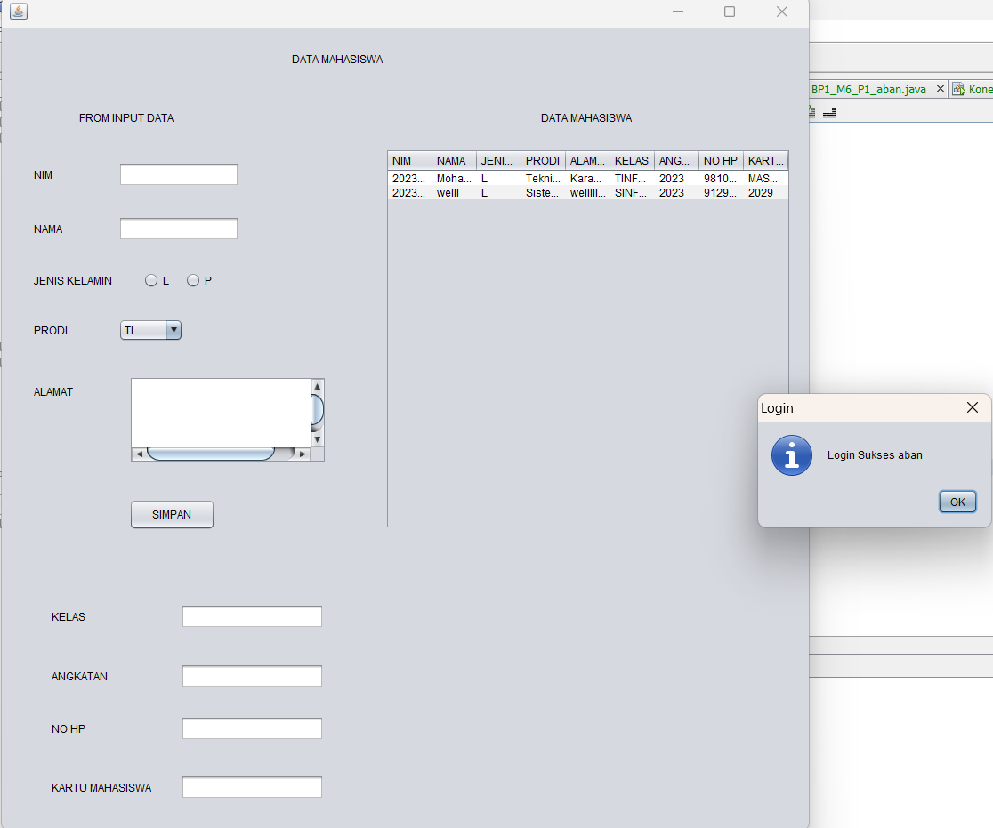

Jika login gagal maka akan muncul seperti gambar di bawah ini

