PUZZLE 1-
Suppose we have 3 glasses and 10 coins. The problem is to place odd number of coins in each glass i.e. each glass should contain coins and the number of coins in each glass must be odd and total coins which will be used must be equal to 10.
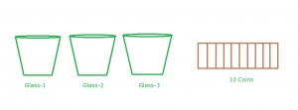
PUZZLE 2-
You have a 3 and a 5 litre water container, each container has no markings except for that which gives you it's total volume. You also have a running tap. You must use the containers and the tap in such away as to exactly measure out 4 litres of water. How is this done?
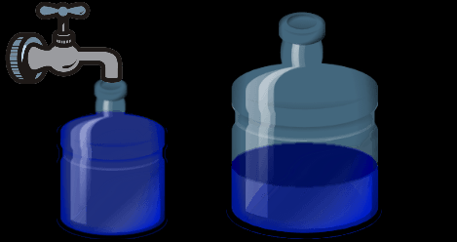
PUZZLE 3-
Your room has three switches. One of these switches is for a fan in the next room. You cannot see whether the fan is on or off unless you come out of the room. What is the minimum number of times you may go in a room to identify the correct switch in another room?

