**The Role of NLP in Speech Recognition**

In recent years, NLP has emerged as a technology with profound implications for various aspects of our lives. One of the most applications of NLP is the Speech Recognition. This article explains the world of NLP and its crucial role in enabling machines to understand and respond to human speech. We will explore the scope, challenges, and future prospects of NLP in speech recognition.

**Understanding Natural Language Processing**

Before we dive into the specifics of speech recognition, it is essential to know about NLP as a branch of artificial intelligence. Natural language processing (NLP) refers to the branch of computer science—and more specifically, the branch of artificial intelligence and Machine Learning. It focuses on the interaction between computers and humans through natural language. It enables machines to understand, interpret, and generate human language in a way that is valuable.

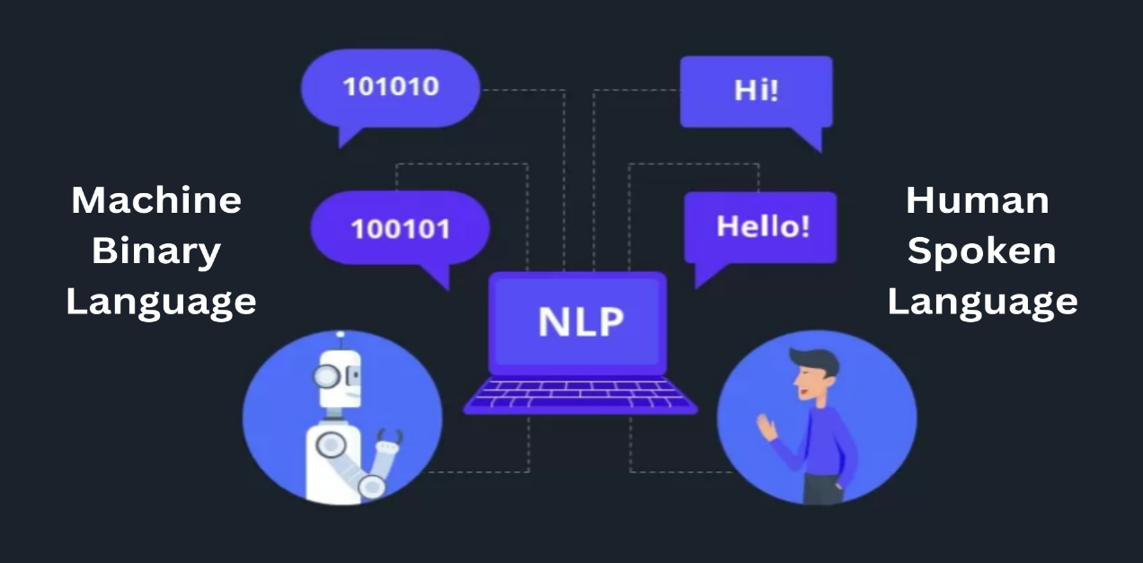

**Speech Recognition: A Revolution in Communication**

Speech recognition has transformed the way we interact with technology as a subset of NLP. It allows us to communicate with devices, applications, and services through spoken language. The virtual assistants like Siri (Apple company), Alexa(Amazon company), and Google Assistant (Google company ) are prime examples of how NLP has revolutionized speech recognition.

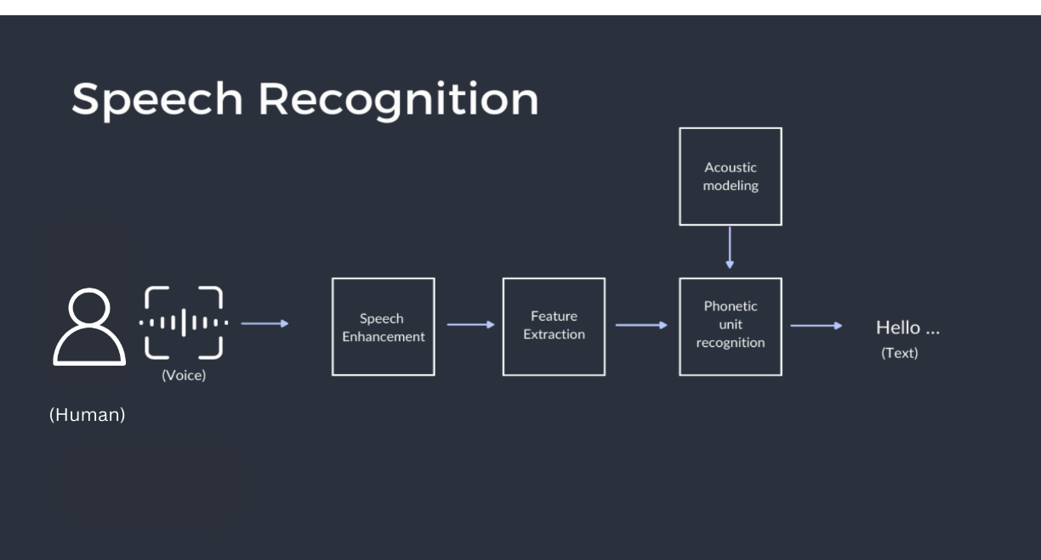

**The Role of NLP in Speech Recognition**

At the heart of speech recognition systems lies NLP. The primary function of NLP converts spoken languages into machine-readable text, making it understandable to all devices like computer, mobiles, virtual assistant machines, and robots. Let us break down the key roles of NLP in speech recognition:

1. **Acoustic Features Interpretation**: NLP models process acoustic signals, such as pitch, frequency, and duration, to distinguish between different sounds in human speech. These acoustic features are then converted into text.

2. **Phonetic Analysis**: NLP algorithms analyze the phonetic components of speech. This analysis helps in recognizing individual phonemes, the smallest units of sound in a language, which are combined to form words.

3. **Language Modelling**: Language models in NLP aid in predicting the likelihood of a particular word or phrase based on the context of the speech. This feature helps in reducing ambiguity in speech recognition.

4. **Contextual Understanding**: NLP systems consider the context of words and phrases, which is vital for accurately interpreting spoken language. The meaning of a word can changes significantly depending on the surrounding words and phrases.

5. **Grammar and Syntax**: NLP models also check the grammar and syntax of the spoken language, ensuring that the converted text maintains a coherent structure. But the languages are not uploaded or updated in NLP models. The mechanics will not recognize the language and misunderstands.

6. **Semantic Analysis**: Understanding the meaning behind words is critical. NLP enables machines to analyze the semantics of spoken language, allowing them to grasp the intended message.

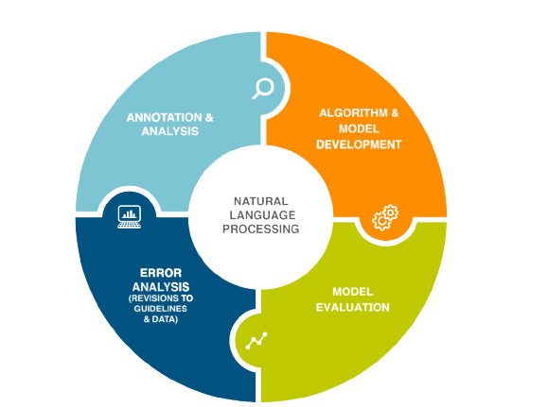

**Challenges and Future Prospects**

While NLP has made significant strides in speech recognition, it still faces several challenges. Accents, dialects, and background noise can affect accuracy. However, ongoing advancements in machine learning and deep learning have shown promise in addressing these issues.

The future of NLP in speech recognition is exciting. With the advent of neural networks and deep learning, the accuracy of speech recognition systems is continuously improving. Multimodal systems that combine speech with other inputs, such as gestures and facial expressions, are becoming more sophisticated.

As speech recognition becomes more integrated into our daily lives, we can expect improvements in human-computer interaction, accessibility features for individuals with disabilities, and applications in healthcare, customer service, and more.

**Conclusion**

Natural Language Processing plays a pivotal role in the evolution of speech recognition technology. It enables machines to understand and respond to human speech, opening up new possibilities for human-computer interaction. Despite challenges, NLP continues to make strides, and the future holds even more promising developments in this field. As speech recognition becomes increasingly prevalent, it is essential to appreciate the role NLP plays in shaping the way we communicate with machines.