**Deliverable 1**

# **Part 1: Problem Statement**

## Background

In modern lives, there is great demand for access to variety kinds of detailed weather information from people from all walks. Modern people tend to search for different kinds of weather information for multiple purposes. For example, examining the weather forecast before determining to bring an umbrella and choosing a good day for activities such as fishing and BBQ.

## Demand

People with modern lives require real time or long-term weather information in multiple aspects. All modern life problems that are related with weather may eventually become a various kind of demands. These may include:

* Weather forecasts for different time intervals (both short term and long term).
* A collection of weather information regarding a particular group of cities (such as major cities in Australia).
* Current, hourly, daily and monthly weather information.
* Gaining a brief understanding of future weather forecasts.
* Information from multiple aspects (urban, marine, ski).
* Recommendations for weather-appropriate activities.

## Problem

1. There is no all-in-one portal for weather information in Australia.
2. The amount of detailed weather information for particular places is not rich enough for a user to figure out current or future weather conditions.
3. There is no program which will give me recommendations of things to do based on the weather forecast.
4. There is no section in most weather applications that provide marine and ski-related information.
5. The information system is not well constructed and the efficiency of sending general understanding to use is very low.
6. The weather data provided is lack of pertinence and may not allow a user to elicit their potential targeting information very well.
7. The system is not convenient enough. The interface for users should be able to switch to various patterns to gain the information in different aspects, different location, different data precision and different time interval.

# **Part 2: Identify and Describe User Stories**

## **Main Page Features**

**Feature:** As a user, I want to have access to the general information for major cities.

**As a user:**

* I want to see the information about sun and moon for the major cities, so that I can have an understanding of the astronomy knowledge for those major cities.
* I want to see the minimum and maximum temperatures for each major city, so that I can gain the general understanding about the climates of those cities.
* I want to see the weather forecasts for each major city, so that I can have an idea of the condition of those cities directly.

**Scenario**: Entering the website.

**GIVEN** I am on home page

**Feature:** As a user, I want to have a port to the detailed weather information about the target destination.

**As a user:**

* I want to be able to click into the major cities, so that I can obtain the more specific weather information for those cities.
* I want to be able to click a button to enter the location system, so that I can obtain the more specific weather information other than major cities.

**Scenario**: Entering the website.

**GIVEN** I am on home page

**WHEN** I do nothing

**Feature:** As a user, I want to be able to change the preference unit.

**As a user**:

* I want to be able to switch different units displayed by clicking the button on the top of the main page, so that I am able to see the preference unit in the searching result later.

**Scenario**: Customizing displayed unit.

**GIVEN** I am on home page

**WHEN** I click “°F/°C”

## **Location Page Features**

**Feature:** As a user, I want to have to enter the information about the location where I want to search.

**As a user:**

* I want to be able to enter the location by the name, so that I can search the weather though the name of that location.
* I want to be able to enter the location by the geo-position, so that I can search the weather information for a specific place.
* I want to be able to enter the location by the IP address, so that I can search for information alone with the place specified by an ZIP address.

**Scenario**: searching for location

**GIVEN** I am on home page

**WHEN** I click on the “Enter your location”

**THEN**  I should on the “Enter location” page

## **Mode Select Page Features**

**Feature:** As a user, I want to select different searching modes.

**As a user:**

* I want to be able to search for the urban information about the target destination, so that I can gain useful weather information that is useful for urban life.
* I want to be able to search for the marine information about a specific place, so that I can gain useful ocean-related weather information.
* I want to be able to search for the information related to skiing, so that I can be informed about the mountain and snow weather information that is important for skiing.

**Scenario**: selecting the weather mode to search for

**GIVEN** I am on home page

**WHEN** I click on the “Enter your location”

**THEN**  I should on the “Enter location” page

**WHEN** I fill the blank

**AND I** click on “search” button

**THEN** I should on the “Mode select” page

## **Urban Information Page Features**

**Feature:** As a user, I want to have current weather information.

**As a user**:

* I want to see current temperature, so that I can have an idea about current temperature.
* I want to see a weather icon, so that I can have a general idea about current weather at a glance.
* I want to see the detailed current weather information, so that I can have a better understanding about the current situation.

**Scenario**: Get current weather information.(about selected place)

**GIVEN** I am on home page

**WHEN** I click on the “City Name”(e.g. Sydney, Melbourne)

**THEN** I should on the “Urban information” page

**OR**

**WHEN** I click on the “Enter your location”

**THEN**  I should on the “Enter location” page

**WHEN** I fill the blank

**AND I** click on “search” button

**THEN** I should on the “Mode select” page

**WHEN** I click on the “Urban”

**THEN** I should on the “Urban information” page

**Feature:** As a user, I want to have the short term future weather information.

**As a user:**

* I want to see maximum and minimum temperature for the following five days, so that I can have an idea about temperature tendency in the near future.
* I want to see maximum and minimum temperature for the following 12 hours, so that I can understand a specific temperature tendency for the coming hours.
* I want to see the weather icon for the following 12 hours, so that I can have a general idea about the weather condition for the coming hours.
* I want to see the detailed information for the day, so that I can have a better understanding about the situation of the rest of the day.

**Scenario**: Get current weather information.(about selected place)

**GIVEN** I am on home page

**WHEN** I click on the “City Name”(e.g Sydney, Melbourne)

**THEN** I should on the “Urban information” page

**OR**

**WHEN** I click on the “Enter your location”

**THEN**  I should on the “Enter location” page

**WHEN** I fill the blank

**AND I** click on “search” button

**THEN** I should on the “Mode select” page

**WHEN** I click on the “Urban”

**THEN** I should on the “Urban information” page

**Feature:** As a user, I want to have the complete information about short term future weather.

**As a user**:

* I want to be able to enter a page that illustrates detailed daily information for one of the coming days, so that I can take a very careful look at detailed information for a specific day in the near future.
* I want to be able to enter a page that illustrates detailed hourly information for one of the coming hours, so that I can take a very careful look at detailed information for a specific hour in the near future.

**Scenario**: Get detailed weather information for the short term.(about selected place)

**GIVEN** I am on home page

**WHEN** I click on the “City Name”(e.g Sydney, Melbourne)

**THEN** I should on the “Urban information” page

**OR**

**WHEN** I click on the “Enter your location”

**THEN**  I should on the “Enter location” page

**WHEN** I fill the blank

**AND I** click on “search” button

**THEN** I should on the “Mode select” page

**WHEN** I click on the “Urban”

**THEN** I should on the “Urban information” page

**WHEN** I click on the “hour”(e.g 10:00 11:00 12:00)

**THEN** I should on the “hourly information” page

**OR**

**WHEN** I click on the “Date”(e.g 3/12 3/13 3/14)

**THEN** I should on the “daily information” page

**Feature:** As a user, I want to have the complete information about long term future weather.

**As a user:**

* I want to be able to enter a page that illustrates detailed daily information for the coming days, so that I can take a very careful look at detailed information for one of a specific day in a relatively long term future.

**Scenario**: Get detailed weather information for the long term.(about selected place)

**GIVEN** I am on home page

**WHEN** I click on the “City Name”(e.g Sydney, Melbourne)

**THEN** I should on the “Urban information” page

**OR**

**WHEN** I click on the “Enter your location”

**THEN**  I should on the “Enter location” page

**WHEN** I fill the blank

**AND I** click on “search” button

**THEN** I should on the “Mode select” page

**WHEN** I click on the “Urban”

**THEN** I should on the “Urban information” page

**WHEN** I click on the “Enter Long Term Mode”

**THEN** I should on the “Long Term information” page

## **Day Mode Page Features**

**Feature:** Get recommendations for activities to do based on today’s weather.

**As a user:**

* I want to be recommended activities I can do based on the weather, so that I can participate in weather-appropriate activities.

**Scenario:** See a list of recommended weather-appropriate activities.

**GIVEN** I am on the home page

**WHEN** I click on the “City Name” (e.g. Sydney, Melbourne)

**THEN** I should be on the “Urban information” page

**WHEN** I click on the “Today” button

**THEN** I should be taken to the “Day Mode” page

**GIVEN** I am on the “Day Mode” page

**THEN** I should see a list of recommended activities which are ranked from most to least appropriate according to the weather forecast.

**WHEN** I click on a potential activity

**THEN** another window should open which returns potential locations for these activities (e.g. if I click on fishing, it should return the locations of fishing spots near/in my city/town).

**Feature:** View detailed summary about today’s weather forecast.

**As a user:**

* I want tobe able to enter a page that illustrates an in-depth summary of today’s weather forecast, so that I can take a very careful look at today’s forecast.

**Scenario:** Get detailed weather information for today. (about selected place)

**GIVEN** I am on home page

**WHEN** I click on the “City Name” (e.g. Sydney, Melbourne)

**THEN** I should be on the “Urban information” page

**WHEN** I click on the “Today” button

**THEN** I should be taken to the “Day Mode” page, where I can view detailed information on today’s forecast

**Feature:** View the forecasted maximum and minimum temperatures in a chosen city/town.

**As a user:**

* I want tobe able to see the maximum and minimum forecasted temperatures, so that I can determine whether it may be cooler later in the day in case I need to wear a jacket today.

**Scenario:** Get the maximum and minimum temperatures in my chosen city.

**GIVEN** I am on home page

**WHEN** I click on the “City Name” (e.g. Sydney, Melbourne)

**THEN** I should be on the “Urban information” page

**WHEN** I click on the “Today” button

**THEN** I should be taken to the “Day Mode” page

**GIVEN** I am on the “Day Mode” page

**THEN** I should see information regarding a maximum and minimum temperature below the astronomy information.

**Feature:** View information about moon phases and times when the sun/moon rises and sets.

**As a user:**

* I want tobe able to enter a page see details about astronomy, so that I can see information about the moon phases and the time of day when the sun and moon are predicted to rise and set.

**Scenario:** Get information regarding astronomy.

**GIVEN** I am on home page

**WHEN** I click on the “City Name” (e.g. Sydney, Melbourne)

**THEN** I should be on the “Urban information” page

**WHEN** I click on the “Today” button

**THEN** I should be taken to the “Day Mode” page

**GIVEN** I am on the “Day Mode” page

**THEN** I should see information regarding astronomy in the top-right corner of the screen

## **Hourly Information Page**

**Feature:** Get more detailed information about city I want to know.

**As a user:**

* I want to get accurate temperature for the hour, so that I can find more useful information of current location I focus.
* I want to see some weather icon, so that I can gain the general idea about weather at a glance.
* I want to know the precipitation information at a glance, so that I can prepare for sunny/raining/snowing/storm weather.
* I want to know the humidity and cloud cover information at a glance, so that I can make decisions about hanging up my laundry outside
* I want to see the UV index and wind speed/direction data at a glance, so that I can gain information to prepare for outdoor activities.

**Scenario:** Get the hourly information on a city.

**GIVEN** I am on home page

**WHEN** I click on the “Location” button

**THEN** I should be on the “Enter location” page

**WHEN** I fill in the location I require

**AND** I click on “search” button

**THEN** I should on the “Mode select” page

**WHEN** I click on the “Urban”

**THEN** I should on the “Urban information” page

**WHEN** I click on the “hour” (e.g. 10:00 11:00 19:00 20:00 01:00)

**THEN** I should on the “Hourly information” page

## Long-Term Information Mode

**Feature:** Get long term information about this city’s weather

**As a user:**

* I want to get two weeks icons, so that I can know one day’s weather information in the future of the city I choose.

**GIVEN** I am on home page

**WHEN** I click on the “Enter your location”

**THEN** I should on the “Enter location” page

**WHEN** I fill the location blank

**AND** I click on “search” button

**THEN** I should on the “Mode select” page

**WHEN** I click on the “Urban”

**THEN** I should on the “Urban information” page

**WHEN** I click on the “Long Term”

**THEN** I should on the “Long Term information” page

**Feature:** Choose one day in the future

**As a user:**

* I want to get sun rise/set and moon rise/set time and every hour’s weather, so that I can get more weather information about the day.
* I want to know the precipitation information at a glance, so that I can prepare for sunny/raining/snowing/storm weather.

**Scenario:** Get weather information for a date in the future.

**GIVEN** I am on home page

**WHEN** I click on the “Enter your location”

**THEN** I should on the “Enter location” page

**WHEN** I fill the location blank

**AND** I click on “search” button

**THEN** I should on the “Mode select” page

**WHEN** I click on the “Urban”

**THEN** I should on the “Urban information” page

**WHEN** I click on the “Long Term”

**THEN** I should on the “Long Term information” page

**WHEN** I click on the icon of one day

**THEN** I should on the “<date>” page

## Marine Information Page

**Feature:** Select date for marine information.

**As a user:**

* I want to get the period of a tide, so that I can get more information on the ocean.
* I want to get the status of the tide, so that I can consider if the weather is appropriate to do research about marine.
* I want to get the period and status of tide for the day, so that I can get more ocean tide information about the day.
* I want to get the information about temperature, wind, precipitation, humidity, visibility and pressure information, so that I can better prepare for marine-related activities.

**Scenario:** Select date for marine information.

**GIVEN** I am on home page

**WHEN** I click on the “Enter your location”

**THEN** I should on the “Enter location” page

**WHEN** I fill the location blank

**AND** I click on “search” button

**THEN** I should on the “Mode select” page

**WHEN** I click on the “Marine”

**THEN** I should on the “Marine” page

**WHEN** I click on the date(e.g. 3/12 3/13 3/14)

**THEN** I should on the “Marine information display page”

## Ski Information Page

**Feature:** Get ski information about this mountain weather

**As a user:**

* I want to see data about snow, wind, freeze level and visibility on the bottom, mid and top of the mountain for every 3 hours, so that I can prepare for my skiing plan that day.

**Scenario:** Get ski information about this mountain weather.

**GIVEN** I am on home page

**WHEN** I click on the “Enter your location”

**THEN** I should on the “Enter location” page

**WHEN** I fill the location blank

**AND** I click on “search” button

**THEN** I should on the “Mode select” page

**WHEN** I click on the “SKI”

**THEN** I should on the “SKI information” page

# **Part 3: Low-Fidelity Prototype**

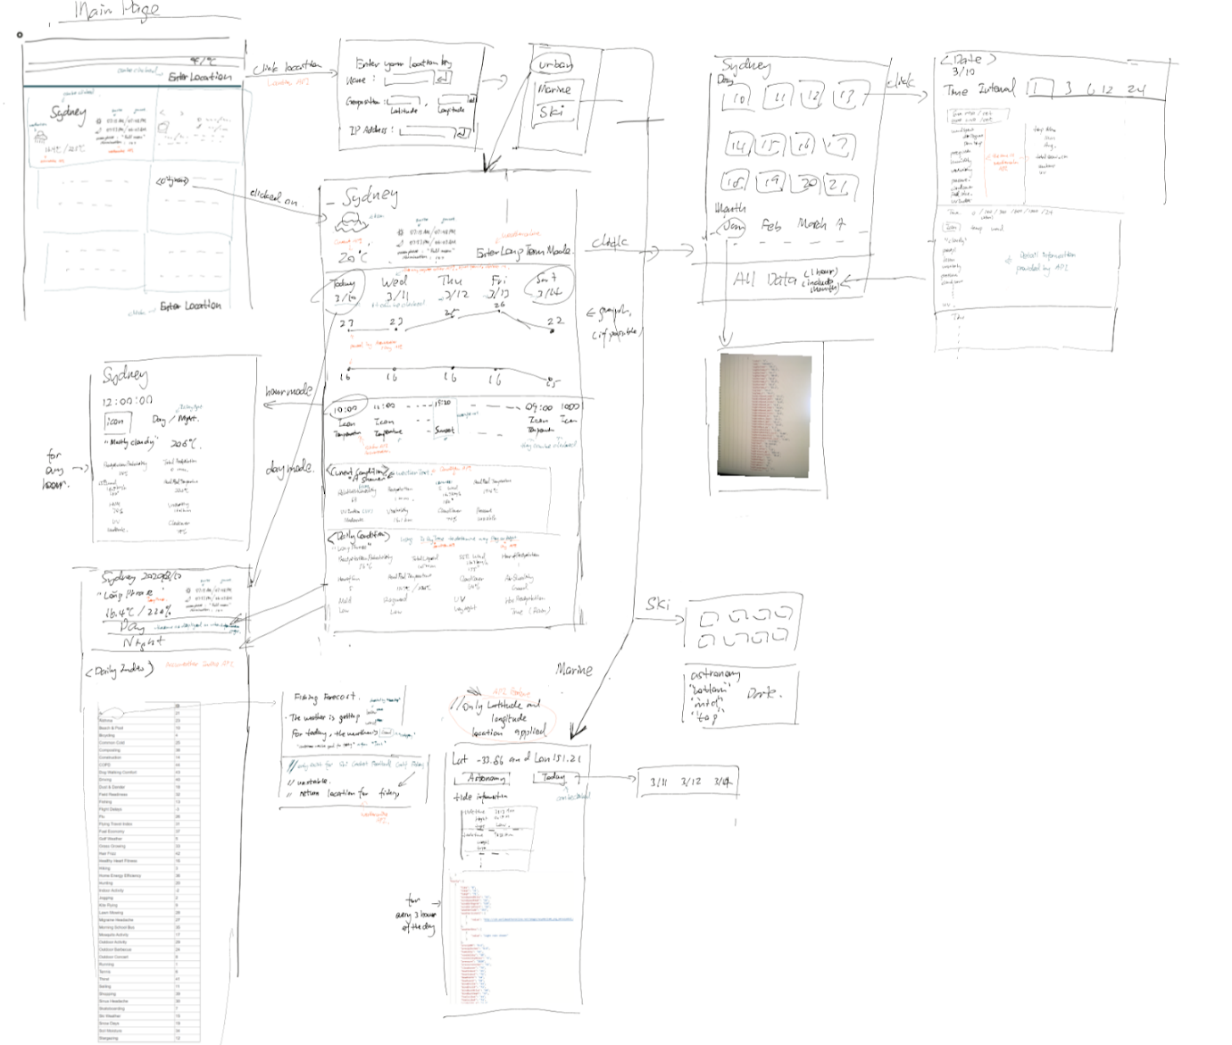

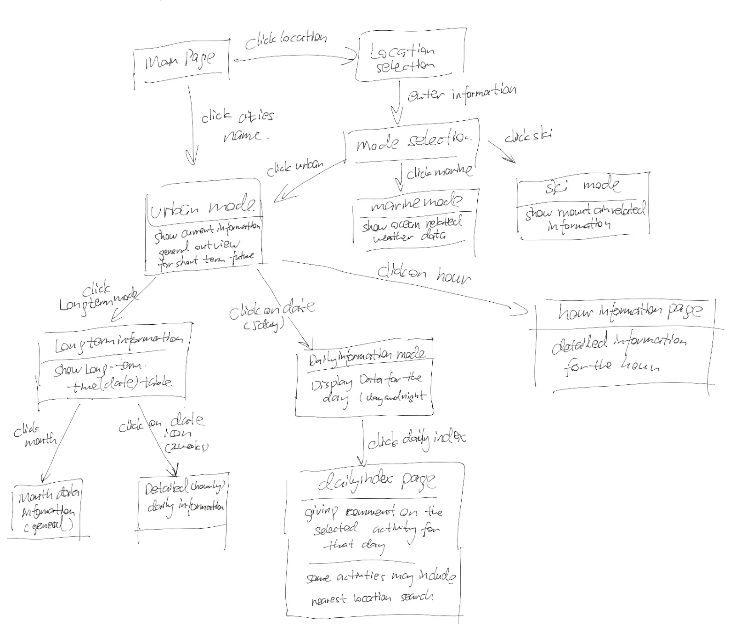

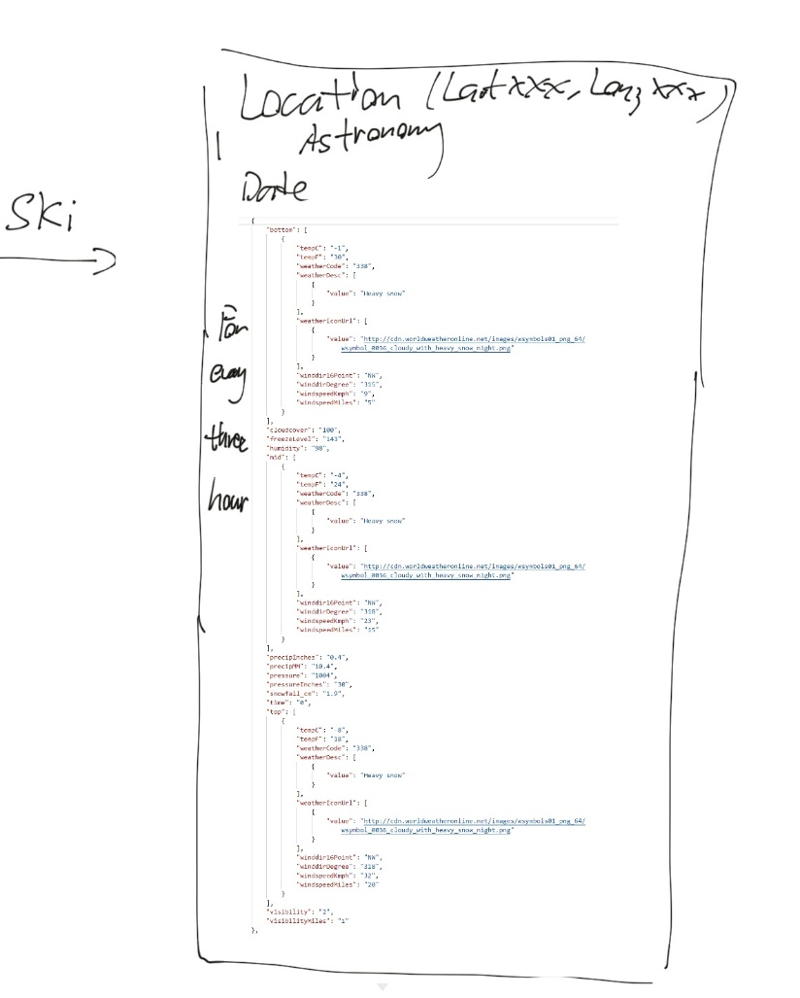

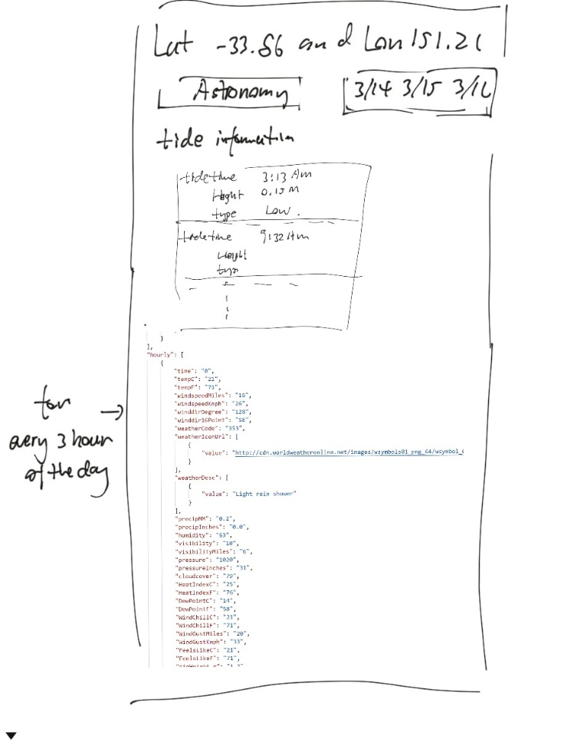

# **Part 4: High-Fidelity Prototype**

See the file *HiFiPrototype.pdf* in our team’s GitHub *Deliverables* folder.