

UNIVERSITY OF MORATUWA

**Project: Design of FIR Filters**

EN2570

DIGITAL SIGNAL PROCESSING

150001C: Abarajitan G.

**Abstract**

This project is undertaken with the objective of demonstrating the design process of a digital filter using the windowing method in conjunction with the Kaiser window to fit given requirements. The filter is then analyzed and verified. A comprehensive summery of the basic principles of filter design also have been revised as a part of this project report. Mathematical analysis has been carried out using Matlab 2014a software.

**Contents**

**1 Introduction** 4

**2 Basic Theory of FIR Filter Design** 5

**3 Filter Specification** 11

**4 Calculation of Parameters** 12

**5 Results** 13

**6 Conclusions** 20

**7 References** 21

**8 Appendix** 22

**Introduction**

Signals in the real world are analog in nature. However, we convert them to digital for processing due to various advantages of the digital format. An example to demonstrate the need for filtering is the preprocessing step, where the corruptive noise is removed before processing these signals using sophisticated devices. In this way, digital filters are extremely useful in processing audio signals, EEG signals, seismological signals…etc.

Creating a digital filter to suit the specifications of a certain application involves four steps such as: Approximation, Realization, Study of arithmetic errors and Implementation. Here, we focus on the first step: **Approximation**, where we are concerned with generating a transfer function that would satisfy the desired specifications. Methods to perform this can be classified in two ways, as *direct* or *indirect* and as *closed-form* or *iterative*.

Nonrecursive filters are designed by using direct noniterative or iterative methods whereas recursive filters are designed by using indirect noniterative methods or direct iterative methods. Hence, this project is an example of a direct, closed form design, where the problem is solved through a small number of design steps using a set of closed-form formulas. The approximation problem for nonrecursive filters can be solved in two ways:

1 Applying the Fourier series

2 Using numerical analysis formulas

These methods involve only a minimal amount of computation and provide a closed form solution. However, the designs obtained here are suboptimal with respect to filter complexity. Filters of lesser order that can satisfy the same requirements may be calculated with computationally intensive optimization methods.

**Basic Theory of Filter Design**

**Design using Fourier Series Method**

Since impulse response $h(nT)$ of digital filters are discrete in time domain, their impulse response in frequency domain $H(e^{-jωT})$ is periodic in nature with a period of sampling frequency: $ω_{s}$ and hence it can be expressed as a Fourier series:

$$H\left(e^{jωT}\right)= \sum_{n=-∞}^{∞}{h(nT)e^{-jnωT}}$$

$$h\left(nT\right)= \frac{1}{ω_{s}}\int_{-ω_{s}/2}^{ω_{s}/2}{H\left(e^{jωT}\right)}e^{-jnωT}dω$$

Here, we have effectively interchanged the roles of time and frequency. With $e^{jωT}=z$, we have:

$$H\left(z\right)= \sum_{n=-∞}^{∞}{h(nT)z^{-n}}$$

Therefore, if we have an analytical form of required frequency response, we can get the transfer function easily. However, observation of the above equation shows two key points.

1. This filter is of infinite order and has infinite length in time domain since $h\left(nT\right)$ is defined for all real values of $n$. Such filters cannot be realized in reality.
2. This filter is non-causal since $h\left(nT\right) ≠0$ for $n<0$. Non-causal filters cannot be implemented in reality.

To solve these problems, we take the following steps.

1. Truncate the signal in time domain to make it a N-length signal. i.e.
$$h\left(nT\right)=0; \left|n\right|>= \frac{N-1}{2}$$

2. However, this filter is still non-causal. To make it causal, we can delay $h\left(nT\right)$ by $\left(\frac{N-1}{2}\right)$ sampling periods. Through properties of Z transform,

$$h^{'}\left(nT\right)= h\left(\left(n-\frac{N-1}{2}\right)T\right) \underset{↔}{z Transform} H^{'}(z) =z^{-\left(\frac{N-1}{2}\right)} H\left(z\right)$$

Hence, $H^{'}\left(z\right)$ is the transfer function of practically realizable, finite length (FIR), causal filter.

**Note:**

* Amplitude response is unchanged as $\left|z^{-\left(\frac{N-1}{2}\right)}\right|=1$
* Group delay of filter is $\left(\frac{N-1}{2}\right)T$ after the delay operation

**Window Functions**

However, abruptly truncating the impulse response in time domain will produce unwanted oscillations near cut off frequencies in the passband and stopband. These are known as Gibbs’ oscillations. To reduce the oscillations, we can use a time domain window function $w(nT)$ rather than directly truncating the signal. Usage of different windows will result in different oscillation properties of the windowed impulse response $h_{w}(nT)$

$$h_{w}\left(nT\right)=w\left(nt\right)h(nT)$$

The different kinds of window functions we can use are:

1. Rectangular Window $w_{R}\left(nT\right)=\left\{\begin{aligned}1, &\left|n\right|< \frac{N-1}{2} \\ 0, &otherwise\end{aligned}\right.$
2. Von Hann & Hamming Windows
$$w_{H}\left(nT\right)=\left\{\begin{aligned}α+(1-α)\cos\left(\frac{2πn}{N-1}\right), &\left|n\right|< \frac{N-1}{2} \\ 0, &otherwise\end{aligned}\right.$$

3. Blackman Window
$$w_{B}\left(nT\right)=\left\{\begin{aligned}0.42+0.5 cos⁡\left(\frac{2πn}{N-1}\right), &\left|n\right|< \frac{N-1}{2} \\ 0, &otherwise\end{aligned}\right.$$

4. Dolph-Chebyshev Window $T_{k}\left(x\right)$ is $k$ th order Chebyshev Polynomial
$$w_{DC}\left(nT\right)= \frac{1}{N}\left[\frac{1}{r}+2\sum_{i=1}^{\frac{N-1}{2}}{T_{N-1}\left(x_{0}cos\left(\frac{iπ}{N}\right)\right)cos}\left(\frac{2nπi}{N}\right)\right]$$

5. Kaiser Window

**Frequency domain representation of a general filter**

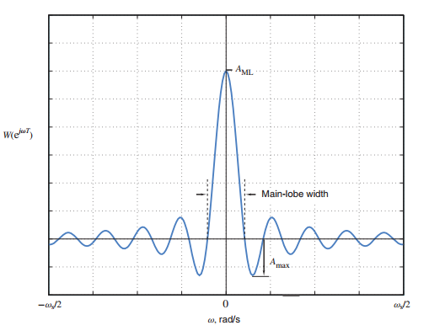

The effectiveness of a window to be used in filter design can be measured in terms of the Gibbs oscillation phenomenon. The three major parameters of a windowed filter are:

1. Width of Transition Band

Width of the main lobe in the amplitude response of the filter, corresponds to the width of a transition band that is present between passband and stopband. A window with a wider width produces a wider transition band. An ideal filter does not have a transition band (width = 0), hence we look for a filter that can minimize the transition band width (hence, minimal main lobe width). Main lobe width is inversely proportional to N

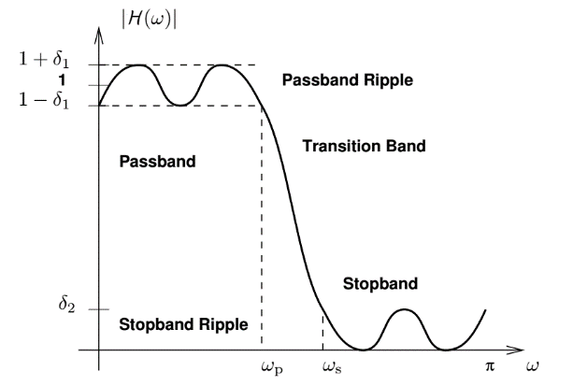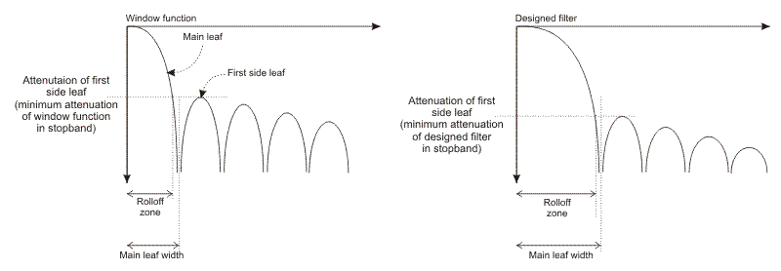

1. Ripple Ratio ($A_{P}$)

Ripple ratio is the measure of the ripples formed in passband due to Gibbs phenomenon. In first three filters, this is practically independent of window length. In the last two filters, parameters can be adjusted to minimize the ripple ratio

1. Window length ($N$)

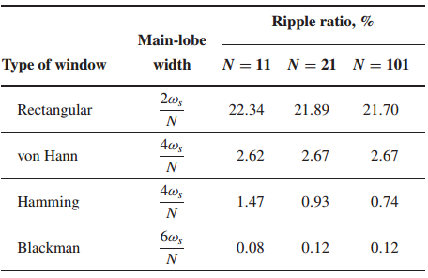Higher length windows make better filters; however, realization of higher length filters is much difficult. Therefore, an optimal design consists of minimal window length that can produce the necessary specifications.

**Kaiser Window**

Developed by James Kaiser in Bell Labs, Kaiser window is one of the widely used functions in digital filter design. For a given parameter $α$ and length $n$ it is defined by the function:

$$w_{K}\left(nT\right)=\left\{\begin{aligned}\frac{I_{O}(β)}{I_{O}(α)}, &\left|n\right|< \frac{N-1}{2} \\ 0, &otherwise\end{aligned}\right.$$

$$β=α\sqrt{1-{\left(\frac{2n}{N-1}\right)}^{2}}$$

$I_{O}(x)$ is the modified zeroth order Bessel function of the first kind, defined by the following infinite summation. However, in practice, only 10-15 terms are enough due to the rapid convergence resulting from the squared factorial term in denominator.

$$I_{O}\left(x\right)=1+\sum_{k-1}^{∞}{{\left(\frac{1}{k!}{\left(\frac{x}{2}\right)}^{k}\right)}^{2}}$$

**The Parameter $α$**

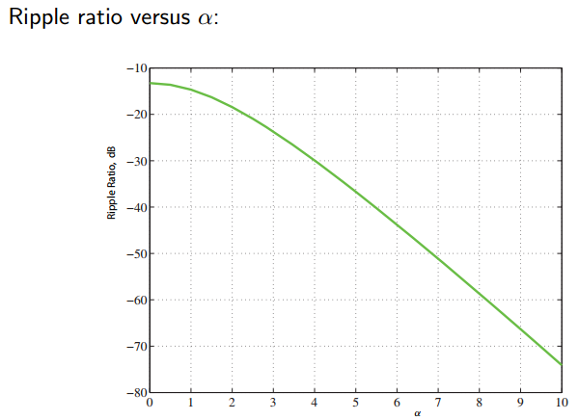Increasing $α$ results in a lower ripple ratio, but increases main lobe width (transition band width). However, by increasing N, we can decrease the main lobe width to necessary level. Hence, we choose $α$ first and then calculate N for a given $α$ and given specifications.

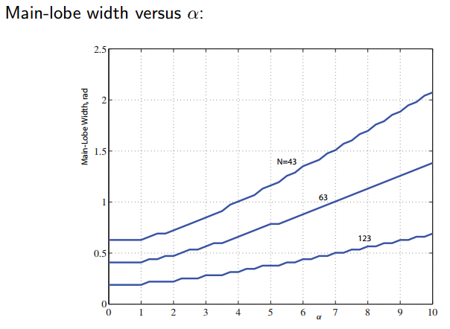

**General Specification for a bandstop filter:**

$$\frac{ω_{s}}{2}$$

$$0$$

$$ω_{c1}$$

$$ω_{p1}$$

$$ω_{a1}$$

$$ω_{a2}$$

$$ω_{c2}$$

$$ω_{p2}$$

1

1+δ

1- δ

$$A_{a}$$

$frequency (rad/s$)

$$Gain$$

**Filter Specifications**

* Maximum passband ripple $\tilde{A_{p}}$ = 0.05 dB
* Minimum stopband attenuation $\tilde{A_{a}}$ = 40 dB
* Lower passband edge $Ω_{p1}$ = 400 rad/s
* Upper passband edge $Ω_{p2}$ = 950 rad/s
* Lower stopband edge $Ω_{a1}$ = 500 rad/s
* Upper stopband edge $Ω_{a2}$ = 800 rad/s
* Sampling frequency $Ω_{s}$ = 2600 rad/s

$$1300$$

$$0$$

$$450$$

$$400$$

$$500$$

$$800$$

$$875$$

$$950$$

0

$$\tilde{A_{p}}=0.05 dB$$

$$\tilde{A_{a}}=40 dB$$

$frequency (rad/s$)

$$Gain (dB)$$

**Calculation of Parameters**

**1 Choose Delta**

$$δ_{a}={10}^{-\left(\frac{\tilde{A_{a}}}{20}\right)}= 0.01 dB$$

$$δ_{p}= \frac{{10}^{-\left(\frac{\tilde{A_{p}}}{20}\right)}-1}{{10}^{-\left(\frac{\tilde{A_{p}}}{20}\right)}+1}=0.0029 dB$$

$$δ=\min\left(δ_{a}, δ_{p}\right)=0.0029 dB$$

**2 Calculate $A_{a}$**

$$A_{a}=20 \log_{10}{δ}=50.8175 dB$$

**3 Calculate $α$**

$$α=\left\{\begin{aligned}0, &A_{a}≤21 \\ 0.5842 {(A_{a}-21)}^{0.4}+0.07886(A_{a}-21), &{21<A}_{a}≤50 \\ 0.1102(A_{a}-8.7), &otherwise\end{aligned}\right.$$

$$α= 0.1102\left(A_{a}-8.7\right)=4.6413$$

**4 Calculate $D$**

$$D=\left\{\begin{aligned}0.9222, &A_{a}≤21 \\ \frac{A_{a}-7.95}{14.36}, &otherwise\end{aligned}\right.$$

$$D=\frac{A_{a}-7.95}{14.36}=2.9852$$

**5 Calculate Transition Band Width**

$$B_{t}=\min\left(Ω_{a1}-Ω_{p1} , Ω_{p2}-Ω_{a2}\right)=100 rad/s$$

**6 Calculate $N$**

$$N≥\frac{Ω_{s}D}{B_{t}+1}, N is odd$$

$$N=79$$

**Results**

**1 Causal Impulse Response**

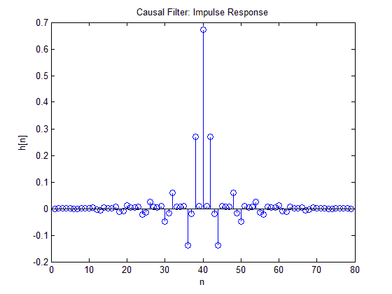

**2 Kaiser Window**

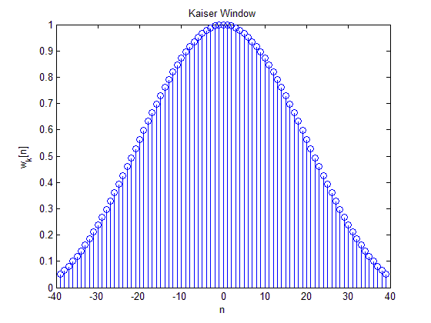

**3 Magnitude Response of Digital Filter**

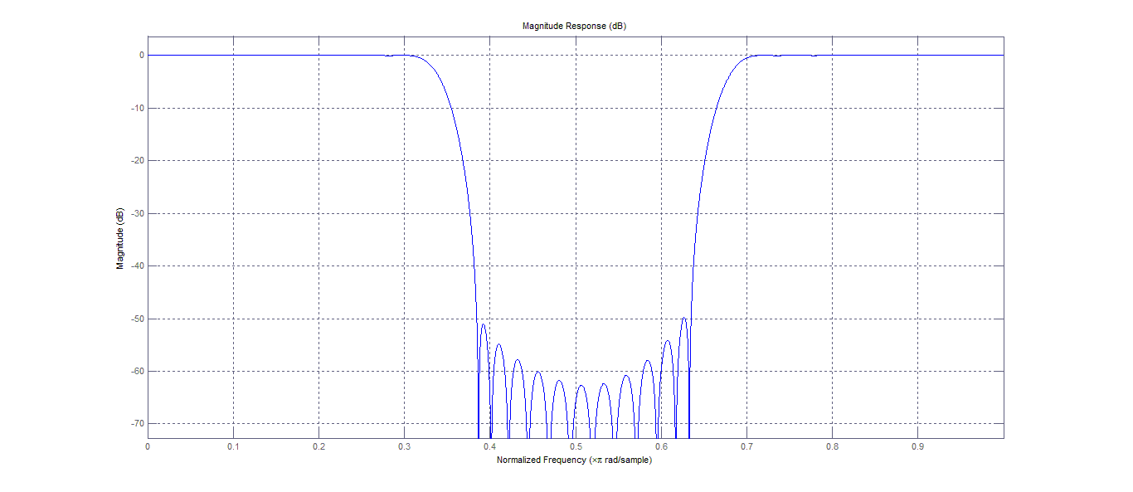

**4 Magnitude Response of Digital Filter in Stop Band**

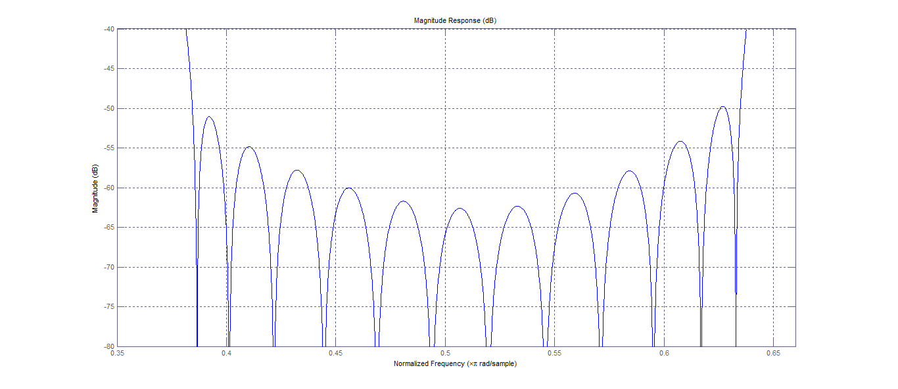

**5 Magnitude Response of Digital Filter in Lower Passband**

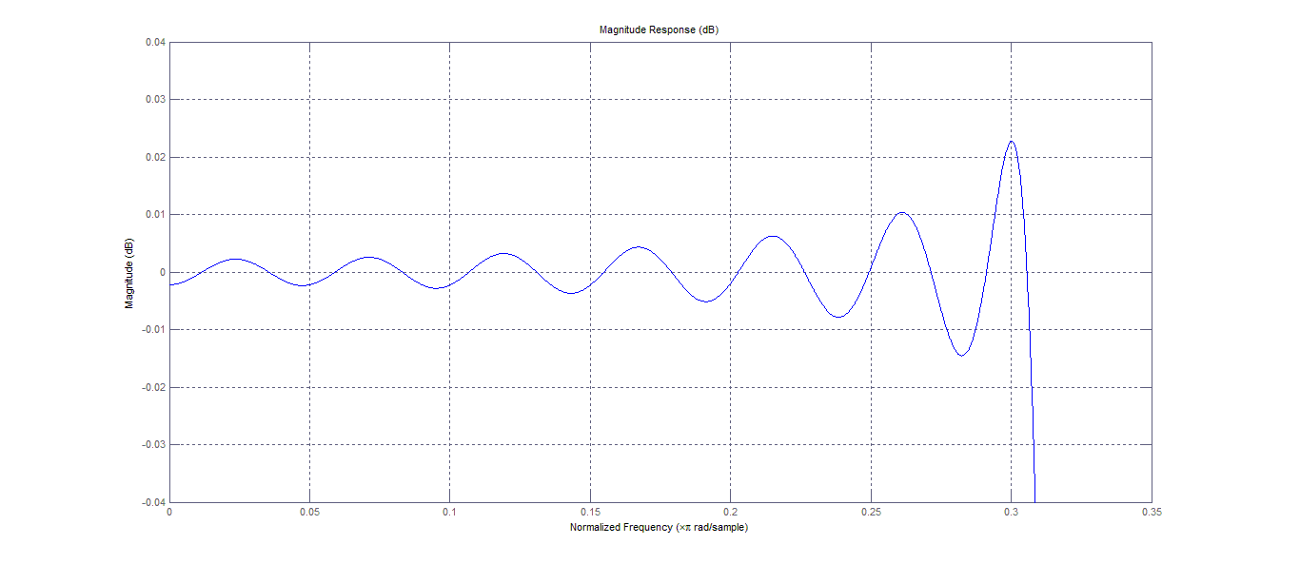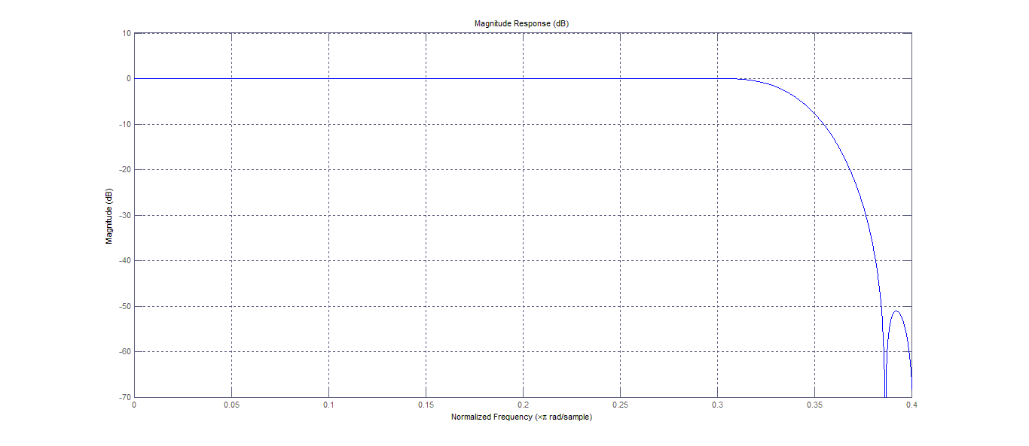

**6 Magnitude Response of Digital Filter in Upper Passband**

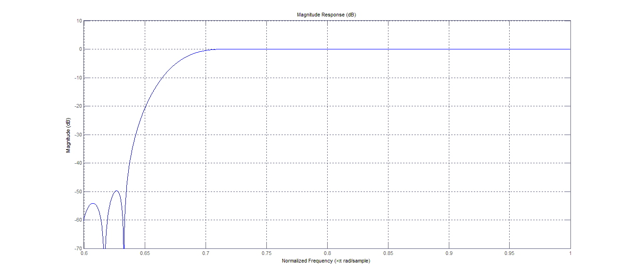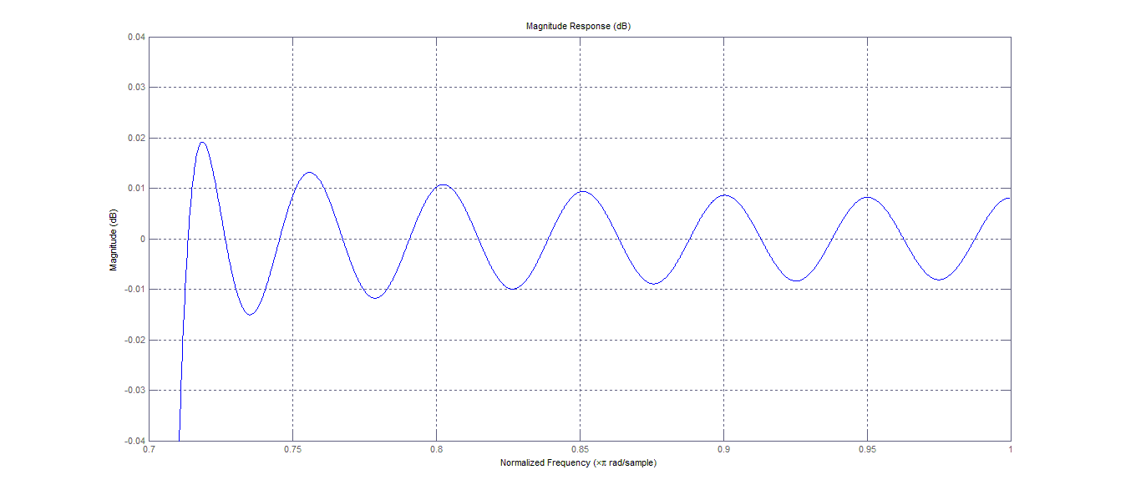

**7 Time Domain Response of Filter to Excitation**

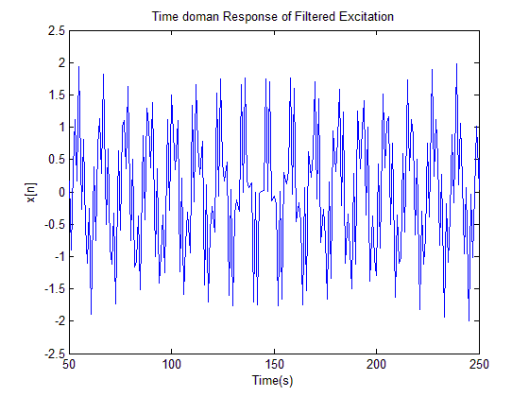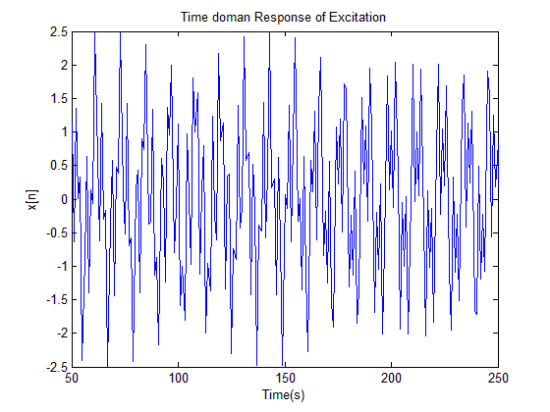 **$x\left(t\right)=\sin\left[225n\right]+\sin\left[662.5n\right]+\sin\left[1087.5n\right]$**

**8 DFT of the Input and Output Signals**

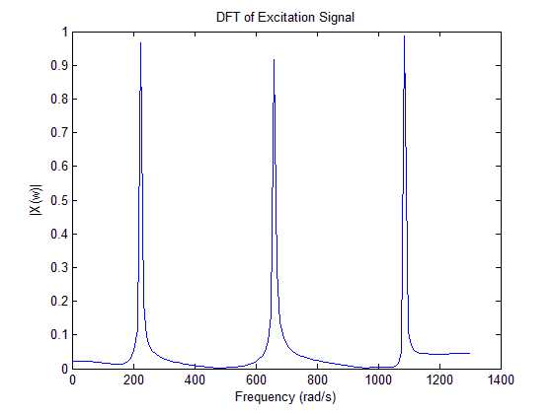

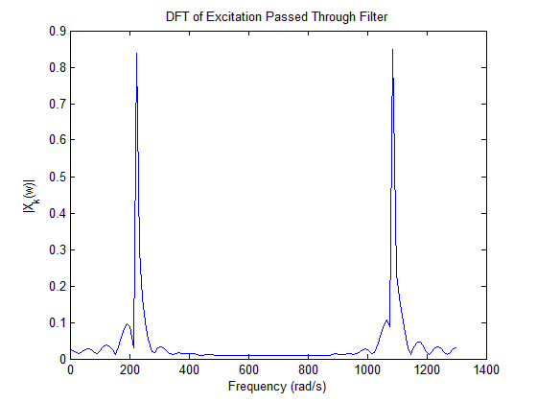

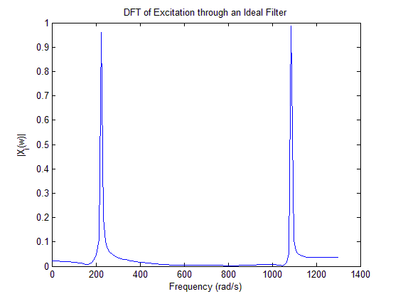

**Conclusions**

The results demonstrate that filter design method proposed by Kaiser is effective in designing non-recursive filters that satisfy arbitrary prescribed specifications. Hence it can be concluded that the prescribed method can be used to design such filters.

The expected minimum passband ripple is 0.05 dB, however the obtained value is 0.02 dB. Also, 49.8 dB of minimum stopband attenuation was obtained, which is more than the expected 40 dB. Hence, the Kaiser method can produce a filter that over satisfies given requirements.

However, a window of length 79 was needed to create this filter for our given specifications. There might exist an optimal filter that can satisfy the design specifications with a lower window length, which may be obtained through other filter design methods such as optimization.

**References**

1. Antoniou, A. (2006). *Digital signal processing*. New York: McGraw-Hill.
2. Oppenheim, A., Schafer, R. and Buck, J. (2013). *Discrete-time signal processing*. Harlow: Pearson.
3. Antoniou, A. (2005). *Chapter 9: Design of Nonrecursive (FIR) Filters*. [ebook] Victoria, BC, Canada. Available at:   
   http://www.d-filter.ece.uvic.ca/SupMaterials/Slides/DSP-Ch09-S3,4.pdf [Accessed 17 Nov. 2017].

**Appendix**