PHP Feature

* PHP discuss & database ----------------------------2
* PHP functionality model----------------------------3
* PHP apply information------------------------------5
* PHP Job information--------------------------------6
* PHP Feedback----------------------------------------9
* PHP webadmin--------------------------------------10

PHP Online exam Page

I have three main features, job post(test post and show,), feedback, and online test, the main features is user apply page user just choose what kind of job you want to apply, then go to apply page, the page will include the Job title, Sex, Marry, Date of birthday, Educational, graduation, Phone number, introduction, user should fill out job information form first, then do the small online exam, after finish it put verification code and submit. The web manager can check the

Applicant information and their text mark in the webmyadmin page then depend them mark and information to decide which one they want to hire.

The database will look like this:

Parking payment





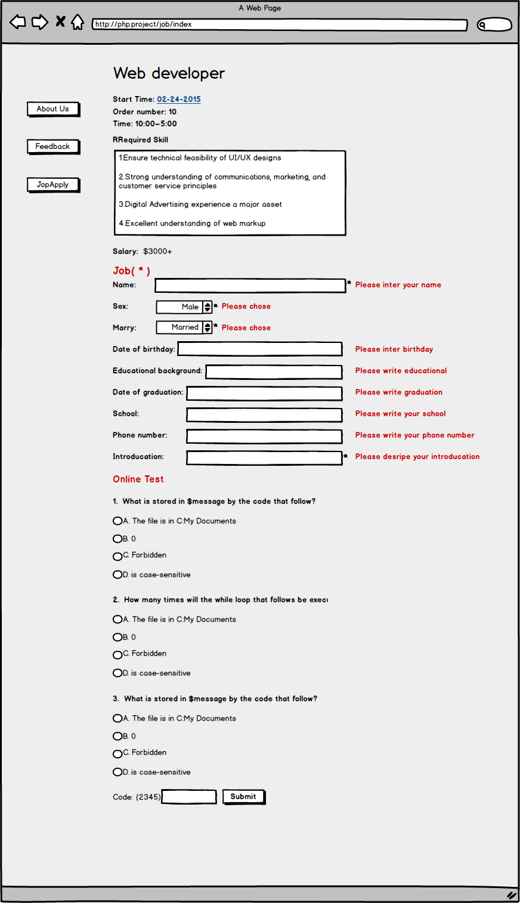

**Show job information**

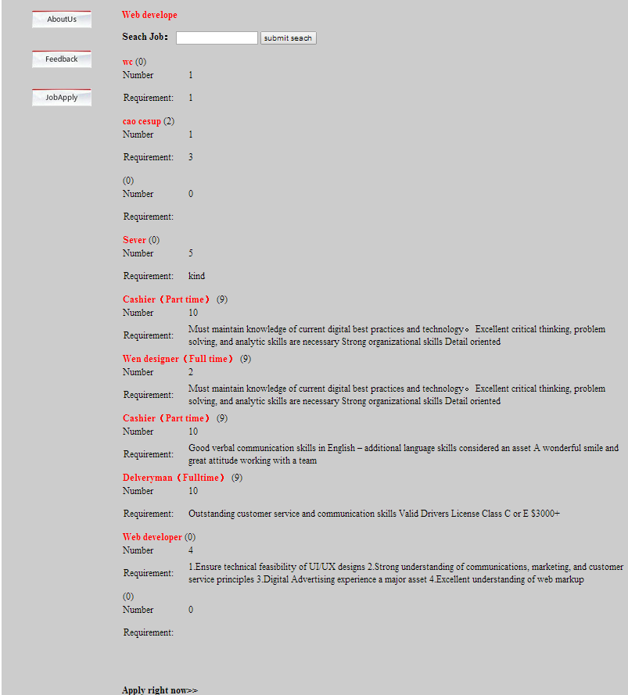

**Show apply information and online test. Question will change every time**

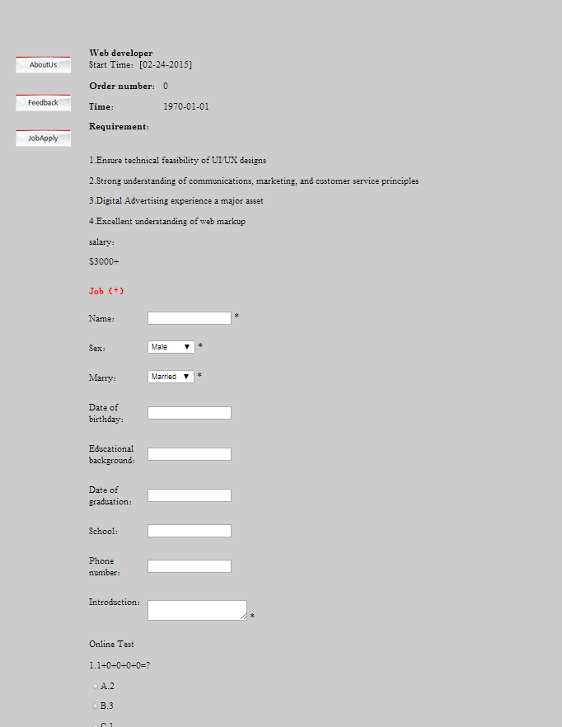

**Have to put right code then can submit**

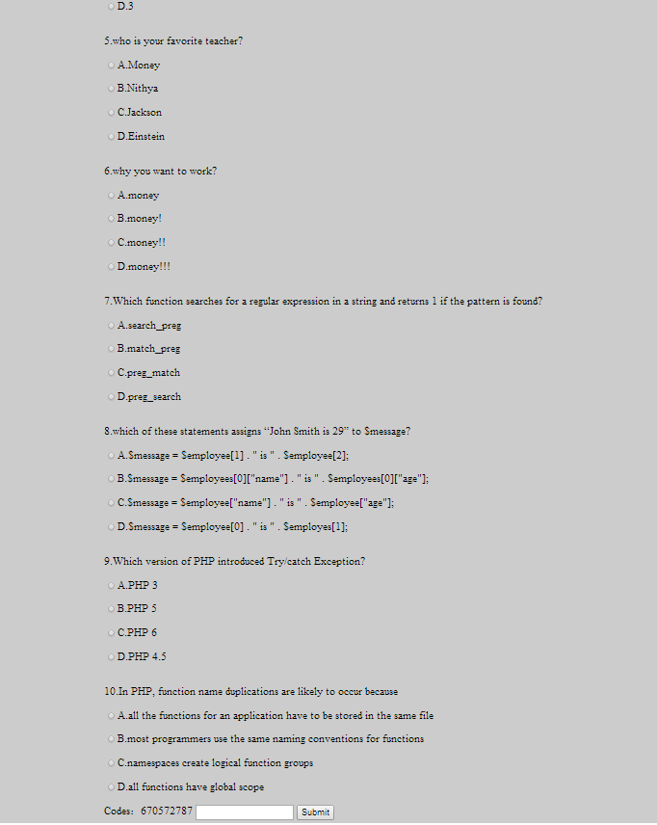

**Show feedback**

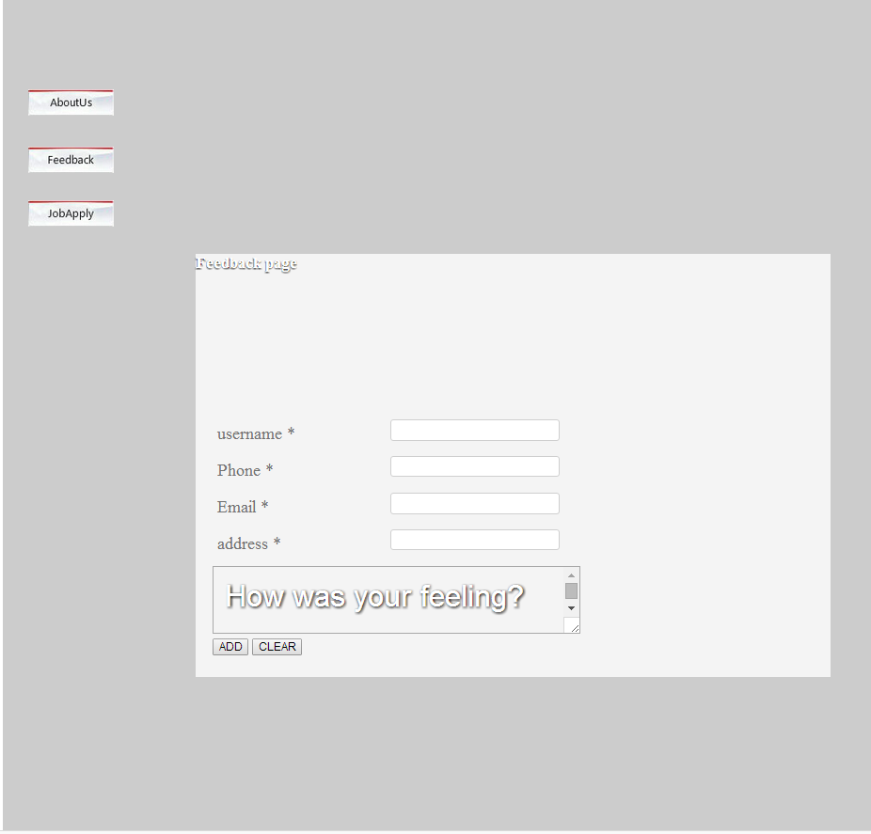

**Webadmin page**

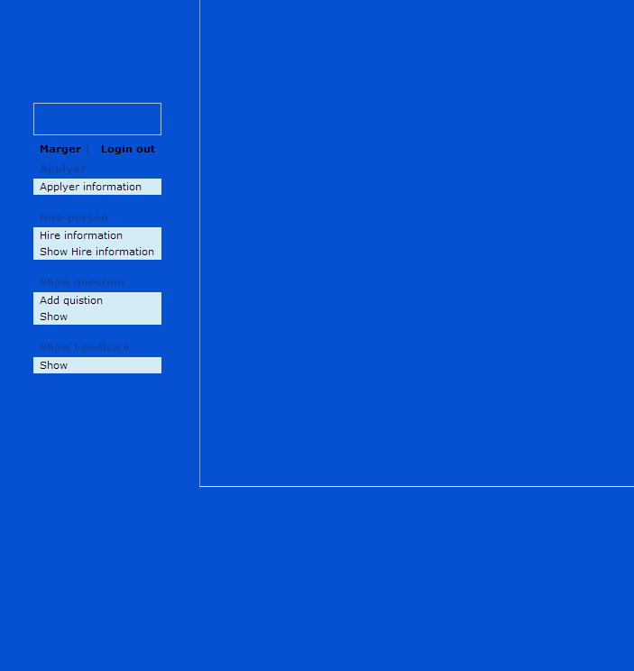

**Applyer information page**

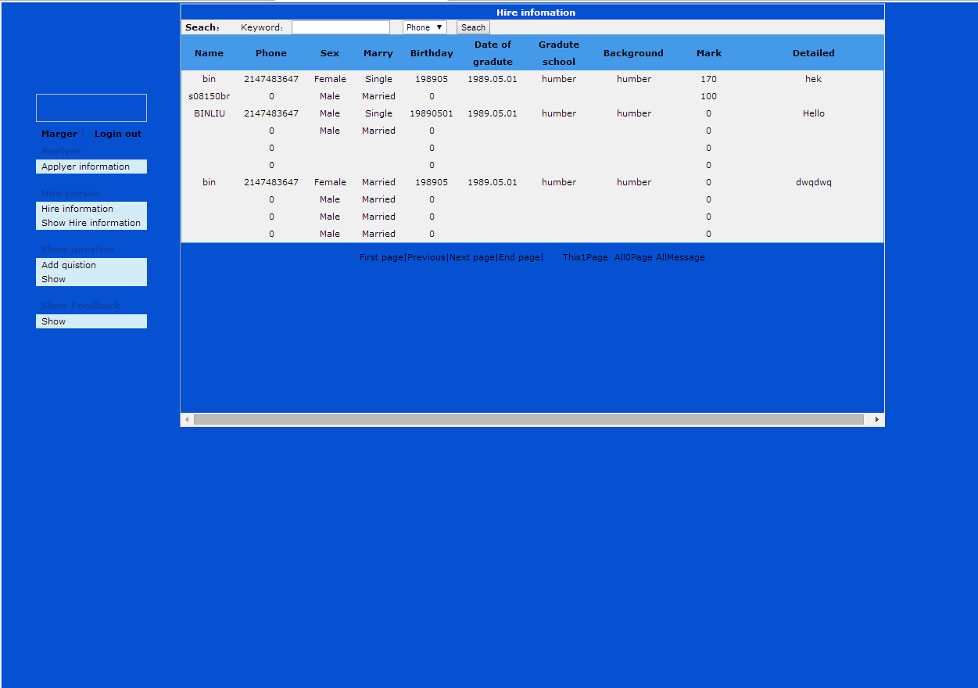

**Hire information page and show hire information**

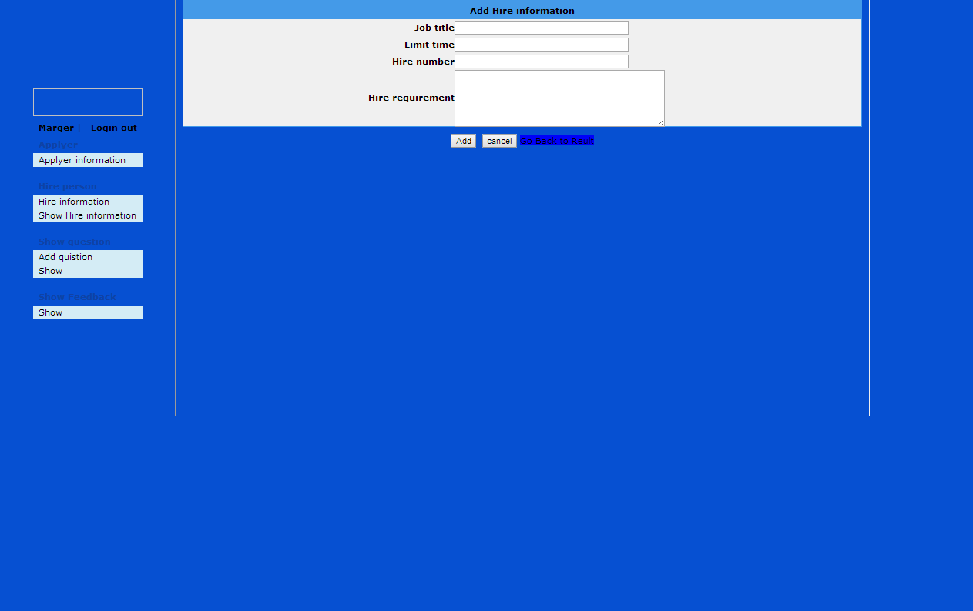

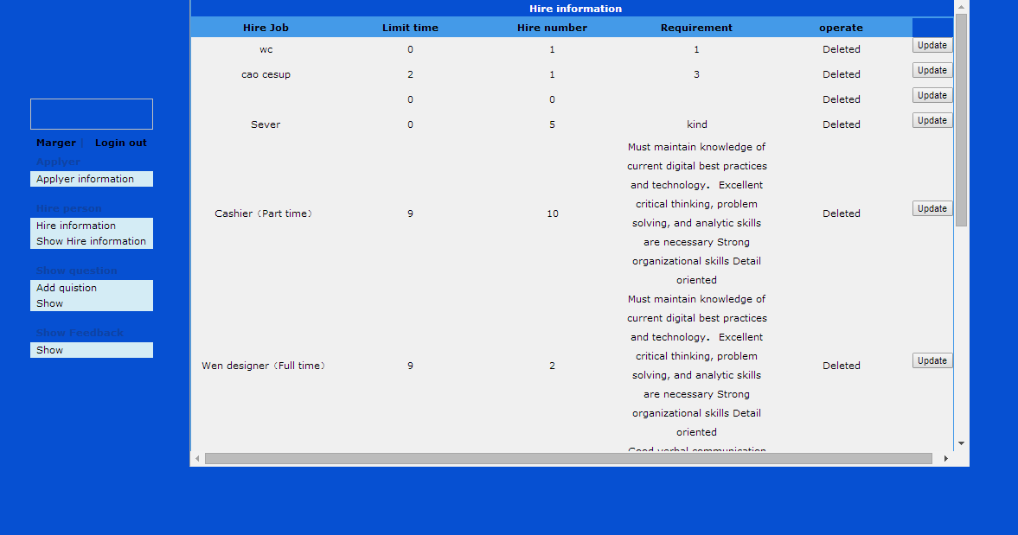

**Add question and show question**

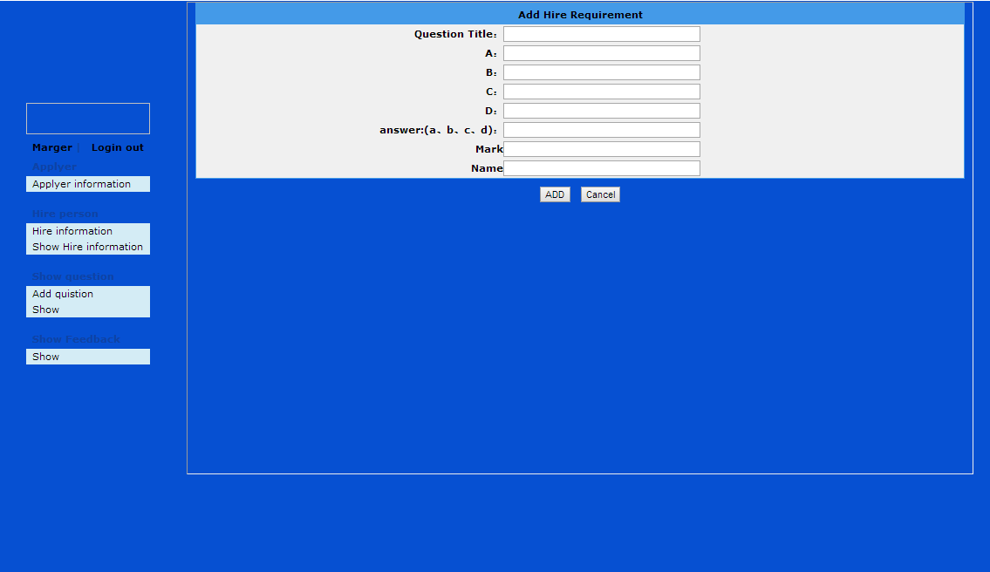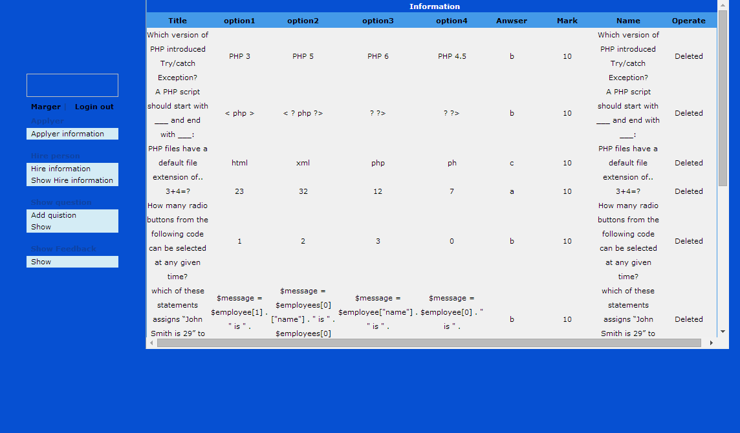

**Show feedback information**

