Feature 1 Booking Page

/Booking/index.php

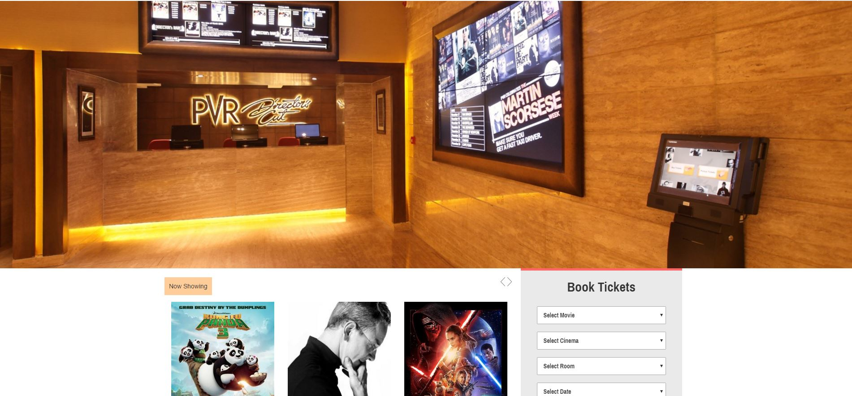

Top rate Film

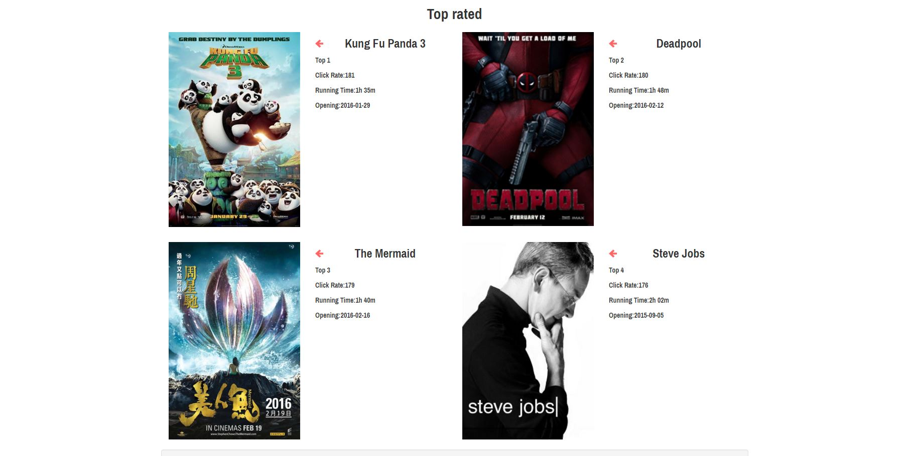

Click booking going to Order Page Login before choose film

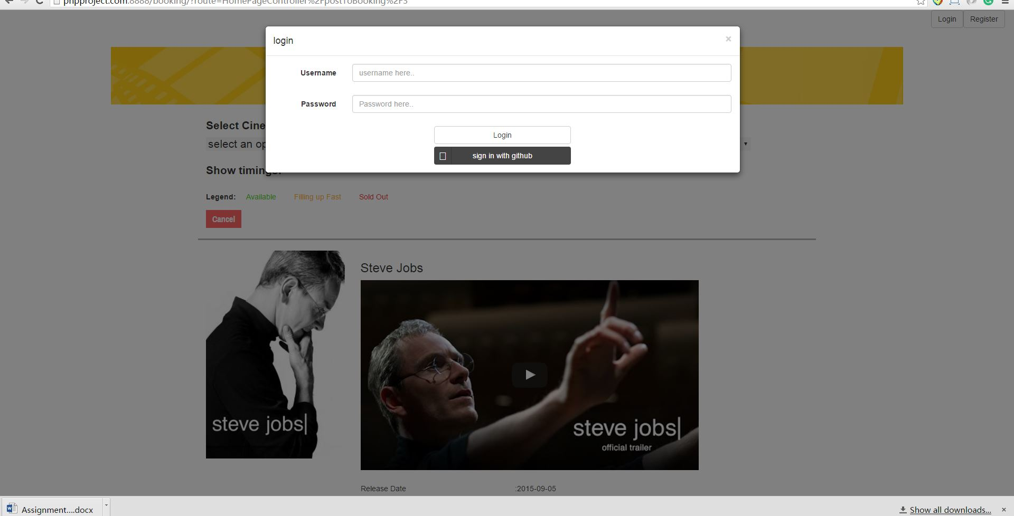

Choose Cinema room time and seats

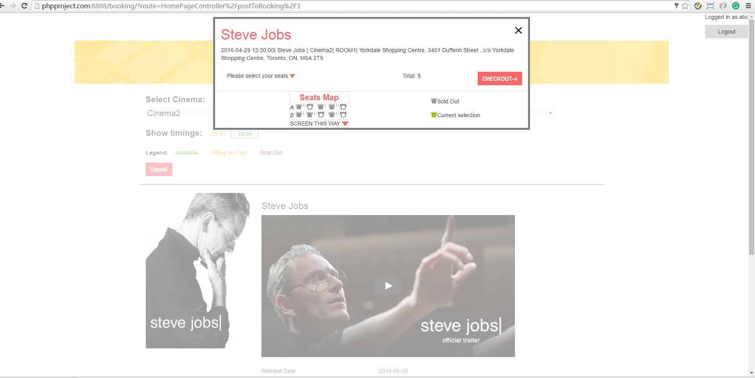

Comfirm page include Edit Delete add film and payment

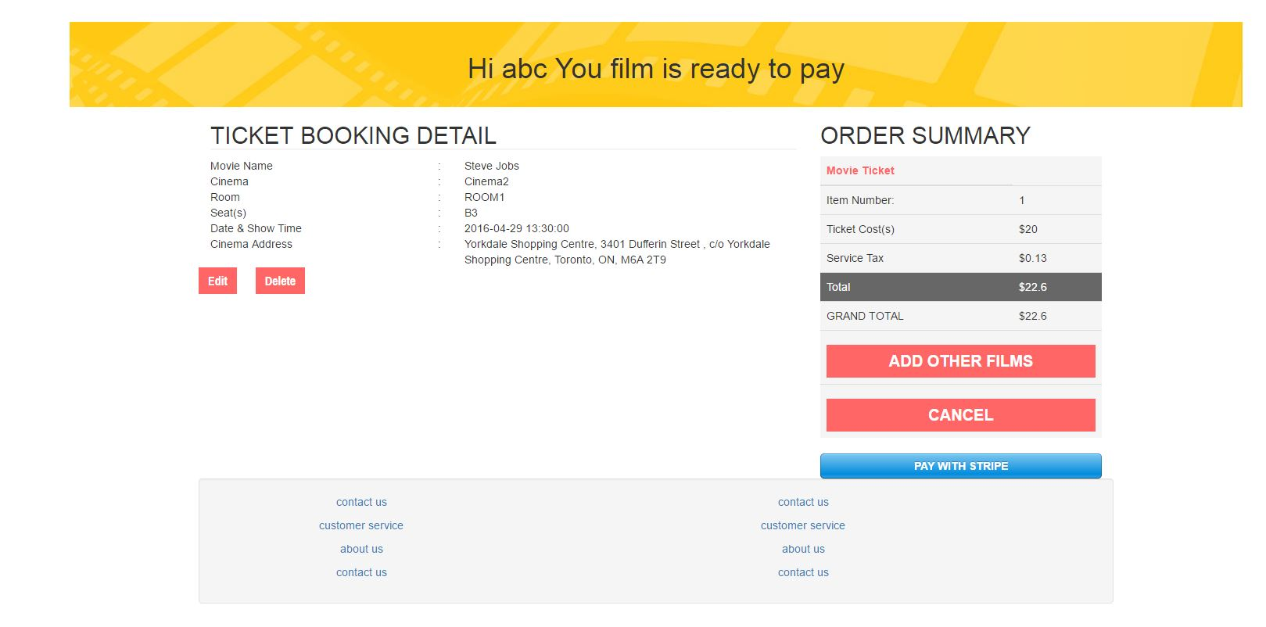

Payment

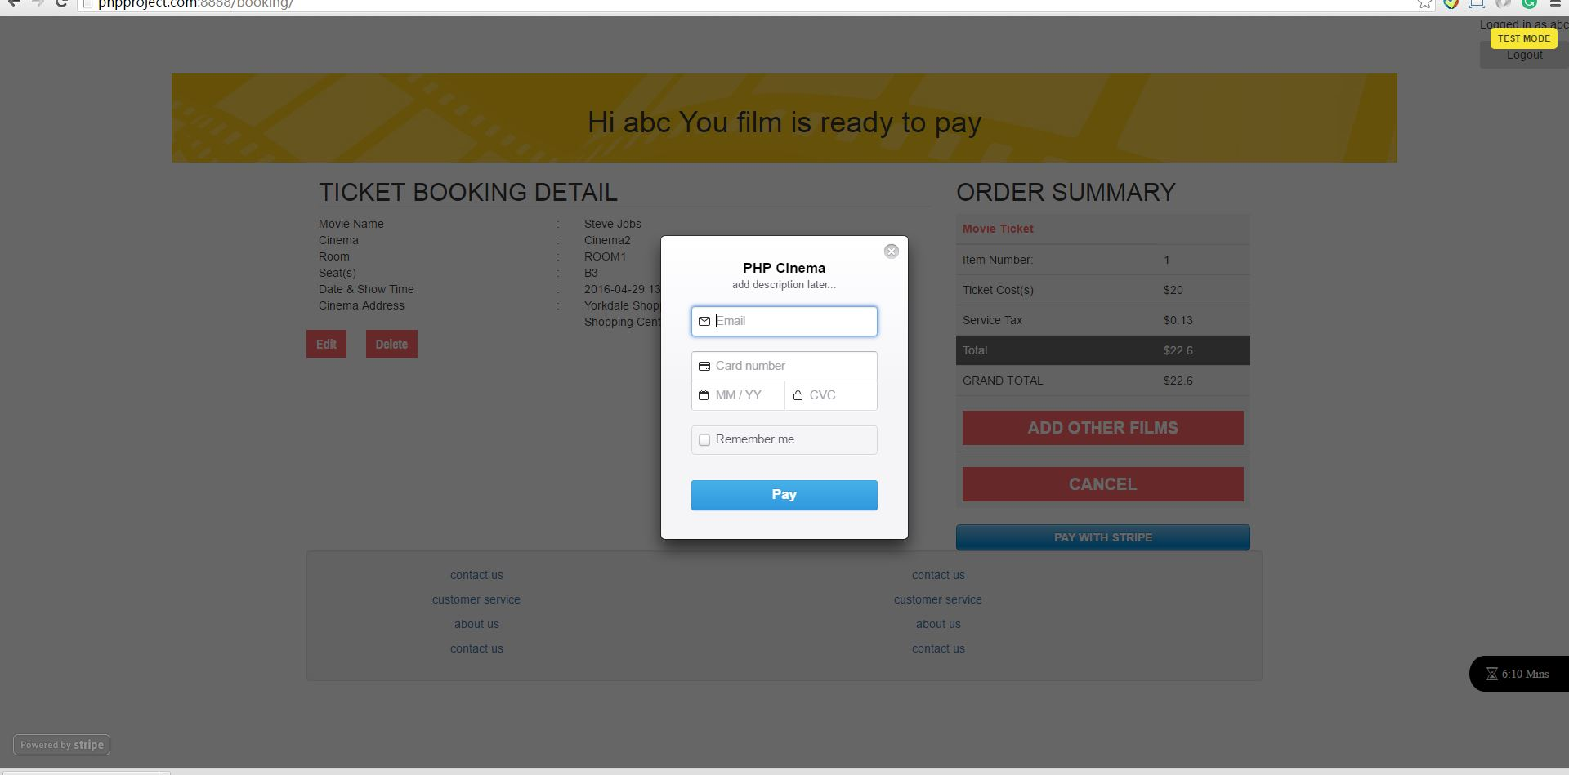

/MovieCalendar/index.php

Feature 2 Create your own MovieCalender

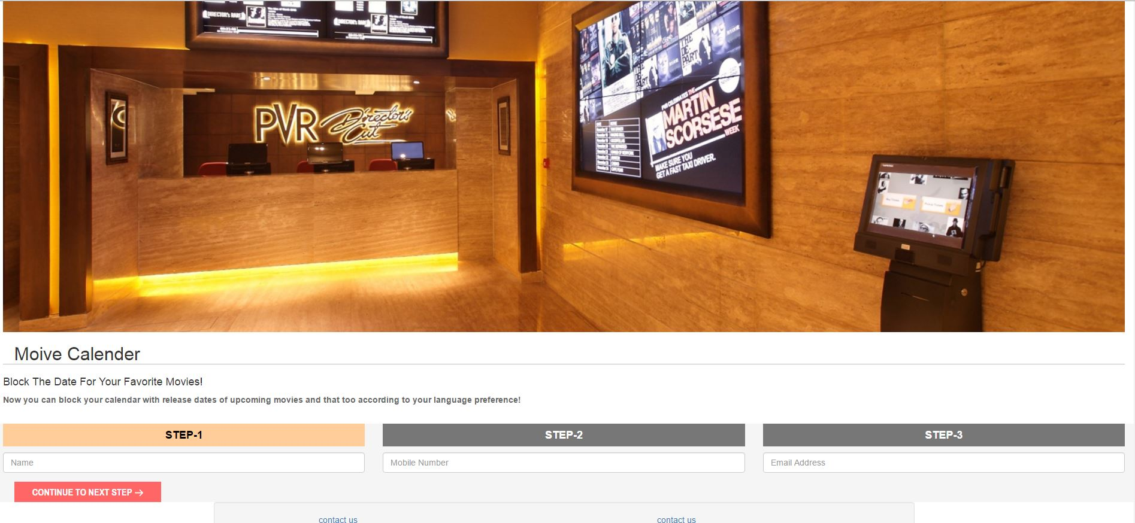

Fill in the form

Choose Films you like

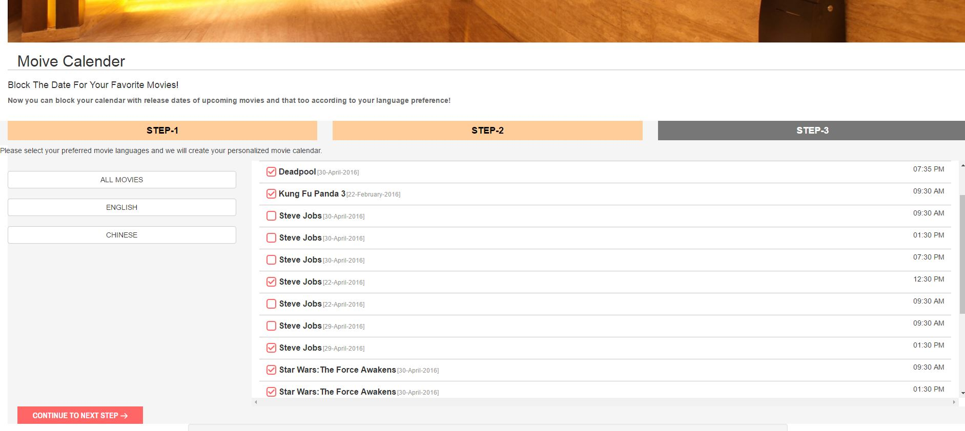

Comfirm Page Send MovieCalendar by Email

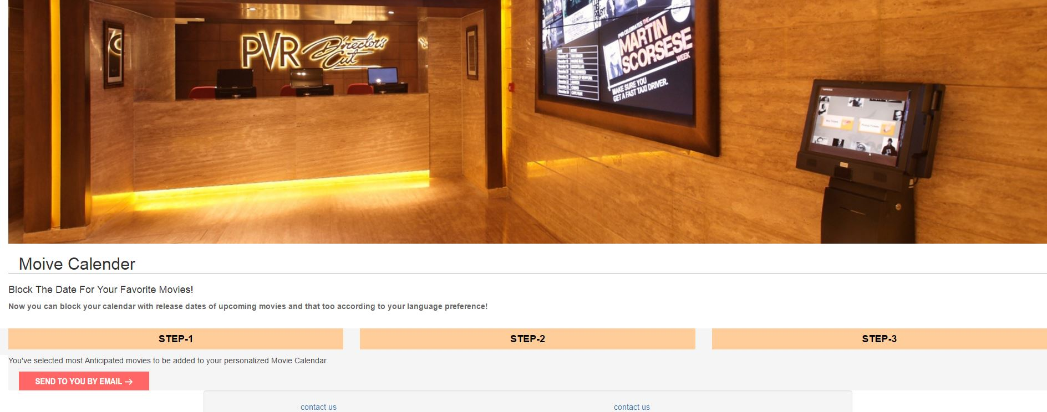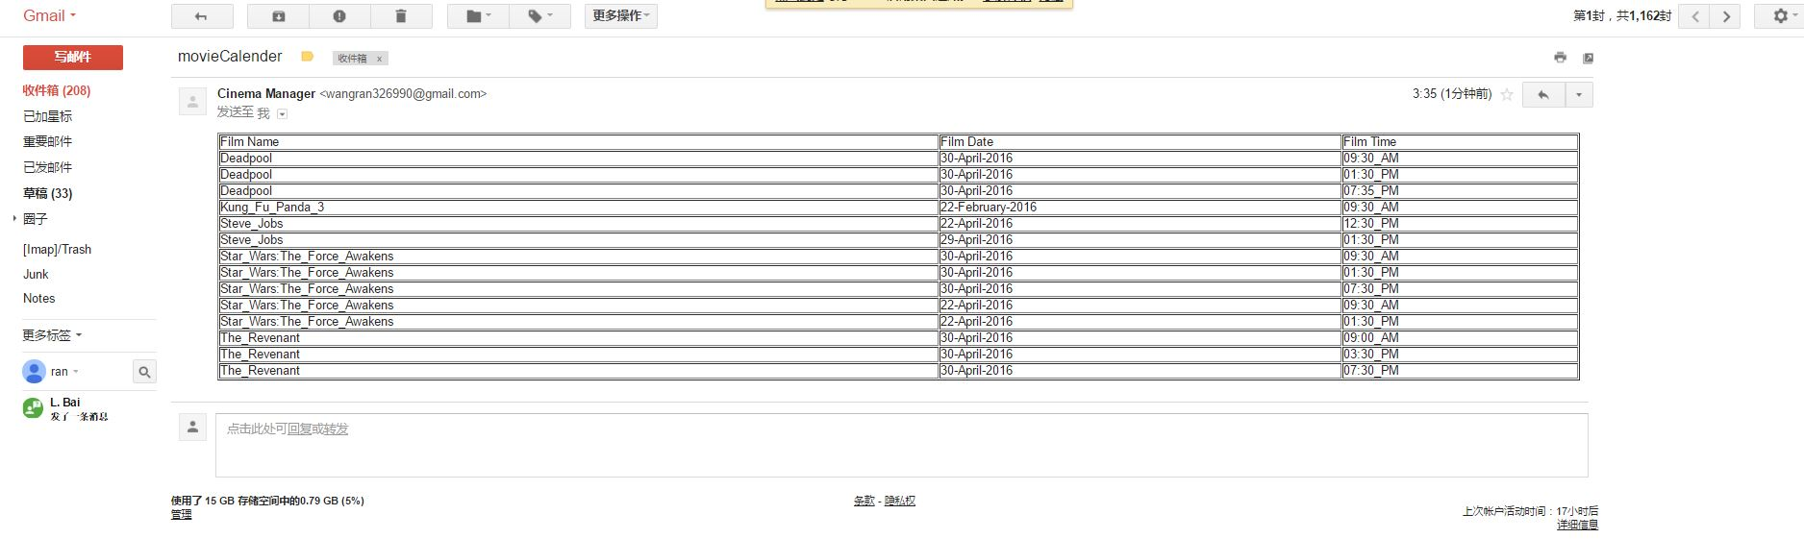

Feature3 FAQ

./FAQ/index.php

Include sorting, search, show by different categories, send email

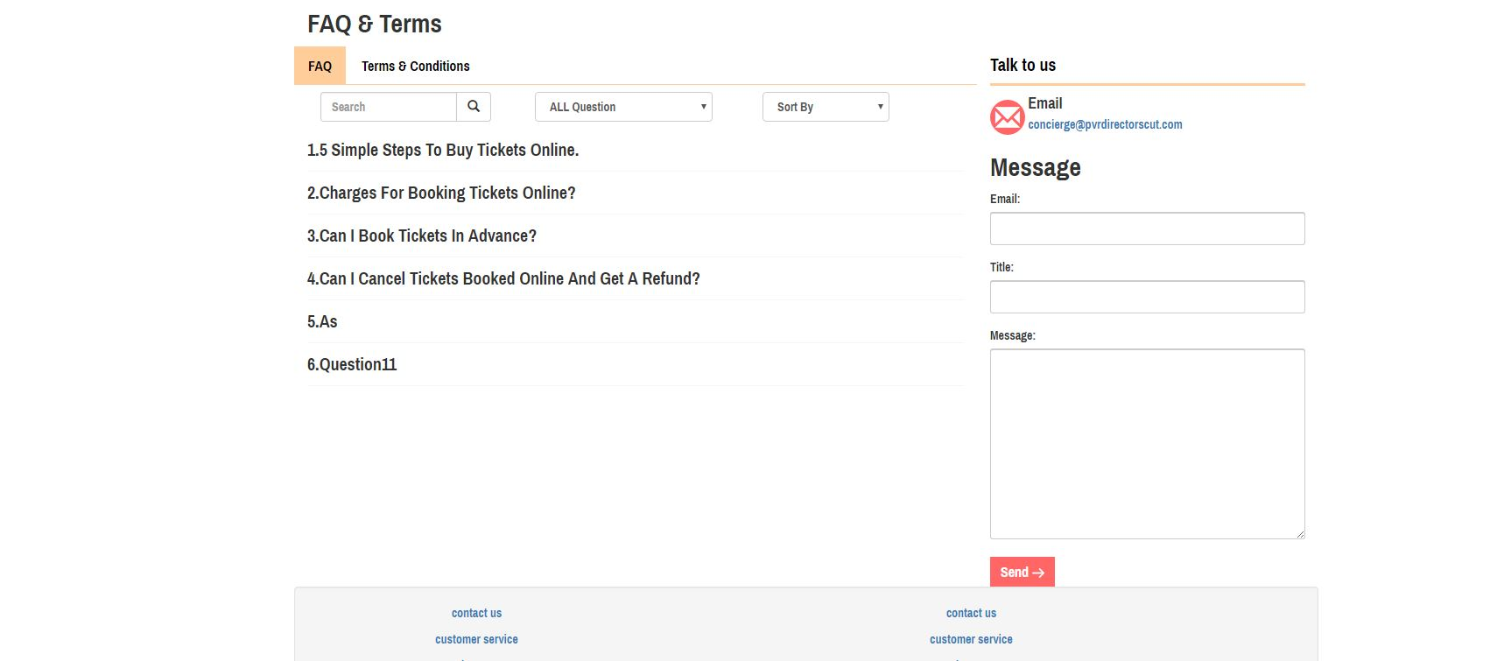

FAQ Admin include delete, edit, add Faq

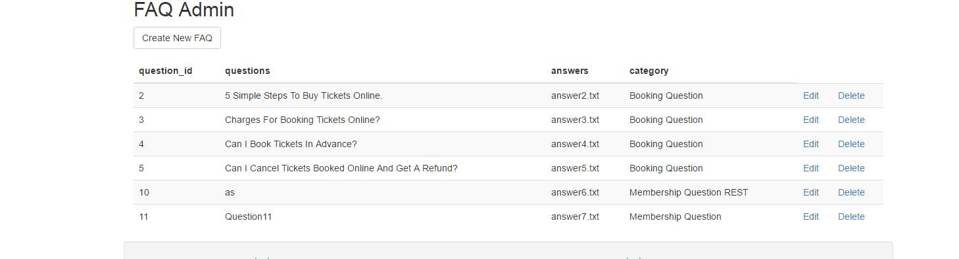

Faq add

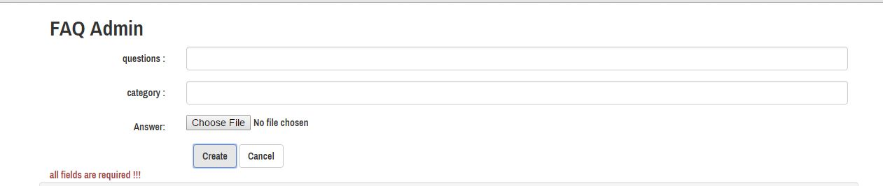

Faq delete

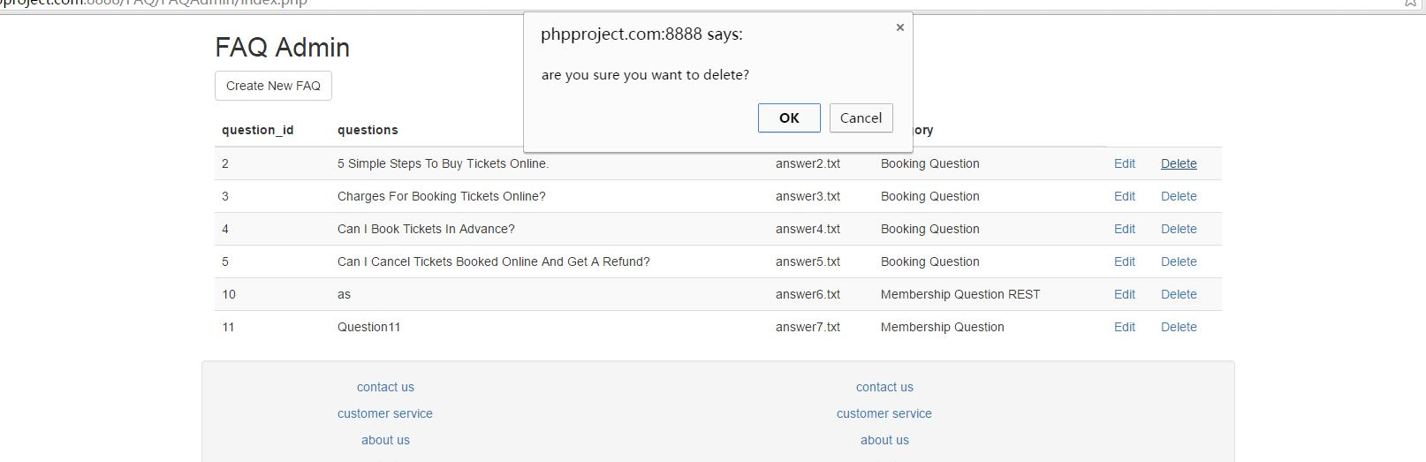

Faq edit

