Run **index.php**

Home page

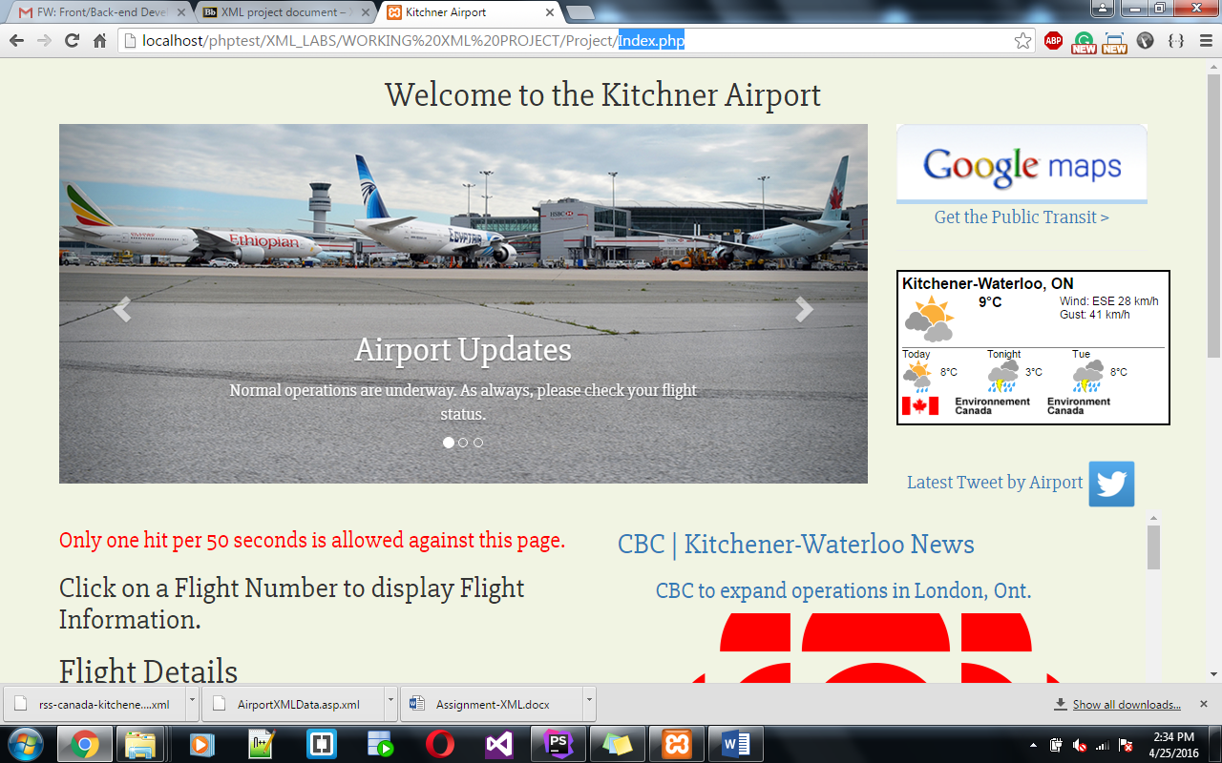

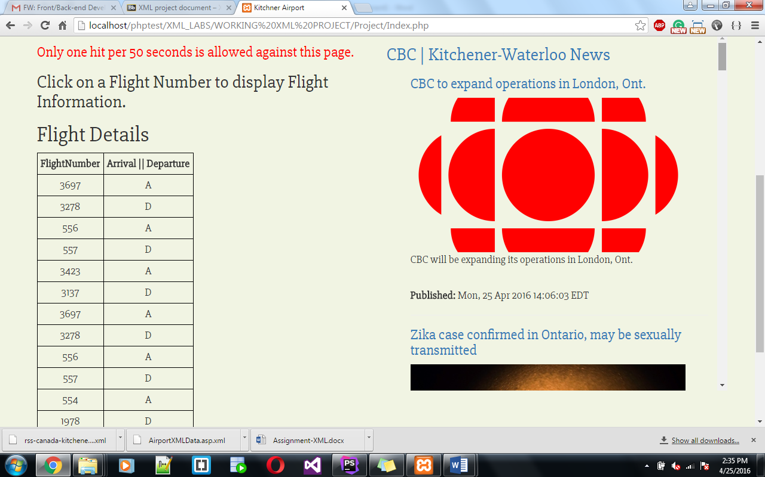

Scroll down...

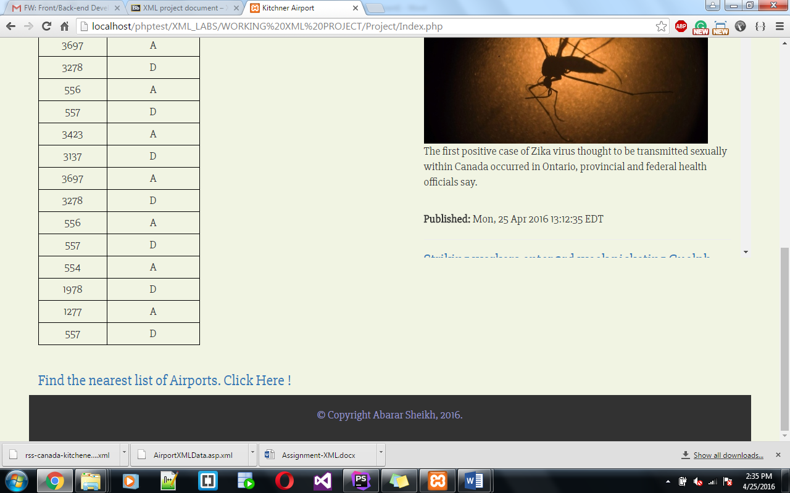

Click on **Get the Public Transit:** will display the following screen.

First Select Walking/Transit /Driving then enter your Source and destination address.

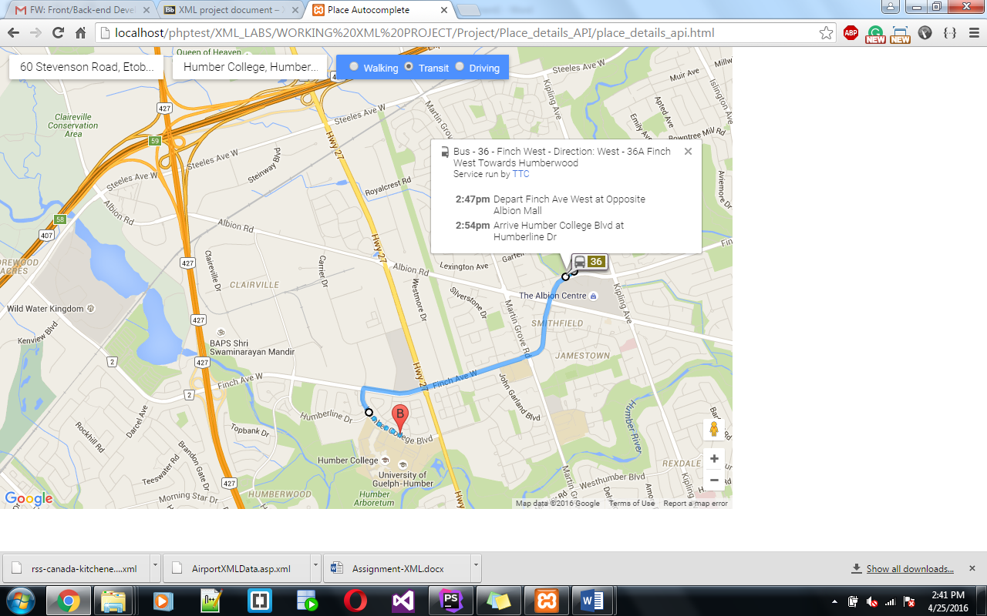

Click on **Latest Tweet by Airport**:

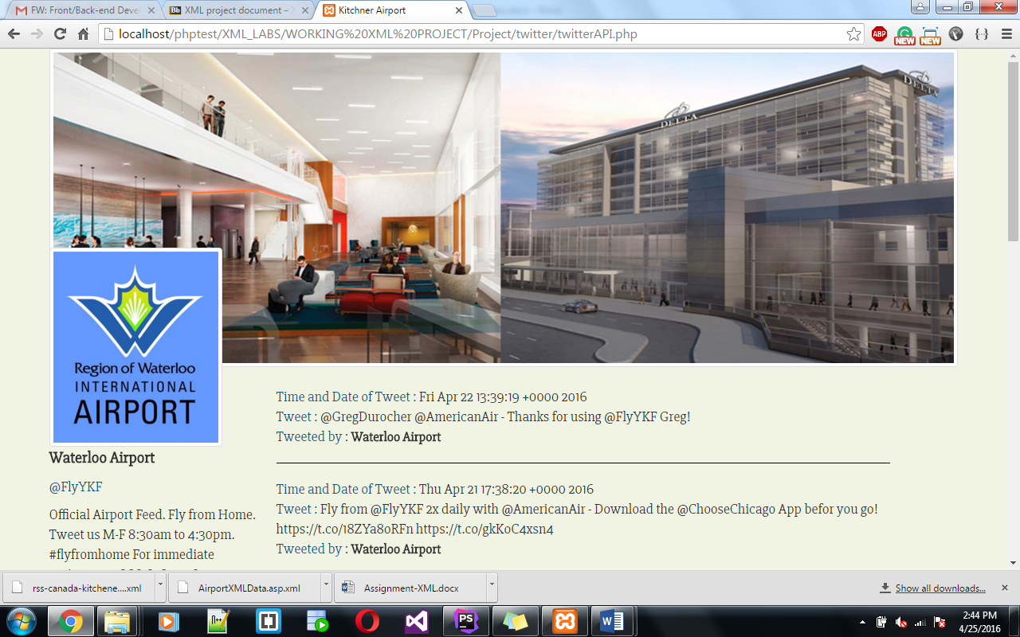

Click on **Flight number** on Table

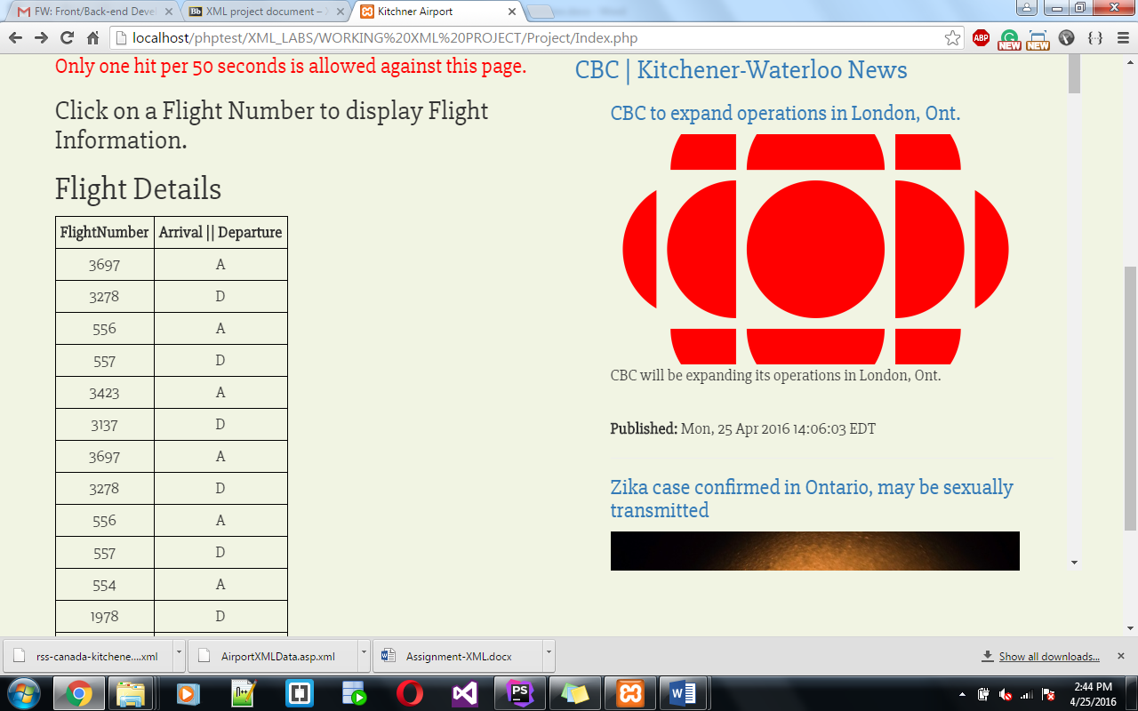

After clicking on the flight number it displayed the following information:

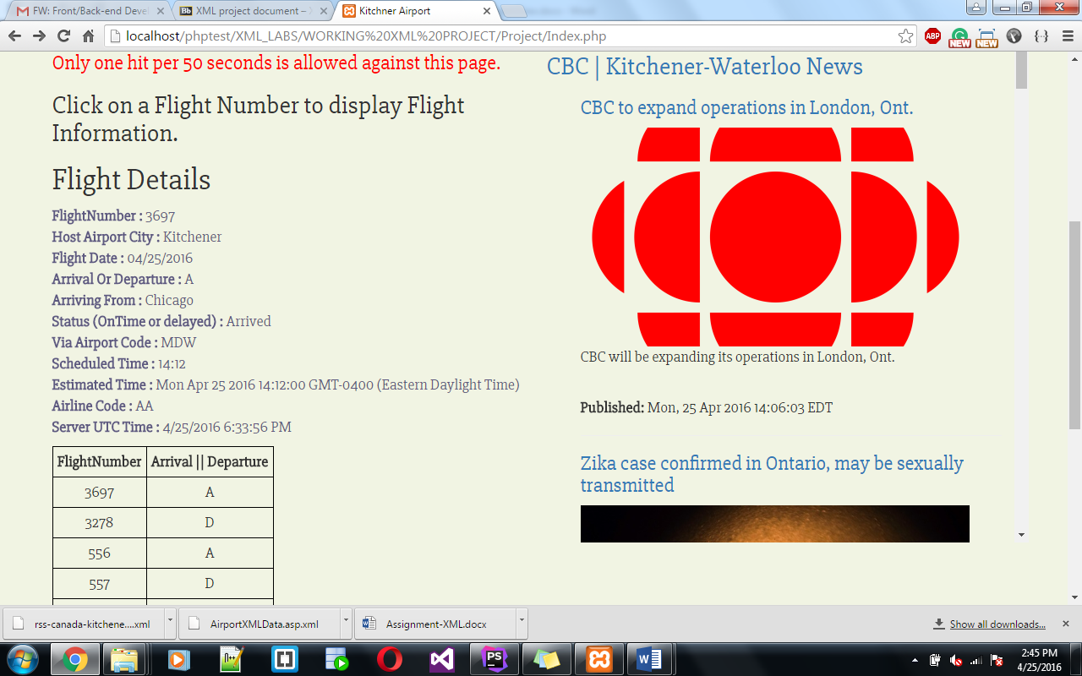

Click on the “**Find the nearest list of Airports**”:

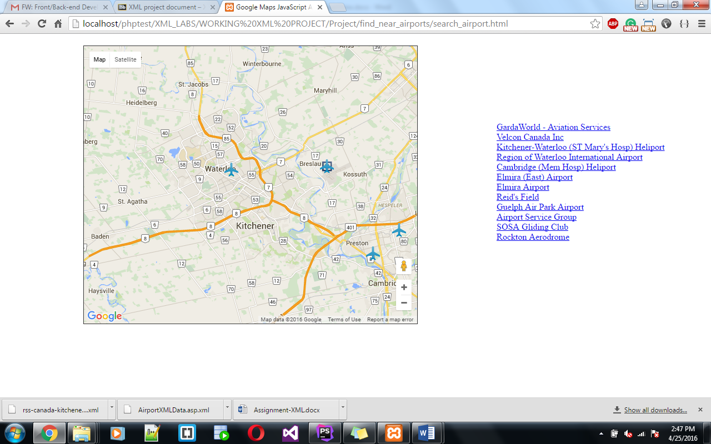

**Click on Link** will display the address of the airport.

