Stopping by Woods on a Snowy Evening, By Robert Frost
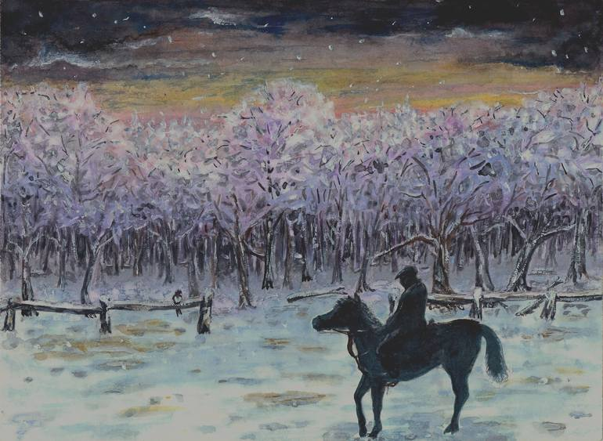
Figure 1: Snowy Woods
Whose woods these are I think I know. His house is in the village though; He will not see me stopping here; To watch his woods fill up with snow.

My little horse must think it queer; To stop without a farmhouse near; Between the woods and frozen lake; The darkest evening of the year.

He gives his harness bells a shake; To ask if there is some mistake. The only other sound’s the sweep; Of easy wind and downy flake.

The woods are lovely, dark and deep, But I have promises to keep, And miles to go before I sleep, And miles to go before I sleep.

Frost’s Collections
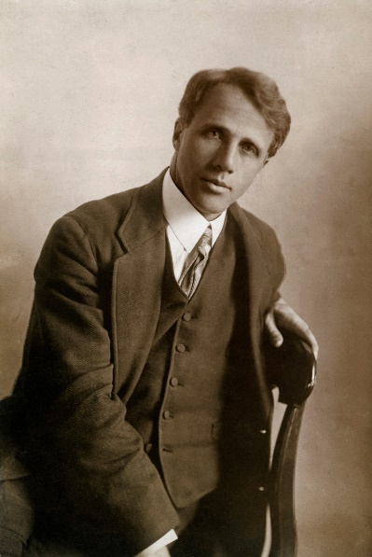
Figure 2: Robert Frost

# | Collection | Year
1 | A Boy's Will | 1913
2 | North of Boston | 1914
3 | Mountain Interval | 1916
4 | New Hampshire | 1923
5 | West Running Brook | 1928
6 | A Further Range | 1937
7 | A Witness Tree | 1942
8 | In the Clearing | 1962
9 | Steeple Bush | 1947
10 | An Afterword | unknown

